## Data Ingestion

### Overview

|  |  |
| --- | --- |
|  | In the next three sections, really just all of the Formula One files that we uploaded into our raw Container. So let me give you a quick overview. Let's do a quick recap of the requirements for ingesting our data. First, we want to ingest all of the eight files into our processed container. We should apply the right schema to the data, including the column names and data types.  We should add some audit columns such as Ingested Date and the source from where the data has been received. The ingested data must be stored as Parquet files. The ingested data should be available for all kinds of workloads, such as ML, further transformation for Reporting, and also analytical workloads via SQL. The data ingestion logic must be able to handle incremental data. So these are the requirements. |

We got our project. Amongst these, we are going to implement, the first four in the next three sections will focus on providing the ability to analyze data via a sequel and the ability to handle incremental load in the future lessons. So now that we're clear about our requirements for transition, let's look at what SPARC provides in dealing with data in different scenarios. In any kind of data processing, we have some input data and the input data can be in files with various formats such as CSV, JSON, et cetera, or in tables or even in realtime streams. The injection process usually reads the data, does the necessary transformations, such as applying schema, fixing data quality issues, performing aggregations, and then once it's been transformed writes into an output storage. Again, the output storage could be in files stores, databases or in streams. Sparke provides data from Reader API to be able to read from a range of data sources and file formats. Similarly, it provides a range of data frame APIs to be able to transform our data. And finally, Spark also provides a Dataframe writer API that provides the ability to write data to various data sources and in a range of file formats. So we'll use this dataframe reader API, Dataframe API and the Dataframe writer API extensively in the next few sections to achieve our goals.

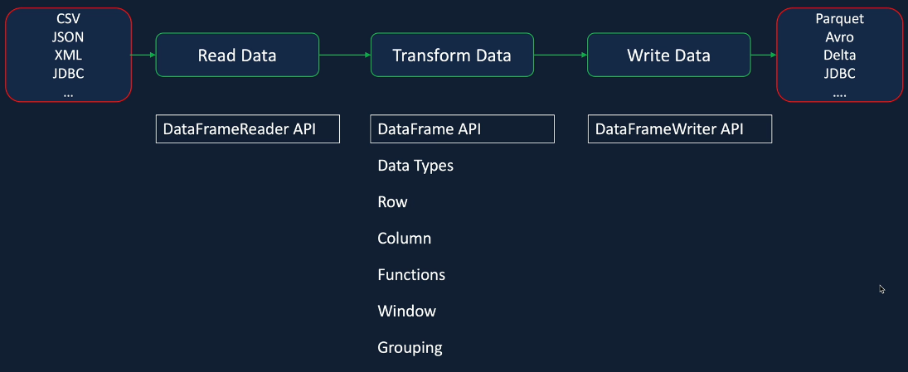

I've split the data injection into three sections in this section will focus on processing CSV files. In the next one will focus on processing the Jason files and the following one will be focused on processing split CSV as well as the JSON files. I'll teach all of the concepts and work through most of this step by step with you, but at the same time, I would like you to take three of these assignments, so you can put the learnings into practice. I'll also provide lessons on the three files which you're taking as assignments just in case you get stuck.

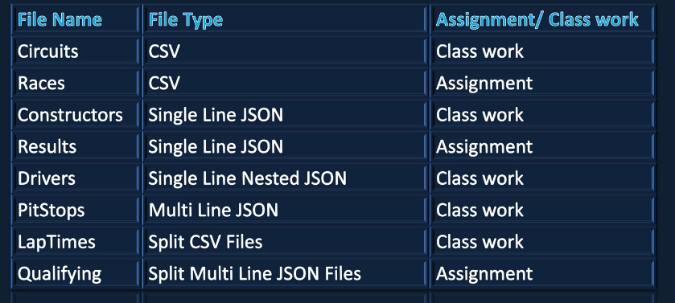

### Data Ingestion – Circuits

We are ingesting the circuits CSV file from a raw container to the process container. First, we'll take the CSV data and read it using the data frame reader API and then perform the necessary transformations and write to the process container using the data frame write API. The data returned to the process folder will be in parquet file format, which is a columnar format more suitable for analytics. The CSV file has the following columns such as circuit-i, circuit-reference, name, location, country, latitude, longitude, altitude and URL. As part of the transformation's will apply transformation's to rename the columns circuit-id and circuit-reference from Camel case to Snake case or variable names with underscores.

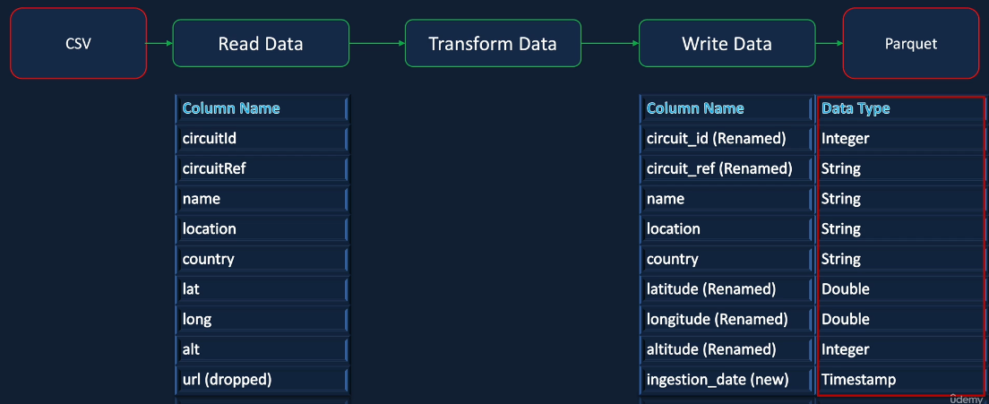

So the main reason I normally tend to do that is when I'm working on Python or PySpark, having a course on the variable names with the lower case, mix them python standard. And also, one of the other reasons why I tend to do this is a lot of the times we tend to create data tables on top of this data, which we'll be doing later in our project. And when you do that and write a standard SQL query, they are case insensitive. So there is nothing stopping someone from writing a career with the circuit-reference without an uppercase or so. Everything could be lowercase and or everything could be uppercase. And it becomes highly unreadable when you have column names, which doesn't have any separation between two words. But by doing this, you're forcing the developer to write the query so that it's more readable. That's the main reason I tend to do it. So as I said, it's not mandatory, if you don't have to do it if you don't want to do it. One of the other transformation we want to do is we want to go from Lat and Long, longitude and latitude to make them a bit more meaningful to read, then the next thing we want to do is we want to drop the Url from our input data. It's not really adding much value for us. So we'll drop that column. And we'll also add a new column called Ingestion Date, which will contain the date and the time of the data being ingested, it will be quite useful for any audit purposes and also will make sure that the data returned to park has the right data types. So there is quite a lot of work to do here.

### Dataframe Reader

OK, here we are in the database workspace, and in this lesson, I'll show you how to use the data frame reader API to read the data from our CSV file into a Spark Dataframe. So the first thing we want to do is to make sure that the cluster is up and running. My cluster is terminated because I've not been active for a while, so I'm going to start a cluster. And while that's being started, let's go to our workspace. And previously we created this folder for our project, Formula One, and also we created another folder called SetUp and kept our setup notebook in there. So let's create another one for ingestion. And I'm going to call this one as ingestion.

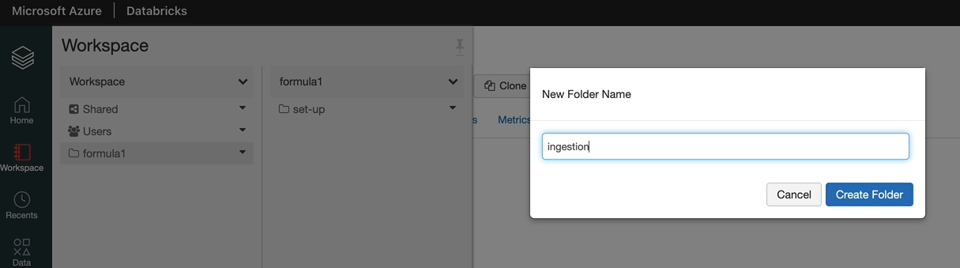

And we want to create a new Python notebook here. And I'm going to call this one as one dart ingest circuits five. And the default language is Python, and our cluster is the database called Cluster.

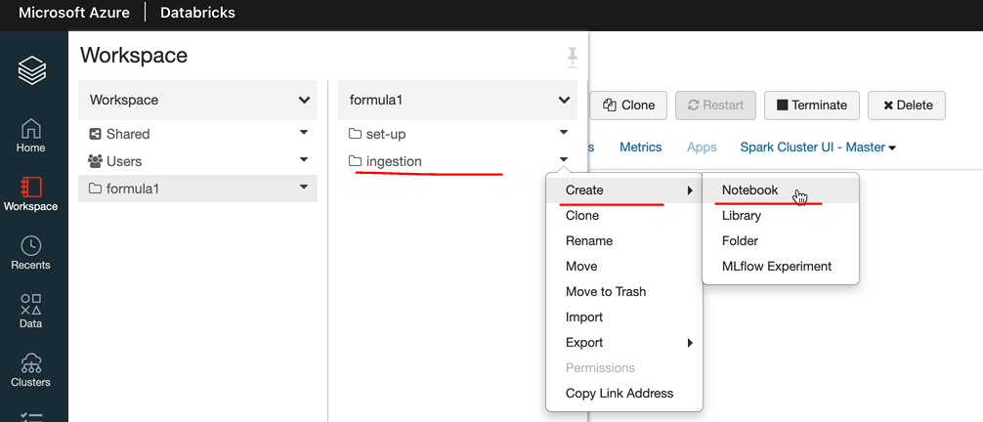

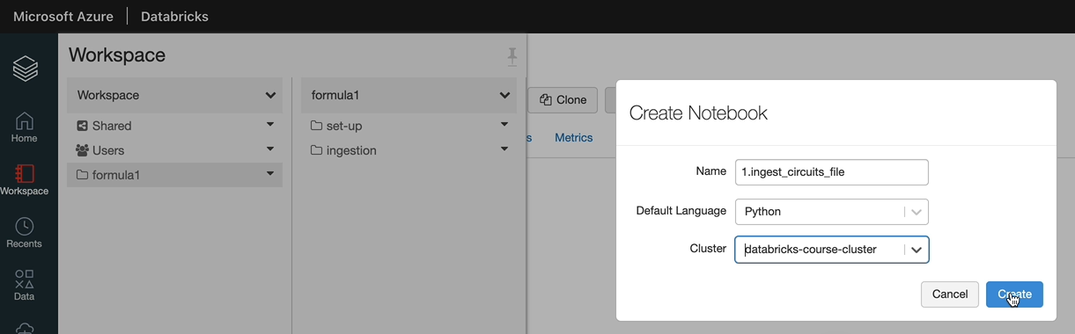

In my case, so click create there and we got the notebook here. The first thing is I want to put some documentation here. And the first step we want to do is to read the CSV file using the Spark Dataframe Reader.

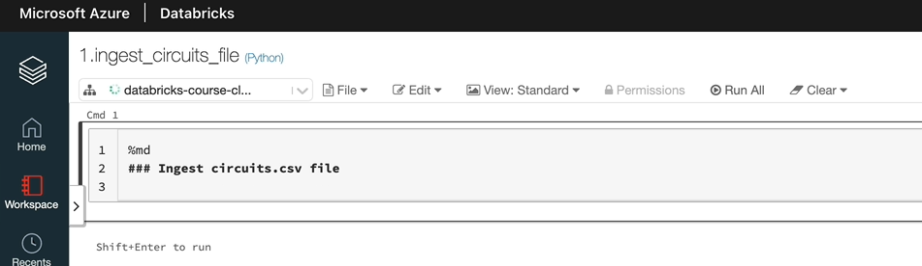

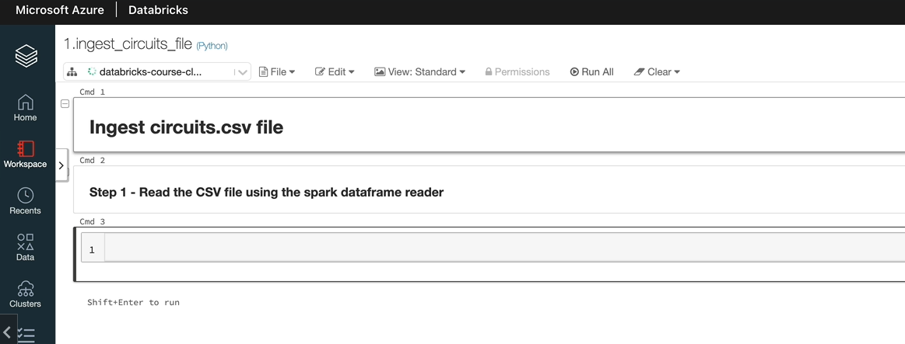

So let's see how we use this Data Frame reader API to read the data, so the entry point to spark session is the spark come out and after that they need to invoke the method to call the spark dataframe reader. So let's switch over to the documentation.

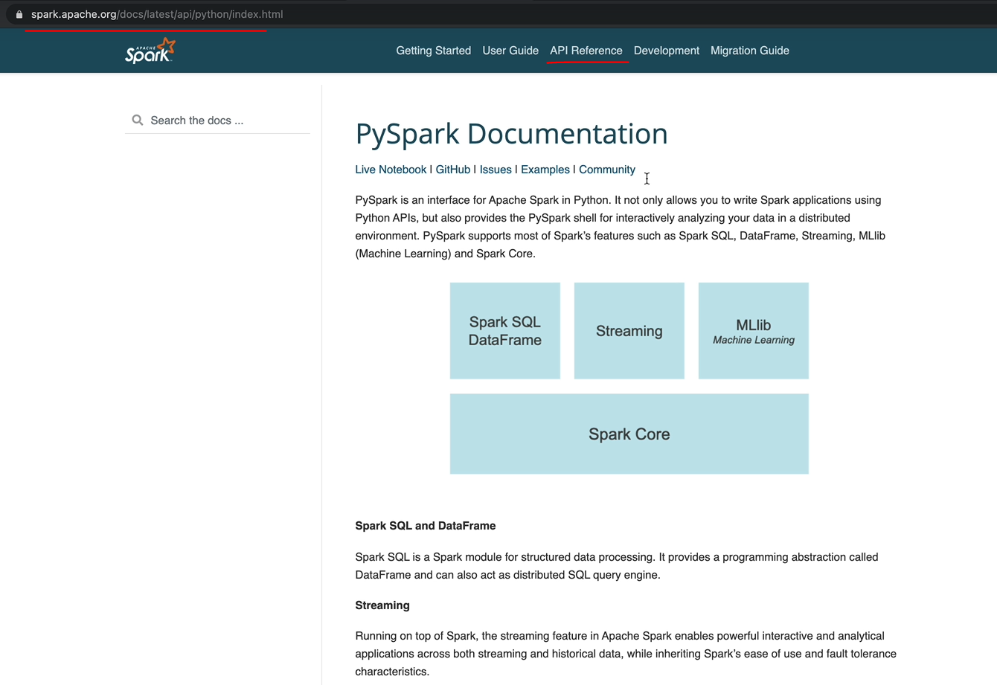

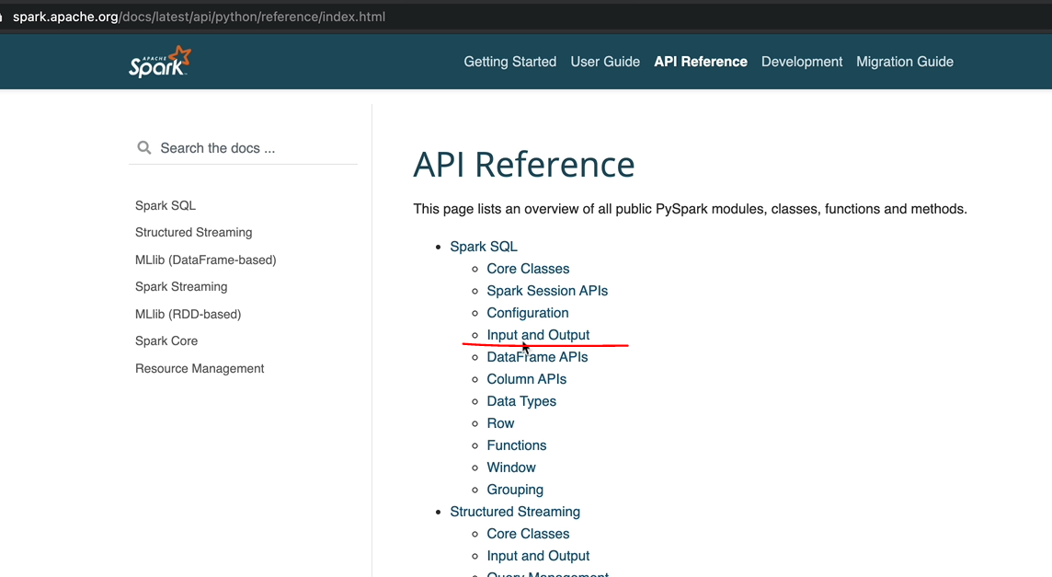

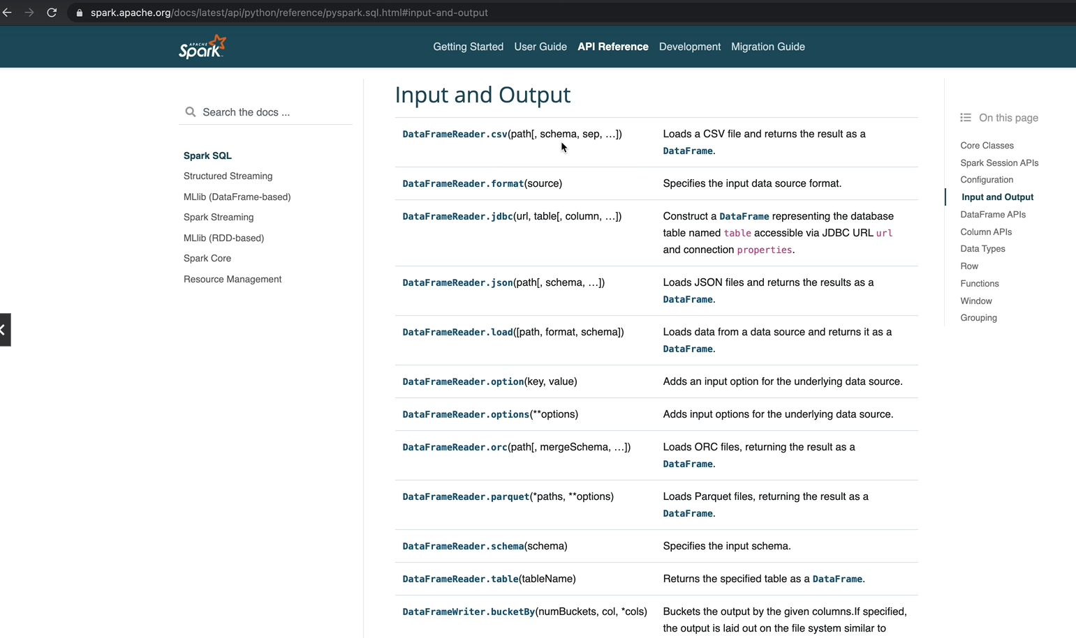

It's important to know how to use the documentation so that you will be able to deal with any kind of scenario rather than just the ones I'm going to teach here. So this is the documentation page and go to reference. And in here, under input and output, you can see DataFrameReader.csv. So that's the API, which is going to let us read a CSV file. You don't have to navigate like I did. You can just come and search for the DataFrameReader API. So click on that one. And that tells you the documentation for data from the API. And if you want to look at the source code, you can go to the source code and look at that as well. I'll show you where that is. And that may sometimes have more information you want to look at. But in our case, we will be OK with just using the documentation here. As you can see, it allows the CSV file and returns the result as a data file. And it's got a number of parameters you can pass in. But the only mandatory parameter is the path and everything else has been defaulted if you don't pass it.

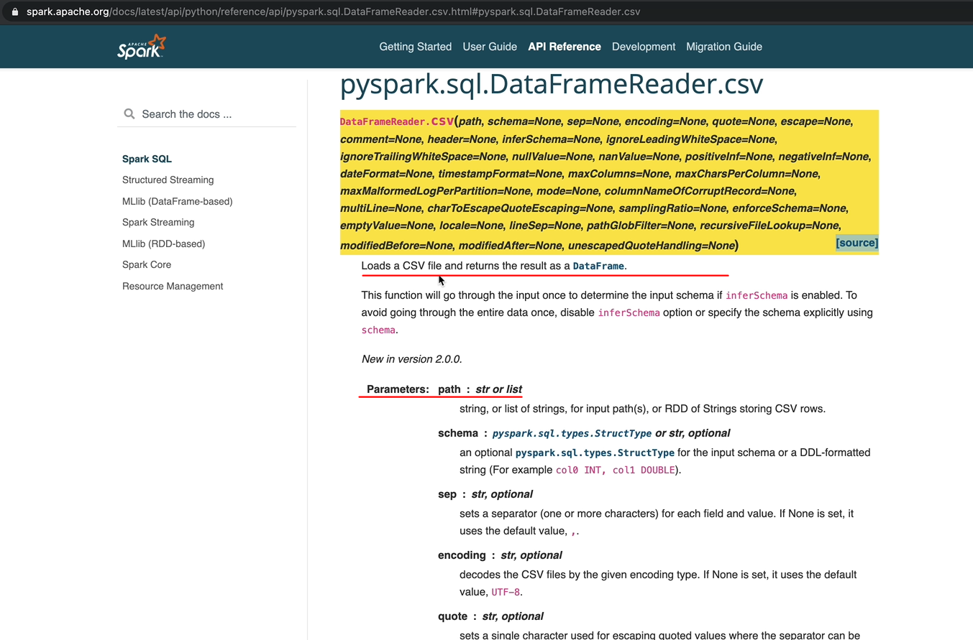

So let's quickly go to the bottom of the page and you can see some examples as well. So the way you call that is using spark.read.csv and then you can pass in the location of your file and you assign that to a variable, which will be a data frame. So let's switch over to notebook and do that. So that will be spark.read.csv.

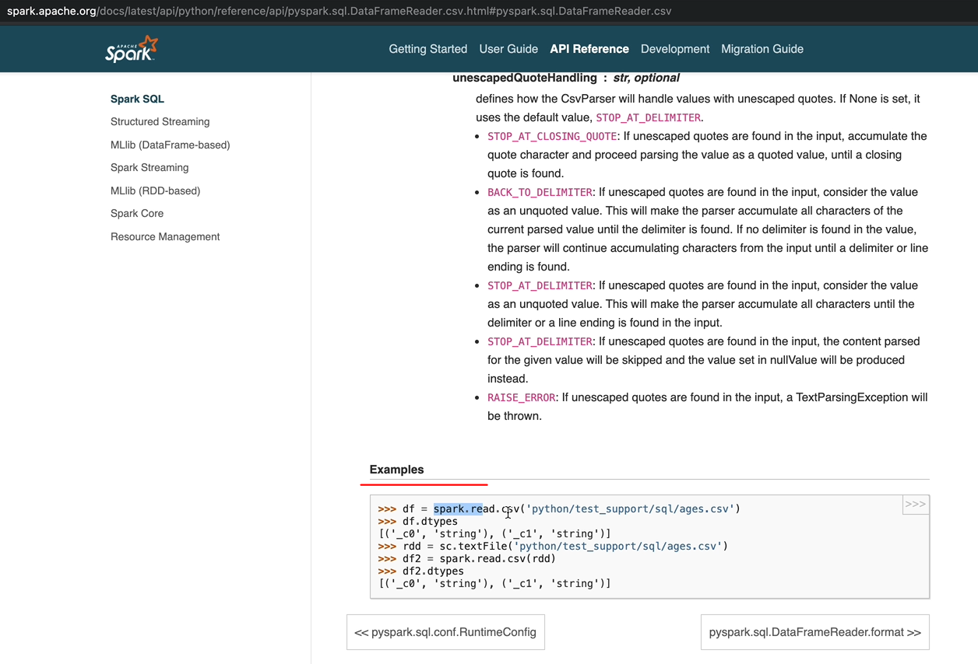

And then we want to pass in our location of the CSV file. As part of our set up, we created our mounts, so let's see what we call the mounts. So in order to do that, if you remember, we need to use the dbutils package and that would be dbutils.fs.mount() and that would list all the mounts. And to see a pretty output from the mouns, rather than saying this, you can wrap it around in a display command and that will give you the output in a table format and that'll be a bit more easier to read. So this is our mount point. /mount/formula-one-dl/raw. And that's been mounted on our data storage here.

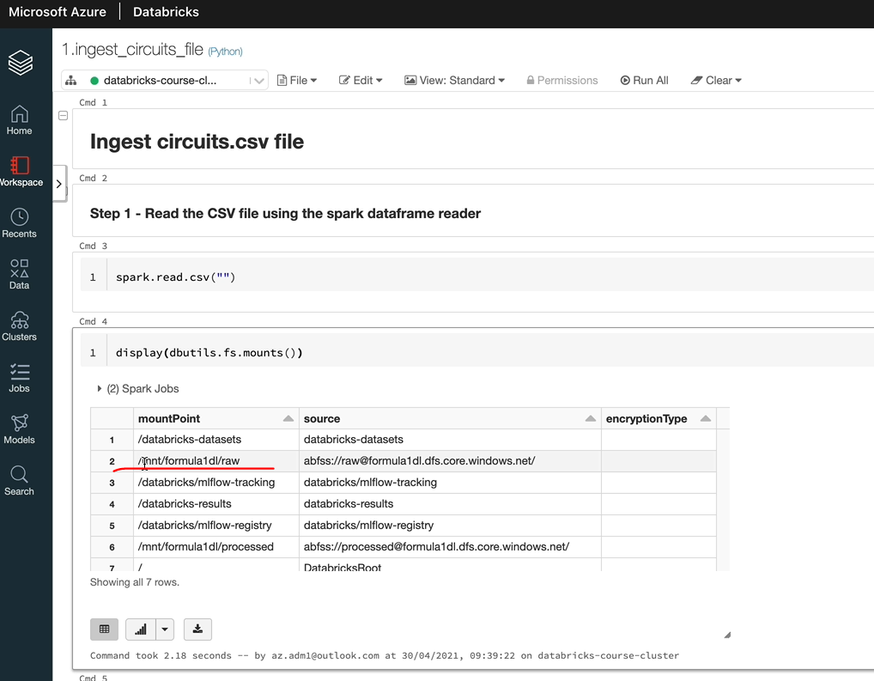

So let's see what the files are inside that. I'm going to use the magic command %fs, you can use the details if you wanted to. But this is a shortcut. So if I did %fs and then it should list all the files in there.

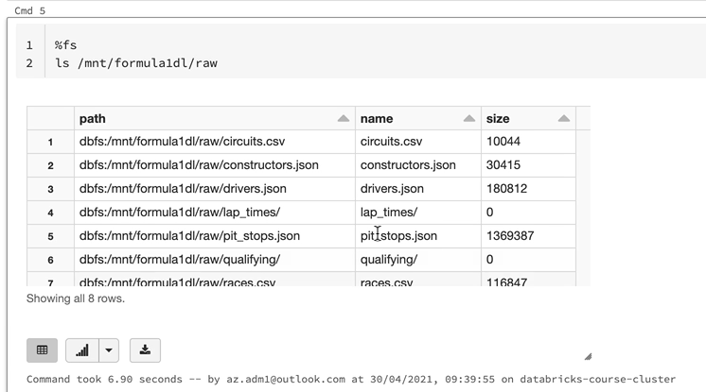

As we know, we got six files and the two folders so we can see them. So we got the six files and the two folders in total. We got the eight eight records listed here. So this is the path for our circuits CSV file, and that's the one we want to use. So let's copy that one. And we're going to put it in here into the spot that we have csv statement and we want to assign that to a variable and I'm going to call this a circuitdf. And let's execute that. OK, so that's executed. Now, as you can see, that return Dataframe object, so that's our first DataFrame being created so we can delete these two statements. We don't need them anymore because we know the location of our files.

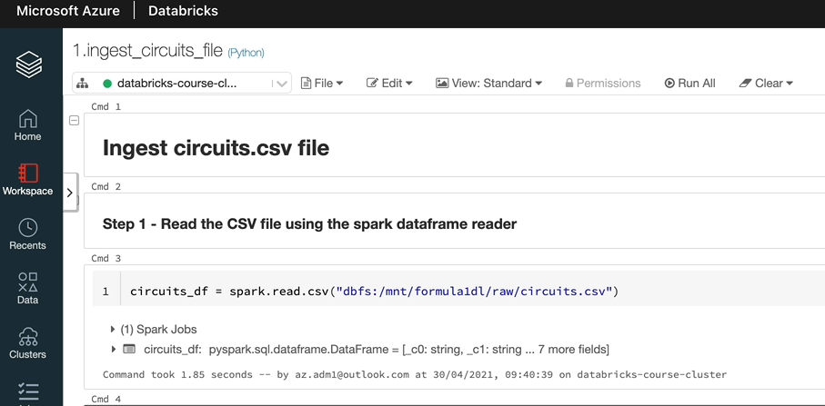

The next thing what we can do is let's see what the type is of the variable. I should be doing circuits_df and that is the type DataFrae and in order to see the contents, you can use the method show() to display the output. So, again, I'll take you to the documentation and I'll show you what that does. So thats the show method, so let's have a look at that and as you can say, this is the documentation. It prints the first 20 records to the console. If you don't specify a number, at least the first 20 records, otherwise you can specify what you want and list the number of records. So there are some examples here as well. Let me go back to the notebook now, and that's in here. So let's use .show(). I'm going to take that out and use .show(). So that's at least the top 20 records. As you can see, there are 19 records from the file, plus the top one is actually the header. So there are 20 records being returned.

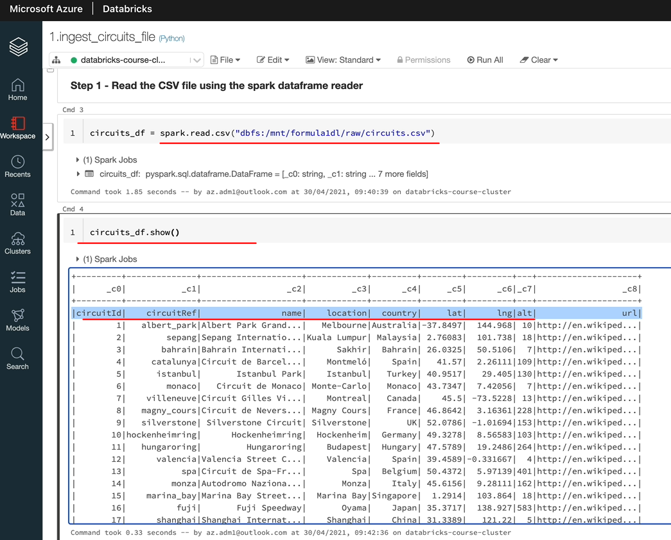

As you can see, we got a problem here. So it failed to identify the header, our file has got a header, but it's not identified that it's listed that as the first record. So there is something we can do to fix that. But before we do that, I want to show you something. As you can see, the .show() has given us the output, but you can it's truncated the field to, I think it's 20 characters, but you can change that by giving another option to say truncate="false". But there is another nicer way of seeing the data in database, and that is using the database visualization command called display(), which we saw previously. Do that and you will get the output in table format here and it's not being truncated anywhere. So you're seeing a nicer data.

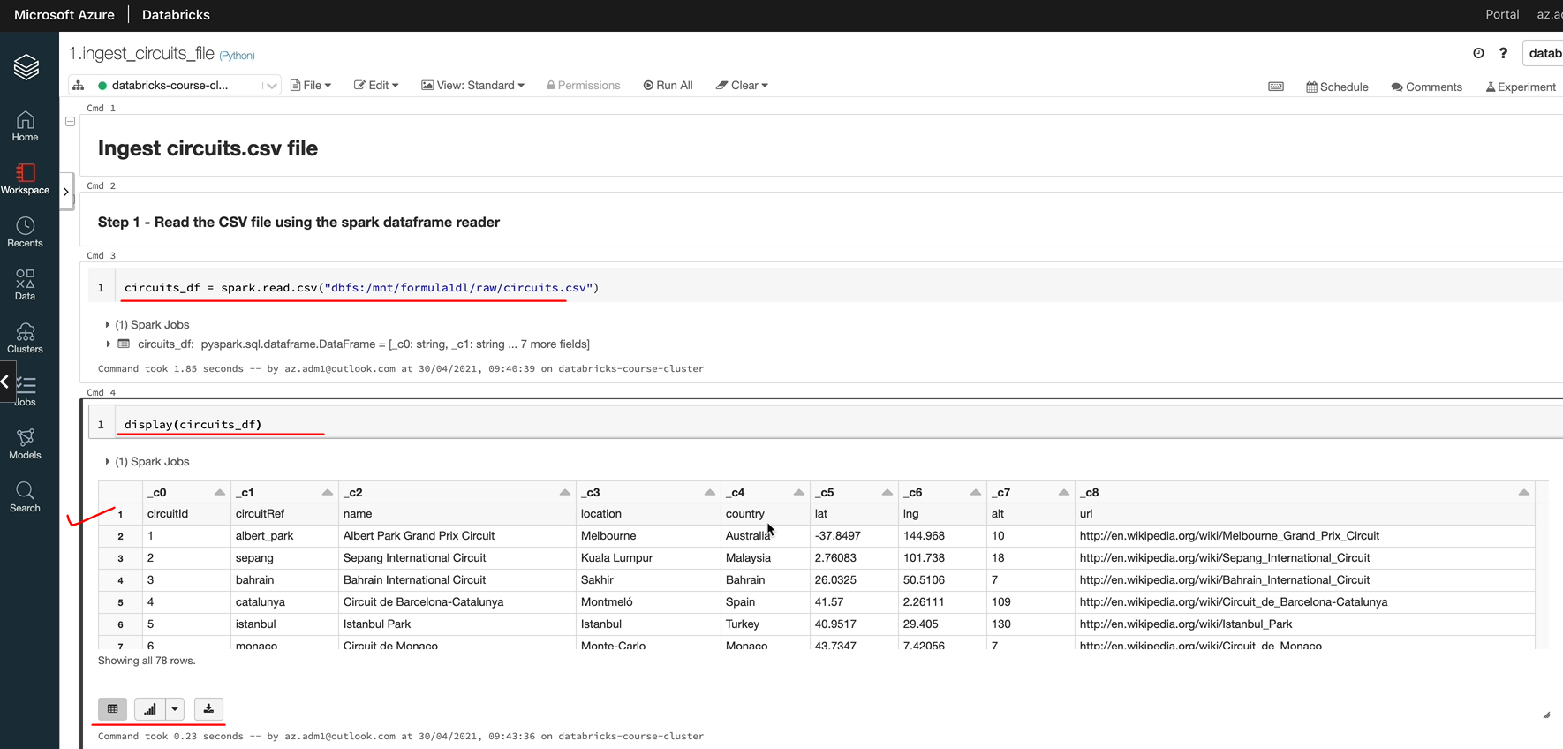

We'll talk about display later because it gives us a lot more capabilities as well. But for now, this should be sufficient to keep you going. And now let's fix our header for the file. So if we now switch back to our documentation to look at the data from the API, that's how CSP, you will see there is something called the header. So let's scroll down. And as you can see here, you got an option that you can specify called header. And the default is false, but you can set it to true in order to get your header being identified.

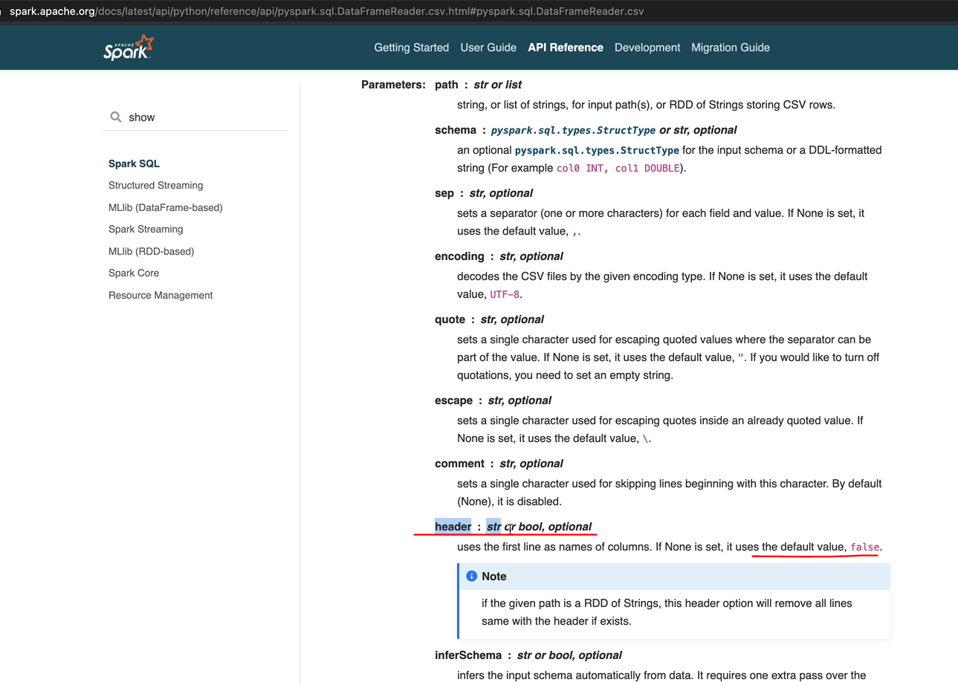

So in order to specify that the header is in the file. So you come over here after the dot raid, you can do dot option and then you can say header is true. And let me execute that now and let us see the output again. And as you can see, it's identified the head that's now.

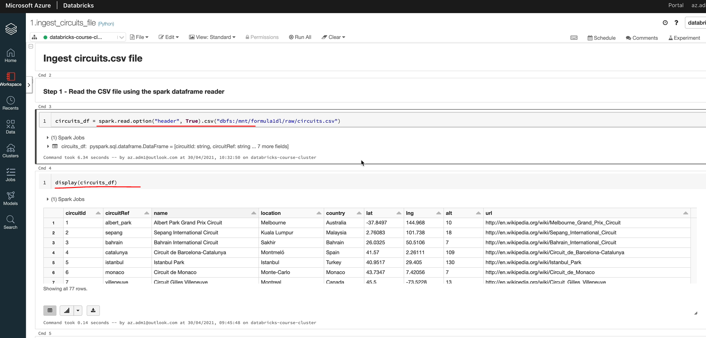

### Specify Schema

Now that our data frame contains the right data and the header being identified as well, let's now focus on the schema for our data being read into the data frame. So in order to see the schema of our Dataframe, we can invoke the method called printSchema. So that's again part of the DataFrame API. So you come up with the data frame API and then there is a method called print schema. You can search up again, as I said here, or this is the documentation for printSchema. It's quite simple. It tells you the columns and the data types and whether they are nullable or not. Let's call that method on our DataFrame and that will be circuits-df.printSchema. As you can see here, the columns are fine, but the data types are all identified as Strings, which doesn't look right as they can see the circuit IDs is an integer and there are some doubles and integers here as well.

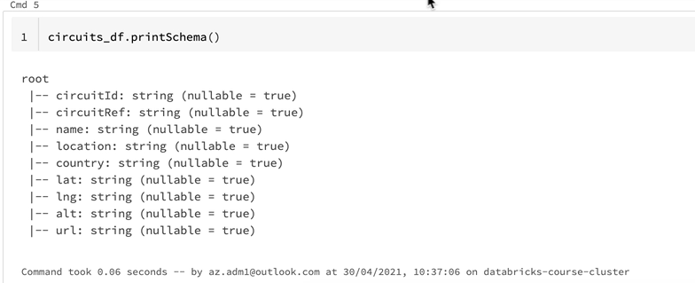

There is another method in our DataFrame API, which gives you some information about the data within our DataFrame so that we can identify what data type it's supposed to have. So that's called describe(). So let's do that circuits_df.describe and then you've got to do a show() on that one and that will tell you the min and the max values on each of the columns and the mean, counts and things like that that kind of helps you identify with the data types are correct.

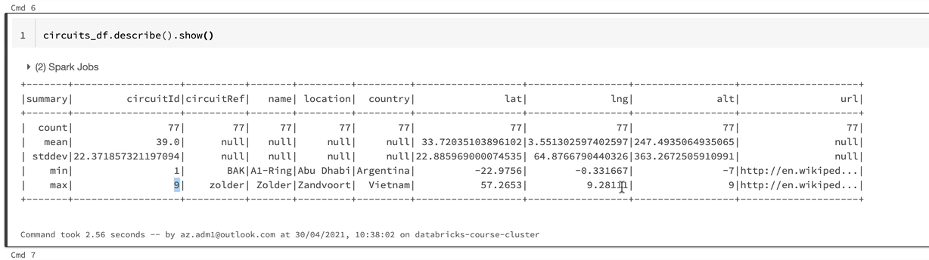

So as you can see here, circuit_id is just numbers starting from 1 to 9 and we've got a circuit reference that's a string field. And these are all strings. And the latitude and longitude looks like they should be doubles and the altitude is, again, an integer. So there are a couple of things we can do. So let's start with the first one, which is the DataFrame Reader API also gives you another parameter to pass into our CSV method called inferSchema. So let's have a quick look at that. So the inferSchema is by default set to false. If you turn it into true, then it will go through the data and identify the schema itself. So let's try that first. So let's go back to our options here and add another option. And that's going to be enforced schema as true.

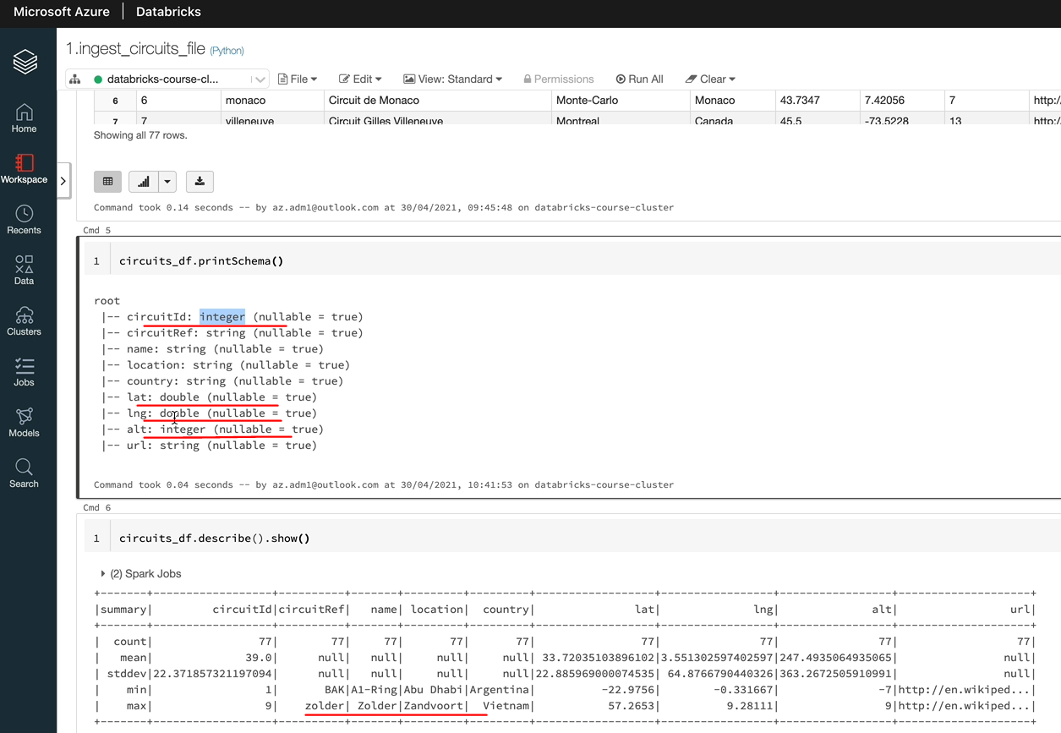

While we're on this, let's also make it a bit more readable, because it's one long line, so I'm going to just break it down into separate lines so it's a bit more easily readable. So let's give that. And if we look at the prince came in now and as you can see, that's identified the circuit_id as integer and the latitude longitude as doubles and the altitude as integer as well, which is great. But one thing you may not have noticed is actually we got to Spark, to Spark jobs now, but previously we would have had only one. So I'm going to just try and execute that one more time without the option here. As you can see, there is one spark job here and there are two spark jobs here. So when you specify enforce schema as to what is happening is a spark going through the data and reading all of the data, identify what the schema should be and then apply that schema to the data frame, which is not efficient because it has to read through the data. So you don't want to be doing that.

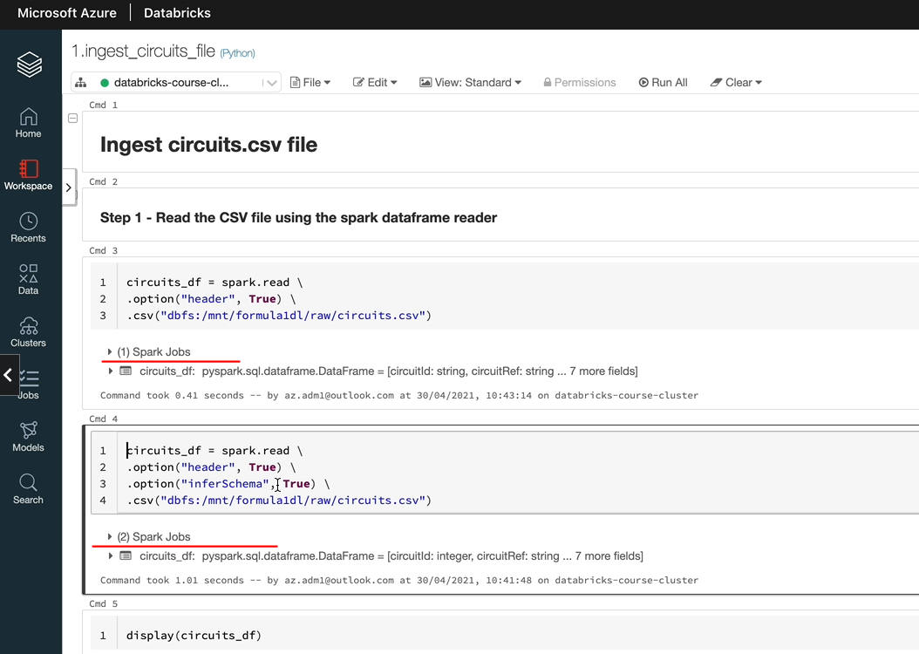

And in a production environment, it's going to be an awful lot of data and it could just slow down your rates. And also, if you get data which doesn't conform to what you're expecting, you want your process to fail and tell you that there is something wrong rather than just inferring the schema and carrying on. So this is OK to use if you are endeavor a test and also sometimes it's okay to do it if you are dealing with very small amount of data. But in order to work on a production level project and also a massive amount of data, you want to specify US schema and then ask Spark to use that. And if the data doesn't conform to the schema, you want it to fail. I'll show you how to do that. In order to specify the schema, we need to understand the data types in data frame. So let's switch over to the documentation again. And if you go back to the AP reference and then you've got the data types here. So under data types, Spark provides you a number of data types here. You can go through each one of them to understand them in a bit more detail. But the ones we are interested in here is the Integer type for circuit_id and then we got a few String types and then we've got the Double type for things like latitude, longitude.

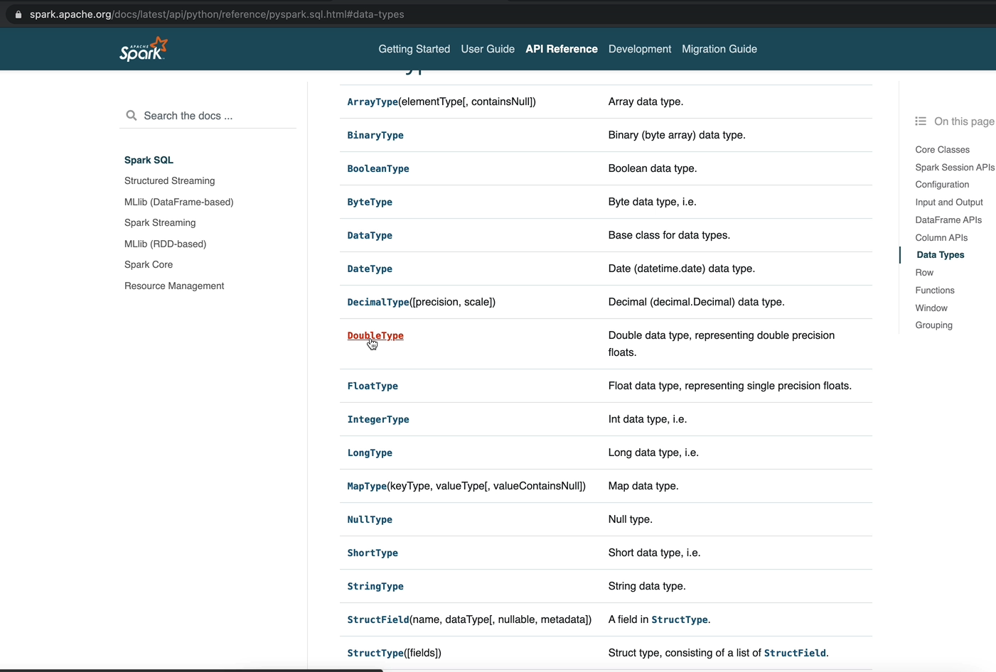

And then there are two special ones you need to understand as well. They are the Struct field and the Stuct type. So let's start with the Struct type.

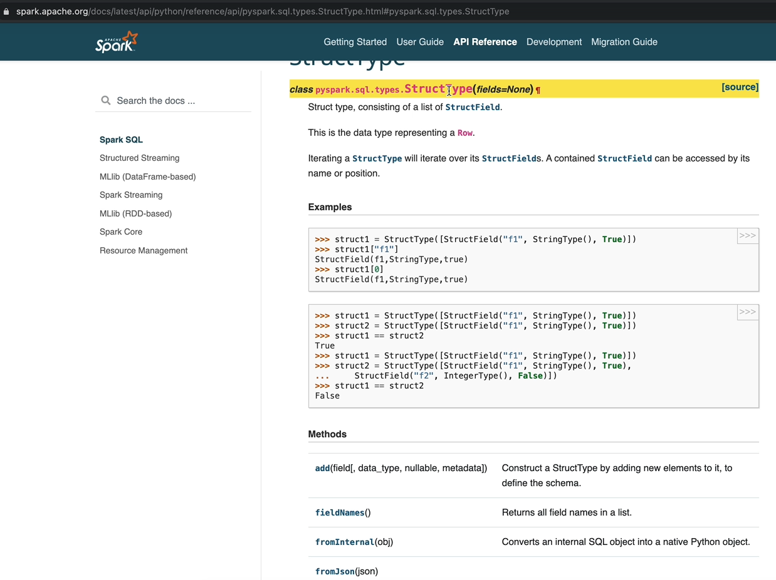

Struct type is going to consist many fields, so the type is a wrapper around all your struct fields. This is basically representing the simplest way to think about it is the struct type represents your Row and your struct fields represent your fields or individual Columns. So normally we would specify a type and within that we'll specify the number of fields and each field is going to have its own data type as well. It'll become a bit more clearer when we come to define that one. And one more thing to know is actually this is part of the class pyspark.sql.types. So the first thing we want to do is we want to import these types. So I'm going to do it here. So let's start with that. So it's it'll be from pyspark.sql.types and then we're going to import the data types we are interested in. Let's execute that and that succeeded, and now the next thing we want to do is to specify our schema. So I'm going to set it to a variable called circuits_schema, and that's going to contain our schema, basically. So we want to start with the struct type, because, as we said, that's the Row or that's the wrapper around our fields. And within that, we want to specify the fields so that fields equals and then here you will specify your list of fields. So that is an array. So within that, let's start with the first field and that is our circuit_id. And the next parameter for that is the data type, so in our case, that is the integer type. So you can tab out and then you can use the autocomplete to complete it. And the next parameter we want to specify is whether that's going to be nullable or not. So in our case, this is a primary key. So let's go for a false for that one and now we can fill in the other fields similar to what we're doing here. And let's execute that.

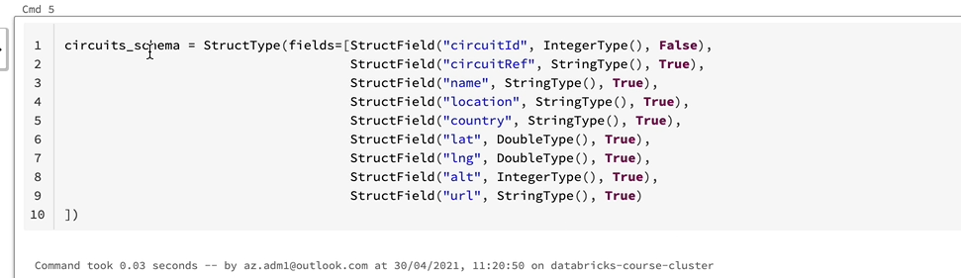

So we got a schema here for our data frame. So the next thing is to use that schema to read the data. So in order to do that, instead of infer schema, you specify schema. So that's another parameter to our data from the API. So that's going to be our circuit schema. Let's do that. And I'm going to just take you now. And that's executed and let let's run the display just to make sure we got the right data and that looks okay to us.

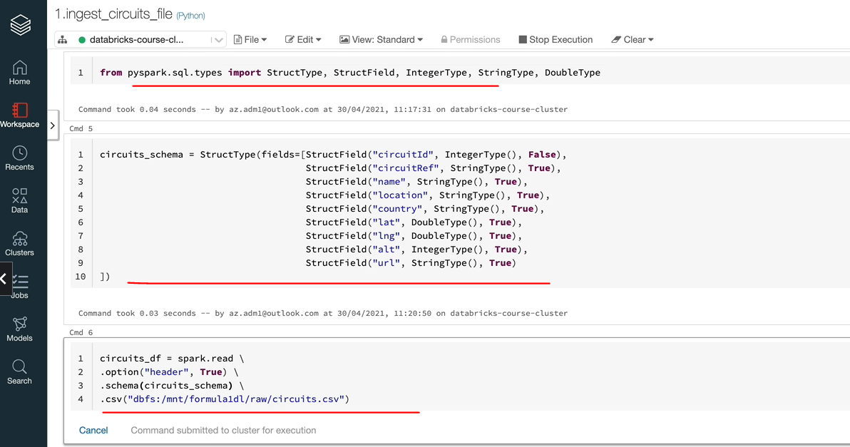

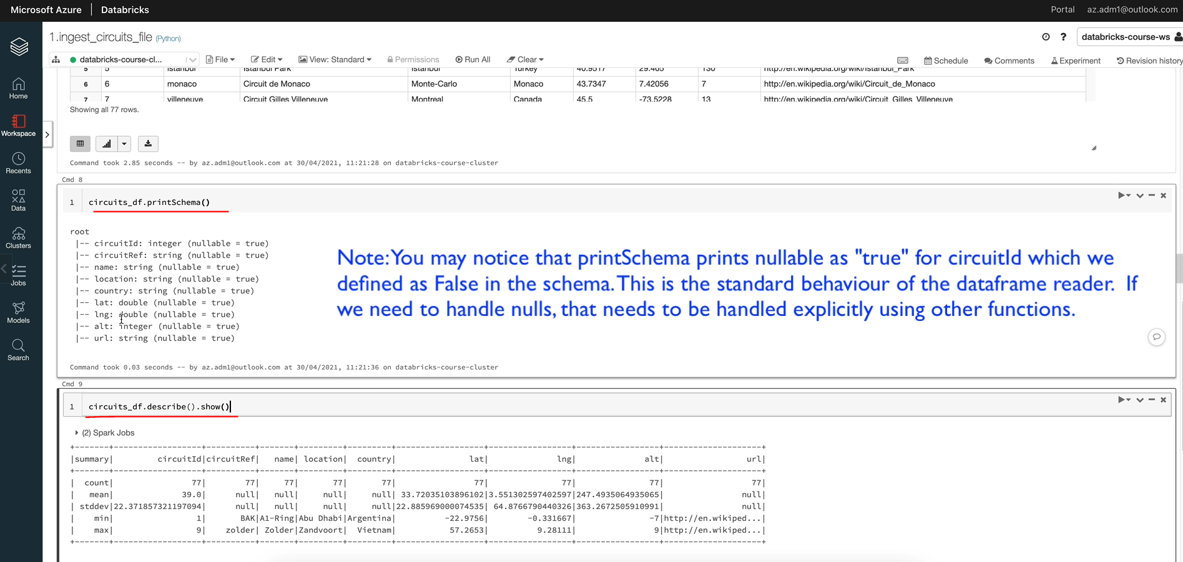

And the important thing is to print this Schema. And as you can see, the data types are as we expected and we've used our schema to do. So let's go back to the schema that we specified and just talk about it one more time very quickly. So as I said, struct type is the it's going to represent zeros and this struct fields are going to represent your columns and you specify the data types for each of the columns as well. You might be wondering what do you do if you have a nested structure? So if you had an extra nested structure, then actually you would have further struct types within your struct fields. Driver file, which is got a nested structure, and at that time we'll use that and I'd show you how to do that as well.

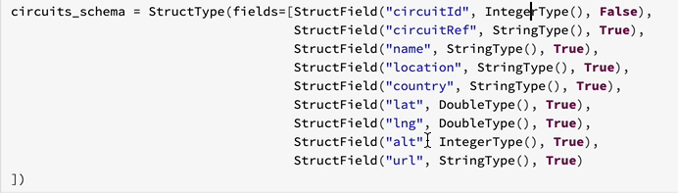

So this is one way of doing it and there is another way of doing it as well. And that's called the DDL based schema. I'll show you that in one of the other ingestions as well. But I normally prefer to do this when I'm working on PySpark. So before we finish this lesson, let's go and tidy up because we got quite a few data frame rates here. We don't need this anymore, so I'm going to just delete that one. So that's gone. So we need that statement. We need that one. And we read the data and that's all we need. Let's leave that one for now. We might need it later, but we've fixed our schema so we don't need that and we don't need this as well. So that's everything.

### Select Columns

Now that we've created our data frame with the data that we needed to read from CSP file and apply the schema as we wanted, let's look at the next step. The next step is going to be selecting only the required columns from the data. So in our requirements, we said we don't want to carry the Url forward. So there are two ways of doing that. The first one is to select all the columns that we need and not select the column we don't need or we can drop the column we don't need. So that means we'll carry everything else forward. So in this lesson, I'm going to show you how to select the required columns. And then in a forthcoming lesson, I'm going to show you how to drop the column you don't need so that automatically you're only selecting the columns that you wanted to select. So let's start with the documentation. Let's switch over to the documentation and go to the API reference and go to data from APIs and you will find the data from DOT selected here.

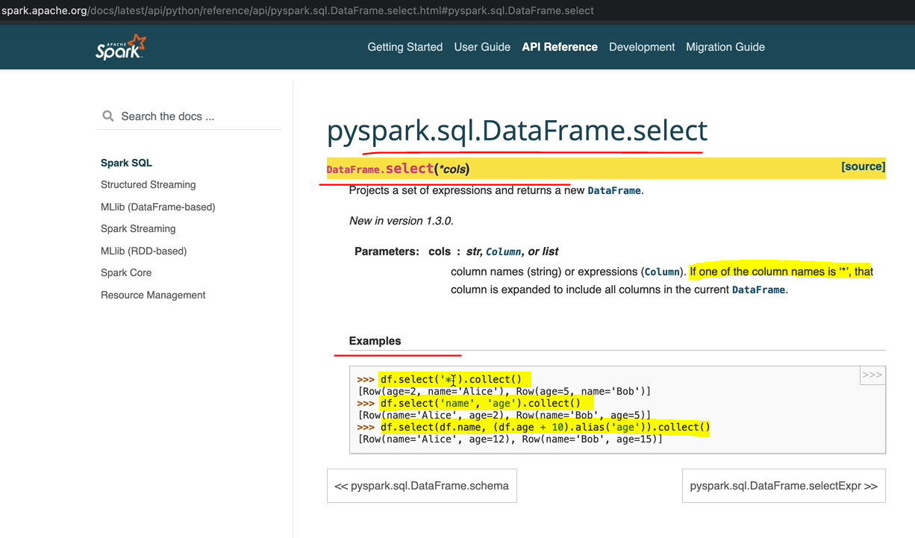

There are a couple of ways of invoking the select so you can pass in a parameter of star and it'll select all the columns, which is not what we want, or you can specify the columns you want. That and there are a couple of styles of specifying the columns in here. You've got the list of column names here. You've got the DataFrame.columnName. But this is quite handy when you wanted to rename a column. At the same time, there are two more styles of invoking the selected, so I'm going to show you all four types there. OK, let's start right in the code. So it's going to be circuits_selected_df, if that's what I'm going to call my new data frame. And that's going to take the data from the old data frame circuits_df. And let's go circuits_df and we're going to invoke the method select and that's going to get the columns that we're interested in. So let's list the columns first. So that's all the columns we're interested in, let's execute that statement and now let's look at what's in the data frame display and that's going to have all the columns except the URL because we haven't selected the order. So that's one style of doing that, one doing it.

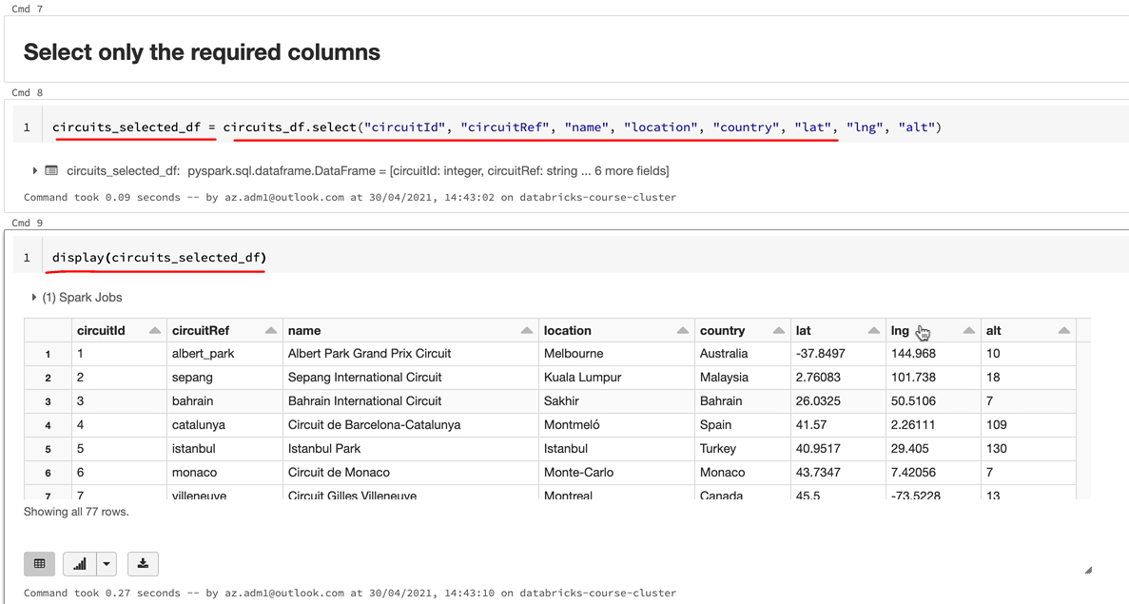

And let's do the next one we talked about. So that would be exactly the same here. But instead of listing the column names here like this, we're going to use the data frame name dot and the column name. So let's do that. OK, let's execute that one. And again, if I ran the display, I'm going to see the same results here. So that's another way of doing it.

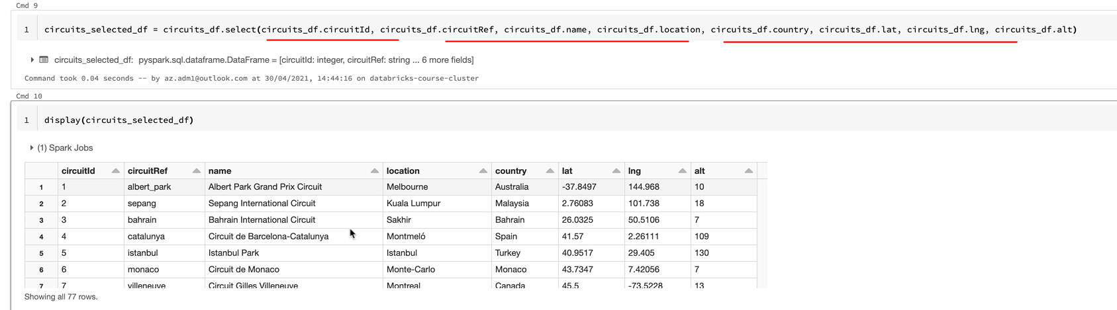

And I'm going to show you the third way that's going to be very similar. But this time it's going to be data frame name, and then you're going to have the column name within a square brackets and surrounded by a double code. So that lions become too long, so let's break it down, and if I execute that and it's going to have a similar effect, you're going to see the same columns.

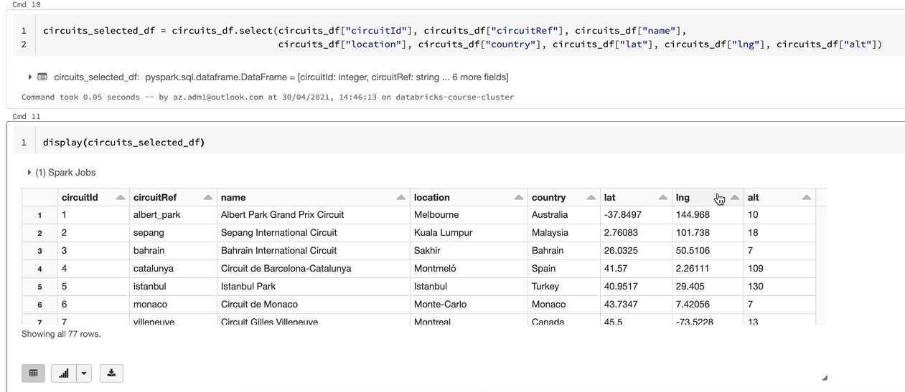

I'm showing everything, because in your projects, you might see people using different styles. And I want you to be familiar with the different styles of invoking it. So the last style you can use to do this is using a function called Col. So in order to do that, we need to import the function. So I'm going to import the function call. So that will be in pyspark.sql.functions and we need to import col. So let's execute that, so we got the function available here and we can write the statements now, so let's do that. OK, let's execute that one, and that's done as well, and you've got the same result.

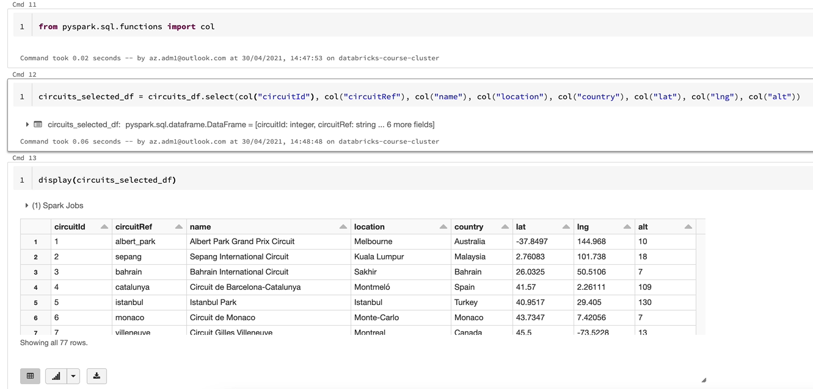

So as you've seen, these four styles can be used, but there is a small difference between this one and these three.

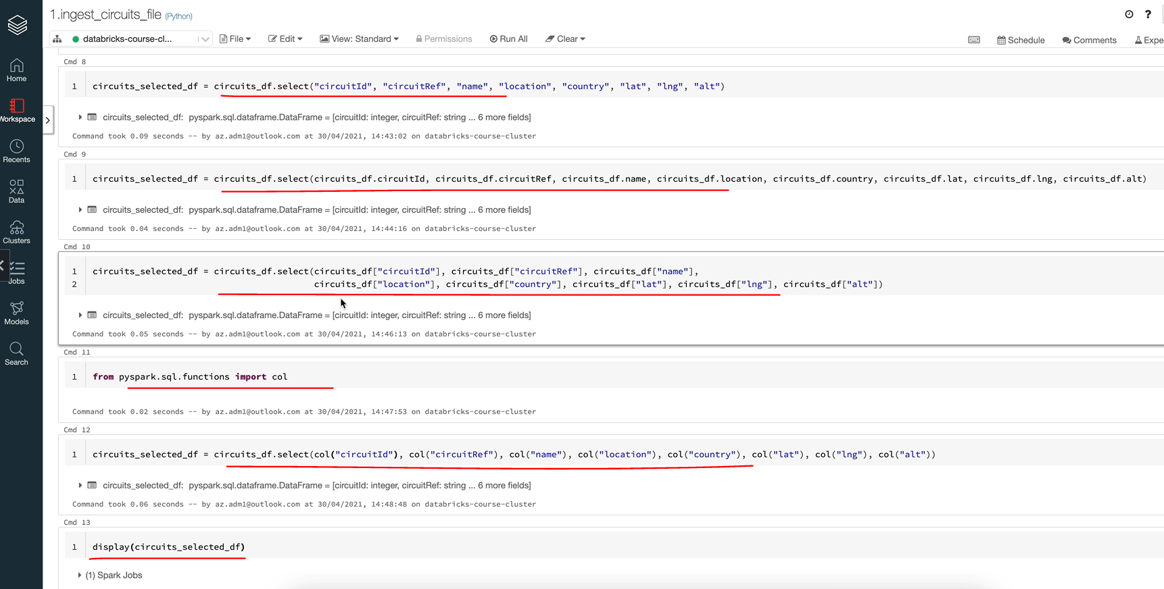

So the top one will just let you select the columns, but the other three will let you apply any column based functions for for example, if you wanted to change the name of the column, you can do it here itself. So let's say I wanted to change the country to race countries so I could just say alias.

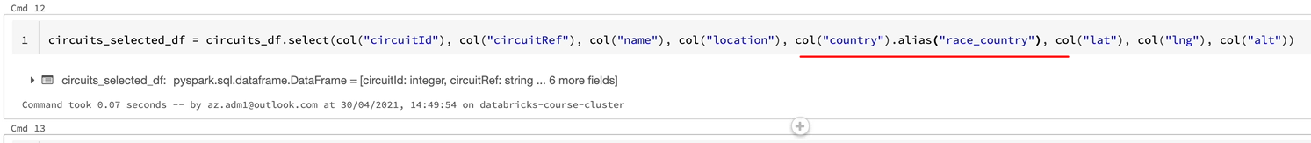

And that'll be a race and let's go country. And if I execute that, you'll see that that name has changed, so that gives you a bit more flexibility. So these things I normally tend to prefer using the call function to select the columns rather than the other two because they are slightly longer than you can type it. But obviously, if you don't have to do any other operations on the data frame, then you could go for the just select. So we're going to stick to the col in here and we're going to delete the others. So let's do that. So I have taken out the alias because we are going to do that later in another place. So let's get rid of the two statements as well, because we only need one of them to do what we want to do. So I'm going to delete this display as well and tidy up as we go along. So now we know how to select the required columns from a data frame and create a new data frame from that. And that's the end of this lesson and I'll see in the next one.

### withColumnRenamed

In this lesson, let's take a look at renaming the columns as we wanted, so our requirement was to rename the circuit ID circuit reference to have on discussing them as well as lat and lang to be renamed to latitude, longitude and altitude, respectively. So let's make a start. So there are a couple of ways of doing that, as we've seen, we could have used an alias after the col function here to rename the columns. That's one way of doing that. We've already looked at that. But I want to show you something which is specific, further renaming columns. So that's an API call withColumnRenamed. That's part of DataFrame API. And as you can see, it is it returns a new data frame by renaming an existing column so it doesn't add a new column.

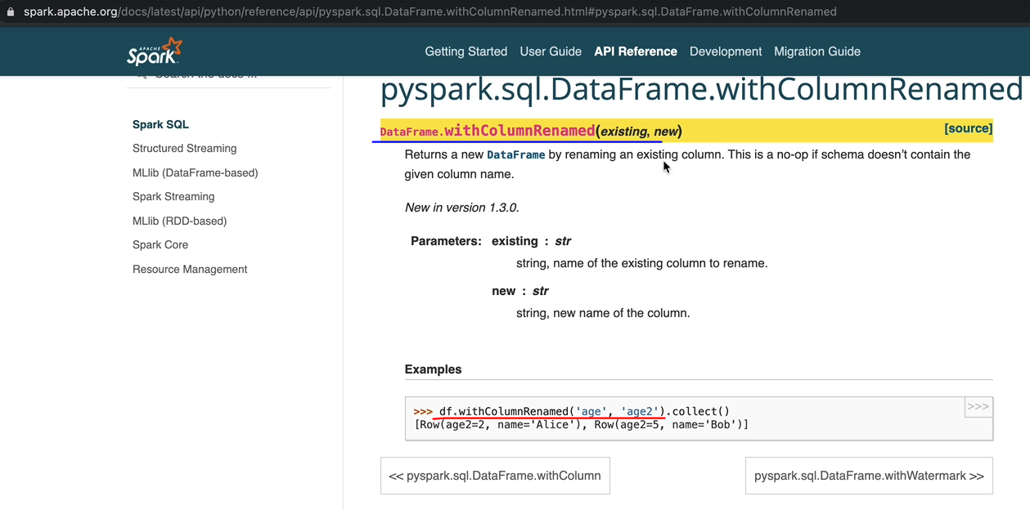

You rename an existing column. So it takes two parameters, the existing column name and then the new column name and the data frame being created would have the new column names in them. So let's switch back to our notebook and then do that for these things. I'm going to call the new dataframe as circuits_renamed_df. And we want to select from the circuit_selected_df and I'm going to tab out and get the dataframes listed and then now we want to use with column renamed and we want to specify the columns we want to rename. So in our case, we want to rename the circuit id and we want the new column to be circuit_id. And similarly, let's do the other columns as well. So that's done.

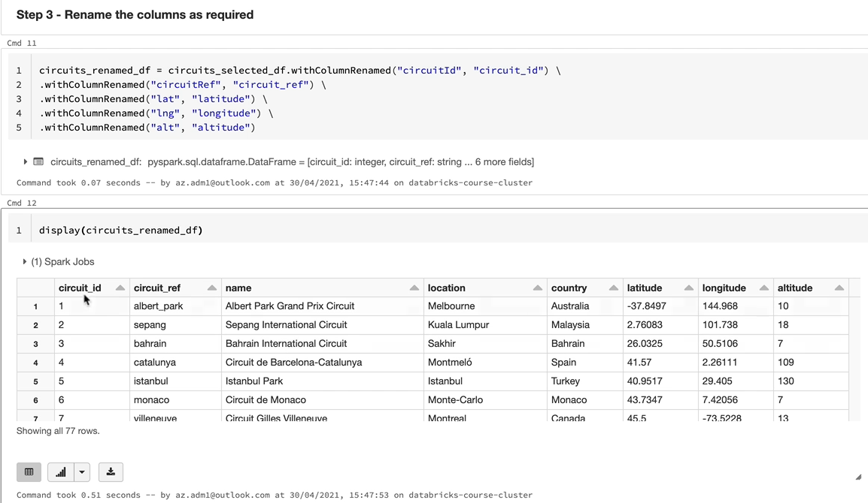

So let's execute this statement now and the new data frame has been created. So let's have a look at the data in the new data frame. So I'm going to use the display command again to display the data frame. And as you can see, these two have got underscores in them. And the latitude, longitude and altitude have got the full names in the column names.

### withColumn

In this lesson, we'll take a look at adding the new column called Ingestion Date and which will hold the current time stamp. So let's make a start. Let's start by looking at the documentation, so in order to do that again, actually if you go to DataFrame APIs, there is the API called withColum. So we looked at the column renamed previously, but withColumn will let you add a new column. So as you can see here, it returns a new data frame by adding a column or replacing an existing column that has the same name.

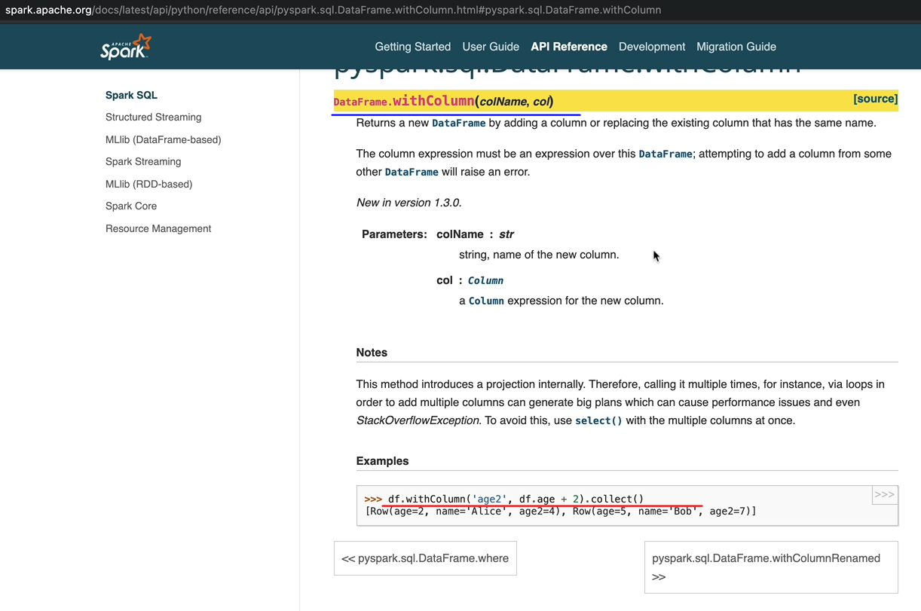

You can use the withColumn to add a new column. But in our case, we also want to populate that new column with the current timestamp in order to do that. Again, if you come to the reference and if you look at the functions, you're going to find a function called current timestamp. So that function returns the current timestamp at the start of the evaluation as a timestamp type column, it returns a timestamp type column object, which you can add to your DataFrame and then the DataFrame is going to have the additional column.

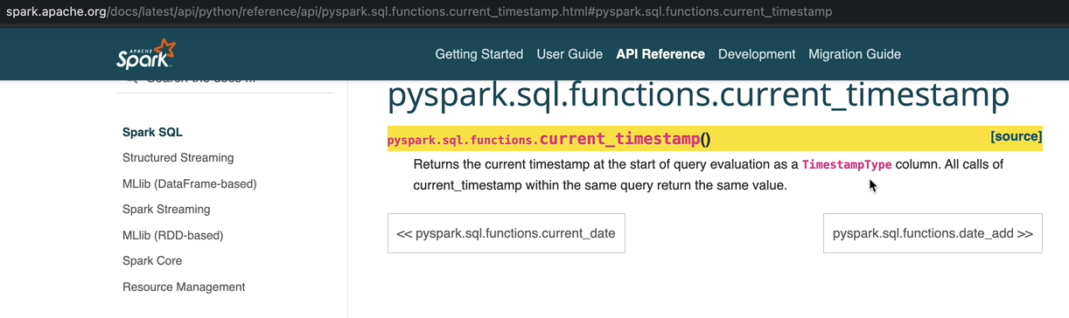

So let's do that now. I'm going to call this one as a circuit_final_df, because we've got mostly everything done at this point and we're going to use the circuits_renamed_df as a source. And we want to use the withColumn. So the withColumn that takes two parameters. The first one is the column name. So in our case, we wanted to call column name as ingestion date. And also we want to give it the value it needs to take. That's going to be current timestamp function. So that is current and it's called timestamp. That's the function.

It's not going to work. It's going to give you an error because the function has not been important. So I'm going to import the function again.

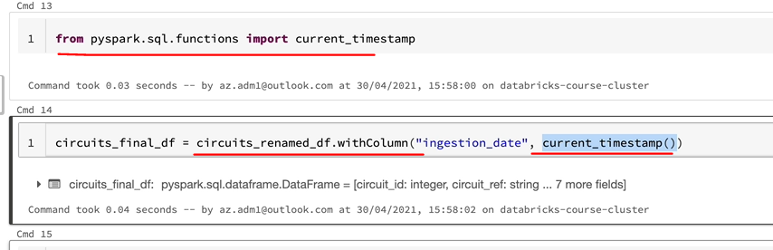

So let's execute that first and then they execute the correct circuits_final_df and let's display the contents of this data frame.

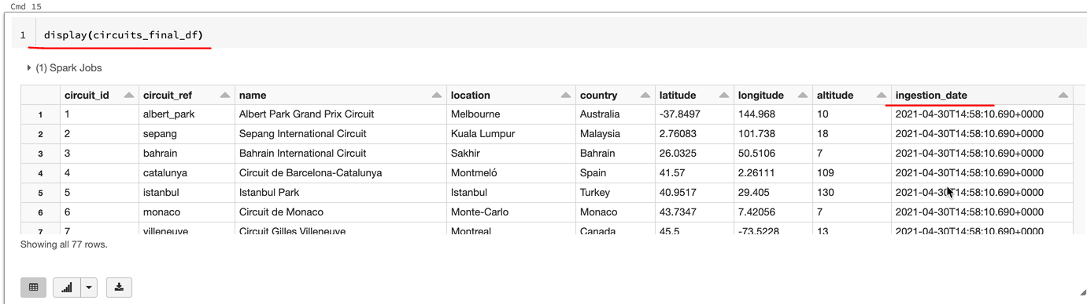

And as you can see, we've got the new column called Ingestion Date, and that's got the current time on recording on the 30th of April, 20, 21 at 14:58. While we're talking about withColumn, I want to talk you through one more thing. In this example, the current timestamp returned column object. So we were able to add it to our DataFrame because I see no DataFrame is rows and columns and we are adding a new column so that has to be your column object as opposed to a literal value. So you might be wondering if you wanted to add a literal value to every record within your data frame. How do you do that? So there is a function to do that. For example, let's assume that in our case, we want to add another column and that's going to be our environment. So let's say the new column is ENV and it's going to have a value of, say, production.

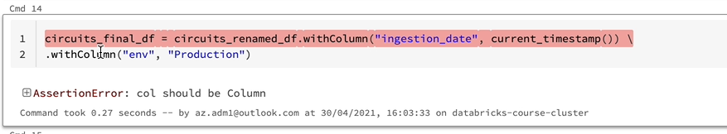

And if I run this one, it's going to fail now because that is not a column, so that call should be a column object, is what it's saying. There is another function which is called lit(). Let's go back to our documeNanentation again. And if I look for lit, it's a very simple function, all it does is it creates a column object from a literal value. So you would have to. Import the functionality, so let's add that to this import, so that's done and all you have to do is wrap this literal value with the lit function. So if I run this one, it's going to have the literal value "production" attached to it.

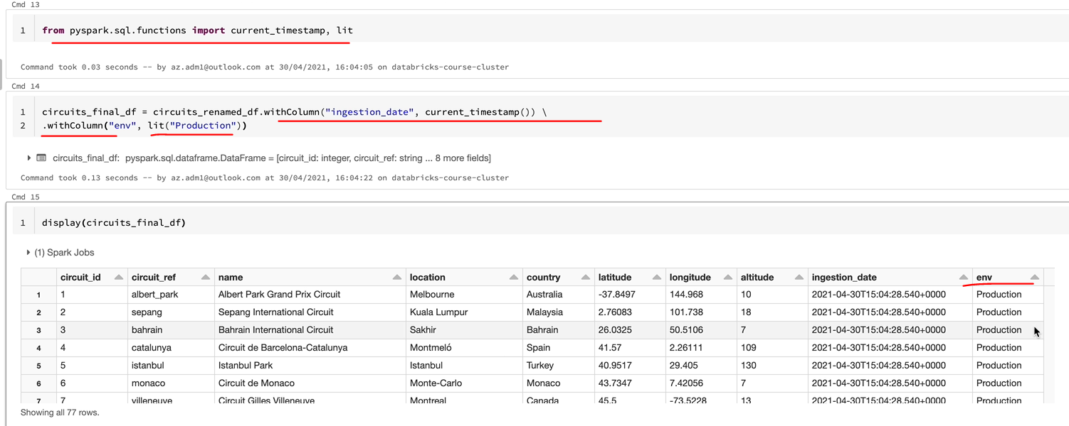

So let's have a look at the display. And I can see every record in here is going to have the production value added. At the moment, we don't have that as a requirement. I just wanted to show you that. So I'm going to take this out and also the withColumn statement from here and rerun these commands and they all look OK still. And now let's get rid of this display statement there. We don't need it and we've done everything we want it to do here.

### DataFrameWriter

OK, we now have all the data as we need in our data frame, so the last thing to do is to write that data to our file system so that it's a data lake and we wanted to write this a parquet file. So let's get started. OK, so similar to the DataFrameReader we got a DataFrameWriter for that one. So let's switch over to our documentation. Go to the API reference and under inputs and outputs after the data frame that you will see the data frame. Right. So you got csv writer, but the one we're interested in is the parquet.

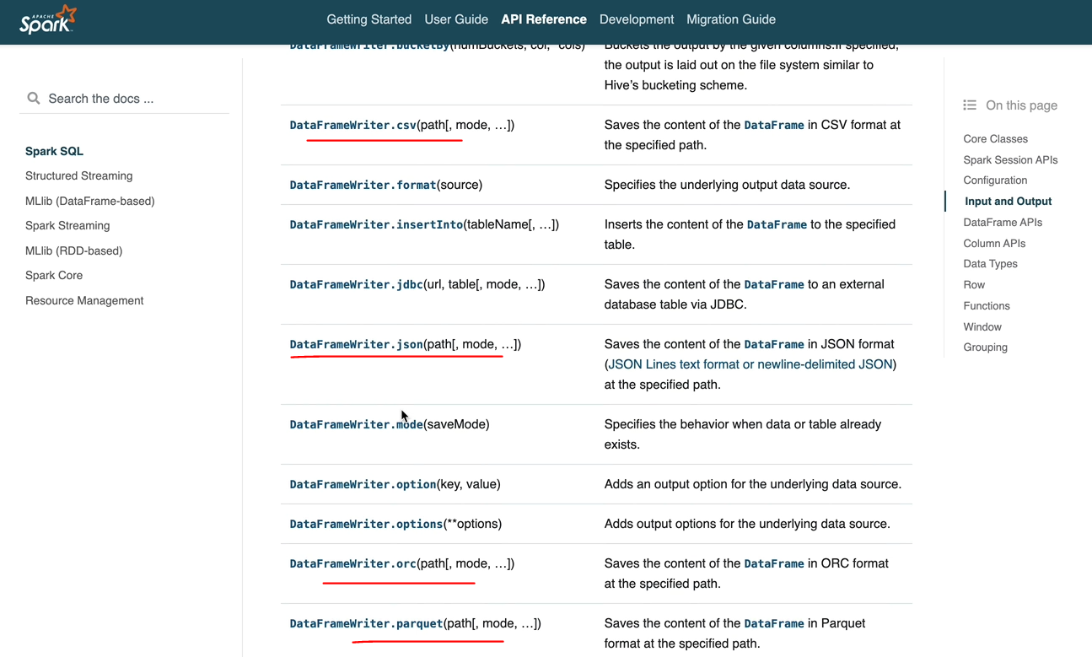

Right. So let's get to that one. And again, actually, that's got a couple of parameters. But the one which is mandatory is the path you can write. The DataFrameWriter.parquet then you can specify the part of the file where we want to write the data.

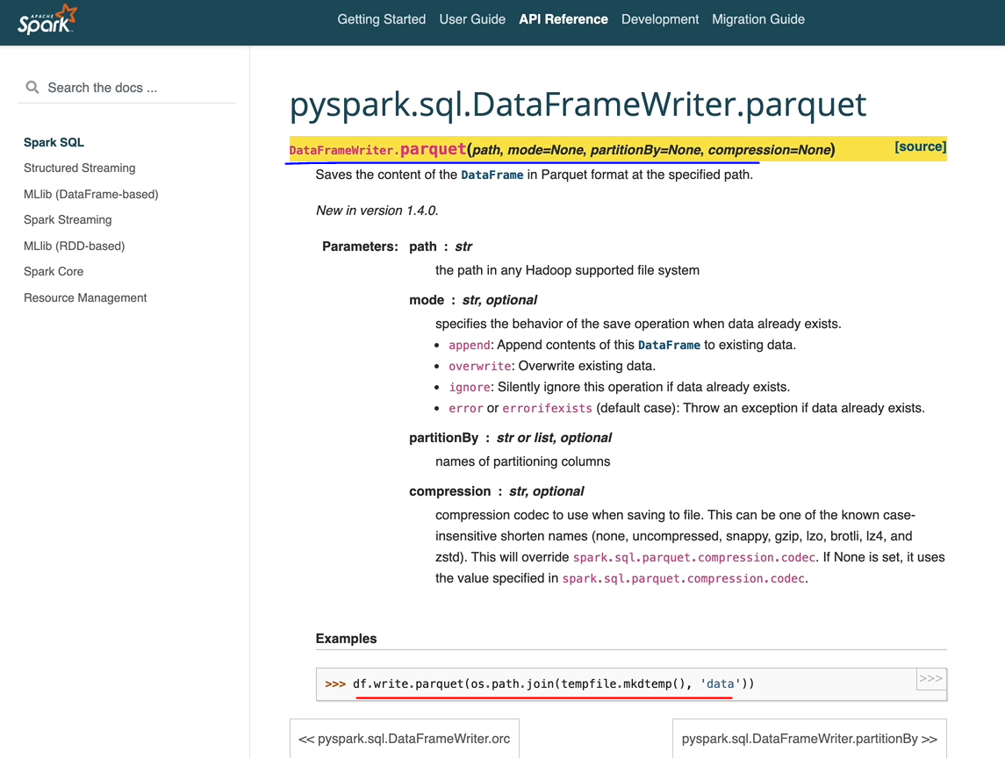

So let's do that, switch over to the notebook and let's start writing in the statement. So it's going to be this DataFrame here cricuits_final_df and we're going to use the write dot and we're going to have parquet as our file format. So it's the Spark API we need and we need to specify the file path. So if you remember, we had the /mnt/formula-one/processed, processed mount point. So let's put the file into there, but we need to specify a folder under which we want the circuits data to be loaded into. So I'm going to call that as circuits. And let's execute that one and that's running now, so this part time jobs finished.

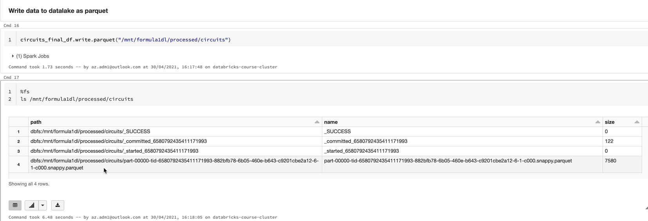

So if we look at the file system, we should be able to see the files. Let's have a quick look at that. I'm going to use the magic command percentage first and that list the file system and look at the folder here. As you can see, the files are there and it's a parquet file, so we got only one partition. But if you partition the data, you'll end up having multiple partitions as well. And I'm running on a single node, so my data is not being distributed. That's why you're seeing just one partition for the file. So under the folder, we've got all the data.

So let's read that data back and see whether we've seen the data as we expected. So I'm going to just create a data frame and we know now how to use the reader API. We don't have a CSV file for this. It is a parquet file, so let's do spark and then if I specify that parquet, we should be able to read that data. So let's execute that. And if I just do a display the dataframe, then I would see all of the data as we wanted to so. So as you can see, the data we had in our data frame is now being returned to the file system.

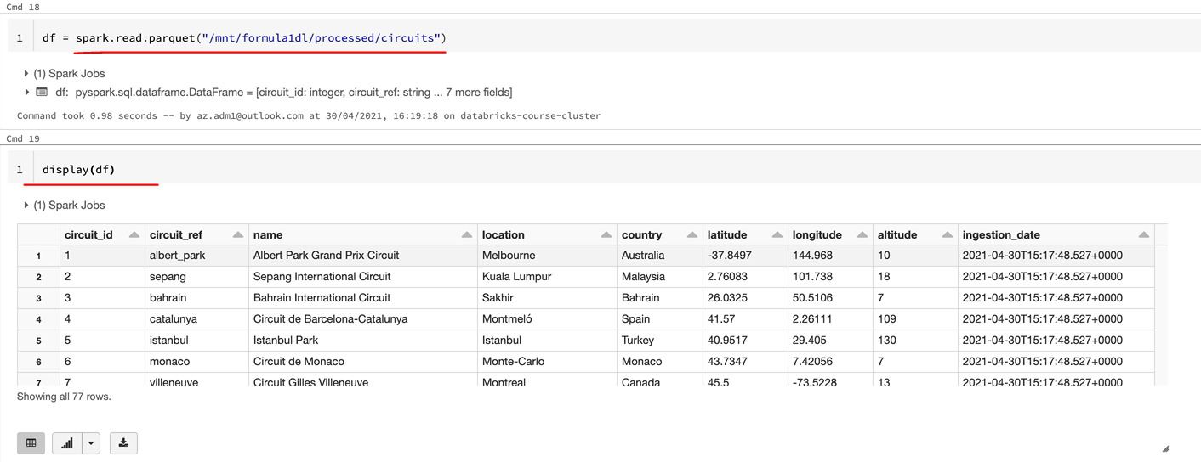

There is one thing we want to create, not books and jobs which are reasonable. So there is a problem with this one. So if I rerun my right statement, it's going to fail because the part already exists. So as you've probably seen, there are a couple of options for more so you can specify, append, overwrite, ignore our error if exists. So we're going to override it so that we can keep rerunning our notebooks without failing. Say that you can pass that as a parameter or you can have another option for that. So that's going to be mode and I'm going to send in over right for them. So let's run it now, and it should just overwrite the data. So that's that's what it's done. So these are all redundant statements. So I'm going to just delete those and make my notebook a bit cleaner.

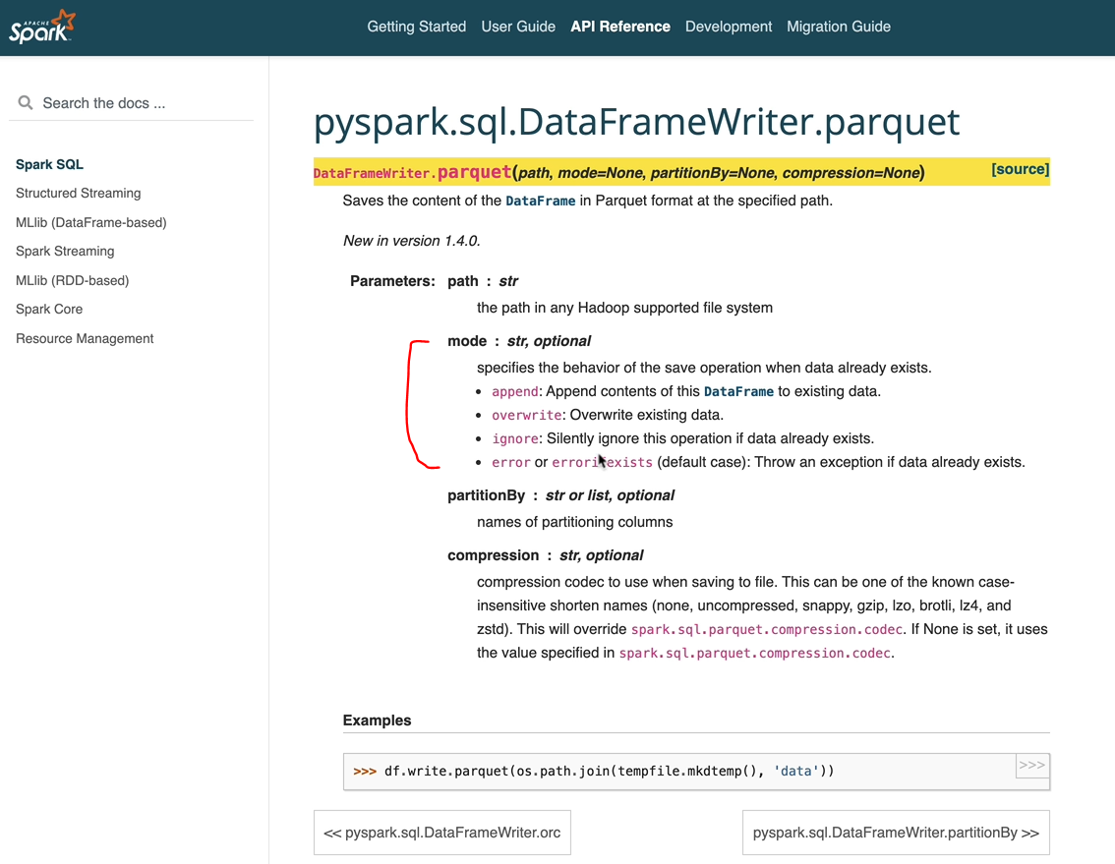

And let's go to the top, make sure we got everything. So we read the files here and we selected only the required columns and renamed the columns that we needed and added the ingestion date. And also we've written the data into our file system. So we've done all of those. And I think it's a good idea just to do a run all to run it through before that. One thing I've noticed is actually abused dfs:/mnt. But when it's mounted, you don't have to specify dfs. It doesn't make any difference, but it's quite clean to do it this way. So you can take that out and I'm going to do it all and make sure it's running through the end end. OK, and that's run through without any problems. So if we wanted to look at the data to make sure whether that's done the right thing. So I'm going to quickly copy that and let's read this. So I'm going to put it in display statements don't have to create a data frame and it'll will be spark.read.parquet and let's do that, and it should give us the same output we start previously, so that's perfectly fine. So I hope you've got a full understanding of how to take raw file and then apply schema to whatever transformations we needed to do and ingest that into our data.

**Step 1 - Read the CSV file using the spark dataframe reader**

from pyspark.sql.types import StructType, StructField, IntegerType, StringType, DoubleType

circuits_schema = StructType(fields=[StructField("circuitId", IntegerType(), False),

StructField("circuitRef", StringType(), True),

StructField("name", StringType(), True),

StructField("location", StringType(), True),

StructField("country", StringType(), True),

StructField("lat", DoubleType(), True),

StructField("lng", DoubleType(), True),

StructField("alt", IntegerType(), True),

StructField("url", StringType(), True)

])

circuits_df = spark.read \

.option("header", True) \

.schema(circuits_schema) \

.csv("/mnt/formula1dl/raw/circuits.csv")

**Step 2 - Select only the required columns**

from pyspark.sql.functions import col

circuits_selected_df = circuits_df.select(col("circuitId"), col("circuitRef"), col("name"), col("location"), col("country"), col("lat"), col("lng"), col("alt"))

**Step 3 - Rename the columns as required**

circuits_renamed_df = circuits_selected_df.withColumnRenamed("circuitId", "circuit_id") \

.withColumnRenamed("circuitRef", "circuit_ref") \

.withColumnRenamed("lat", "latitude") \

.withColumnRenamed("lng", "longitude") \

.withColumnRenamed("alt", "altitude")

**Step 4 - Add ingestion date to the dataframe**

from pyspark.sql.functions import current_timestamp

circuits_final_df = circuits_renamed_df.withColumn("ingestion_date", current_timestamp())

**Step 5 - Write data to datalake as parquet**

circuits_final_df.write.mode("overwrite").parquet("/mnt/formula1dl/processed/circuits")

display(spark.read.parquet("/mnt/formula1dl/processed/circuits"))

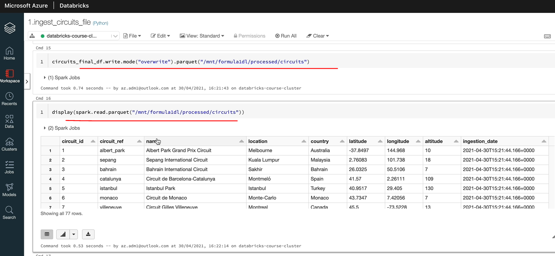

### Data Ingestion – Races Data

Welcome to this lesson on ingesting the racist NTSB file from a raw container to the processed container, similar to what we did before for the circuit file will take the CSV data, read it using the data frame, read the API and then perform the necessary transformations and write to the processed container using the DataFrame write API, through the data returned to the process folder will be in Parquet format. The CSV file has the following columns, things like raceId, year, round, circuit and name, date, time and the URL as part of the transformation will apply transformation to rename the columns.

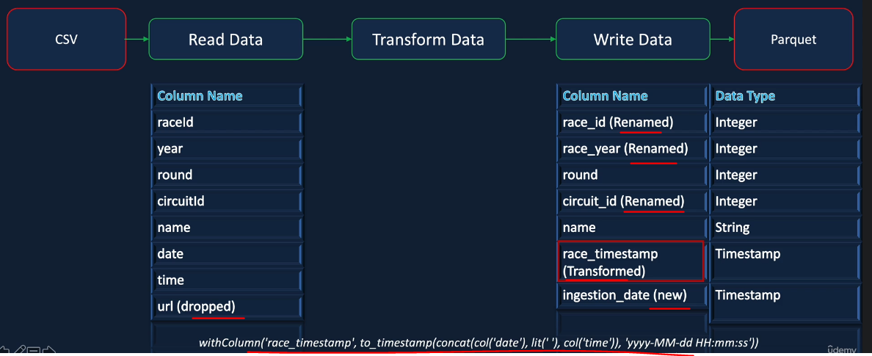

raceId ID to have underscores and also will rename year to race year. We want to create a new column called Race Timestamp, which will combine the date and time from the source to create one field. Will drop the Url from the input data, as we did before, and will add a new column called Ingestion Date, which will contain the date and time of the data being ingested into the process container. And also we will make sure that the data written in parquet has the right data type, which we did before as well for the circuits file, we've done most of the things already for the circuits file. But one thing we haven't done before is combining two fields to create one field, which is the race time stamp in this case. So I've given the function that will help it do that. So we know that with column helps us add a new column in this case. That is the race timestamp. But we want to have the rest timestamp to have the values from the date and the time combined to create a one field called timestamp, so toTimestamp function lets you convert a string to a timestamp. So we're creating this trend in using the concat function. So the concat will let you combine the date and the time and also be given a literal value of space. So the output of the concat would be date space time in this format. So if we give the format string as well, so which is the M day and then space and you've got the hour, minutes and seconds, the two timestamp will create the timestamp for us and that will be added to the date frame as race_timestamp.

**Ingest races.csv file**

**Step 1 - Read the CSV file using the spark dataframe reader API**

See the table for races

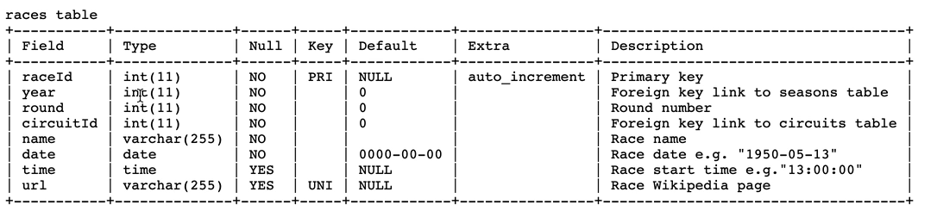

See how the data types are mapped here

And we know that raceId is an integer type, so let's do that and the parameter we want to give in is true or false. It doesn't really matter too much, but this is a primary key.

So let's go for a false value here because we don't want it to be not.

from pyspark.sql.types import StructType, StructField, IntegerType, StringType, DateType

races_schema = StructType(fields=[StructField("raceId", IntegerType(), False),

StructField("year", IntegerType(), True),

StructField("round", IntegerType(), True),

StructField("circuitId", IntegerType(), True),

StructField("name", StringType(), True),

StructField("date", DateType(), True),

StructField("time", StringType(), True),

StructField("url", StringType(), True)

])

races_df = spark.read \

.option("header", True) \

.schema(races_schema) \

.csv("/mnt/formula1dl/raw/races.csv")

**Step 2 - Add ingestion date and race_timestamp to the dataframe**

from pyspark.sql.functions import current_timestamp, to_timestamp, concat, col, lit

races_with_timestamp_df = races_df.withColumn( "ingestion_date", current_timestamp()) \

.withColumn( "race_timestamp",

to_timestamp(concat(col('date'), lit(' '), col('time')), 'yyyy-MM-dd HH:mm:ss'))

**Step 3 - Select only the columns required & rename as required**

races_selected_df = races_with_timestamp_df.select( col('raceId').alias('race_id'), col('year').alias('race_year'),

col('round'), col('circuitId').alias('circuit_id'),col('name'),

col('ingestion_date'), col('race_timestamp'))

**Write the output to processed container in parquet format**

races_selected_df.write.mode('overwrite').partitionBy('race_year').parquet('/mnt/formula1dl/processed/races')

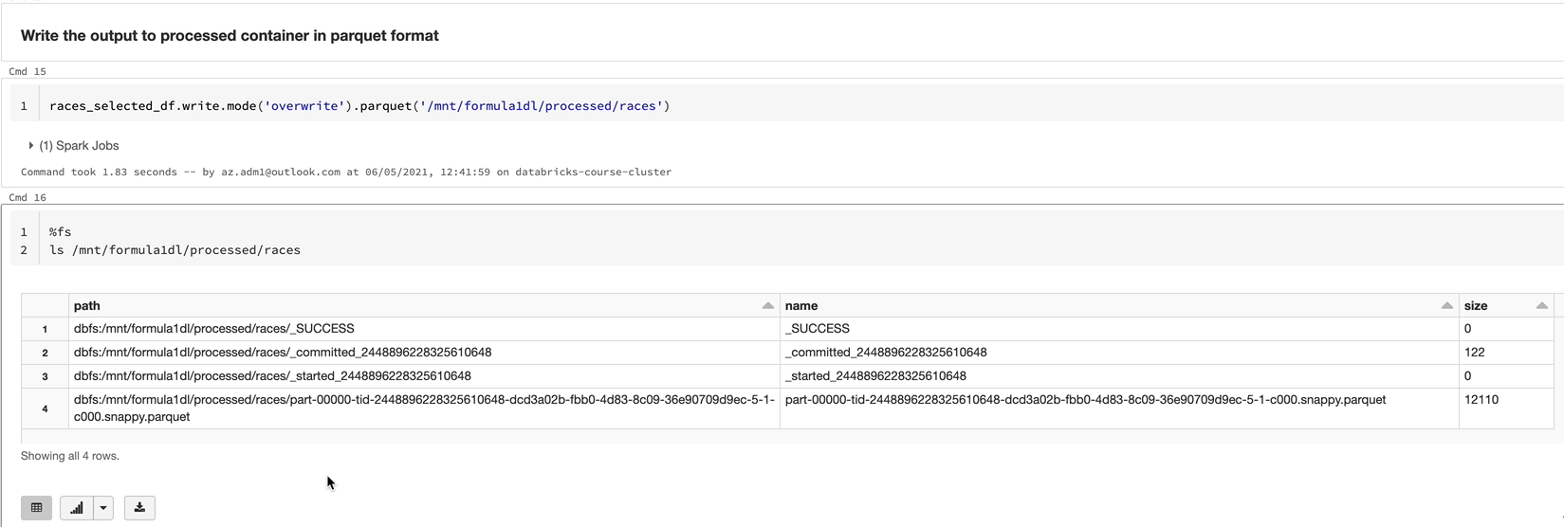

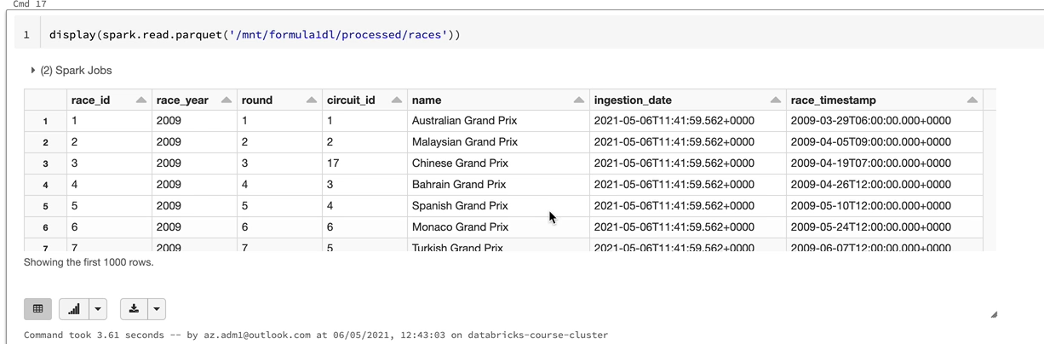

### Partitioning

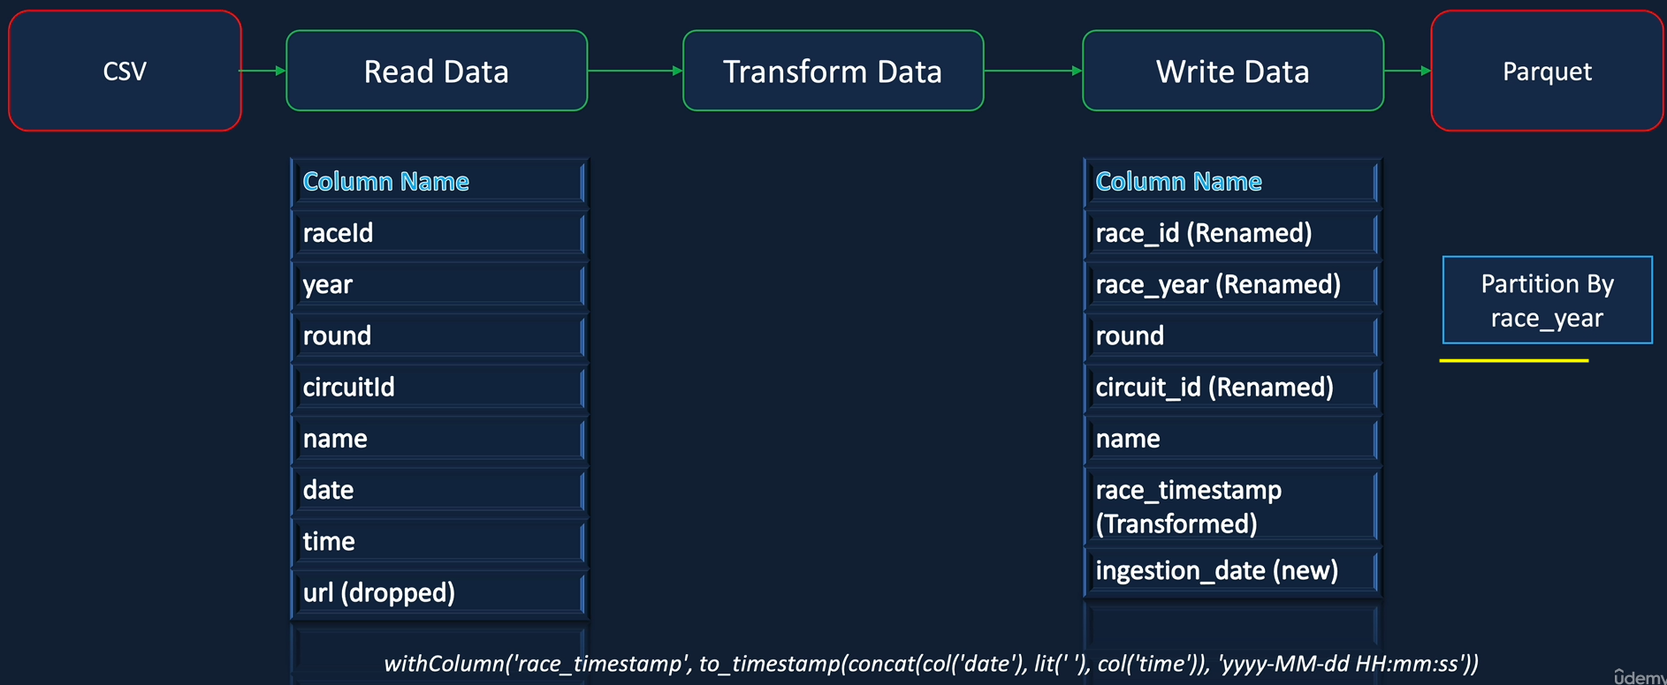

In this lesson, we are going to look at partitioning the data at rest. What we mean by rest here is the storage layer. The data frame, writer API provides a function called party partitionBy that, we can use to partition the data being returned to the storage, which is which in our case is ADS. By specifying the partition by class with a column name, we can partition the data based on the column when the data is written to the desk, which is ADLS in our case, it is written in such a way that there will be a folder created for each of the distinct values from the column specified. For example, if we specify race year, there will be a separate folder for each of the race years. This will make it easier for Spark to read the data if you're only looking at specific race years and also it helps to process the data in parallel. Having said that, we are working with a single node cluster with only two course in this course, so Spark won't be able to achieve the same performance gains as it would in a multi node cluster. If anything, we will see a performance degradation because it is more work for Spark to create a separate folder as well as to read from many folders instead of just one. But this is a key feature of Spark, that you'll be using in your real time projects dealing with massive amounts of data. But you need to use this with a word of caution when choosing a partitionBy column. Please be careful not to create too many partitions that can give the adverse effect. So you need to strike a balance, common partitioned columns are dates, for example, the date on which you've received the data, even if you're not receiving a lot of data every day. Then you can have a week or a month as your partitioned column.

For example, we could partition our data by race side so all our data for a particular race can be in one partition, which would make a lot of sense for things like lap times and qualifying and things like that. But that might be a bit too much for this table because there will be only one record per race in this table. So I want to show you the use of partition by column using race year in this case to demonstrate. But at some point we will be switching to race Id because that gives us a bit more benefits in terms of being able to override a partition, but that is for a later lesson. But pay attention to create the partition based on the race year and how it works in this lesson. So let's switch over to our notebook and get started with creating the partition. Here we are in the database workspace and that's our notebook ingest races file. And as I said, actually the data frame writer API provides a function called partitionBy so that's what we going to use. So in order to use that, you put the function name, which is partition by. And then you give it the name of the column you want to use, which in our case is race year. And that's that's all you need to do, so it's going to partition the data by race. So let's execute that now. As you've seen that take slightly longer, that's because it took time to create these separate folders.

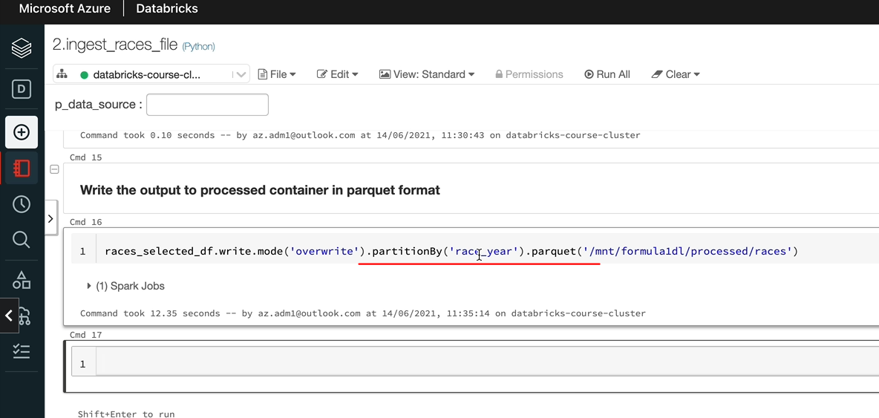

So let's see that in our storage explorer, which would make a bit more sense. So let me switch over to Storage Explorer. So this is what we had. So we had the data partitioned within one part file and there are no folders here. So let's refresh that and we should see each year in a separate folder. So as you can see, Rasiah 1950s in a separate folder and 1951 is in a separate folder like that.

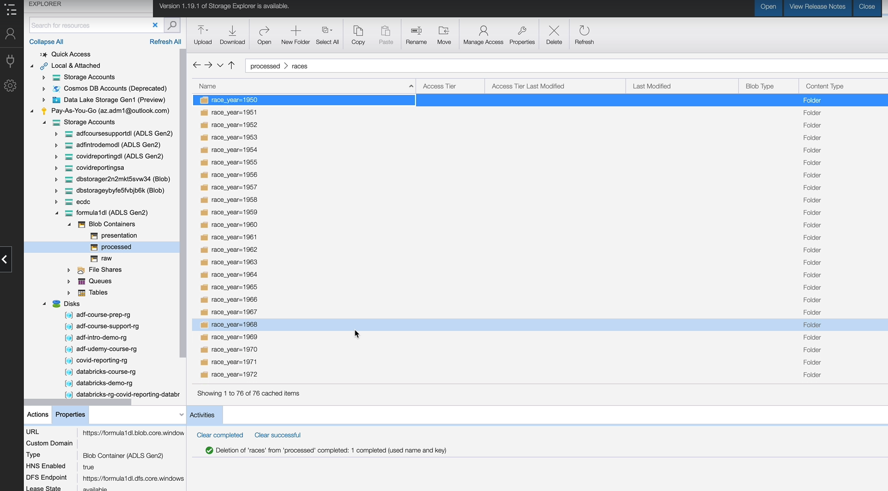

So we have got 76 years worth of data within 76 different files. And the part folder, which was in the main folder, has now disappeared. So that's what partitioning does for you. So when you have data partition this way, when you access the data for a specific partition. So if you're doing a lot of analysis based on a race year, then that's going to be much more quicker than just reading big files and then trying to find a separate taxes are three separate race years data. But as I said before, if you had too many partitions, then that can make the job of Spark a lot harder. Let's switch back to our notebook and read this data to show that which is this is working. OK, so let's use the read API. So that is going to be spark.read.parque and I'm going to put it in a display statement. And the data looks, as you would expect to see.

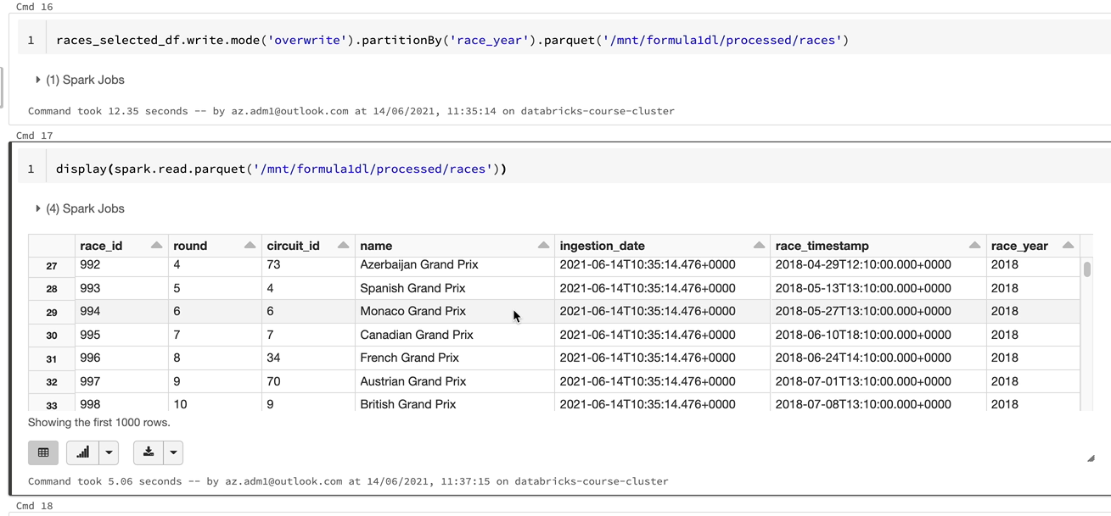

## Data Ingestion – JSON

OK, welcome to this lesson on ingesting the constructor's json file from our raw container to the processed container. Unlike the previous lessons we're dealing with, JSON file, this time, we'll take the JSON data, read it using the data frame API and then perform the necessary transformations and write to the process container using the data frame writer API. The data returned to the process folder will again be in Parquet format. The JSON data has the following columns. I'll walk you through the file shortly, so we'll go into a bit more detail there. As part of the transformations will apply the transformation to rename the columns, constructor id and constructor reference to make them snake case using underscores. We will drop the url from the input data and also similar to what we did in the previous lessons, we'll add a new column called Ingestion Date, which will contain the date and time of the data being adjusted. So this is quite a simple file, but there are three new things I want to teach you as part of processing this file. Firstly, we learn about the JSON data frame. Secondly, I want to teach you how to use the DL based schema rather than the one we used previously, which used the struct type and this track field to define the schema.

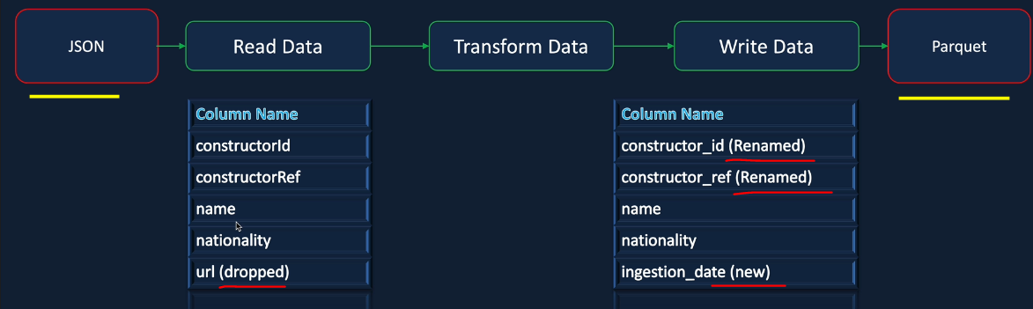

And finally, we'll use the drop method to drop the U on column rather than the select method to select only the required columns before we get into in the notebook. Let me quickly walk you through the file. Let me open the file. I'm going to open it up in Visual Studio called. As you can see, this is a single line JSON, what that means is every line in the file is full JSON.

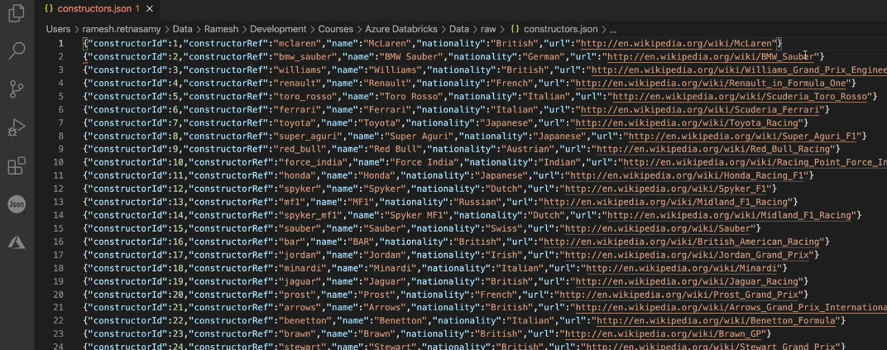

So let me make it slightly smaller so I can show you that he can see the line starts from here and ends here. And that is the full Jason object. And we its again a very simple file, so it's got the constructor id, constructor reference, name, nationality and URL as the columns that are known, nested structures or arrays in this one. It's quite simple, one to deal with. The construct id you can see is integer and the others are all strings. So that's the file again. Actually, if I scroll down, it's only 211 records. It's such a small file. So it is a good candidate for the first decent file for us to process.

### Read JSON File

Just to save a bit of time, I've already created a notebook called ingest_constructors_file, and I put that in the same folder, which is ingestion, and I'm keeping it alongside other files. And I've done the documentation here. So the first thing we want to do is to read our constructors file. And as I said in the previous video, I want to show you another style of defining the schema because we use the type previously. But there is another option available. So let's look at the documentation here. So that's the documentation for the data frame reader schema. And as you can see here, you've got two options. One is to use this struct type. That's what we used for our CSV files previously. And the other one is the formatted string. So the way you define that is you put the column name and then the data type and then it goes like that. So if you had arrays, then you will use arrays as well. But there isn't a lot of documentation around this one. I couldn't find at least. And I normally tend to prefer this type because that goes in line with the rest of the Python code.

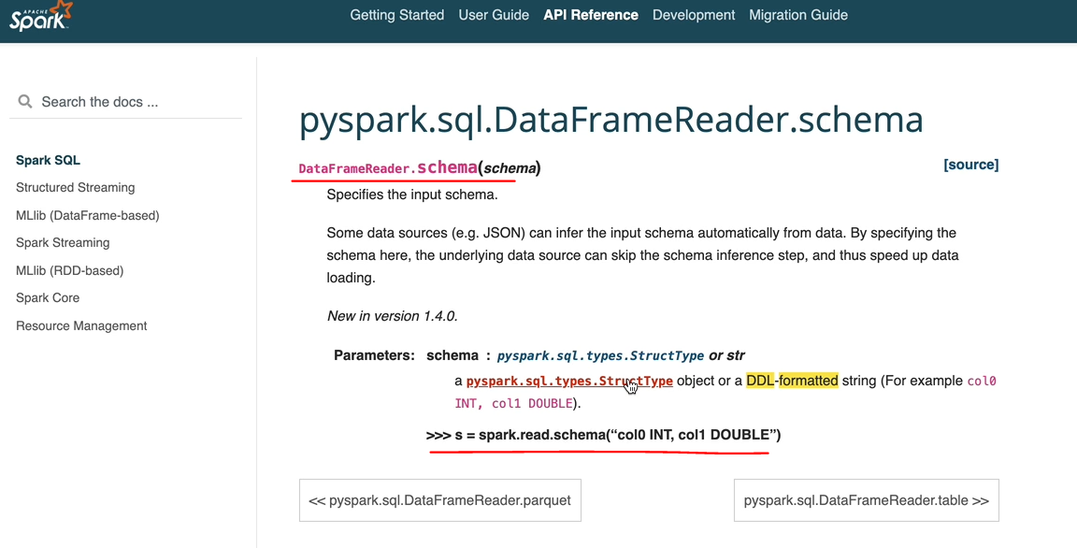

But I want to show you this way of doing it as well. So if you come across this kind of schema defined by one of your colleagues, then you won't be surprised. So let's switch back and use the DDL style to define the schema. And I'm going to call this one as constructor schema. And let's define the columns now, as we know, we have a number of columns, and the first one is the constructor-id. And we know that the data type for that one is an Integer, so you can either do Int or Integer. These data types come from Hive. But as I said, actually, I couldn't find much documentation. But when you use the Hive data types, it works fine because it uses high Metastore for everything. So the first one is constructor-id and the next one is the constructor-reference. And we know this one is a string and we also had the name that is a string, nationality and that is a String too and finally we've had the you are url which is again a string. So we define the schema. It looks quite simple here. And let's hit enter to execute.

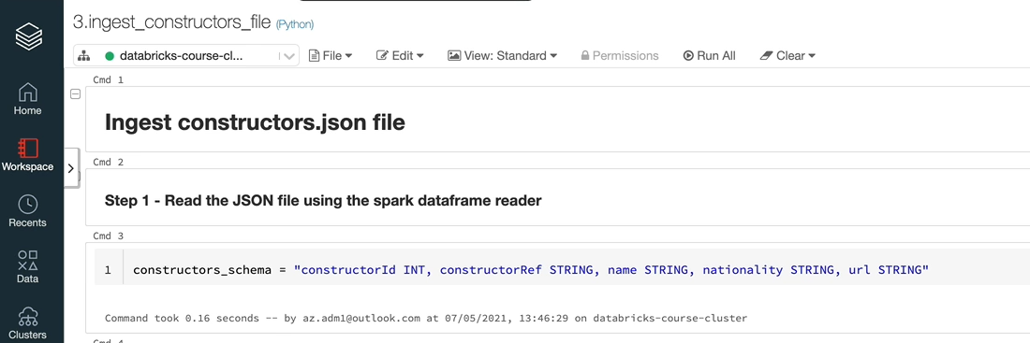

And now with the schema, we can read our data from the adjacent file into a Dataframe. So this is going to be read into a later frame called constructor-df. And now let's switch to the documentation to look at the data from read for JSON. So if I go back to the reference again under input and output, we got the data from reader.json. And again, similar to the CSV Dataframe reader, this takes a number of parameters and path is the only mandatory parameter everything else is got, nonetheless, the default value. And you can go through these parameters available for you. So we got the part and we are going to define the schema in our case. But if you wanted to define any of the others, then you could do that as well. Actually, that is quite a lot of options here. And at the end, actually, you've got an example. So let's switch back to a notebook, and that will be a spark.read and we want to define our schema. So let's do schema. And that schema is the one we defined up there so that we constructor_schema.

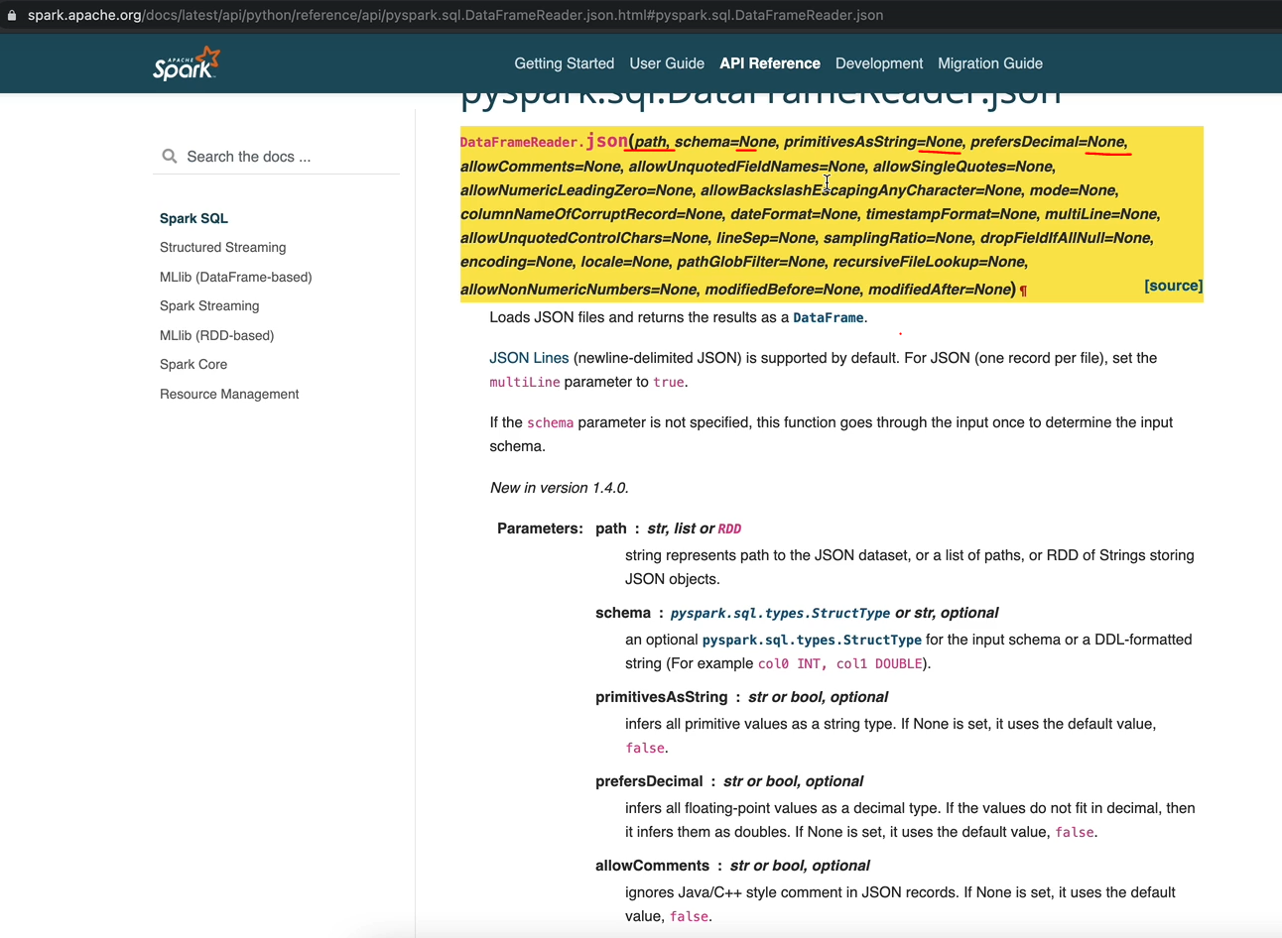

And we also want to specify the date, Jason, file for that one. So that is Jason. And then we want to specify the name of the file. So that is in our /mnt/formula1dl/raw/constructors.json and \ here, because that continues to the next line, so let's execute this one and we should see the data in our data frame. So let's execute that. And we've got the data from now populated. So let's quickly do a display on the data set and see the contents.

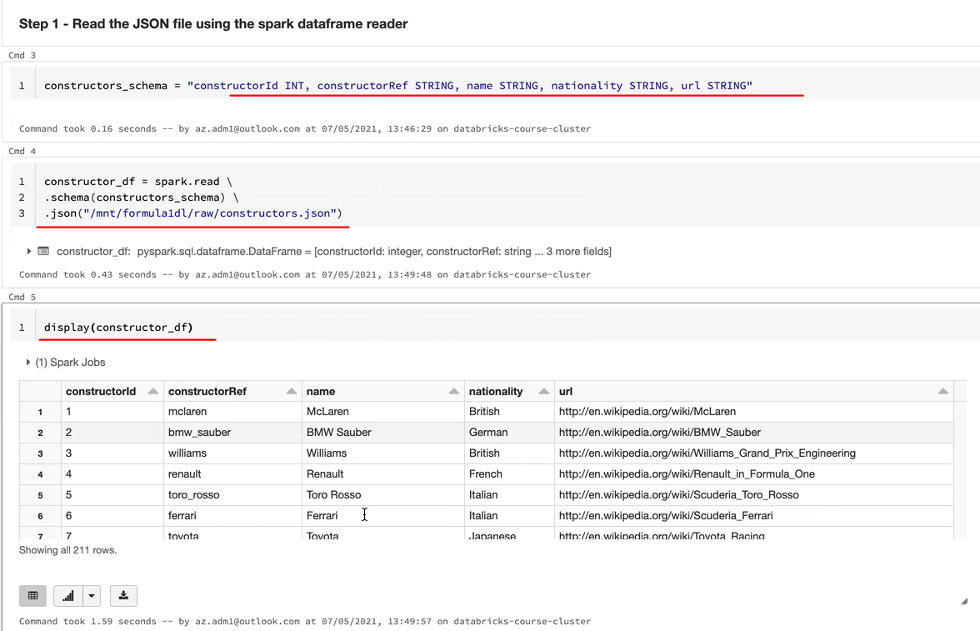

And as you can see, we got the contract Friday, construct, reference, name, nationality, and you are one more thing you may want to check his. We've defined the schema in a different way now, so let's do a print schema on the data frame. So that'll be present schema and that should print the schema for us.

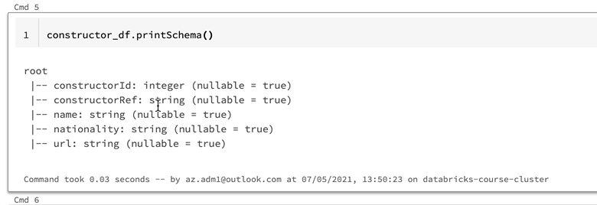

And as you can see, we got the construct radius integer and everything else is a string. So this style of defining the schema works in the same way to the other one we did before, but as I said, my personal preference is to use these struct type and the struct fields. But if you feel comfortable doing this, you can stick to this as well. I don't think there is any other difference between the two. Let's now tidy up the notebook before we move on to the next step so we don't need the Pinski statement here, but we'll keep the display so that we can look at the data while we do the next step.

### Transform and Write Data

So the next thing we want to do is to drop the unwanted column, which is the URL in our case, let's do that. So as I said before, in the previous lessons, actually, we selected the data we needed, but now we are going to look at how to drop a column from a Dataframe. So let's switch to the API reference. And under the Dataframe APIs, you will see a method called drop. So it's quite simple, as it says here, it returns a new Dataframe that drops a specified column and there are a couple of examples here and they've got the drop 'Age' in this case. 'Age' is the column which is getting dropped. You can specify it like this or you can say df.Age. Or then I showed you in the select couple of other ways of referencing this column. You can use the Dataframe and then open square brackets age and then close the square brackets df['age']. Or you can do the col method as well around the age column. So let's switch to the notebook and implement that for our data frame. So I'm going to call the new Dataframe as constructor dropped the Url. And that's kind of read from our original constructor_df. And this time, as we said, we are going to drop the data, so let's specify URL in here, so that should drop and the new data frame shouldn't have the new column. So you can do a display on that. Or you can just see here, as you can see, we've we've only got the four columns. We don't have the Url.

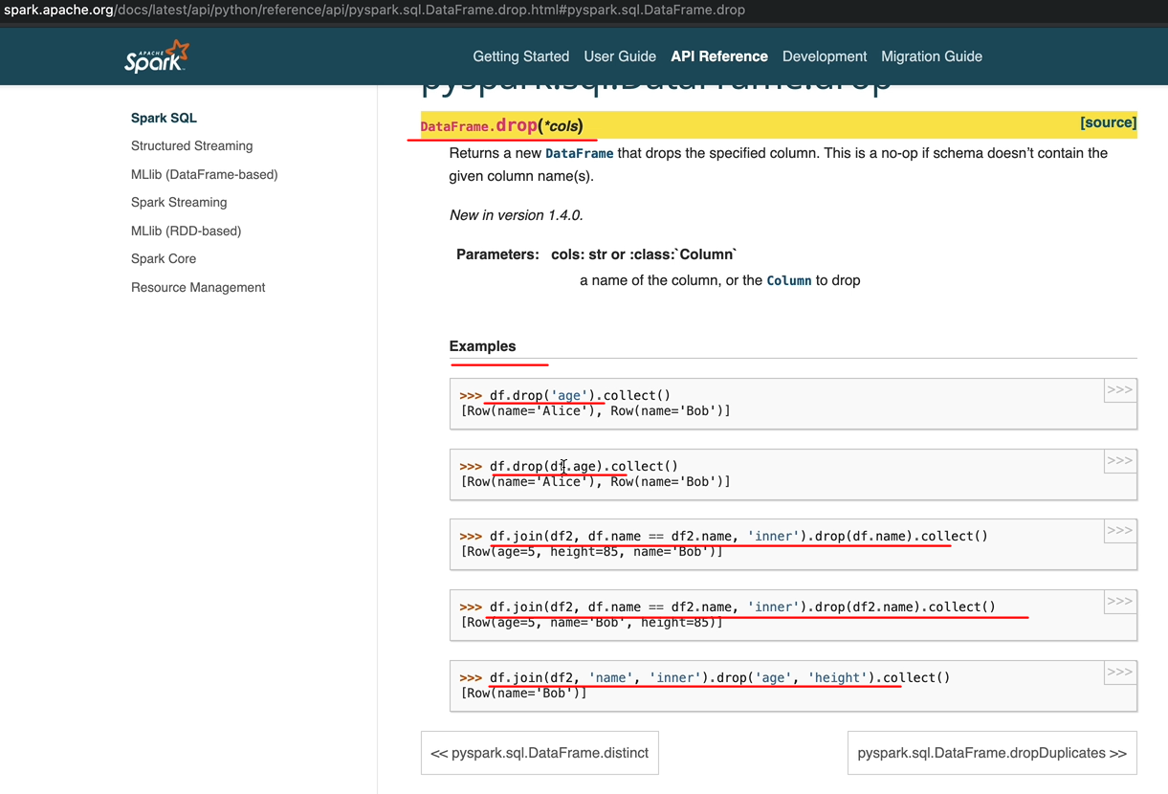

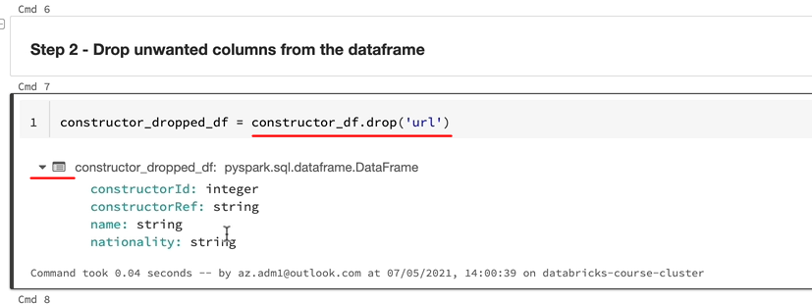

So the other way of referencing this column is using the data frame name and then have square brackets around that. So let's do that. This is quite handy when you have multiple data frames and you want to reference a column within the specified data frame. In this case, it's not an issue because we are only dealing with one data frame. But if you go back to the documentation, if you look here, we're joining two data frames here, different data. But the column we want to drop is from the data frame and both data frames have got that column name, name. So that's why it's easier to reference using the name or the open brackets, which is a square bracket and then the attribute name.

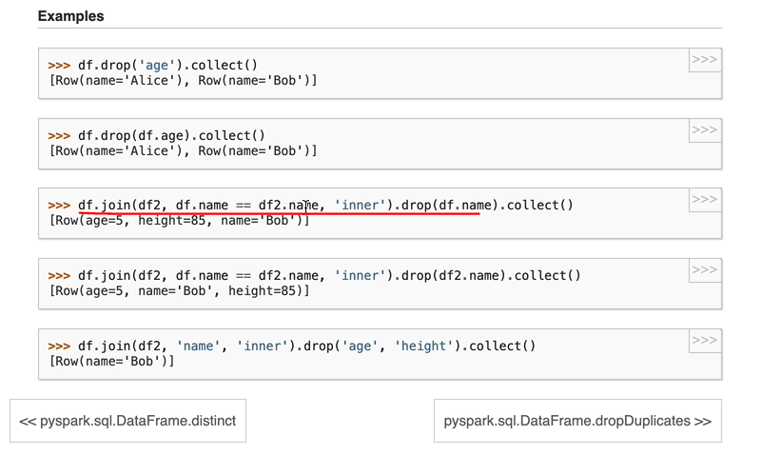

So in our case, it's not really quite useful. And the other option you got is to use the col function around that. So let me import the col function first. And instead of the dataframe name, I would have a col and then I just need the brackets here. So if I execute that, I should see the same thing, the Url doesn't appear anymore, so that's cool.

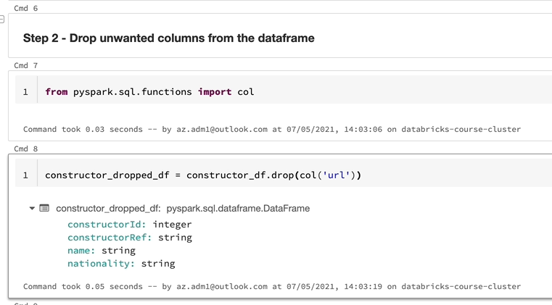

The next requirement we had is to rename our columns as well as to add the injection date as a new column, say, in the previous lessons, we did them in two steps. But let's try and do that in one step here. OK, so we're going to call this one as constructor_final_df, because that's our final date frame before we are going to write it into our file and we're going to take the data from the dropped_df and let's use withColumnRenamed and rename the first column, which is the constructor_id. And this is going to be called constructor_id. And we got another one, which is going to be the constructorReference. And we're going to do the ingestion date here as well. So let's use the withColumn function method for this one. And the name of the column is Ingestion Date, and as we did before, we are going to use the current time stamp function. And in order to use that current time stamp function, we need to import the function as well. So that's going to be from pyspark.sql.function and we're going to import current timestamp. So let's execute that statement and also execute this one and let's now do a display on this date frame to see whether we got the data as we expected.

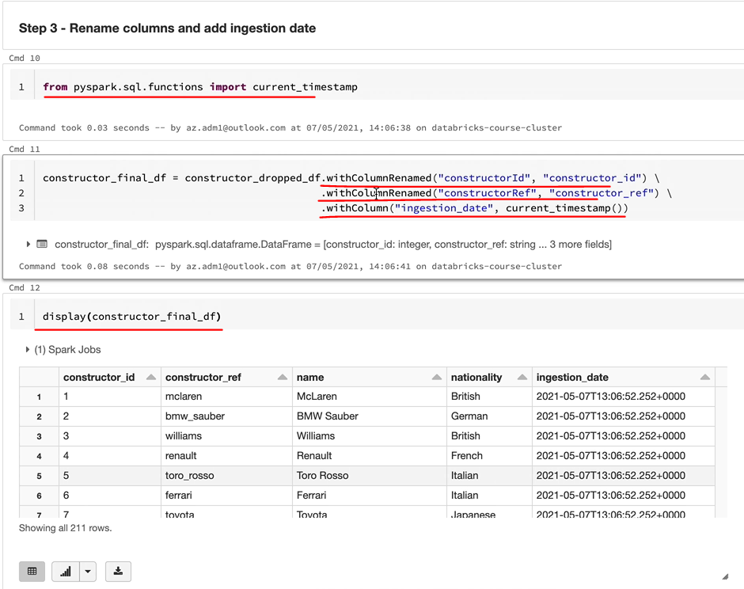

So as you can see, we got the columns as we expected and also the new column edition date has been populated with the right data as well. And the column names look OK. So you might be wondering actually why did this in two steps previously and we are doing in one step here. Spark lets you combine your different API calls in one statement. But the line you need to draw is when does it become too complicated? In this case? It doesn't matter. When somebody comes in here, they'll be able to see that a couple of columns are renamed and a new column is added. But we don't want to be doing a drop as well at the same time, for example. So it's it's up to you as a developer to break down the calls as much as you want, but make it as easily readable so that the other developers can come and support your code. Having this in one statement or two statement doesn't make any difference to spark, because at runtime, Spark will put them together and find the most optimum way to execute your spark statements.

And the final thing we want to do is to write the data to a parquet file. There is nothing new we are going to do here, we are going to do exactly same as what we did here by using the Dataframe writer? So that is write.. And the more we wanted to use this mode as "overwrite". So that we can rerun our notebook as many times as we wanted. And then that will be spark and we want to specify the location of the place where we want to write the file. So that would be /mnt/formuladl and the container name is processed and we want to give a full name for our data frame data to be returned, and I want to write that data into constructor's. So let's write that and that's being executed and that's brilliant.

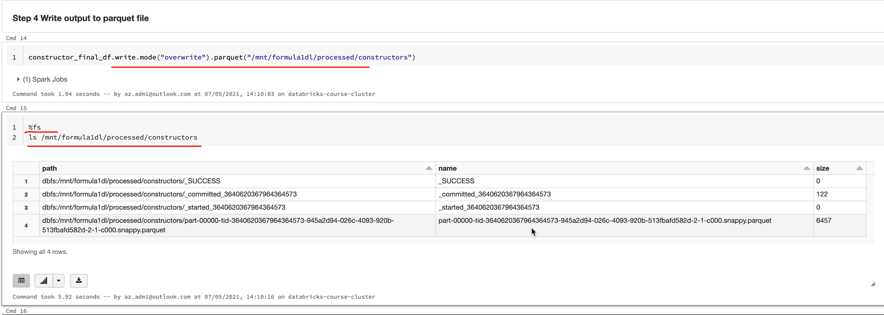

So as a final step, let's just quickly check to make sure that actually we've got all the files. So we got the parquet file being written here, which is brilliant.

Data Ingestion – Drivers file

We are going to be looking at the requirements for ingesting the driver's Jason file into the data lake in our processed container. We want to do exactly the same as what we did to the constructor's file. The only difference is that the JSON has their nested object. As you can see, the full name and the surname forms the Object name. I'll walk you shortly through the file to show you what I mean by that. In the meantime, our transformation requirements are to rename the columns, the driverId and the driverReference and drop the URL as we did before. The new requirement here is to create a new column called name to contain the concatenated string from full name and surname in our source file. And also to create injection date, as we did before, we will focus most of her time in dealing with the nested objects and will speed up the implementation of the rest of the requirements because we've done that before. I'll quickly walk you through the file before we start writing any code. But first, I'll quickly walk you through the file before we start writing any code. Let's open the file in Visual Studio Code and then we can look at the data. As you can see here, we got driver reference, and code and all of that. But we got this column here, which is the nested object, but it is the nested JSON object with the surname and the firstname. So I'll show you how to write. This came to be able to read this data and also concatenate these two fields together to create a column called Name in parquet file.

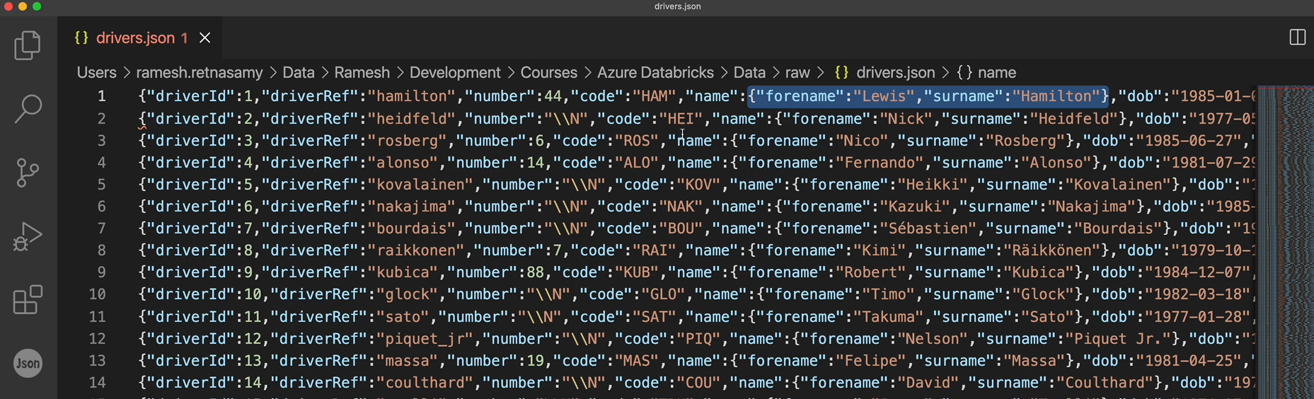

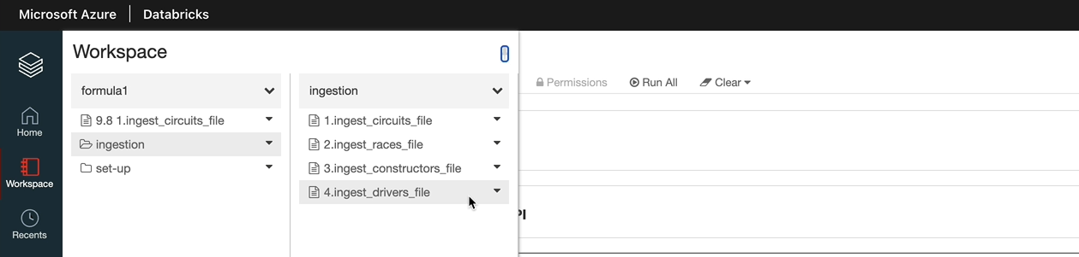

|  |  |
| --- | --- |
|  |  |

So now we've defined the names schema and let's define the driver schema now. So this is the Stack field for the name and the type here is not one of these IntegerType, the StringType, the type name_schema. So let's let's give the name schema for this one, because we've already defined it. And let's carry on with the rest of the struct fields now. So with that, we've defined all the fields, let's do shift and execute that, so the scheme is now being defined. Let's read the file like we did before. OK, let's hit shift enter to execute this.

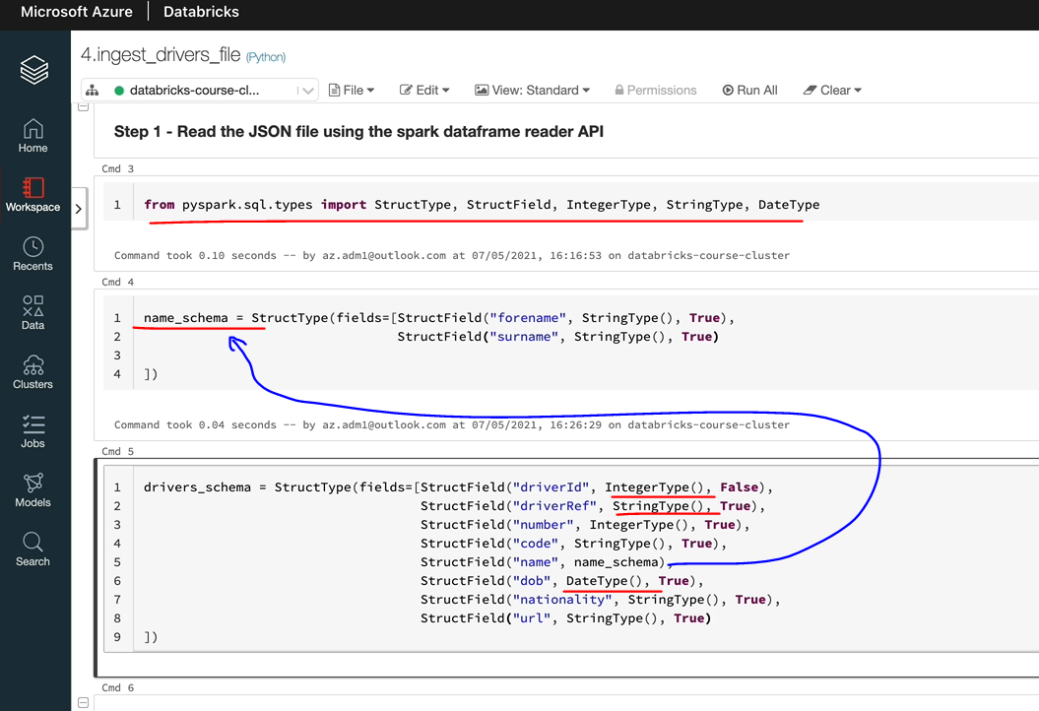

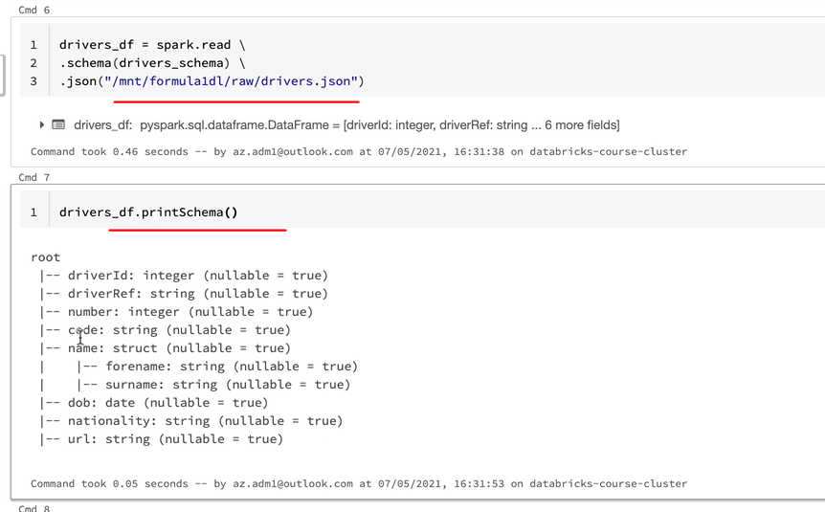

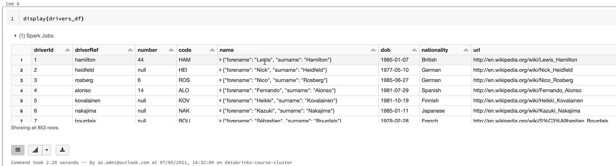

**Step 2 - Rename columns and add new columns**

1. driverId renamed to driver_id
2. driverRef renamed to driver_ref
3. ingestion date added
4. name added with concatenation of forename and surname

from pyspark.sql.functions import col, concat, current_timestamp, lit

drivers_with_columns_df = drivers_df.withColumnRenamed("driverId", "driver_id") \

.withColumnRenamed("driverRef", "driver_ref") \

.withColumn("ingestion_date", current_timestamp()) \

.withColumn("name", concat(col("name.forename"), lit(" "), col("name.surname")))

**Step 3 - Drop the unwanted columns**

1. name.forename
2. name.surname
3. url

drivers_final_df = drivers_with_columns_df.drop(col("url"))

%md

##### Step 4 - Write to output to processed container in parquet format

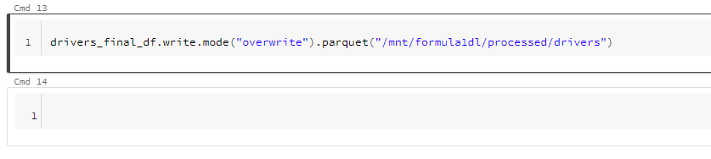

drivers_final_df.write.mode("overwrite").parquet("/mnt/formula1dl/processed/drivers")

**The complete code**

**Ingest drivers.json file**

**Step 1 - Read the JSON file using the spark dataframe reader API**

**from** pyspark.sql.types **import** StructType, StructField, IntegerType, StringType, DateType

name_schema = StructType(fields=[StructField("forename", StringType(), True),

StructField("surname", StringType(), **True**)

])

drivers_schema = StructType(fields=[StructField("driverId", IntegerType(), False),

StructField("driverRef", StringType(), **True**),

StructField("number", IntegerType(), **True**),

StructField("code", StringType(), **True**),

StructField("name", name_schema),

StructField("dob", DateType(), True),

StructField("nationality", StringType(), **True**),

StructField("url", StringType(), **True**)

])

drivers_df = spark.read \

.schema(drivers_schema) \

.json("/mnt/formula1dl/raw/drivers.json")

**Step 2 - Rename columns and add new columns**

1. driverId renamed to driver_id
2. driverRef renamed to driver_ref
3. ingestion date added
4. name added with concatenation of forename and surname

**from** pyspark.sql.functions **import** col, concat, current_timestamp, lit

drivers_with_columns_df = drivers_df.withColumnRenamed("driverId", "driver_id") \

.withColumnRenamed("driverRef", "driver_ref") \

.withColumn("ingestion_date", current_timestamp()) \

.withColumn("name", concat(col("name.forename"), lit(" "), col("name.surname")))

**Step 3 - Drop the unwanted columns**

1. name.forename
2. name.surname
3. url

drivers_final_df = drivers_with_columns_df.drop(col("url"))

**Step 4 - Write to output to processed container in parquet format**

drivers_final_df.write.mode("overwrite").parquet("/mnt/formula1dl/processed/drivers")

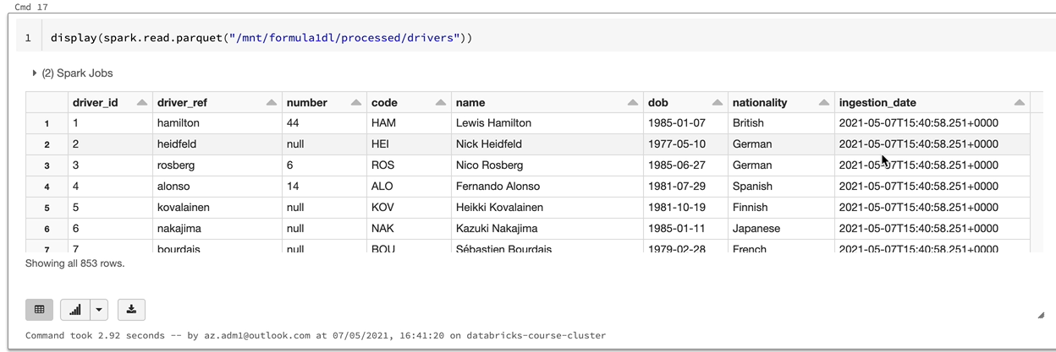

### Data Ingestion – Results Assignment

In this lesson, we're going to be looking at the requirements for ingesting the results.json file into the Data Lake. This is a standard single line JSON file similar to the constructors.json file that we processed previously as we process one of these types of files already. I would like you to do this as an assignment. Our transformation requirements here are to rename the list of columns as highlighted to make them snake case, i.e. with underscores. We want to drop the status id from our source data and also create the ingestion date, as we did before with the current time stamp. We also want to partition the data and return to the data lake by race id. So let me quickly show you the file and also the schema for the file before you get started.

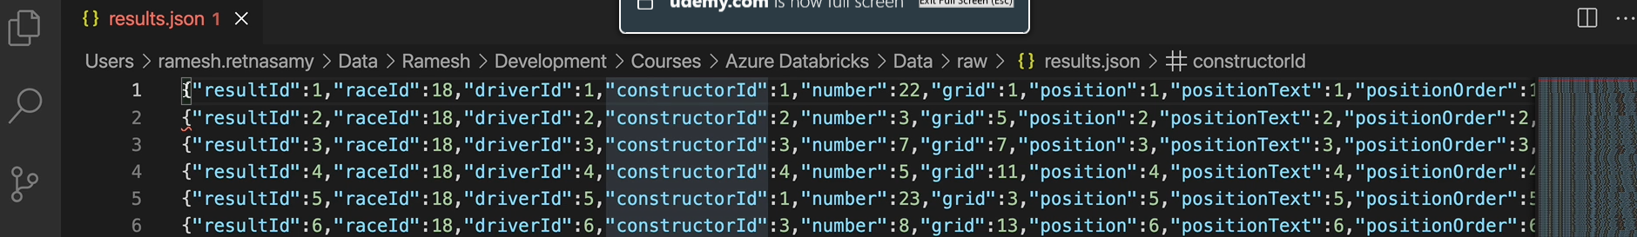

This is the result that Jason filed that I've opened up in visual studio code. As you can see here, it's a single line, Jason, with no nested objects. As you can see, they're all simple objects. There are no nested objects here. And it's got quite a few records, roughly about 25000 records of twenty four thousand nine hundred and sixty records to process. But it is quite simple, like we did before. Let me show you the data types for the fields. So let's come over to the guest developer API and enter the database. Use a guide. We got the results table defined as he can see. We got a number of integer fields and these ones can be integer types and spark and this will be string type and then a float can be converted into a float type as well.

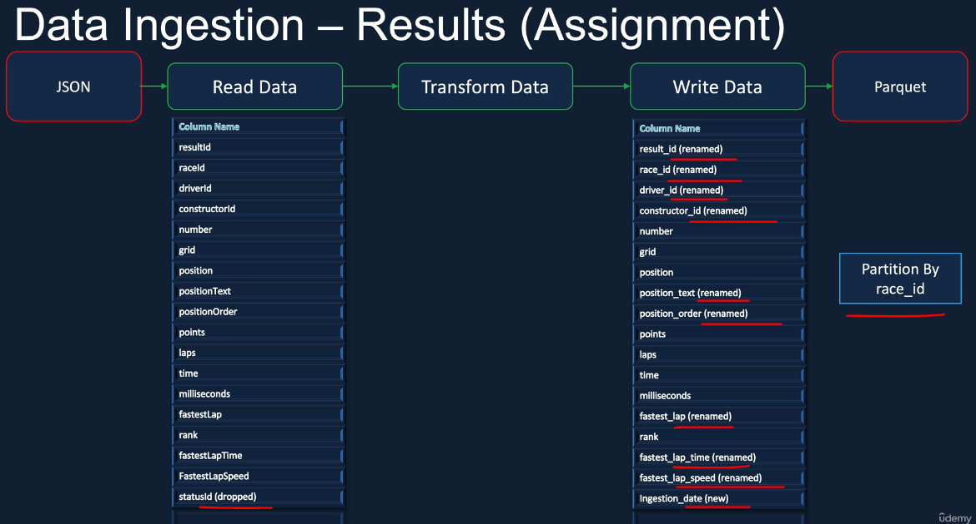

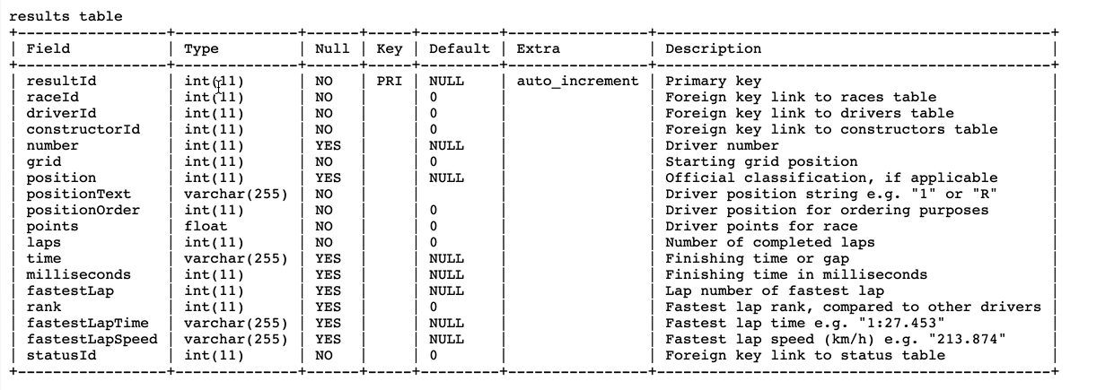

So as I said, that is a simple file and we've done one of these kind of files before.

**Ingest results.json file**

**Step 1 - Read the JSON file using the spark dataframe reader API**

from pyspark.sql.types import StructType, StructField, IntegerType, StringType, FloatType

**results_schema** = StructType(fields=[StructField("resultId", IntegerType(), **False**),

StructField("raceId", IntegerType(), **True**),

StructField("driverId", IntegerType(), **True**),

StructField("constructorId", IntegerType(), **True**),

StructField("number", IntegerType(), **True**),

StructField("grid", IntegerType(), **True**),

StructField("position", IntegerType(), **True**),

StructField("positionText", StringType(), **True**),

StructField("positionOrder", IntegerType(), **True**),

StructField("points", FloatType(), **True**),

StructField("laps", IntegerType(), **True**),

StructField("time", StringType(), **True**),

StructField("milliseconds", IntegerType(), **True**),

StructField("fastestLap", IntegerType(), **True**),

StructField("rank", IntegerType(), **True**),

StructField("fastestLapTime", StringType(), **True**),

StructField("fastestLapSpeed", FloatType(), **True**),

StructField("statusId", StringType(), **True**)])

results_df = spark.read \

.schema(**results_schema**) \

.json("/mnt/formula1dl/raw/results.json")

**Step 2 - Rename columns and add new columns**

from pyspark.sql.functions import current_timestamp

results_with_columns_df = results_df.withColumnRenamed("resultId", "result_id") \

.withColumnRenamed("raceId", "race_id") \

.withColumnRenamed("driverId", "driver_id") \

.withColumnRenamed("constructorId", "constructor_id") \

.withColumnRenamed("positionText", "position_text") \

.withColumnRenamed("positionOrder", "position_order") \

.withColumnRenamed("fastestLap", "fastest_lap") \

.withColumnRenamed("fastestLapTime", "fastest_lap_time") \

.withColumnRenamed("fastestLapSpeed", "fastest_lap_speed") \

.withColumn("ingestion_date", current_timestamp())

**Step 3 - Drop the unwanted column**

from pyspark.sql.functions import col

results_final_df = results_with_columns_df.drop(col("statusId"))

**Step 4 - Write to output to processed container in parquet format**

results_final_df.write

.mode("overwrite")

.partitionBy('race_id')

.parquet("/mnt/formula1dl/processed/results")

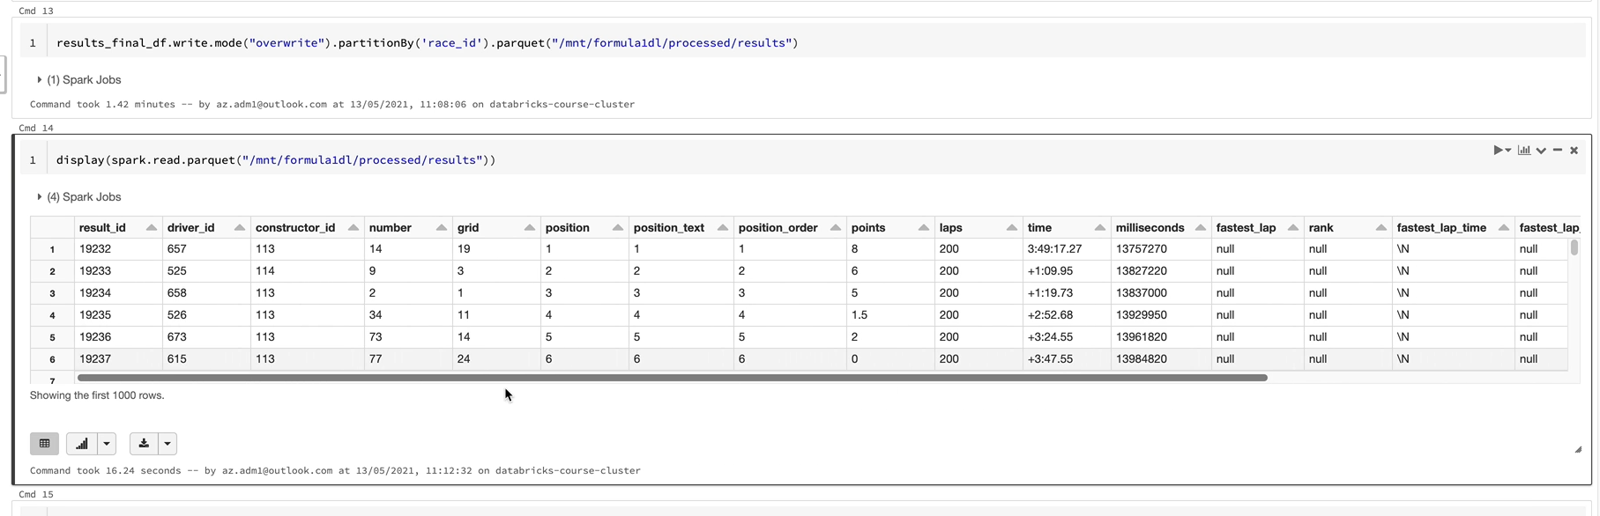

### Data Ingestion – Pitstops

We want to do pretty much what we did in the previous files. The main difference here is that we'll be processing multiline JSON rather than a single line Jason. The other requirements are to rename a couple of columns, raceId and driverId, to have underscores in them and also add the new column ingestion date with the current timestamp. As you can see, these are things we've done before. So our main focus here is to process the Multiline JSON File. Before we start, I'll quickly walk you through the file and then we can start creating our notebook. OK, here is the pit stop stop.

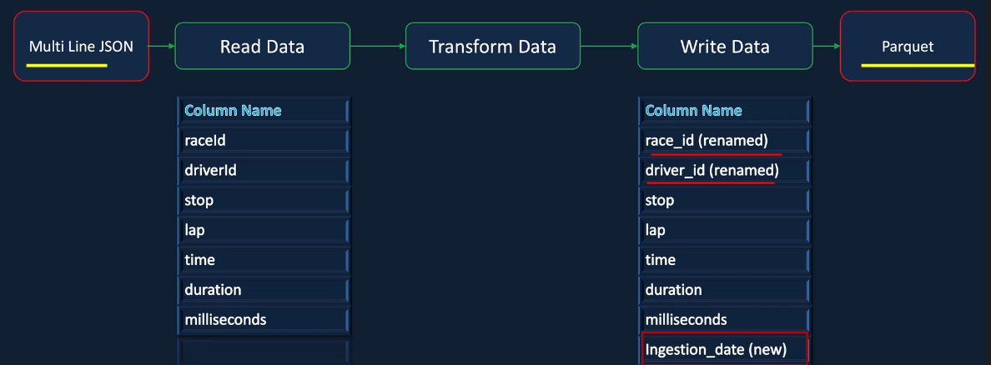

The main difference is that the JSON is on multiple lines, rather than a single line

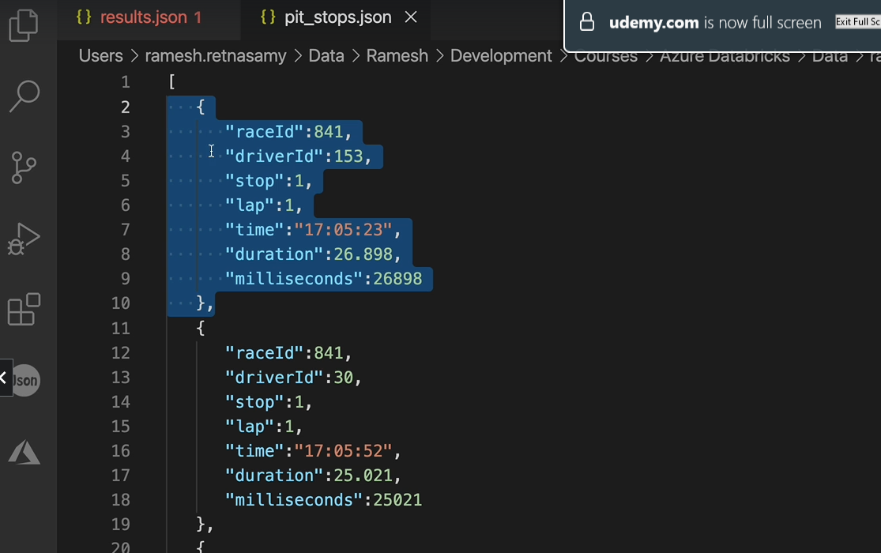

You will need to explicitly tell Spark that this is a multi line JSON

Lets look at the data types of pitstops

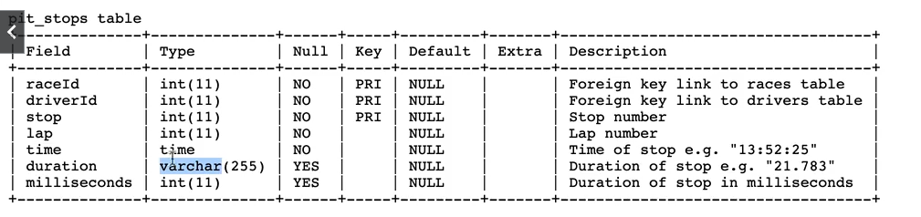

When we read directly for a multi line schema we get data like this even though we have data in our multi line JSON file

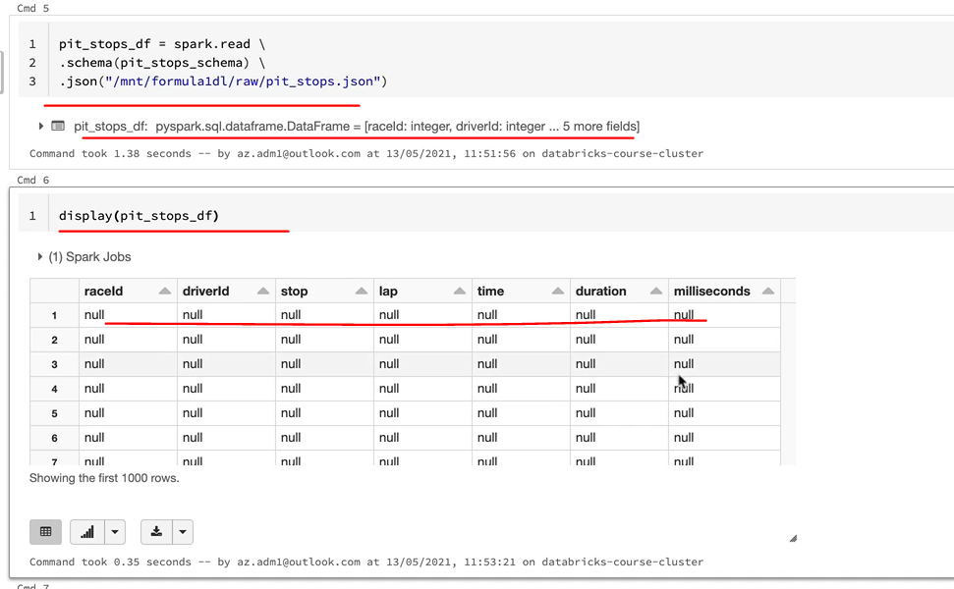

**Ingest pit_stops.json file**

**Step 1 - Read the JSON file using the spark dataframe reader API**

**from** pyspark.sql.types **import** StructType, StructField, IntegerType, StringType

pit_stops_schema = StructType( fields=[ StructField("raceId", IntegerType(), False),

StructField("driverId", IntegerType(), True),

StructField("stop", StringType(), **True**),

StructField("lap", IntegerType(), **True**),

StructField("time", StringType(), **True**),

StructField("duration", StringType(), **True**),

StructField("milliseconds", IntegerType(), **True**)

])

pit_stops_df = spark.read \

.schema( pit_stops_schema ) \

.option( "multiLine", **True** ) \

.json( "/mnt/formula1dl/raw/pit_stops.json" )

**Step 2 - Rename columns and add new columns**

1. Rename driverId and raceId
2. Add ingestion_date with current timestamp

**from** pyspark.sql.functions **import** current_timestamp

final_df = pit_stops_df.withColumnRenamed( "driverId", "driver_id" ) \

.withColumnRenamed( "raceId", "race_id" ) \

.withColumn( "ingestion_date", current_timestamp() )

**Step 3 - Write to output to processed container in parquet format**

final_df.write

.mode("overwrite")

.parquet("/mnt/formula1dl/processed/pit_stops")

**Result**

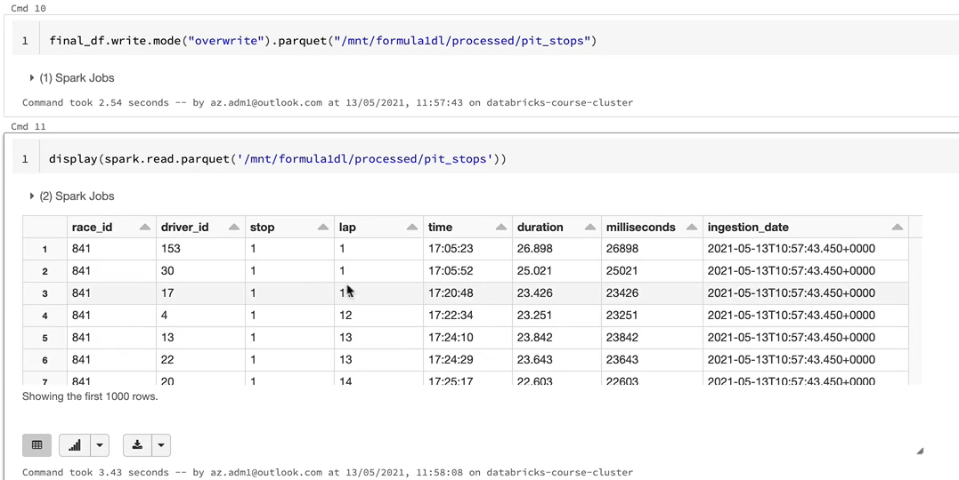

### Data Ingestion - Laptimes

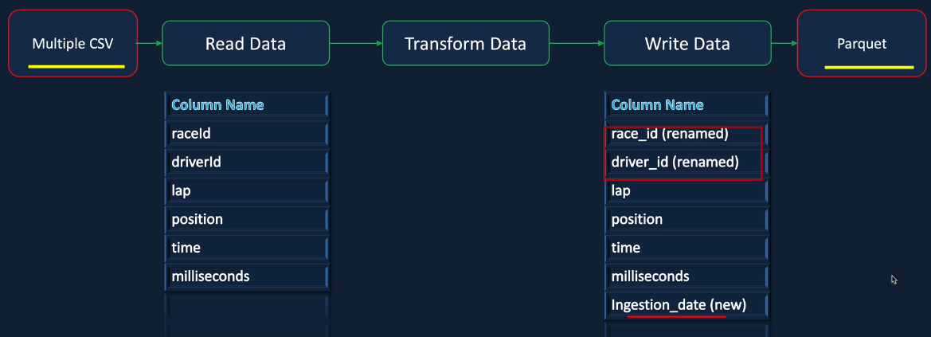

Lets look at the file

As you can see that lap_times is not a file but a folder and within the folder we have multiple files for it, the data is split up into multiple files

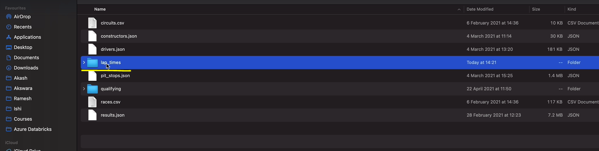

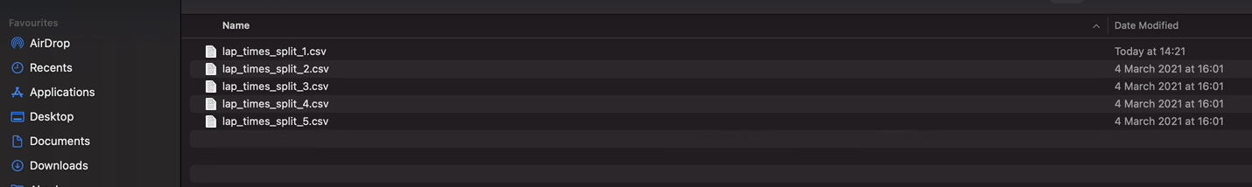

Opening up one of the csv file ( there is no header here ) – normally files arrive without a header when we have multiple files ( we wouldn’t know which one has a header )

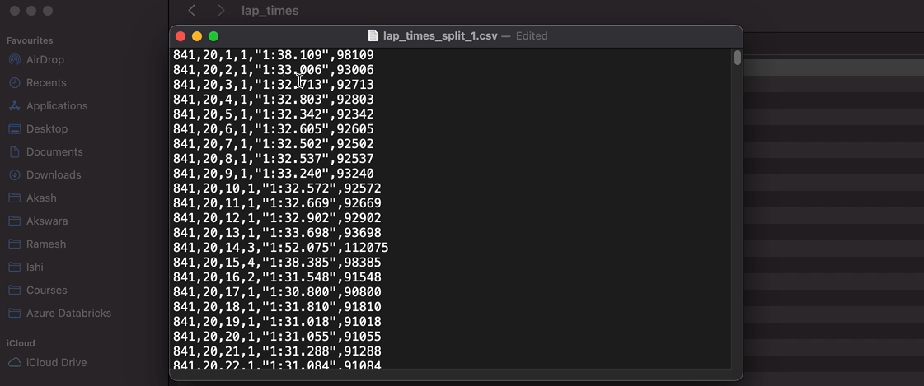

So 5 numbers and a string in here

The main difference between the pit stops and the lap times file processing is that in the case of lap times, we're going to process a folder as opposed to a single file.

So this folder contains five different files.

Clone the previous notebook and make changes for lap_times notebook

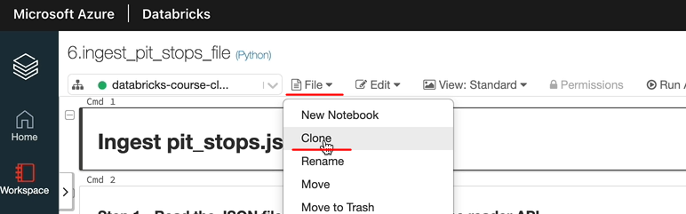

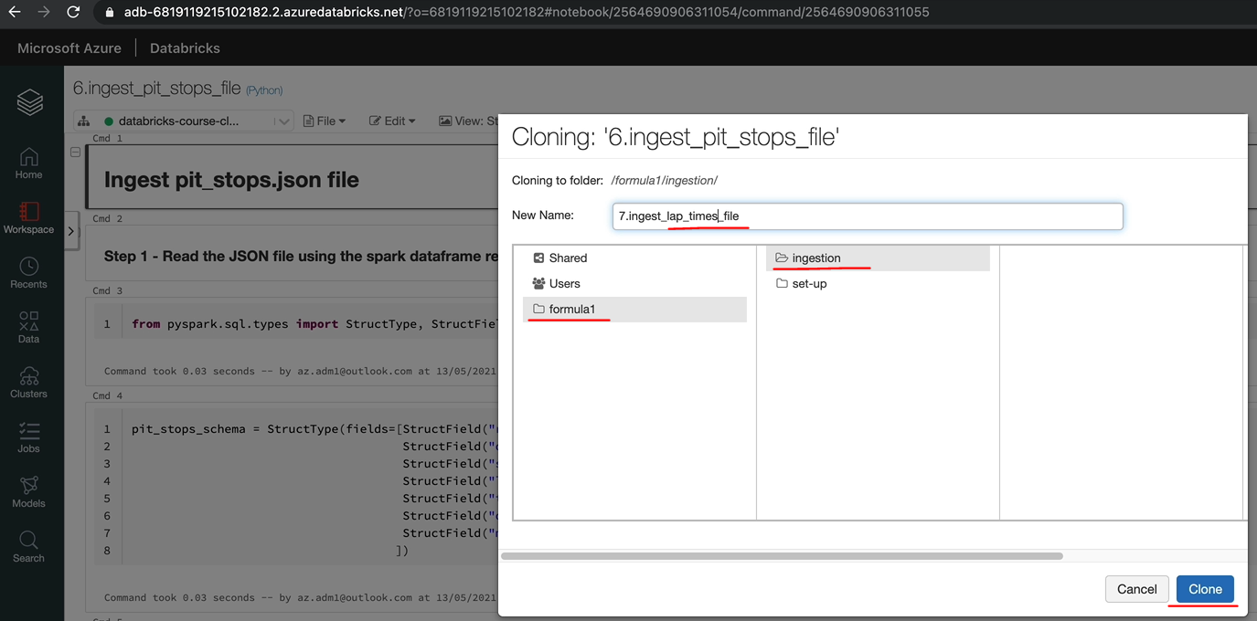

Rename this to lap_times instead of pit_stop and then lets work on this

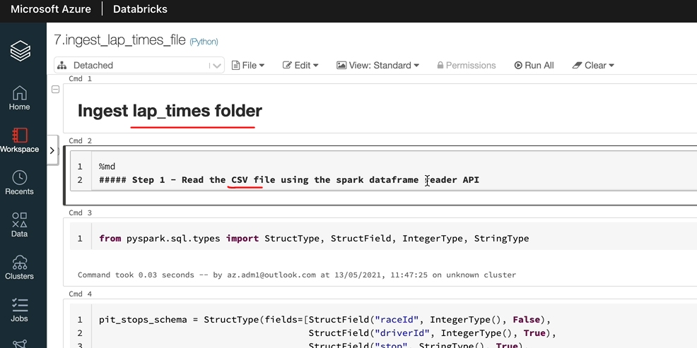

On cloning the file is detached, so attach it to the cluster

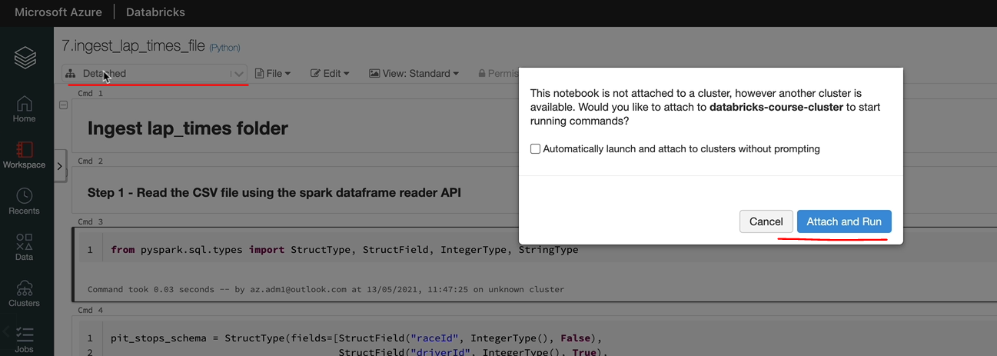

Or we could cancel on that prompt and attach it to the right cluster that we wanted to

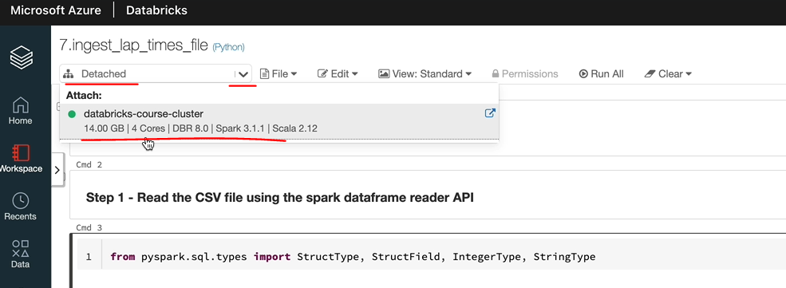

Schema is only slightly different to the other one ( pit stop ) so we will make those changes only.

**Ingest lap_times folder**

**Step 1 - Read the CSV file using the spark dataframe reader API**

from pyspark.sql.types import StructType, StructField, IntegerType, StringType

lap_times_schema = StructType( fields=[ StructField("raceId", IntegerType(), False),

StructField("driverId", IntegerType(), True),

StructField("lap", IntegerType(), True),

StructField("position", IntegerType(), True),

StructField("time", StringType(), True),

StructField("milliseconds", IntegerType(), True)

])

**lap**_**times**_**df** = spark.read \

.schema(lap_times_schema) \

.csv("/mnt/formula1dl/raw/lap_times")

Using folder in path above instead of the file name, since we have multiple files in a folder

We could also do something like .csv("/mnt/formula1dl/raw/lap_times*") to pick only the files that are named that way

**Step 2 - Rename columns and add new columns**

1. Rename driverId and raceId
2. Add ingestion_date with current timestamp

**from** pyspark.sql.functions **import** current_timestamp

final_df = **lap_times_df**.withColumnRenamed("driverId", "driver_id") \

.withColumnRenamed("raceId", "race_id") \

.withColumn("ingestion_date", current_timestamp())

**Step 3 - Write to output to processed container in parquet format**

final_df.write

.mode("overwrite")

.parquet("/mnt/formula1dl/processed/lap_times")

Lets see that data, so that looks fine

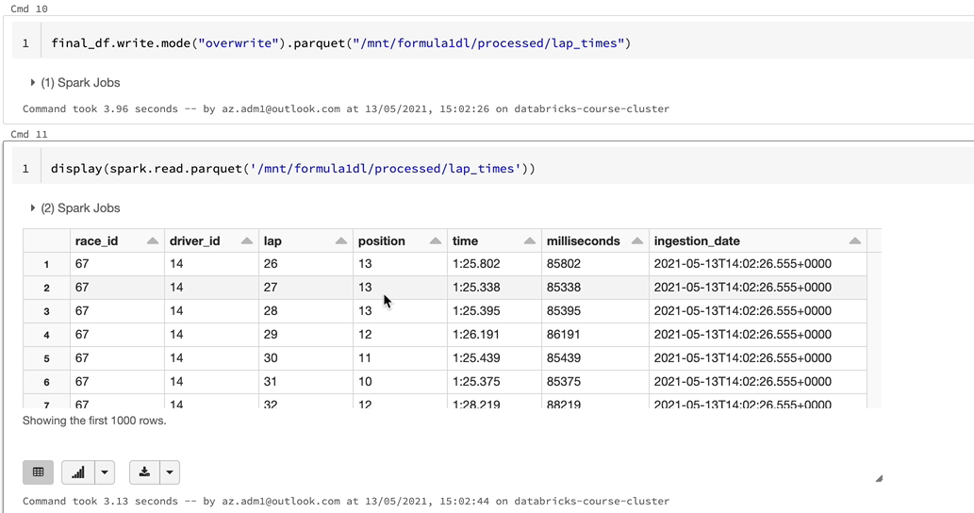

Half a million records in there

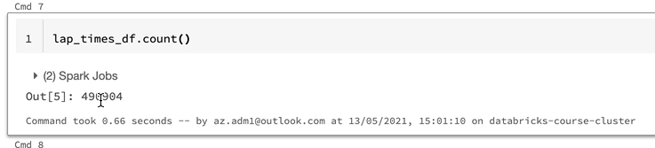

### Qualifying – Requirements

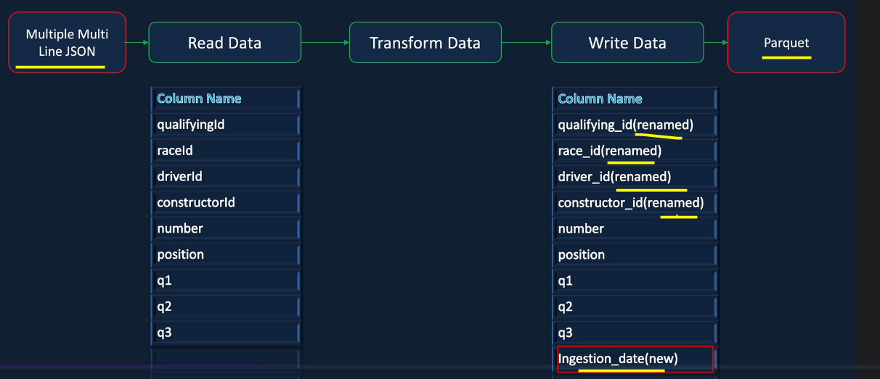

As you can see, we've already done these kind of transformations. Also, we've done multiple CSV files and multiline JSON files separately.

So we have a folder for this containing the files

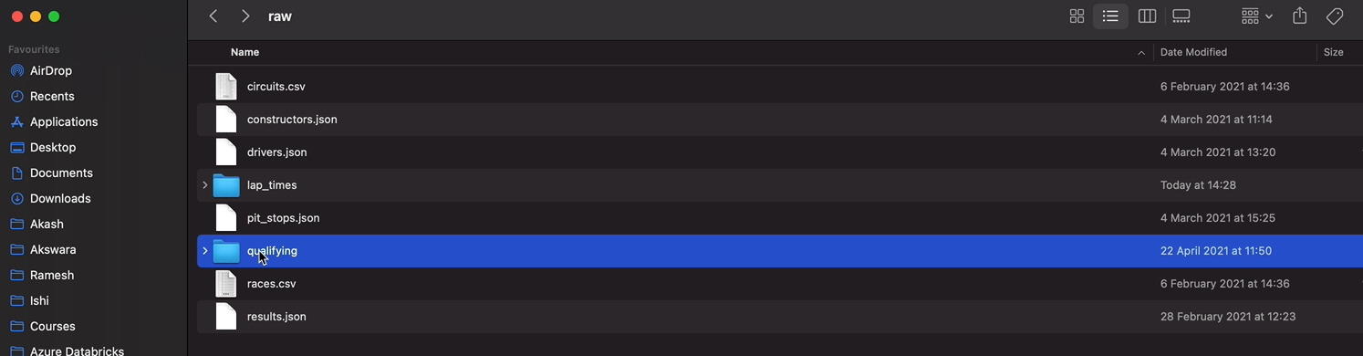

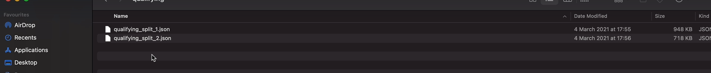

Opening one of them – it’s a multi line JSON file with multiple objects and in multiple files

So we have a set of numbers and then some strings in this

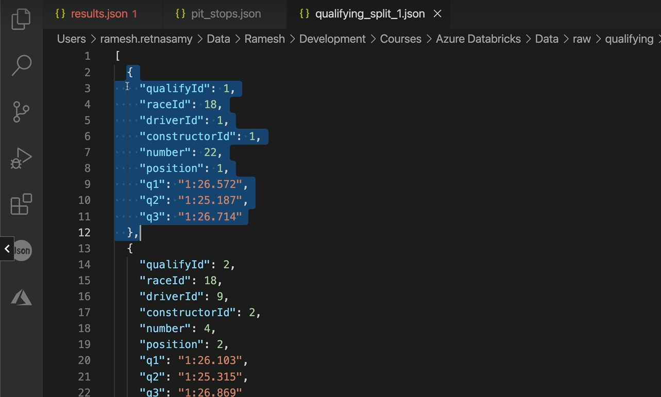

**Ingest qualifying json files**

**Step 1 - Read the JSON file using the spark dataframe reader API**

**from** pyspark.sql.types **import** StructType, StructField, IntegerType, StringType

qualifying_schema = StructType(fields=[ StructField("qualifyId", IntegerType(), False),

StructField("raceId", IntegerType(), True),

StructField("driverId", IntegerType(), **True**),

StructField("constructorId", IntegerType(), **True**),

StructField("number", IntegerType(), **True**),

StructField("position", IntegerType(), **True**),

StructField("q1", StringType(), **True**),

StructField("q2", StringType(), **True**),

StructField("q3", StringType(), **True**),

])

qualifying_df = spark.read \

.schema(qualifying_schema) \

.option( "multiLine", **True** ) \

.json( "/mnt/formula1dl/raw/qualifying" )

**Step 2 - Rename columns and add new columns**

1. Rename qualifyingId, driverId, constructorId and raceId
2. Add ingestion_date with current timestamp

**from** pyspark.sql.functions **import** current_timestamp

final_df = qualifying_df.withColumnRenamed("qualifyId", "qualify_id") \

.withColumnRenamed("driverId", "driver_id") \

.withColumnRenamed("raceId", "race_id") \

.withColumnRenamed("constructorId", "constructor_id") \

.withColumn("ingestion_date", current_timestamp())

**Step 3 - Write to output to processed container in parquet format**

final_df.write

.mode("overwrite")

.parquet("/mnt/formula1dl/processed/qualifying")

display( spark.read.parquet('/mnt/formula1dl/processed/qualifying') )

## Databricks Workflows

We now have eight notebooks to ingest our data into the data. There are a few things we can do better to productionize them so that they can be scheduled to run at regular intervals as well as they could be moved between different environments without any changes. And just by changing some configuration parameters, this section will be focused on implementing those aspects using onely data because there are better options available and easier than using Databricks for scheduling. But that will be covered in a later section in this section.

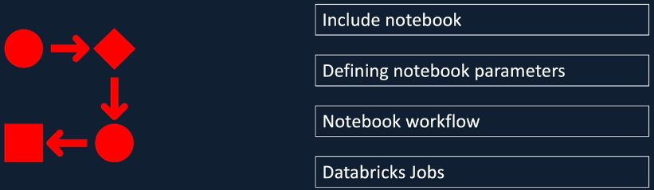

First, we look at how to include a notebook in another notebook with configuration parameters are common functions. Then we look at how to define parameters in a notebook, we will then look at how to invoke one notebook from another and chain them together and also pass the parameters that we defined earlier. Finally, we look at creating Databricks jobs to execute notebooks at regular intervals and on demand. By the end of this section, I hope you will have a good understanding about the capabilities offered by Databricks to create notebook workflows and running them from database jobs.

### Including a Child Notebook

|  |  |
| --- | --- |
| In any programming language, it is important to write reusable code so that the bigger project can become more manageable and Spark is no exception. Spark lets us reuse and not book in another notebook using the %run around magic time. And we've seen this previously, but we want to apply that to our project so that our understanding becomes more concrete. |  |

So let's get started. Here we are in the data workspace and that we are in the first edition file that we created, which is to ingest the circuits data into our data lake. It's a very simple notebook, but still there are a couple of things we can do to improve it. Firstly, as you can see, we got the folder path hardcoded here as well as in here for the processed container. This is not a good idea because you want to be able to move between different environments without changing your notebook. Having this hardcoded in every notebook means when you want to debug your notebook, you'll have to go and change each one of your notebooks to change the folder part, which is not a good idea. We can put them in variables in another notebook and invoke that notebook from here so that when you come to change the folder part, you just go and change that notebook and everything else would work without a problem.

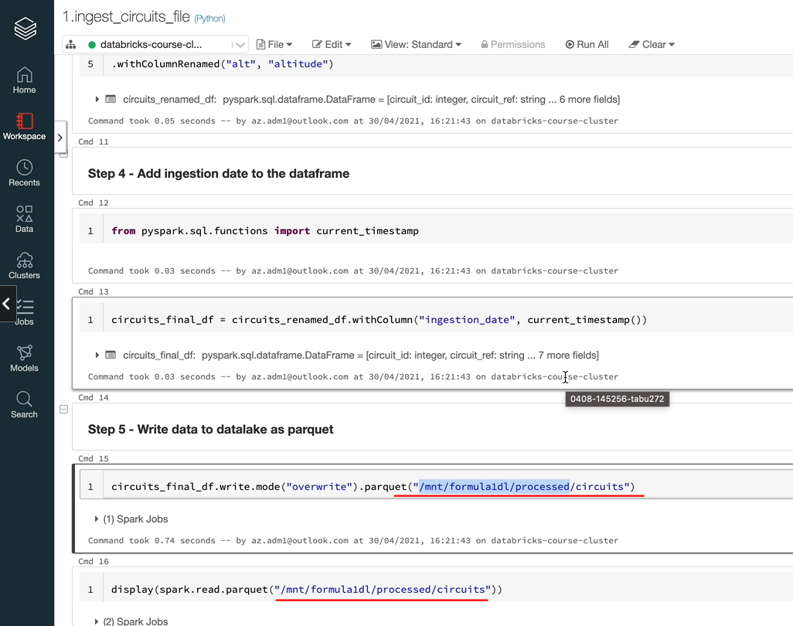

So that's one of the things we can do. The other thing that you can do is in every notebook, as you can remember, we are adding the ingestion date. So instead of writing the code specifically in each of the notebook, you can have a function in another child notebook and you can invoke that in every single notebook and that will just do what you want to do. So let's do those two things, and that should help us demonstrate the power of the %run magic command and how you can use the contents of one notebook in another. So let's first create another notebook.

|  |  |
| --- | --- |
|  | So what I'm going to do is under the Formula One folder, I'm going to create another folder and I'm going to call this one includes. |

And within that I'm going to create a new notebook and let's call this one as configuration.

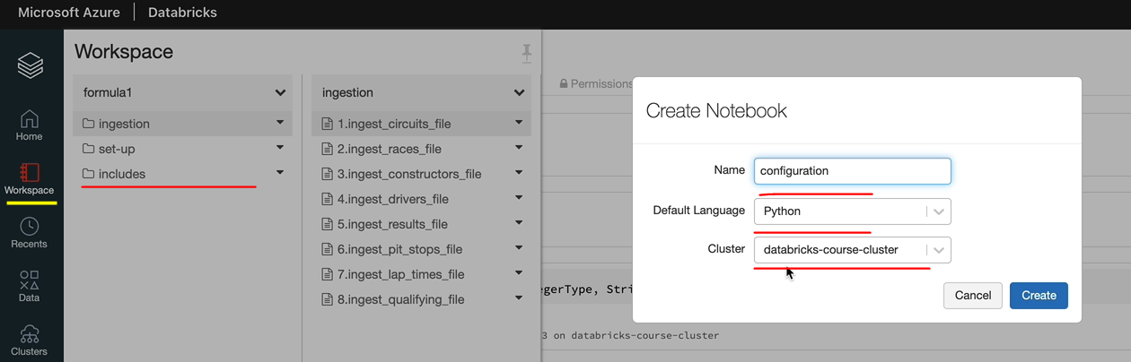

And that's attached to our cluster, and that's a python, notebook as well, because we are dealing with Python here. So we just need to have two variables here. And the first one is raw folder path and let's put the folder path for that. And the next one is our process to follow the path. OK, now that we have created the two variables in here, we can use them in our other notebook.

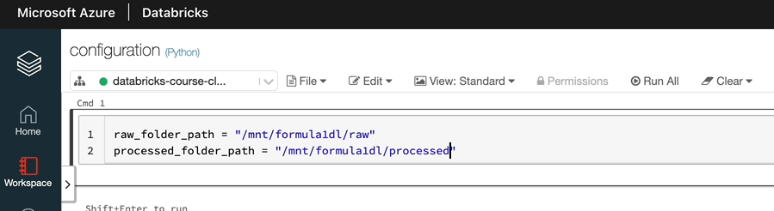

So let's switch over to the other notebook, which is under the ingestion folder and the first file is this one. So let's add the %run command here. So that'll be percentage run and then you need to navigate to the other folder. So we are in our ingestion folder and we got to go out of this folder into the includes folder and invoke that one. So in order to go back one step. Use the .. notation and then we want to go to the includes folder and run the configuration notebook. So let's execute that one.

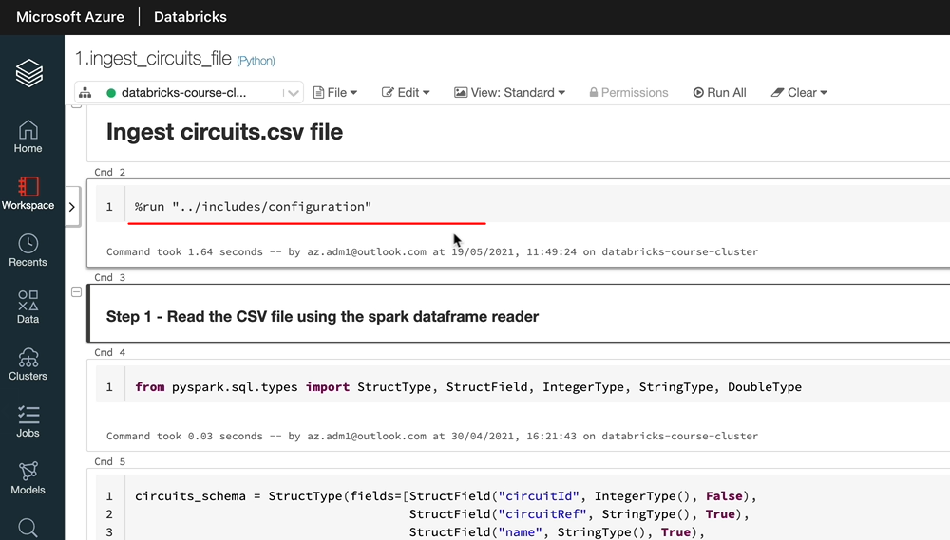

And as you can see, that's done and let's see whether we can now use those variables. I'm just simply going to print the value of the raw folder part here just to see whether that's worked. So, as you can see, that's worked really well. So we can delete that. Now, let me copy that variable anyway and let's use that in the appropriate places. So the first one is here. I'm going to use the fstring just to replace the variable value here. And instead of the folder path, I'm going to use the variable name with the folder path. And the next place we want to do that is in write the parquet files, let's do exactly the same thing. We don't want this anymore. And this is going to be the process to folder path. And we want to use the fstring so that the variable gets replaced in our string, so we've done both changes. So let's click control enter to see whether the changes we've done have worked. As you can see, the data has come out as we would expect it to.

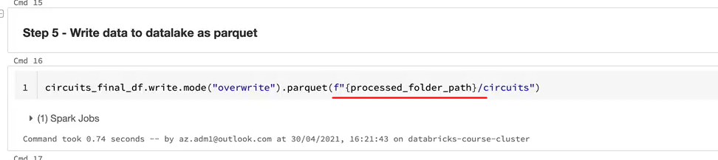

So let's create a notebook which will contain our functions. So, again, let's switch to our clothes and I'm going to create a notebook and I'm going to call this one has common functions because we might have other functions specific for certain areas. For example, just intuition. In this case, this can be a common function and click create. So I'm going to create the function called addIngestionDate. And this function would take in a Dataframe and they will also return a data frame, so I'm going to create the output, and as we know, we want to add the column to the input data frame. So that would be input the df.withColumn and we know our column name is ingestion date. That's the one we want. But we want to do the we want to update it with the current timestamp or populate with the current timestamp. We also need to do one more thing, which is to import the current timestamp function.

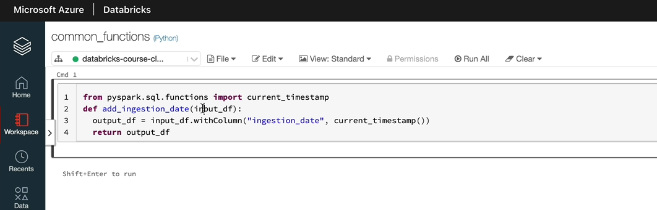

from pyspark.sql.functions import current_timestamp

def add_ingestion_date(input_df):

output_df = input_df.withColumn("ingestion_date", current_timestamp())

return output_df

So basically what this function does is text in a data frame and at the injection date and return the output data frame. So let's just execute that. That worked, OK. Let's now switch to the other notebook. And we are going to use the function instead of the statements here so I can delete this one and say,

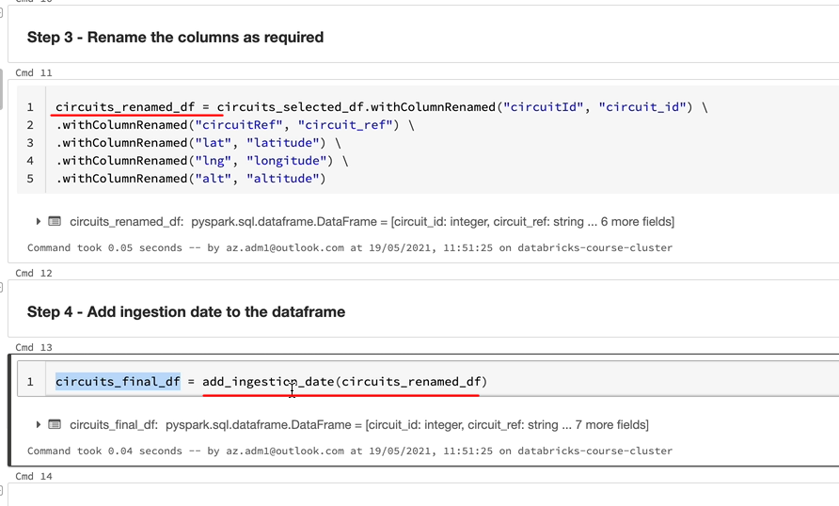

**Step 4 - Add ingestion date to the dataframe**

circuits_final_df = add_ingestion_date(circuits_renamed_df)

So what that's doing is calling the original date function by sending the previous data frame and the output will be returned to the final the here. So it's exactly what we did, but we're doing it using a function. So let's again go up and add then run that command. So that works, OK, so I'm going to do it all just to make sure everything works as we expect it to. So let's look at the output and as you can see, we got the same output again.

So just to summarize, the %run magic command basically runs the notebook and makes everything from that notebook available within the notebook from where it's being run. So one thing to be careful about is when you are doing a %run, you need to have that in its own cell.

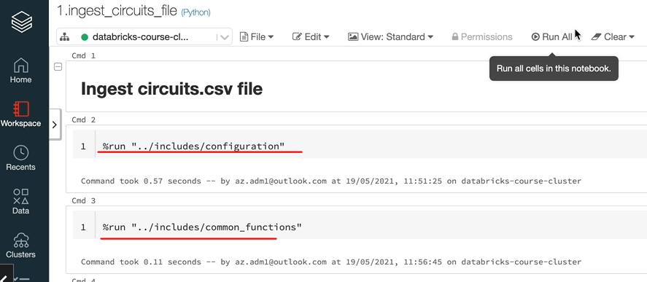

%run "../includes/configuration"

%run "../includes/common_functions"

You can combine it with anything else. So make sure you are putting a %run in individual cells. So next thing I'm going to do is to update all my files to use these run commands as well as the function that we've written. But without this changes, our notebooks work. We know that. But it is better to go and update them and that will give you a bit of experience doing this, even though you like to do it eight times. But if you do run out of time, I'll make all these books available so you can just use those notebooks.

### Passing Parameters to Notebooks

We are going to look at passing parameters to Databricks notebook's in the last lesson we established that the %run command gave us the ability to reuse code. In a similar manner parameters help us use the entire notebook. For example, if you're processing data from two different sources with the same characteristics, instead of writing two different notebooks, you can write one notebook and send the data source name as a parameter and tell that against the data in our project. Let's assume that we can get the data a from the esgast API, as we discussed before, or from the official Formula One website directly. We want to process both data sets using the same notebooks, but want to store the data source name against the data so that we can identify the origin of the data for any exploitry purposes. In this case, you can parameterize all our notebooks with the datasource name as a parameter and send the value at runtime. Widgets in Databricks help us do that. So we spoke briefly about these earlier, but let's implement this in our project to make our understanding a bit more firmed up.

Here we are in our notebook for ingesting the circuits file. Let's start by looking at the help for our widgets utility in Databricks. OK, as we discussed before, you got a number of options, you can create a combo box and drop down or multi select or a text widget, but let's go with a simple one, which is this text widget. And for that one, you give a name of the widget and then you give a default value. And if you want to have a label, you would give a label as well. But in order to get the value from the text itself, we can use another method called get to the method, get you, give the name of the widget, then it will give you the value that's been passed in.

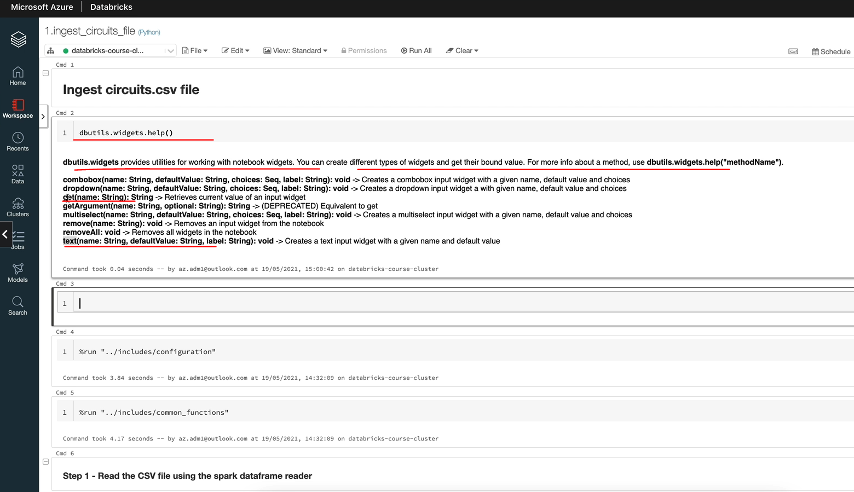

So let's see how we use that. So I'm going to define the widget here and I want to call this one p_ datasource, p here is for parameter. For the default value, I'm going to leave that as blank. So that means now you will see that parameter appearing here. And the next thing we want to do is we want to get the value of the parameter into a variable. So, again, I'm going to call the variable name as v_data source. And in order to get the value being passed in, you want to use the get method in dbutils.widget. OK, so with that now, the variable is going to have the value that's being passed in. So if I just defined this as testing, for example, and if I execute that, and if I come here and print the value of v_ datasource, I'm going to see the value as "testing". So for this notebook, we can send in a value and then this will take the value and pass it on. So now that we've done this, our objective here is to take that value being passed in and add it to our output, which is the parquet files being written.

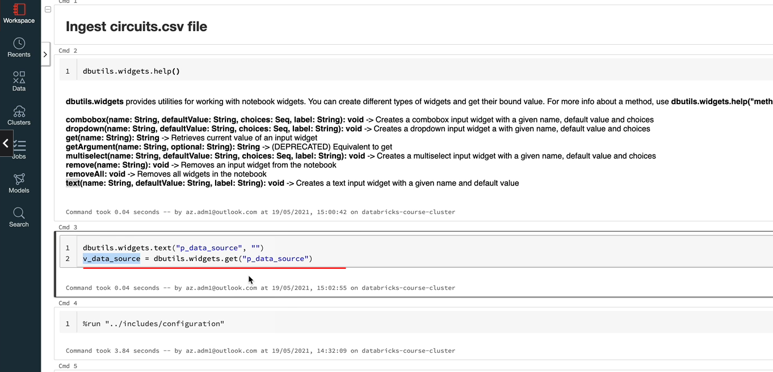

So you can add it anywhere you like. I'm going to put it here where we're renaming the columns. So let's add the width column method to add our datasource. And the value here is the variable being sent in, but as we know, actually the variable is not of column type, so we can't use that. In order to use that, you need to use the lit function. And we're going to import that as well so that it works.

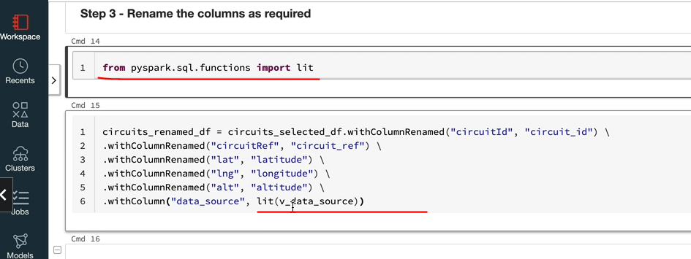

That'll be pyspar.sql. functions and import lit. Let me go over this one more time. So v_datasource is just a text variable, but in order to add a column to a data frame, you need to convert that to column type and then you add that. So a lit basically gives you the ability to convert a text into a column type and then you can add that to a data frame. So now that we've done this, let's run this through. So let's have a look at the columns being added here, as you can see, we got DataSource as well.

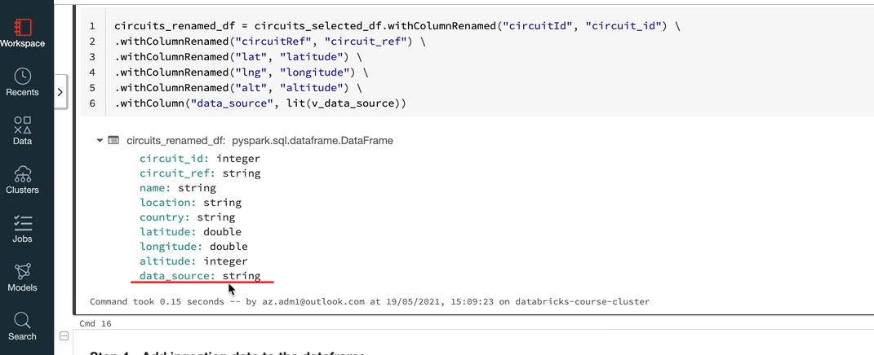

So let us quickly read the data back and we can see what's in the data. OK, as you can see, we got the new column datasource that's being populated with the value testing that we sent in to the notebook site runtime, you can send whatever value you want to this notebook and it will populate that into this additional column here. I would encourage you to go and make these changes to the other seven notebooks here.

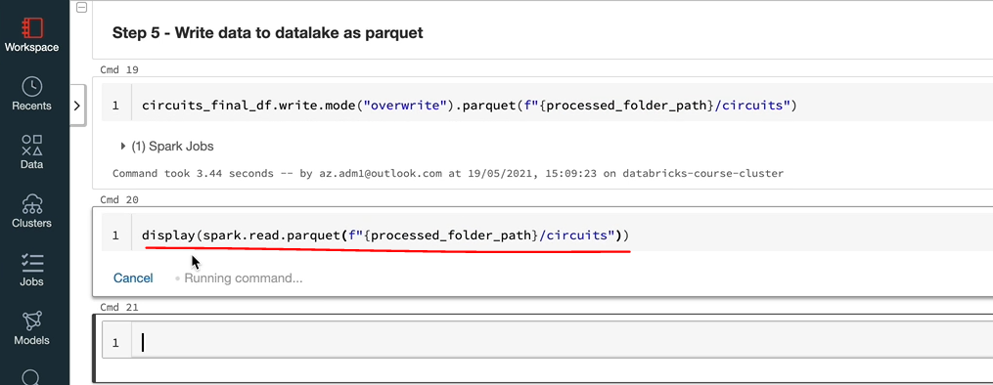

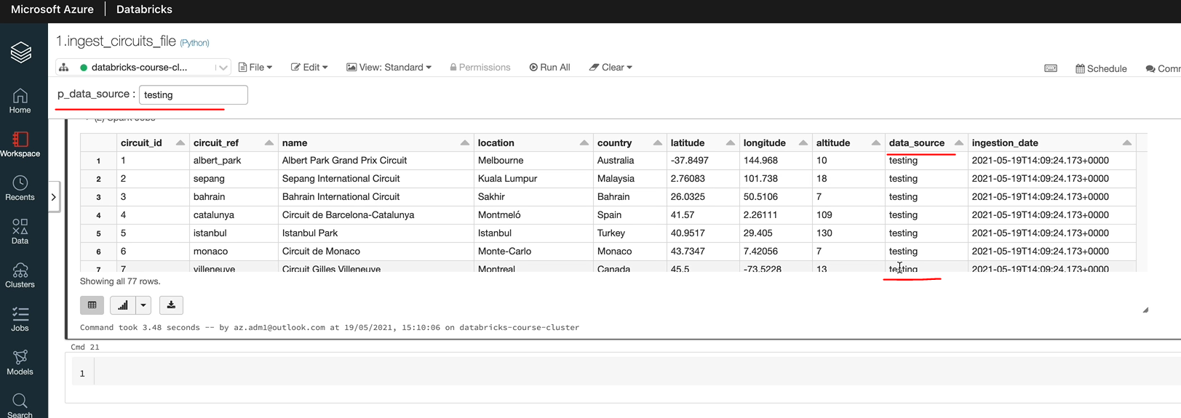

But I do appreciate that actually there are seven notebooks to do the changes to and it will take a bit of time. So if you are short on time, I'll provide all the files and you can download them and take them from here.

### Notebook Workflows



Now that we have eight different notebooks and so far we've been running them by hand, you might be wondering how they're executed in production scenarios, databricks offers jobs that you can schedule to run at a specific time, a regular interval, which is great, but it lacks a lot of functionality that you would normally get with any kind of scheduling tools. For example, you can't create dependencies between jobs to address that databricks offers utility a notebook utility, which lets you create notebook workflow. We are going to look at that in this lesson. Having said that, if you are in a year, you're not likely to be using data to create workflows and scheduling jobs in production due to its inferior functionality. Azure offers a much better workflow tool called as your data factory. And that's what you will be using. We will cover the important aspects of your Data Factory later in this course. It won't be a full blown Data Factory course because it's too broad, but we will cover the important things which are required for this course. But I would also like to take you through the notebook workflow and database jobs so you can create quick jobs for testing are one of workloads without having to use Data Factory. So in this lesson we look at the notebook workflow, as we said, and in the next lesson we'll look at databricks jobs. So let's get started. Here we are in the database workspace, so let's create a new notebook.

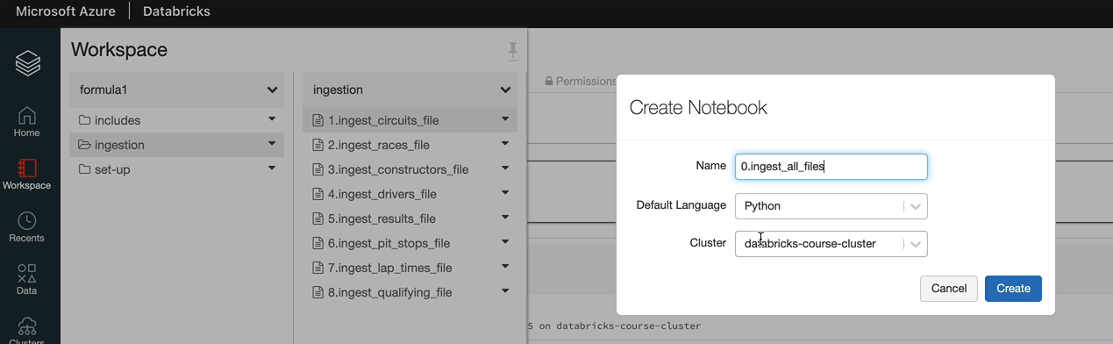

And there in addition and I'm going to call this one as zero dot in just all files. And we want to have a python, the default language, and attach to the cluster and click create. So we're going to use the dbutils.notebook.help. So let's look at the help for that one. As you can see, it's certainly got two methods.

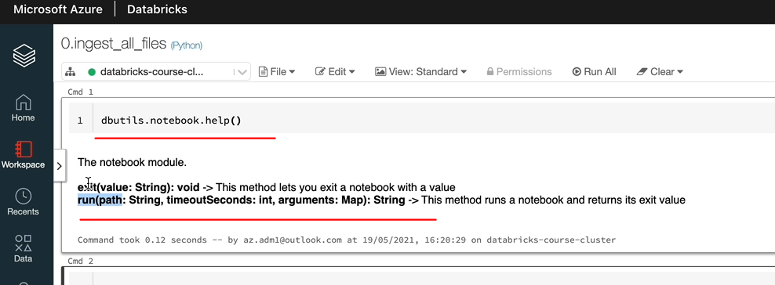

One is a run for which you can send a notebook name and the timeout in seconds, and if you have any arguments, then run that and the other one is to send an exit value so you can use to run to run a notebook. And the notebook being run can use the exit to send back a value. So first, let's use the run method to to invoke our in the sacred file. And let's specify zero, which is the default value, so it doesn't time out at all, and we want to send in an argument. We have the argument, which is our data source, which is called PPI, and it's called data source. So that needs to be sent as a dictionary. So our argument name was p_data_source and let's give the value as ergast API, because that's where we're getting the data from and let's run that. And as you can see, it ran as a job, notebook job, and it took 18 seconds.

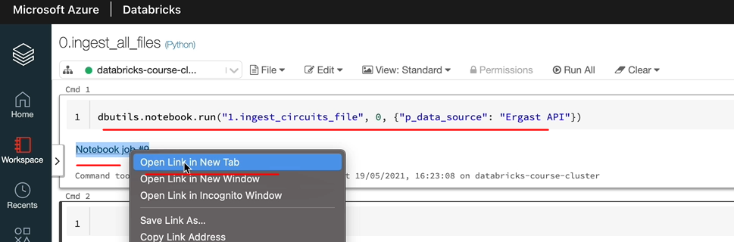

So let's open this up. I'll open it in a new tab. And let's go through, as you can see, these things have succeeded and the parameter being passed in is ergaster API. So hopefully that's going into the data as well. And all of these have succeeded.

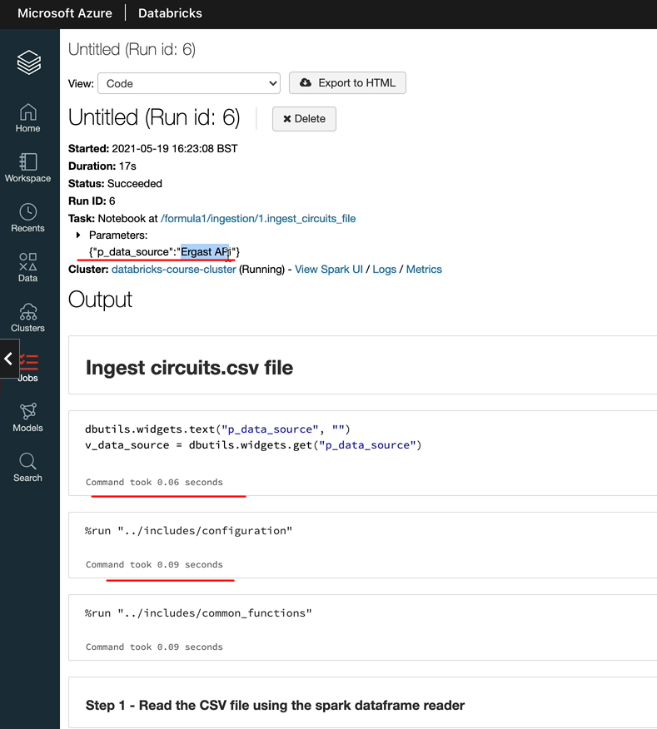

And as you can see, the final output is also looking good. So we got a API in the data source as well.

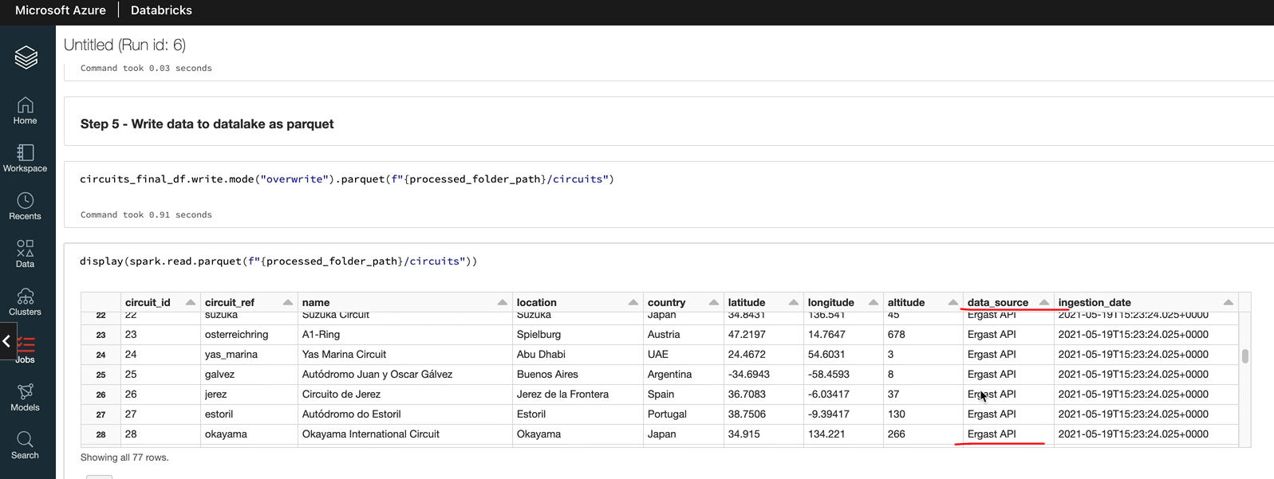

So that's kind of work. But one thing you may notice is if that has failed, then you've got nothing to tell us that actually there is a failure. So what you can do is you can add the dibutyl exit command to the existing status, to the other notebook. So let's do that. If you come over to the workspace and we need to do that in the notebook being called. I'm going to open this in another tab. The shortcuts are if you are in Mac, control and then click enter. Or if you are in windows, you control and then click enter, it's open in another tab here for me. So I've got a couple of taps open.

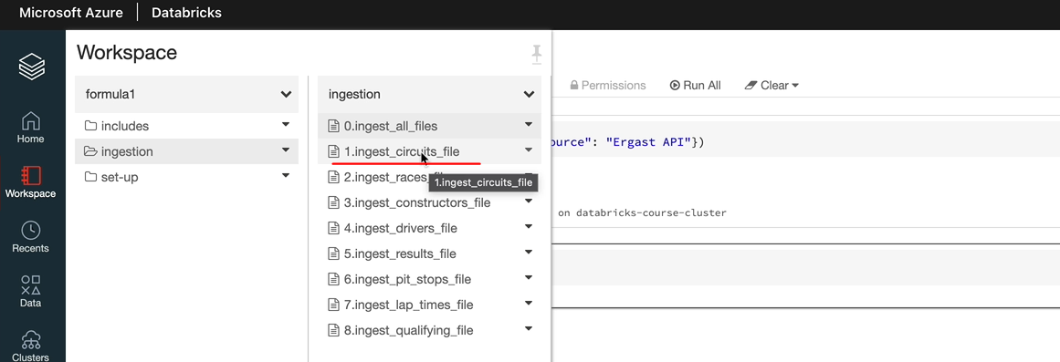

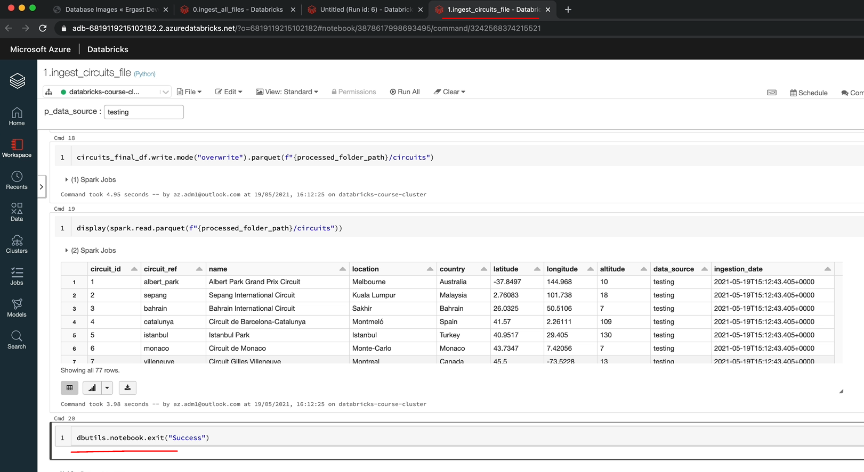

So what we want to do is the last statement here as dbutils.notebook.exit("success"). And I'm going to send out an exit command of success. So if it succeeded, then you're going to have the value success, otherwise it'll be blank. So we can close that now and I'm going to call this and capture the value in a variable, so that could be v_ result equals, so it returns the value that's going to go into the variable result. So let's execute that again.

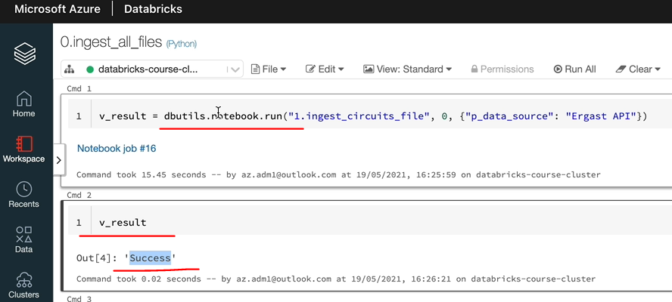

So let's print the value of the v_results, as you can see, that is success. So what you can do is if you want to read the next notebook, onely, if this is succeeded, then you can write a statement saying if we and the result is success, then carry on. Otherwise you can fail here. So in case of ingestion and then if you want to do some transformations and then make it available for a presentation layer, you could say one day when all my ingestions have succeeded, I want to do the transformation so you can capture the exit code and then execute the following notebooks only based on the condition there. So that's how it works. So I'm going to put all the other notebooks in here now. So that's all done now, so let's just execute this, I'm going to do it, and also it's supposed to execute all our files and we should see the results after that is right. OK, that's completed now, but I haven't got the results of success with the other ones. That's because I haven't added the zip code to other notebooks. So I'll quickly go and add them and then we can come back and get. OK, so that's now completed and success for all of the notebooks here.

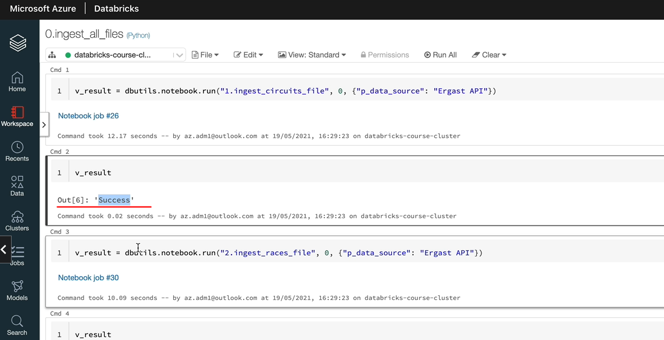

So this is how you chain your notebooks and they run based on dependencies so you can have dependency on the outcome of one notebook execution for the next one. So one thing you may have noticed is the execution of the second notebook waited for the first one to finish in scenarios where actually you might want to run them in parallel as well.

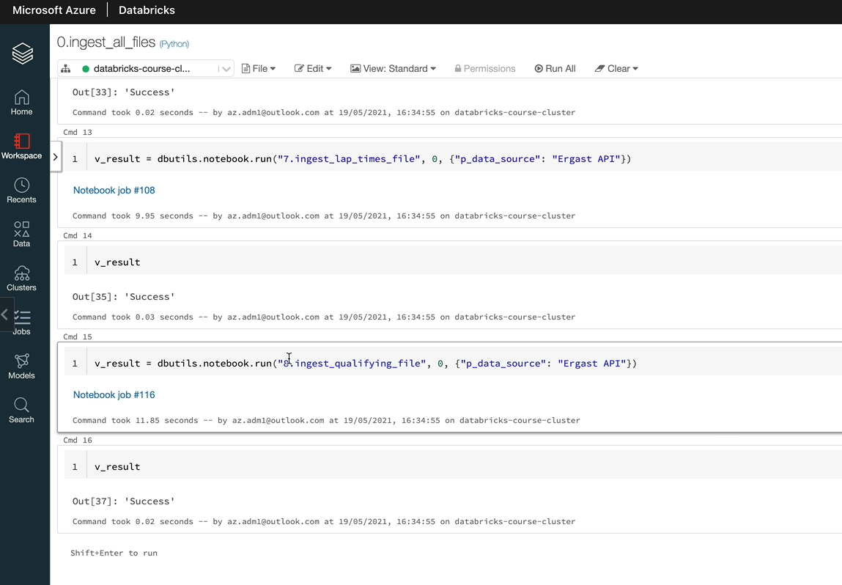

So you might be wondering how how do we do that? So Databricks gives you the ability, but that is basically using the python construct, such as threats to do it. And let me pull up the help for that one here. So this page has got the implementation on how to run multiple notebooks, so there is an example as well here. So I would like you to go and have a look at that. As I said before, generally these kind of things are not done in databricks because of its limited capability within the scheduler itself.

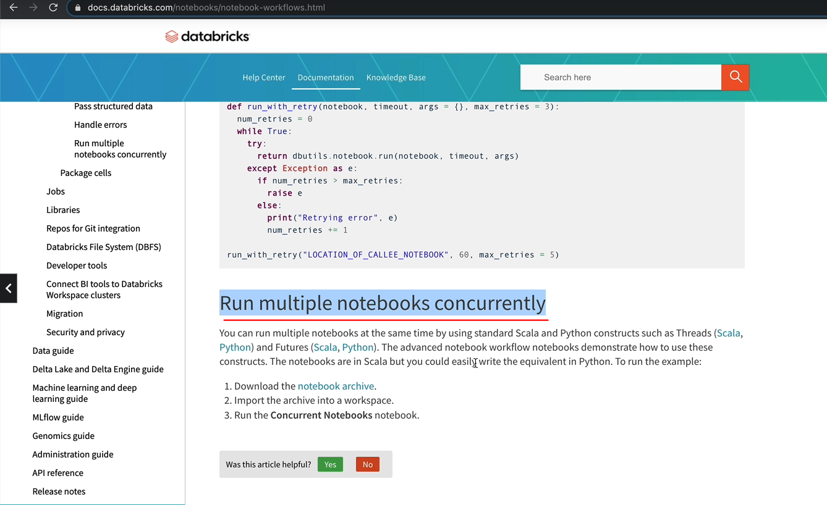

You'll have to write Python code like this in order to achieve execution, concurrent execution and things like that. So instead of this in a production scenario, you would go to as your data factory, because that gives you a rich set of capabilities, like you can execute things in parallel. You can have different types of clusters for each one of them and all of that kind of stuff. So we will look at that later. But I just wanted to say to you that this is possible and there is an option here. I leave the link in the useful links section of the course for you to go in and investigate.

### Databricks Jobs



We're going to look at databased jobs, basically jobs, let us schedule a notebook to run at a specified time at regular intervals while creating the job, we can specify a number of options, such as the cluster type we want to use, the parameters to be sent to the notebook, etc. Let's switch over to the databricks workspace and explore the options, as well as create a job to execute our ingestion notebooks in order to create jobs. You come over to the jobs I can hear and you can create a job from here. Click Create job and we need to specify a job name. I'm going to call mine as F1 Ingestion. And you need to specify the configuration for the job, so you've got a couple of options for the schedule type so that you can set it to manual. So that means it won't run until you go and run out to execute it. And schedule is to schedule it to run a specified time. So it can be every day, every hour or every minute or month or whatever you want to specify, you can specify that and then it will run at those intervals. I'm going to set mine to manual because we're going to just run it once. And you specify the task details here. So the first thing we want to do is to pick the notebook. Let's pick a notebook from our innovation pipeline. We probably want to run the in just all files, but I'm going to show you how to put in a parameter value because this one has got parameters. Let's pick this one, which is the circuit file and click confirm.

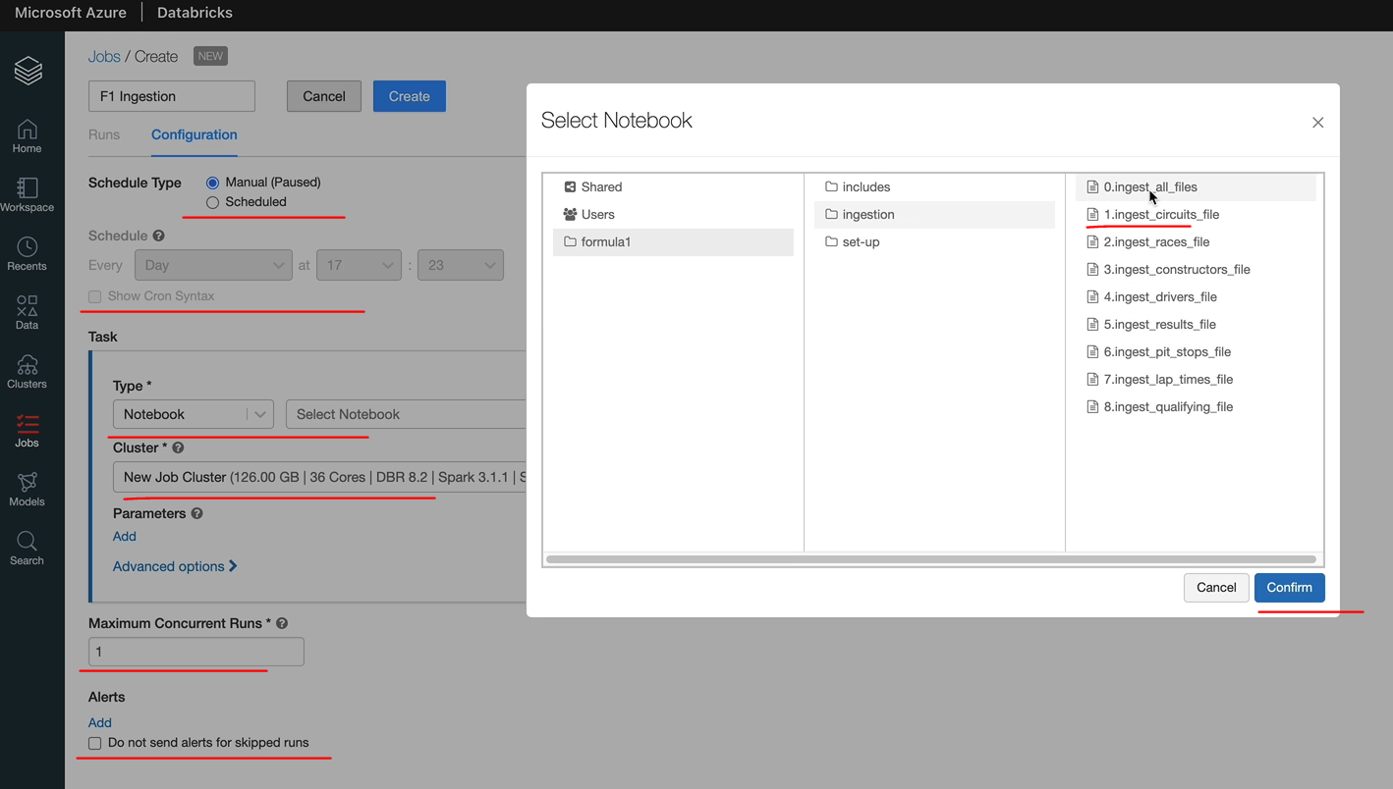

And in terms of picking up the cluster, you can have a job cluster or an interactive cluster. So we already created the interactive cluster and we can run things in there. We've already done the interactive cluster as part of our work, so let's pick a job cluster. But we don't want to have one hundred and twenty six gigabytes and 36 cos it's too big for our work. So let's click, edit and let's pick the single node cluster because that's the only one people on Tier can use. But others, if they want to use the standard cluster, you can pick the standard cluster. So let's pick the single node cluster and we are using version 8.0 for this course, but you can pick 8.2. I don't think it makes any difference. And we want to specify the node type so similar to what we did previously for the All Purpose Cluster. You've got all the options. So I'm going to go with the default DS3_v2 with 4 cores.

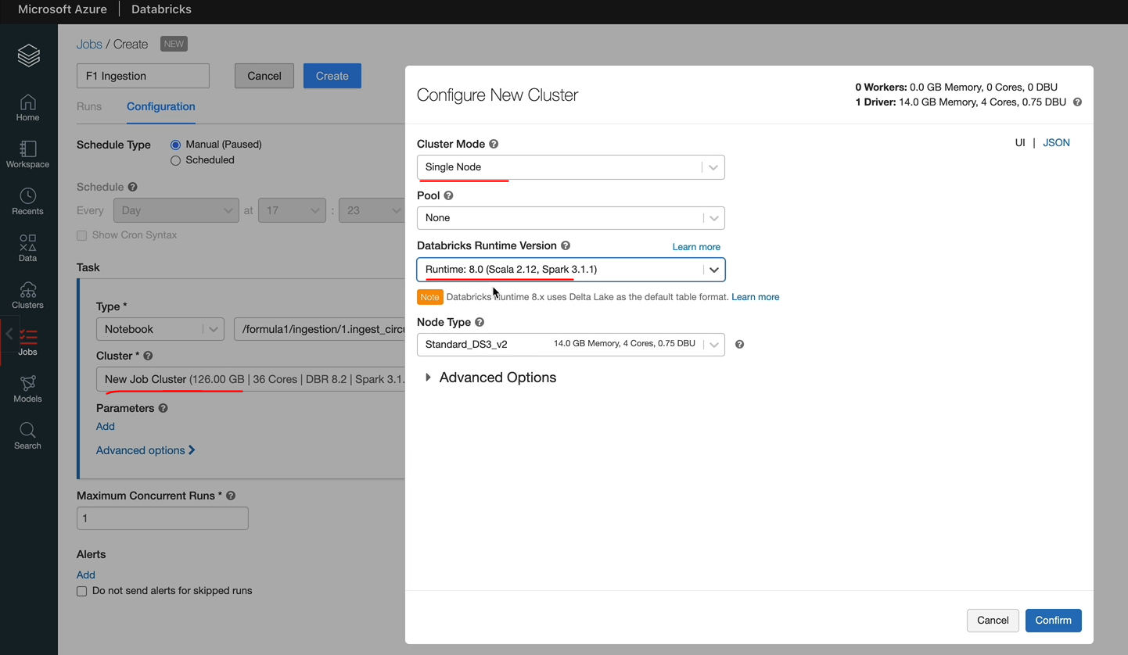

And you've got the advanced options to specify these Spark configurations and things like that as well, or any scripts you want to run as part of the classic creation and things like that. So let's click confirm. So we got the cluster detail specified. Now we want to add the parameters, so for this one, as you know, we got one parameter, which is called p_data_source, and we want to specify the value. So I'm going to call it as EApi just to give it a different value to what we've already done. And the next thing you've got is advanced options.

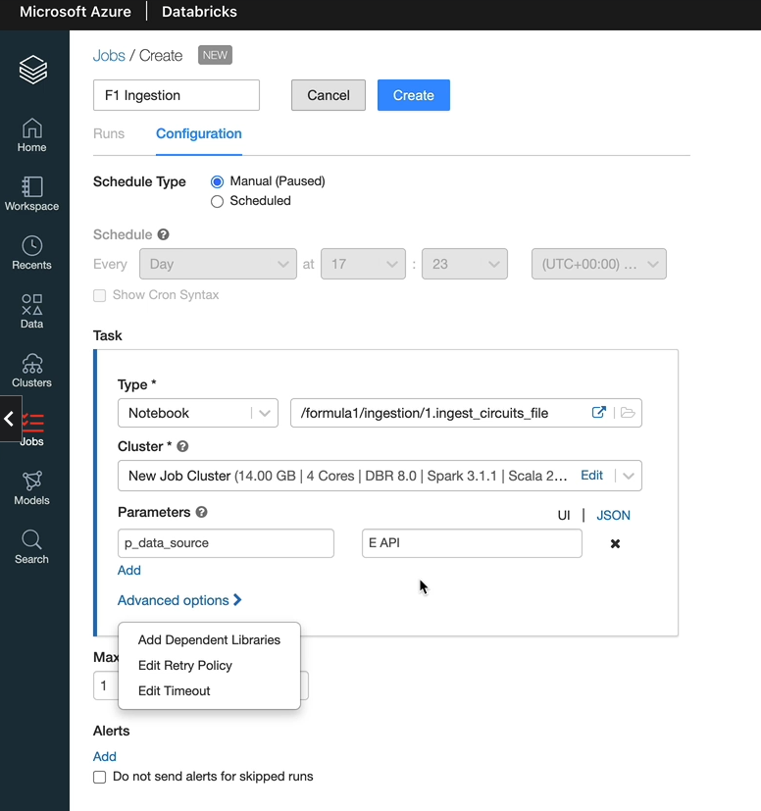

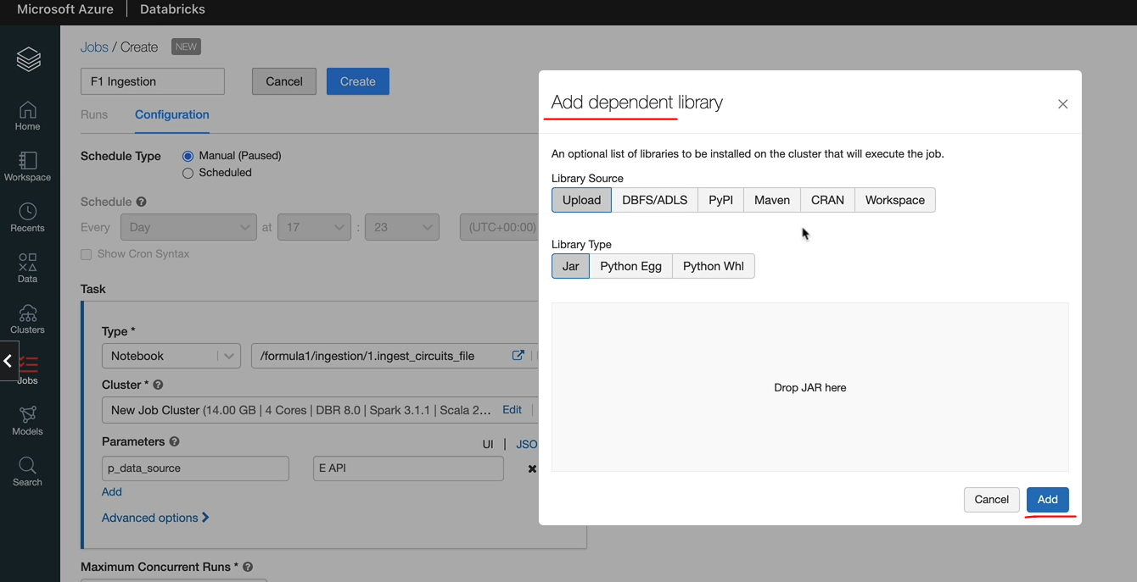

So you can specify an independent libraries similar to what I showed you as part of the interactive cluster. You can pick up a library from any of these sources and any of these types and get them deployed as part of the job creation. And also, you've got retry policy so you can specify how many trade price you want to you want to do. So one time will be two items. So if it fails, it's going to try one more time. Otherwise it it'll just go with what you specify in here. I'm going to leave it as no retries. And the last option is any time out. So you can say, actually my job is running for, say, over a certain number of seconds. I want a timeout so you can do that. The default is zero.

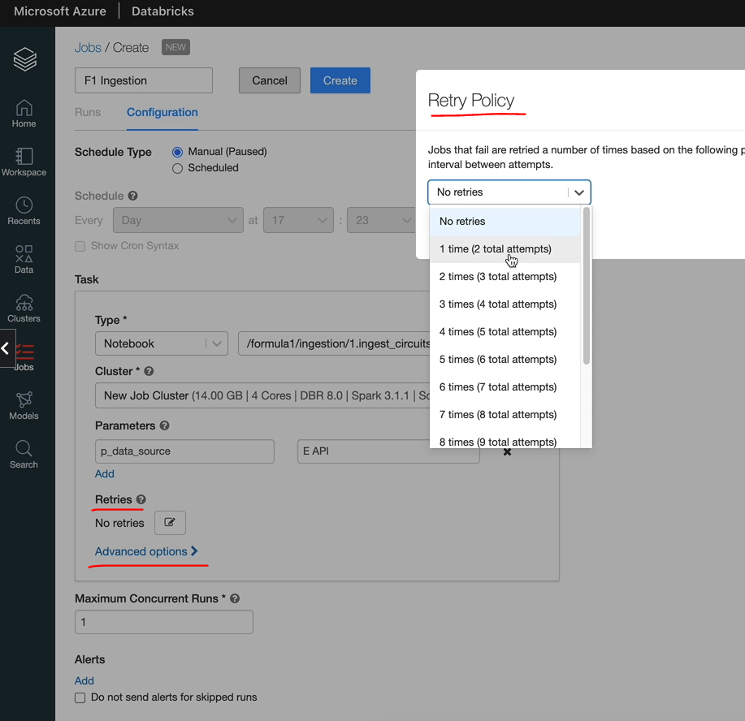 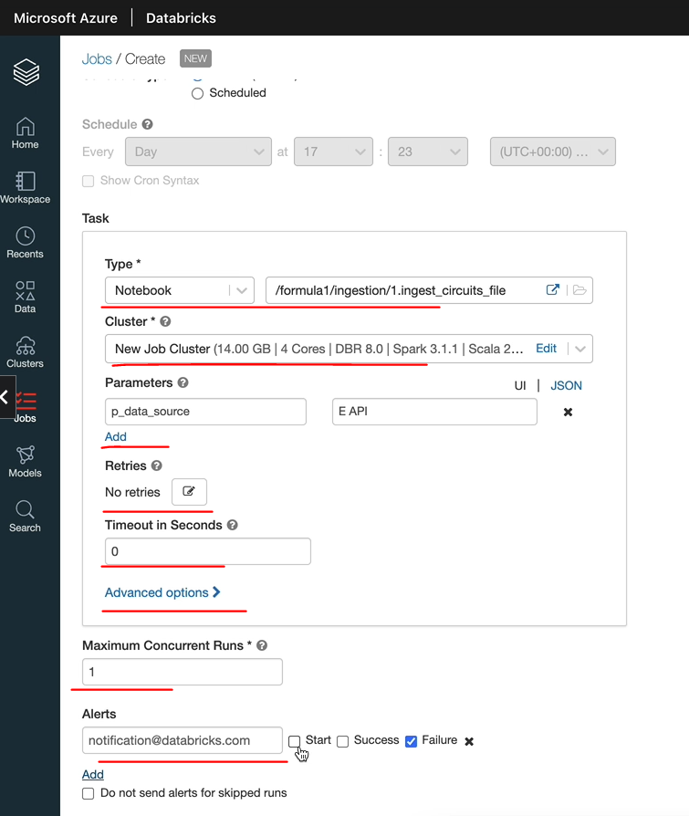

That means it won't time out. So I'm going to leave the default as it is. Right. And here you specify the maximum number of concurrent runs. So how many concurrent runs of this job is allowed will leave as one. And if you wanted to add any alerts, you can do that so you can send an email to yourself on a startup success or failure of the job as well. So we've done everything we wanted to do and let's click on Create and that should create the job and leave it at Post State. So let's go to the Arun's and then as you can see here, there are no runs for this job, but you've got the option to run it now. So you can change the parameter values at runtime if you want to, but we don't want to do that in this case. So let's click on Run now, and it should spin up the job cluster and it should execute the notebook and give us the results as well.

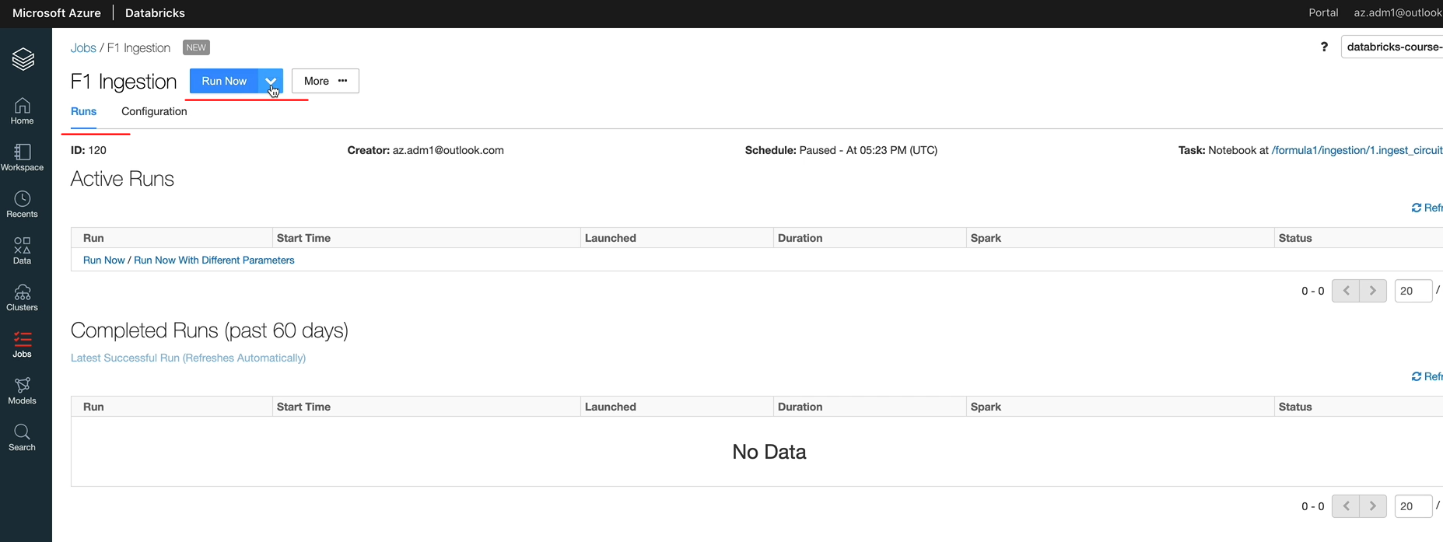

As I said before, as part of the cluster lessens, job clusters are cheaper than All-Purpose or interactive clusters. So whenever there is an opportunity to run a job, go for a job cluster because that's cost efficient for you. So let's click view details to look at the details as he can see its provisioning the cluster now. So it'll take about four to five minutes to provision the cluster and it'll execute the notebook for us. As you can see, the execution has now completed and it's moved to the completed run. So let's have a look at the details here. And that. We sent in the data, so says EApi, rather than Ergast, just to see whether that managed to go through.

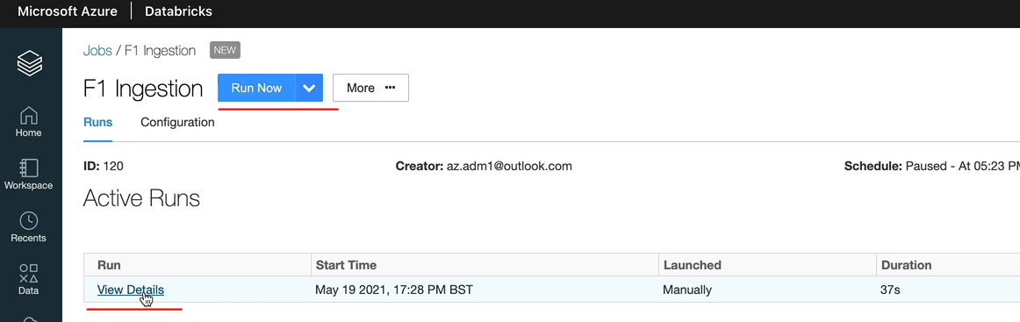

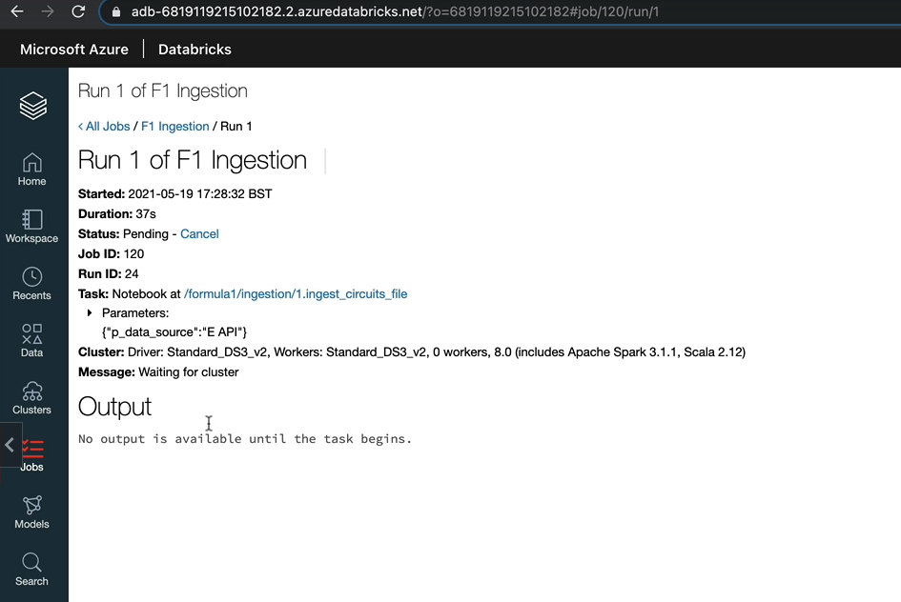

And also, as you can see, it's done everything it's supposed to do. And Notebook's exited with a success code. And we got the data source as EApi as well. So that's brilliant. When you click back on the jobs, it's going to put you in the screen where you'll see all the jobs you've created and the last one is here succeeded ( image below ). But in order to see any history, you can go into the job and then look at the previous trends.

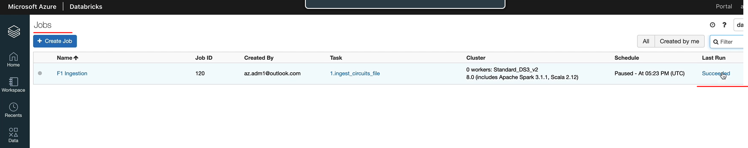

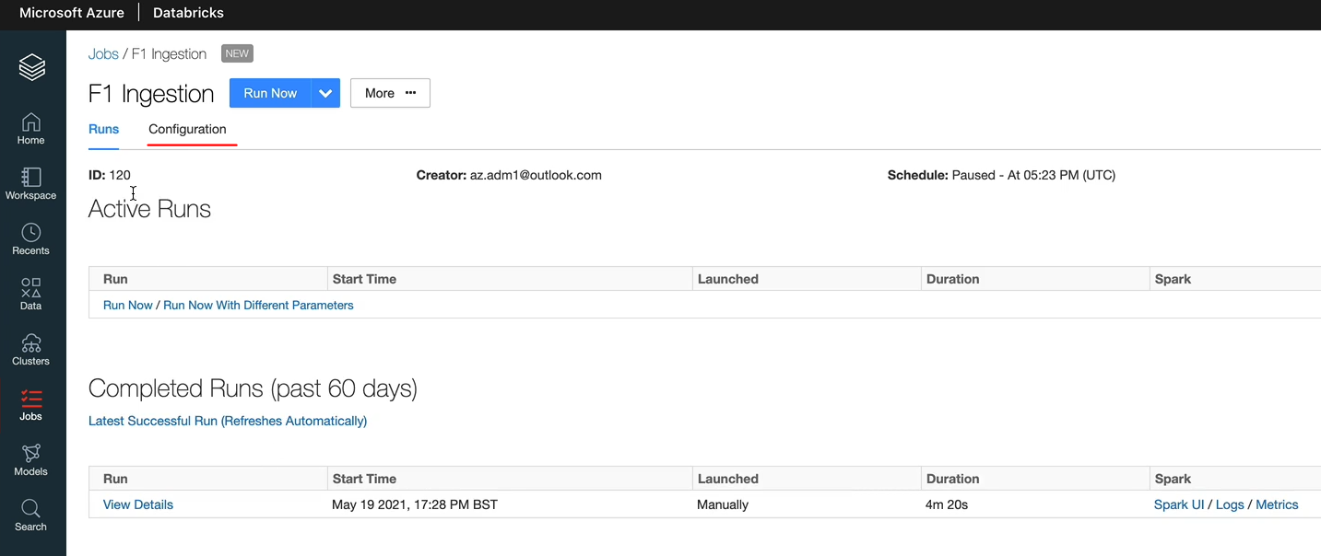

And if you wanted to change the configuration, you can change that and then you can update it. Let's change our configuration to use the notebook we intend to use, which is the in just old files. And I'm going to click confirm on that one. And for this one, there is no parameters to be sent because the parameter is inside the notebook. But if we want to be good parametrized, that is bad. And let's click save. And then I'm going to click run now and it's going to execute the job for us. And that job's now running. So again, that take about four to five minutes to execute and then we can come back after that. OK, so that execution has finished as well. It took a bit longer because we've run eight notebooks within that job. So that's that's brilliant.

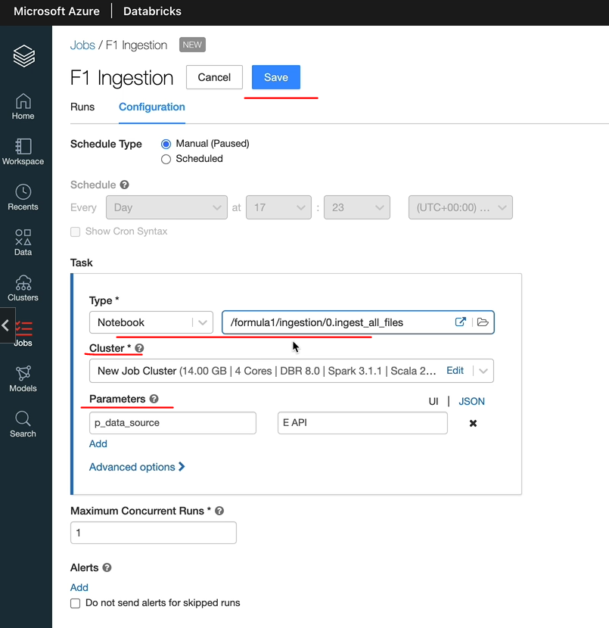

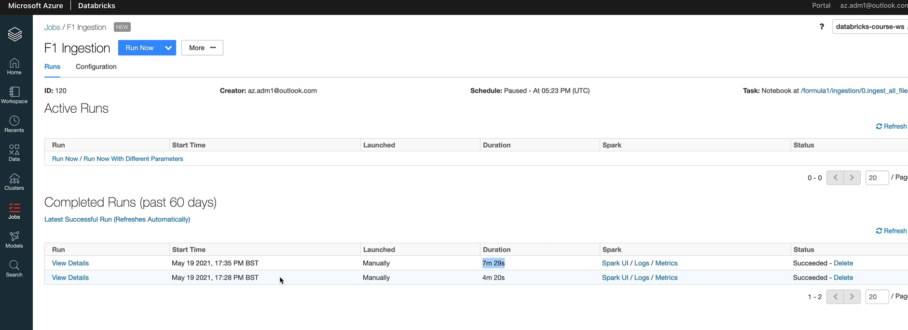

But before we finish, I want to just show you one more thing you might be wondering. It's running on job clusters, where are they and how do we see them? So if you switch to clusters, we got the all purpose clusters. That's what we created earlier. Mine's terminated because I've not been using it.

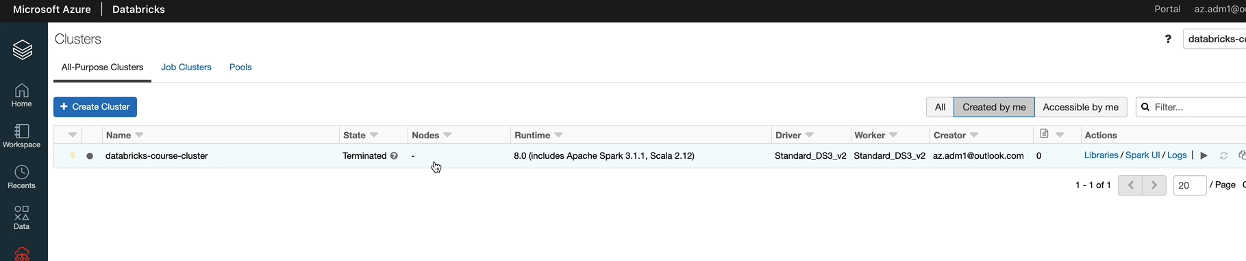

And job clusters you would see them under here. So as you can see, we got two runs and both of them have got separate clusters for those.

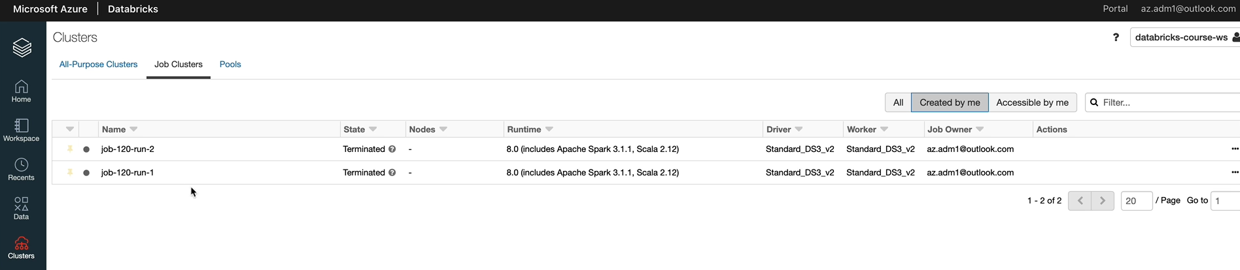

If I go into one of them, as you can see, there is no option to start your cluster.

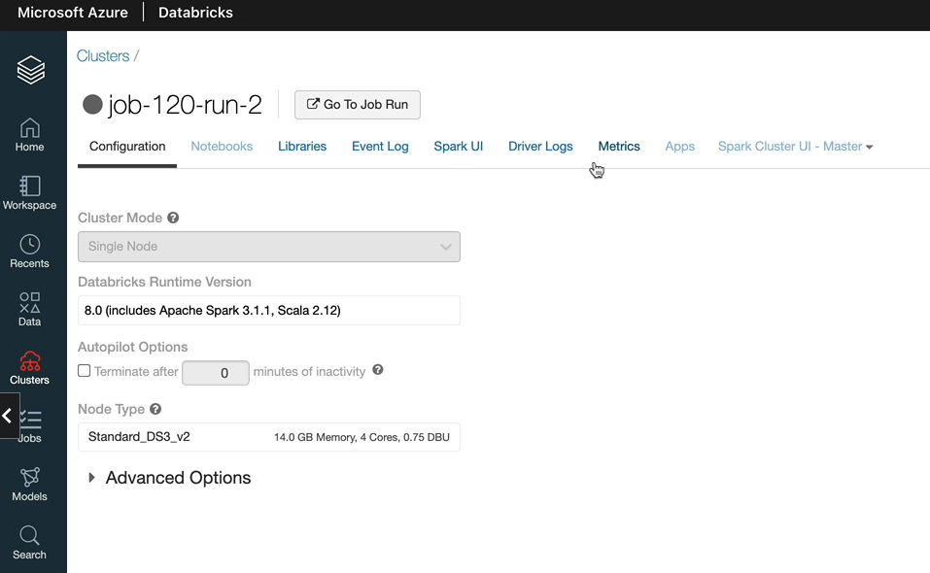

So when you have a job cluster, it gets spun up and the jobs run and it gets terminated and you can't go back and restart a job cluster. We went through this before, but I just wanted to show you how they looked. And if you wanted to see the execution of the job, you can navigate it from here as well.

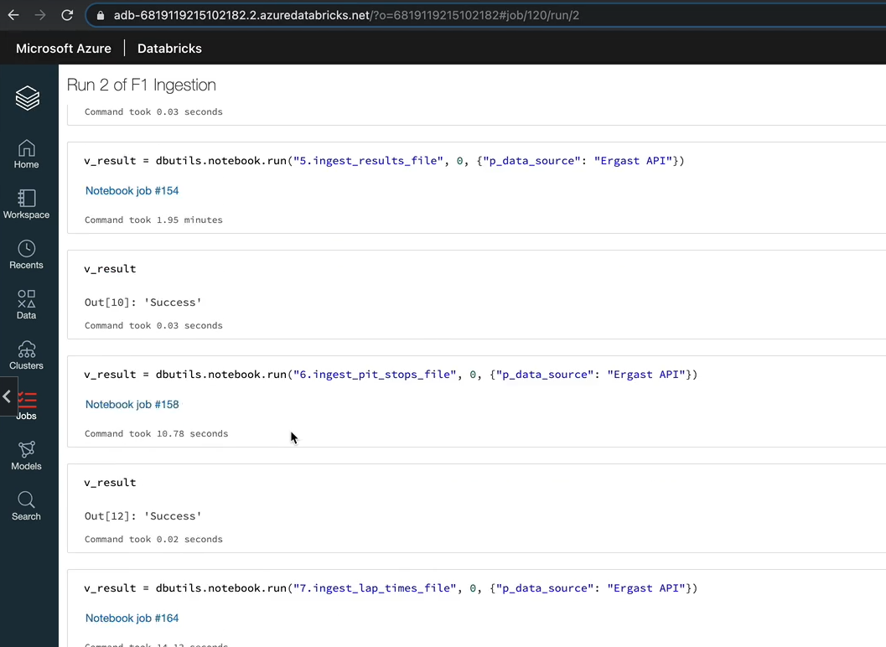

So this is kind of what we saw previously and this is the executions here as well. So I hope that's given you a complete picture of database jobs and the clusters and how they all hang together. And also, they're not the workflow which we went through in the last lesson.

## Filter and Join Transformations

we are going to focus on two of the important transformations in Spark. It's more likely in any data project that we have more data than we need and we need to filter the data required for us. Spark gives you the full transformation to achieve this. Similarly, the data received usually is spread across multiple tables of files. We would have to bring them together to make sense of the data and obtain business value. Spark provides a rich set of joint transformations to achieve this. We're going to learn about these two transformations once we have learned about them.

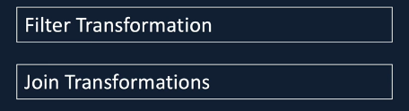

We'll put them into practice in our project, will bring together data from five different tables to create one table that could help us with analysis and reporting further down by the end of this section. I hope you will gain a good understanding about Felter and join transformations and also the scenarios in which to use a specific type of joint transformation

### Filter Transformation

We may want to get only the data related to current tax year over the last three tax years. For example, if you're familiar with SQL, this is same as using the where clause. Spark gives us the full transformation for exactly the same reasons. Let's start with the documentation and then I'll show you a couple of ways of writing the filter transformation. You'll find the documentation for the filter transformation in the Dataframe APIs, this is the same as the where clause in a SQL statement. So Spark also gives you an alias so you can use where instead of filter if you want to use. And it gives you the rows that satisfies the given conditions. It just takes one parameter and it filters the data depending on the conditions specified there. So here are a couple of examples.

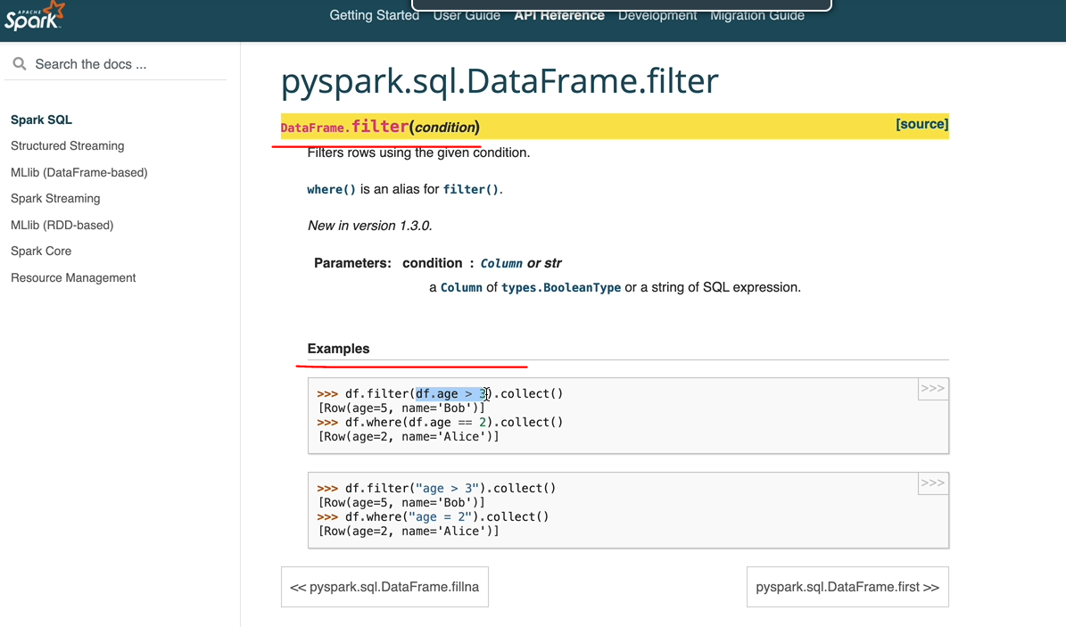

As you can see, this is the kind of Python way of doing it, the age greater > 3. Or you could use the SQL syntax like you would normally use in a clause like this as well. So you've got both options to do. Let's switch to a notebook and write a couple of conditions to see that in action. My cluster is not running, so I'm going to quickly start that up.

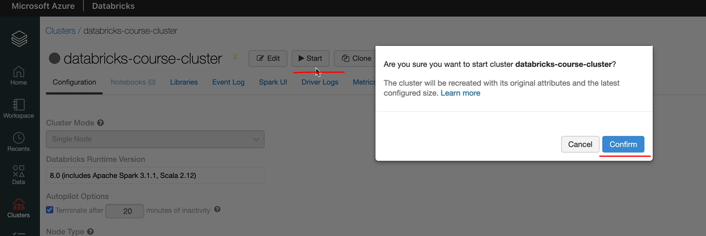

And. What I have done is I have created a folder called 1.filter_demo, and then I created a notebook just to save a bit of time, and that's called 1.filter_demo. And I've included the configuration here. So that means we can use the folder parts, which we've specified in our configuration.

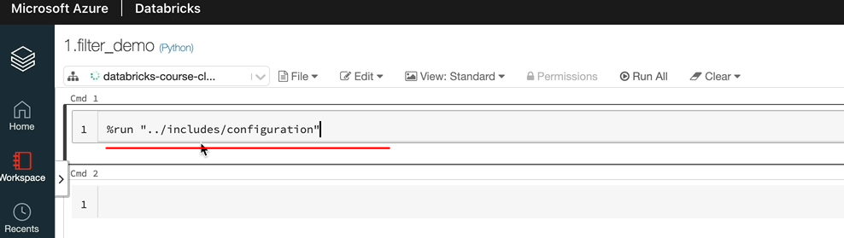

So the first thing we want to do is to read some data. So what I'm going to do is I'm going to read data from a racers file. It's got a column as well. So I'll show you how to do filters on here and also I'll show you how to do filters on a couple of conditions as well together.

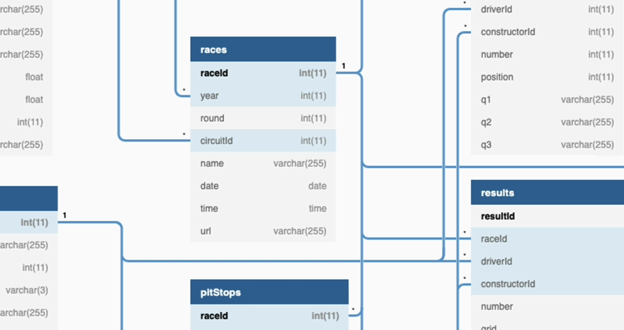

So let's switch back and I'm going to read the data first into a data frame. So the cluster is now up and running, so let's give these statements. And I'm going to display the contents of the data frame as well. As you can see, it's got 1000 records here, so I think it's about 1000 records in this file, which includes data from every single trace.

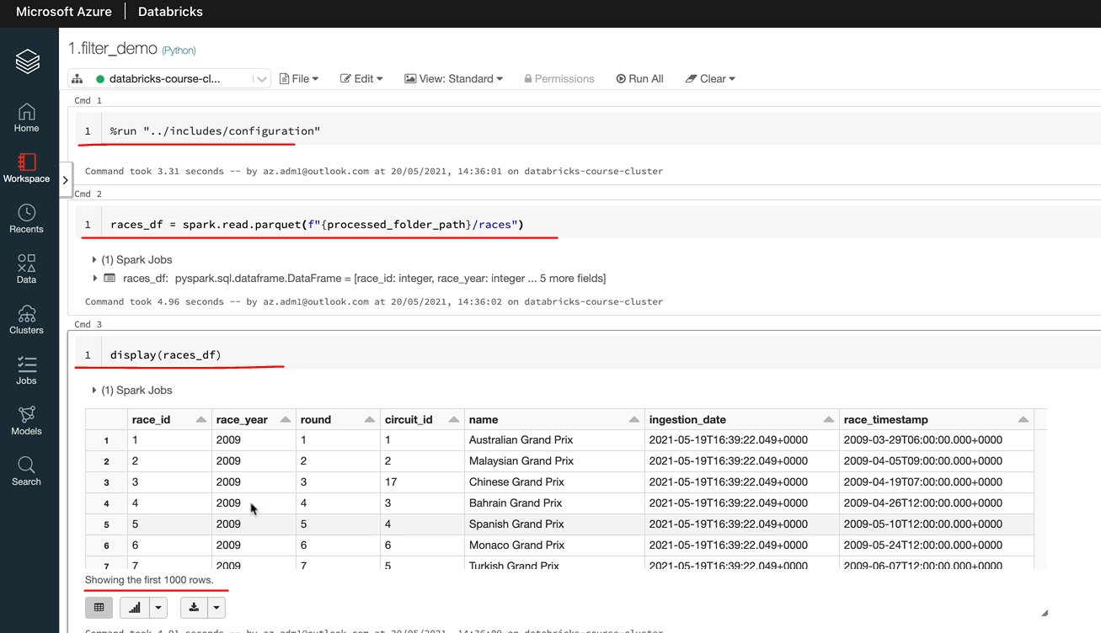

But let's assume that we only want to get data related to 1 of the races. So the way you do that is you can either specify the filter on here or I'm going to create a new data frame, I'm going to call this one as races_filtered_df. and that's going to be reading data from this data frame. And you need to specify the filter condition here. So as I said before, there are two ways of doing it. I'll show you the SQL way. So the first SQL way is actually you can do last year equals 2019, let's say, I pick to 2019 because 2020 was one of the weird ones because of covid. So let's pick 2019. I think we would see about 21 records because there were 21 races that year. So, yeah, so we've got the 21 races that happen during the 2019 year here.

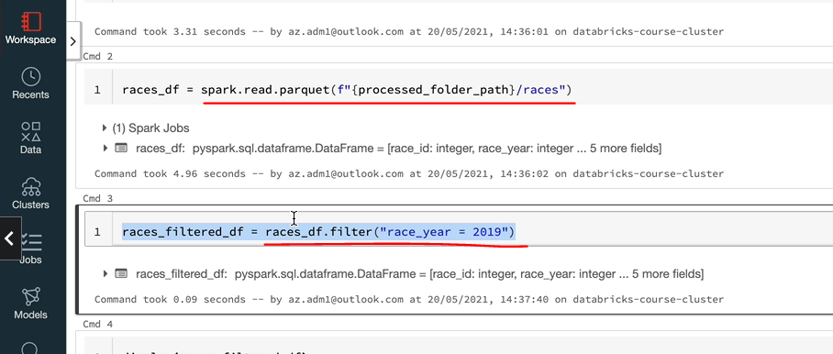

So it is as simple as this just to specify a fault condition. And I'll show you how to do the first condition you a kind of Pythonic way. So you would have to use the data frame name here. So as we discussed before, when we talked about Selecta, there are a few ways of refereeing a column in a data frame. So that's kind of what you would do. So you can either go for the dot notation or you can go for the square brackets and double code for these.

And because now we're in Python rather than SQL, because they specify the calls to get the equal. So if I did just "=" it won't work because it's not really valid in Python. So you just do double equals "==" and then that should work now and give us the same data, which is 21 records.

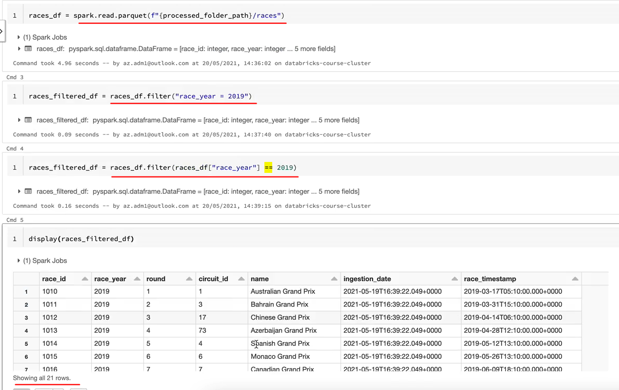

So now let's look at how to specify multiple conditions, so let's assume that I want to pick one lady records from the first five rounds so I can say and round <= five. That should give me the top five records here. And if I look at the data, as you can see, it's brought back to 5 records from that date frame. OK, let's now apply that in the python way, so here you can use and you'll have to use & for and "==" the "|" symbol for or. And similar to what we did before, we need to refer to the column via the date frame. So one more thing you need to do is to enclose these in brackets because they are separate conditions.

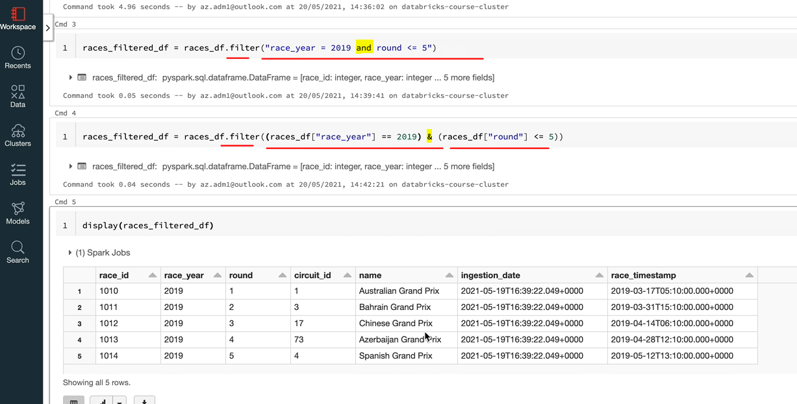

So if I just do this and this, and now if you execute, you'll get the same results here. So a few things to remember, if you want to go with a cycleway, you can specify the condition, as you would specify, in sequel. If you wanted to do it this way, you need to refer to the date frame notation and also you need to use the python and our ( "&" "|" ) conditions and things like that. And if you have multiple conditions, you need to put them in brackets. Unlike here, you don't have to worry about that. So that's how the filter transformation works. You can change the filter to there and there will be no difference in the results, as we saw in the documentation there is synonymous with filter.

### Join Transformation – Inner Join

We are going to look at the giant transformation, usually the data we need is likely to be spread across multiple files or tables, as we've seen in our Formula One data set was in a number of files too. To take an example, driver, details are in a separate file and race results are in a separate file. So if we wanted to report on the results by driver, we need to join the driver file to the results file. This is where the joint transformation comes in handy. There are a number of joint types offered by Spark and we are going to go through all of those. So let's start with the documentation and then we'll go into the notebook and create the join transformation for ourselves. Here is the documentation for the Join transformation. And as you can see, you apply the joint method on a data frame and the parameters for the method are either which is the other data frame or Sparke that as a right data frame, right side of the joint. And this one is called the left side of the joint. And then the next parameter you specify is the conditions on which you want to join the two data frames. And then the last parameter here is where you specify how do you want to apply the join.

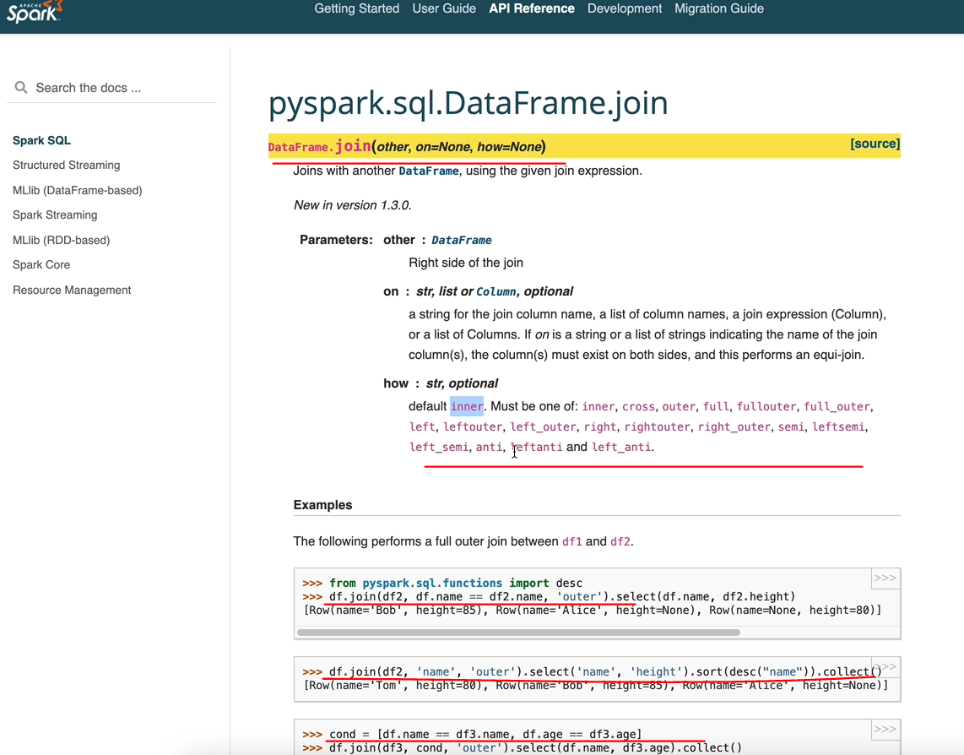

So there are different types of joins here. As you can see, the default is the inner join. Otherwise you've got the outer joins and a couple of variations of that which is left outer, right outer join, full outer join. And similarly, you've got the semi joins and anti joins and the cross joins as well. We're going to look at all of these joins. So let's switch to our notebook. So I've created a notebook again under the demo folder and called it to 2.join_demo. And the first line, I've got the run for configuration so that we've got default parts made available for us. And the next thing we want to do is to read our data. So the two files we are going to read in to be able to join are the circuits file and the races file. So we'll read the processed data because we've ingested all of that data already. So we're going to read the circuits data and the races data and then I'll show you how the inner join works and left outer and all of those joins as well. And as you can see here on the diagram, the join condition between these two tables of files is the circuit_id.

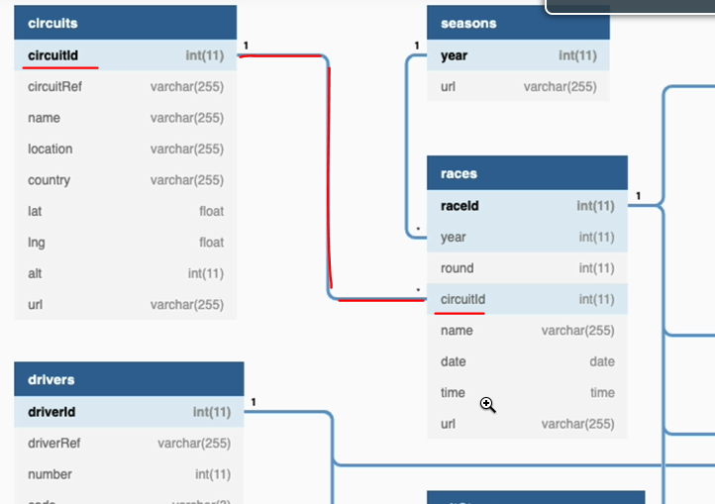

So let's switch to the notebook and start reading these two files into data frames. OK, let's execute these statements.

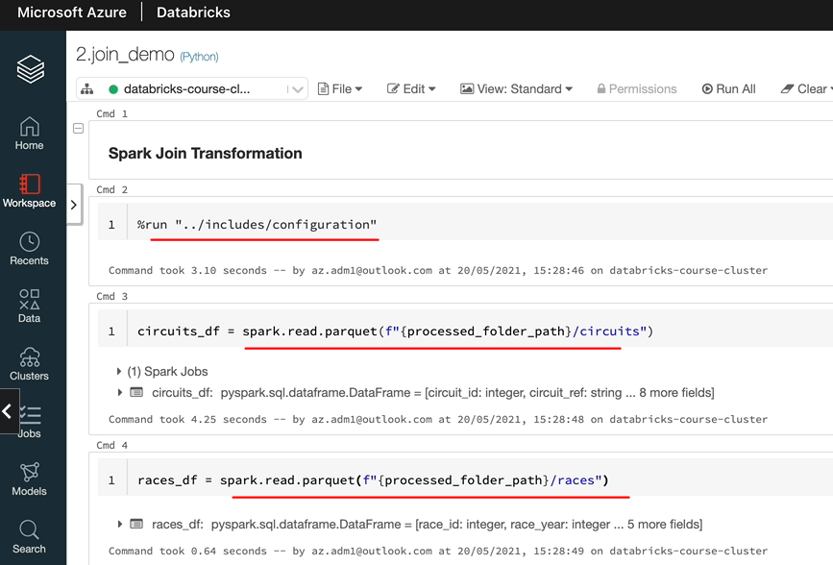

And I'm going to display the data for these data frames so the circuits data frame itself has got only 77 records. That includes all the races circuits around the world. But the races data frame, I'm going to show you that in a minute, is going to have a thousand records, which is not going to be good when we want to do some testing and show you the data.

So what I'm going to do is I'm going to apply a filter here so that we want lose if we want to pull out data for one of these years. And it'll be easier to look at the data when we have them the join. So I'm going to look at the data for year 2019.

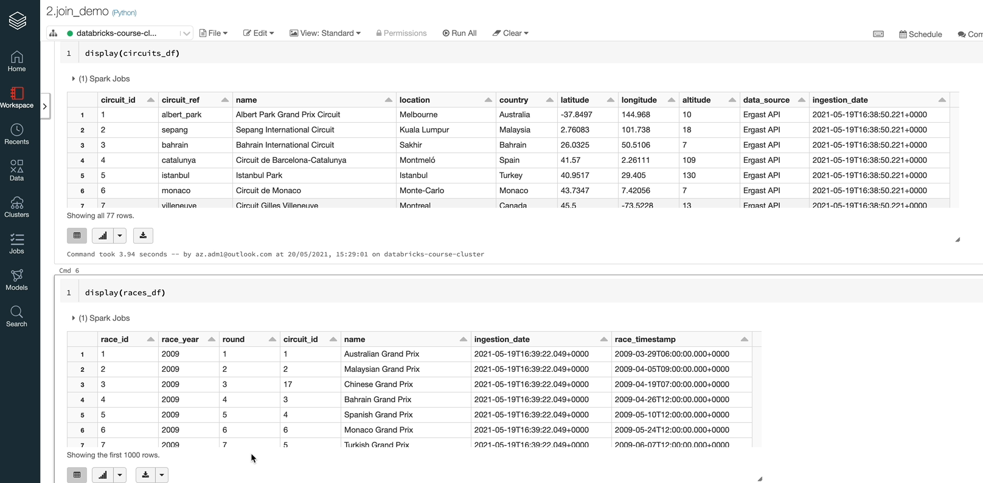

So let's run the display again, and as you can see, it's got 21 record, so that's more manageable. So we're going to use the 77 from here and the 21 from here. So now let's create a data frame to join the two data frames here. So I'm going to call this one as race_circuits_df. And on the left hand side, I'm going to have the circuits_df. And on the right hand side, we lose the races_df. Let's now specify the join condition, which is using the circuit_id. You may have noticed that I've used the double equals because it is the Python syntax and the equals itself in Python is an assignment operator. So that's why we need to use the == if you are looking for equality condition. So the last parameter itself is optional if you want to leave it. But I'll put that in just to make it explicit. It is Inner Join. So the last condition, if you don't specify it's the last parameter, if you don't specify, then it will be assumed as the Inner Join, because that's the default. So let's run this code. So that's gone through. OK, so let's look at the data in this data frame now. And as you can see, we got the 21 record, so what that does is it takes data from this table, which is this, which is the circuit data frame, and uses the circuit daily to join to the races data frame and then gives us back the results.

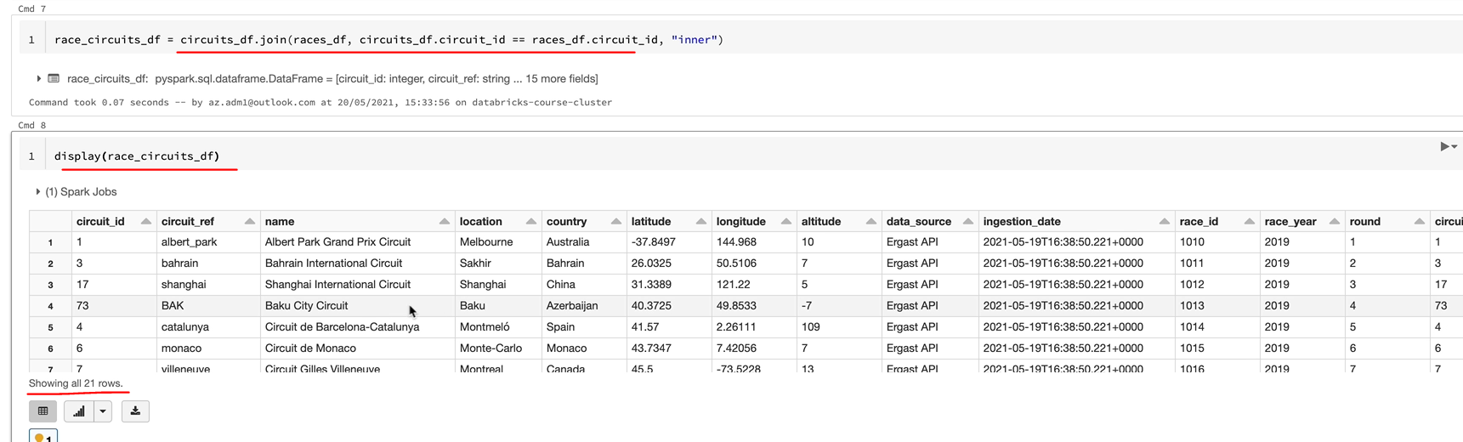

Not every circuit had a race in 2019, there were only 21 races, and that happened on the 21 circuits. So that's why you've got 21 records and everything else has been excluded. So that's how the Inner Join works. But there are a few things you need to understand here. As you can see here, we'll have some of the columns repeated. So circuit_id is here twice and the name is here twice as well. So there is a name. This name relates to the circuit name and there is another name which relates to the race name. So what we can do is we can use the select select method just to get the columns we are interested in. Let's do that. So let's say these are the columns we're interested in, so we want to get the circuit name and the location, so that would be in Australia and the sorry, the location is Melbourne in Australia and the race name in this case will be Australian Grand Prix. And the round in this case is number one, for example. So we want to pull all these five columns out of this one and we've got a select statement and we expect this to work. And that has worked.

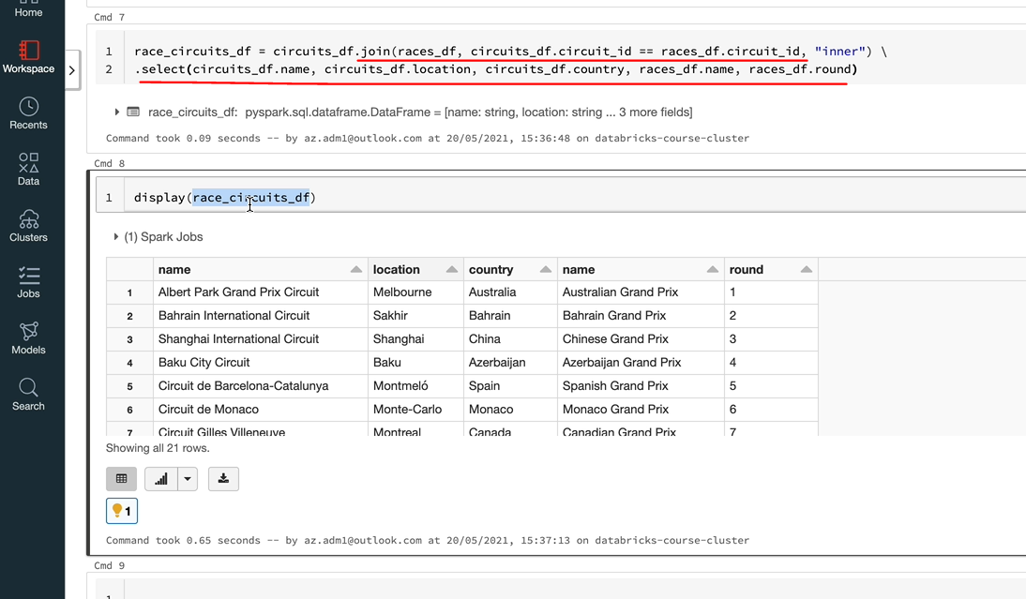

So let's display again the data from Output's. We got a problem here, right? So we got name repeated twice. So if you wanted to get data from this and if you said, I want the name and you're going to get a problem, so it's going to tell me that the name is ambiguous and it could be the name here or it could be the other name. We don't want to have the same column name used for two of the columns, so we need to change that. The best thing to do is to rename the columns before they come into the join condition. So what you do is actually, as we've seen previously, we can use the word column renamed here just to rename the columns.

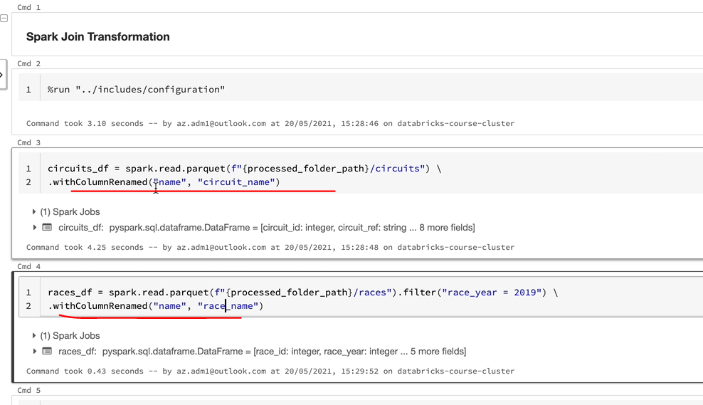

So what we've done is we've renamed the name here on the second date frame to say good name and the name here on the race, D.F. to race name. So that means when you do your join, you will pull the right name. So it's circuit_name and race_name. And if I run this again, you're going to have columns with the right names, circuit_name and race_name. And if you want to select it later on, you would specify which column you want. So in this case, let's assume that I want to select this good name. I'm going to have that data so I could do a show on that just to see the values in the data frame as well.

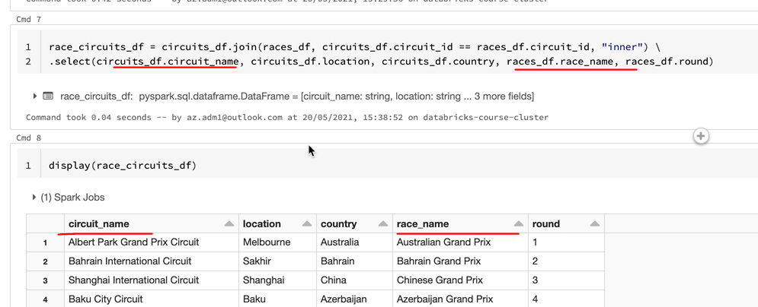

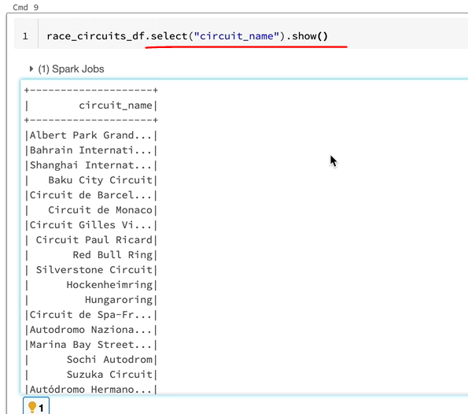

So this is something you want to be careful about because it's a common thing when you join two tables. A lot of the times you are going to have the same column name on both tables and it's better to rename them before you do the join so that you can select the right column names from the output data frame, as you would expect. So in summary, the Inner Join basically joins two data frames and gives you the record which satisfies the condition. So in this case, the circuit_id is present on both of the data frames. You get the output from those.

### Outer Join

So the next type of join we want to look at is the outer joins, the difference between the inner join and outer join is that in the case of inner join. The join only returns the records, which satisfied on both left data frame as well as the right data frame. So in our example, we only had records for which the circuit_id existed on both the left data frame, which is our secular state frame and the right data frame, which is our races data frame. As opposed to the Inner Join, in the case of the Outer Join, you can have records which doesn't exist on either of those. So there are three types of Outer Joins. The first one is the left outer join. So in case of the left outer join the left data frame is fixed. So you get every single record from the left data frame. And you get the corresponding data from the right data frame, if the value existed for the matching condition right outer join looks exactly the opposite. The right data frame is fixed and you get the matching results from the left data frame. If the value existed for the matching condition or if the record existed for the matching condition in case of the full outer join, you get everything from both data frames. And if the condition is not satisfied on either the left or the right, you get nulls for those columns. We will look at all of those, we got data to satisfy left outer join because we have got circuits, as you know, we got 71 circuits something, 77 circuits and we got a 21 races records. So all of the race records have got a corresponding circuit as we know. But let's change the data slightly so that we can delete some of the circuits. So that means we would have some races without the circuits. And I can show you how the right outer join works and the full outer join works as well. So in order to do that, I'm going to apply a filter on our circuits_df to remove some of the circuits. So what that filter condition does is it's going to include only the circuits with the circuit_id, less than 70, up to 69. So let's run that code and let's run the races_df as well. And if I display the output of the circuit_df, we should see fewer records. We've got 69 because we said actually we don't want to take a daily greater than 70 or yeah, greater than or equal to 70. So we got circuits up to sixty nine. And race has been as we know, we still have the 21 records. But now we are going to have some races which don't have circuits and some circuits which don't have races. So let's find the circuits which don't have the races first. I'm going to copy this join here. And we're going to put it here and change that to left so that you can use left outer or left both of them work in the same way, and I'm going to execute that statement now. And that's done. So let's run the display as well again, just to have a look at the data.

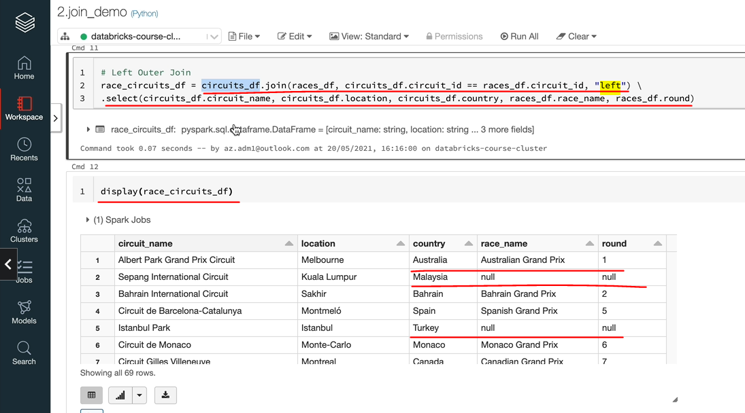

So as we can see, we got the sixty nine record. So as I said, when you do the left outer join your left is fixed. It's a left data frame. Here is the circuit data frame and the right is the races data. So you've got the 9 records from the circuit_df and if it found a matching record in the rest of the data frame, you'll get the value, otherwise you'll get nulls. So let's have a look at this. As you can see, we got this one existed on both data frames. So you've got the value here. But we didn't have a race in the Malaysian Grand Prix circuit. So you got nulls for those once. So this is how the left left outer join works. So let's now have a look at the right outer join. It works opposite to the left outer join. What I mean by that is you're going to have every right match from the right side of the join, which is the races data frame, but the left data frame it's going to put null where there is no record. So you should see 21 records with some nulls because we deleted some of the circuits. So let's have a quick look at that. And that's you can see here we got the twenty one records and all the twenty one records would have the of name because our right side is fixed now. And as you can see here, Azerbaijan Grand Prix didn't have a second because that's one of the circuits we've deleted. And similarly, I think you should see the Australian Grand Prix didn't have a circuit and the Russian Grand Prix didn't have a secret either.

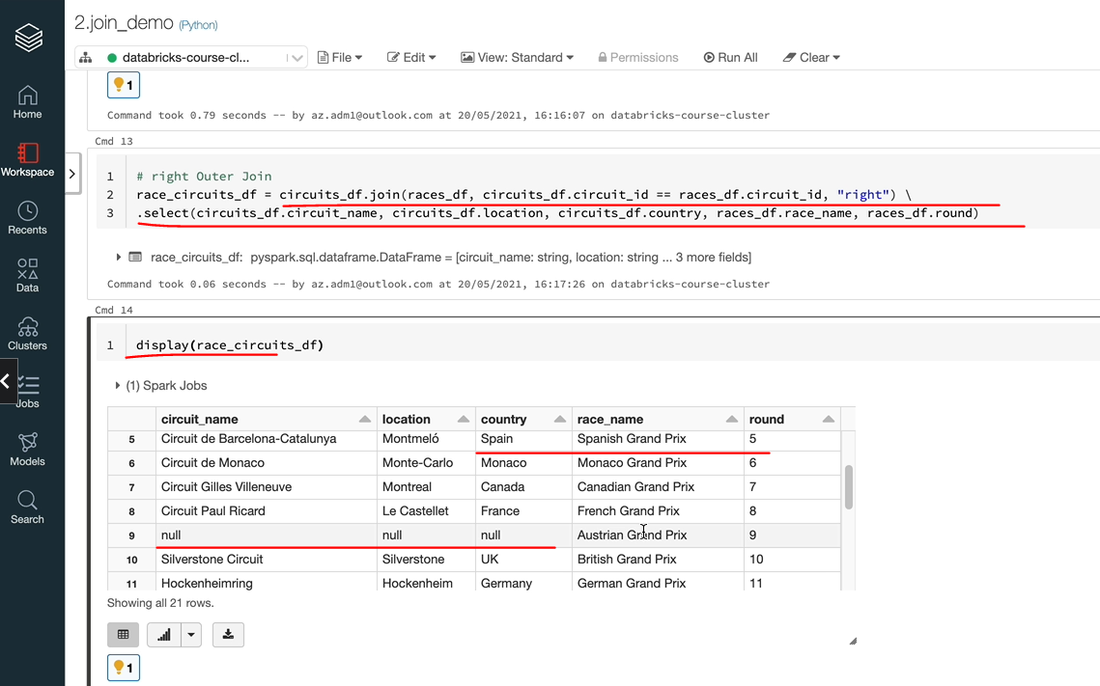

So the three that we deleted, we deleted 8 records, but the three didn't have the race in 2019, that's why we've seen the nulls here. So that's how the right out of join works. So let's do the full outer join as the last one. Full outer join is a combination of both of these. So let's do that. So this is going to be again you can use either full outer join, and I'm going to run the display as well just to show you the output. And as you can see, we got 72 records here. So in this output, we are going to see some nulls on the right as well as some nulls on the left. But for the records that matched, you're going to have all the fields populated, which is one example here is Australian Grand Prix.

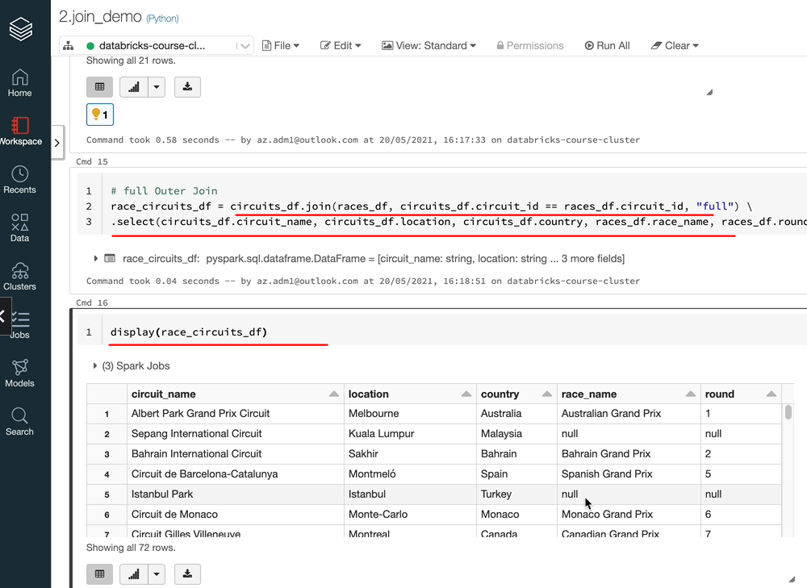

But as you can see, the Malaysian one, we don't have a race, Istanbul, we don't have a race. But similarly, if we scroll down, we will find some which didn't have the circuit. So the three here, Australia, sorry, it's the Austrian, Russian and the Azerbaijan one don't have a circuit.

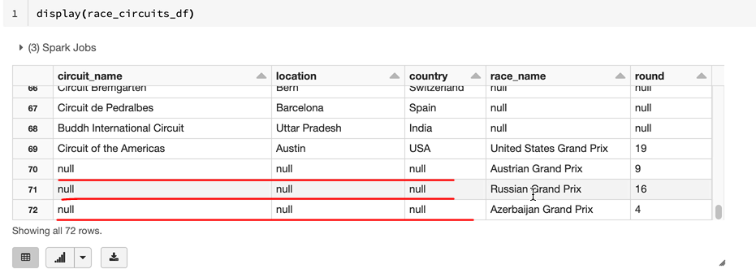

So it is giving you a combination of both data frames and fill in nulls where it didn't find a match. But the records, it found a match. It would just give you the full record there. So that's how the full outer join works.

### Join Transformations

Inner Join and the outer joins are the most commonly used join transformations in Spark, but there are three other ones which are semi joins and joins and cross joins offered by Spark, so we'll go through those three as well. Semi joins is basically very similar to Inner Join. So that means you'll only get the records which satisfy the condition on both tables. But the difference between Inner Join and a semi join is you're only given the columns from the left side of the join, which is the left data frame, so you won't have access to any of the right data frames. So this is very similar to writing the Inner Join, but selecting the columns only from the left data frame. So because of this, I never end up using semi joins. I always write in a join and select the columns I need to select. So let's do this now. And I'm going to change the full to semi, so you can use semi or left semi, both are the same. You can't specify any columns from the right data frame here. I'm going to run it anyway just to show you what happens. So as you can see here, it tells me the attribute name, race name is not available and also round would be the same. So you can't use them, but instead you can take out these two columns and it should work, OK?

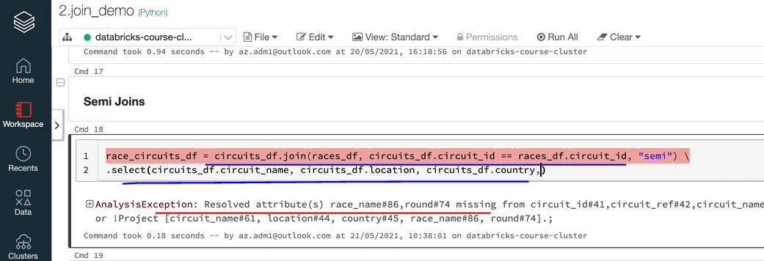

And I'm going to display the contents for you here. And as you can see, it's picked up the 18 Records' because we believe the three circuits, if you remember 18 records and it's given us the data, if you take out these select all together, which you can do, and what you will see is every column from our circuit data frame and no columns from the racist data frame.

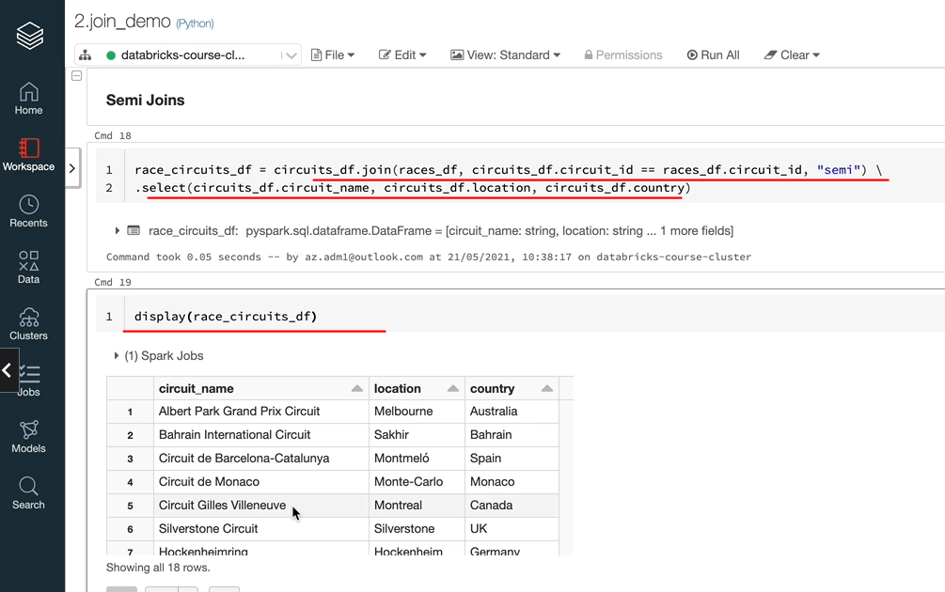

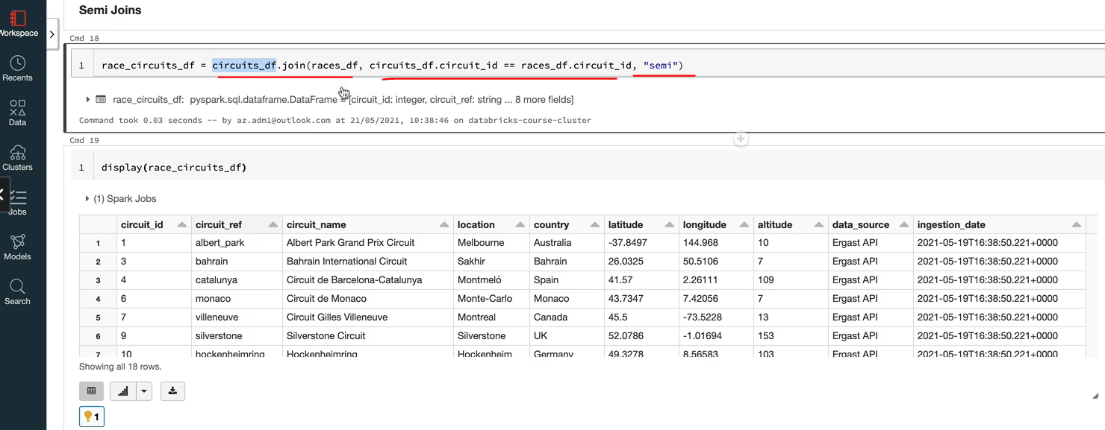

So as I said, it's an inner join basically, but you only get the columns from the left data frame, which is the circuit_df here, and nothing from their races_df. So that's the only difference. And as I said, I don't normally tend to use this, but it will be totally up to you. The anti join is an interesting one. It is quite useful. What it does is it gives you the opposite of semi join. So basically here in semi join, it gave you everything which was available on both data frames. But what the anti join is going to give you is everything on the left data frame, which is not found on the right data frame. So let's run this one and you can use anti or left anti they mean the same thing. And again, I'm going to just do display. And as you can see, we got 51 records, but that wouldn't include any records we found up here. So the 2, 5, 8, 12, 16, 19, they won't be here. As you can see, we're seeing only two, five, eight and things like that. If we turn it around, it'll be easier to see because we should see one only 3 races which are not available on the circuit.

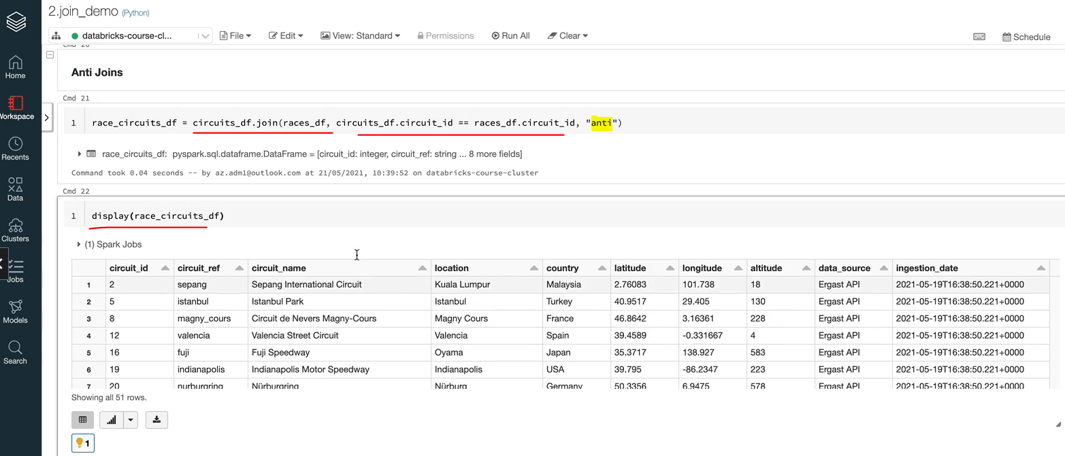

As you know, we deleted the 3 circuits. So I'm going to just do that here. And we should see just 3 records coming out of this one. Because our left data him now is the races data frame and we got 3 workers here for the Azerbaijan action and the Russian Grand Prix. We don't have a corresponding circuit in our circuit state. So that is Anti Join for your.

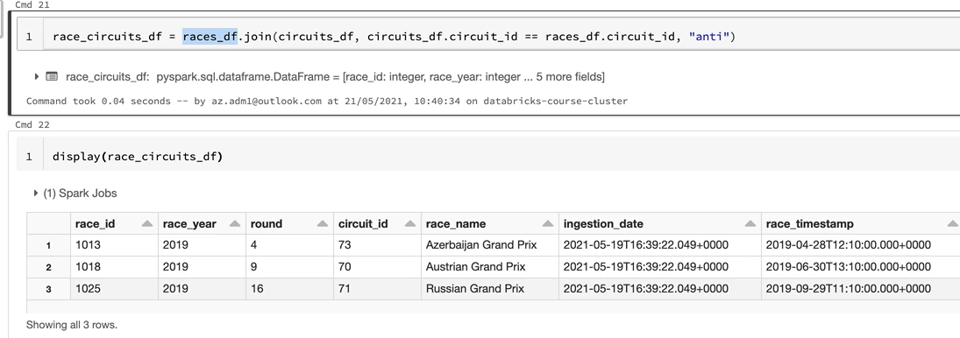

Cross joins, you need to be really, really careful because Cross Doyennes is basically give you a Cartesian product. What that means is it's going to take every record from the left giant to the record on the right, and it's going to give you the product of the two. So let's do that just to show you how that works here. The difference is you've got a different syntax to do. The cross join, it's going to be the left data frame and then cross join with the J in uppercase and the right date frame. So that is the syntax for that one. And if I just do a display, you'll see thousands of records and I'm going to quickly. Yes, you can see in the first thousand records and let's do a count on that. OK, so we got one thousand four hundred and forty nine record, so each record from the left, which is the security one here, for example, is being joined to every record on the right, which you may need it at times, but it is very rarely that you would want to join every record to be at the table.

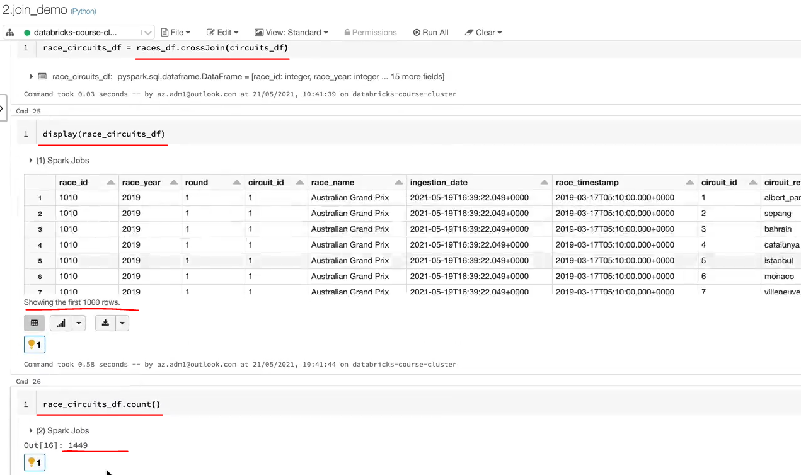

One typical scenario, normally people tend to find this. You may have a dimension table with a handful of records and then you've got a fact you want to duplicate with every record on the dimension. So that means you just joined the two to get the final results. But otherwise, please don't use it because one thing you will end up having is out memory errors because you are going to be dealing with big data when you're working on Spark. And if you join a big data table to another big data table, a massive table, you're going to end up with massive amount of data just to prove the point that it is a Cartesian product. I'll just do a count on both of the data frames and then show you whether that is the multiple Cartesian product. I'm going to do the count of this one and multiply that by the count of the other data frame, which is our circuit_df frame. And that should come up with the same count as the resultant data frame here, 1449. So that's what's happened here. With that, we've been through all the join available within SPARC and I hope you've got a good understanding and that's the end of this lesson I'll see in the next one.

### Join Transformation – Race Results

Now that we've learned extensively about the join transformation, let's put that into practice. From the data we've ingested into our data. We want to produce a data set that will serve a dashboard or a website with the drivers arrest results. So that is our requirement. Let me show you an example of what I'm talking about from the BBC Sports website. Here I am in the BBC Sport website, and as you can see here, and the Formula One, they got the results for the last, I think, 5 years worth of races. We don't have any data for 2021 in our data set. So let's pick 2020. And if I click on the full results, as you can see here, BBC Sport website makes the data available for us on all of the race results.

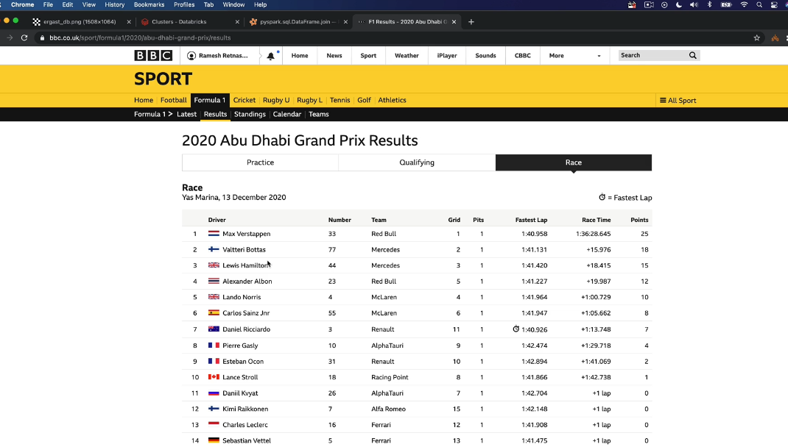

So this one here is the 2020 Abu Dhabi Grand Prix result. So I would like you to get a data set which will satisfy the data requirements for this website. So as a data engineer, the first thing we want to look at is actually what are the data points here? So we got the data item 2020, which is the year in which the race happened and the name of the Grand Prix is here. And then you've got the Yes Marina, which is the race ciruit and the date here is the date on which the race happened. And then as part of the table, we got a few data items as well. So firstly, we've got the driver driver details, the nationality of the driver in the form of the flag as well as the name of the driver. And then you've got the car number, the team, we call it the constructor for which the driver is racing for. And then the grid position from where he started the race and the number of pit stops. And we've got the fastest lap for the driver in the race and the time it took for him to complete the race, which is the race time, and then the number of points awarded to the driver as part of the race. So, as you know, we have all of these data items in our data and we want to create one data set which would contain all of this information so that an API or a dashboard can access the data and make it available in a dashboard on a website. This is our entity relationship diagram.

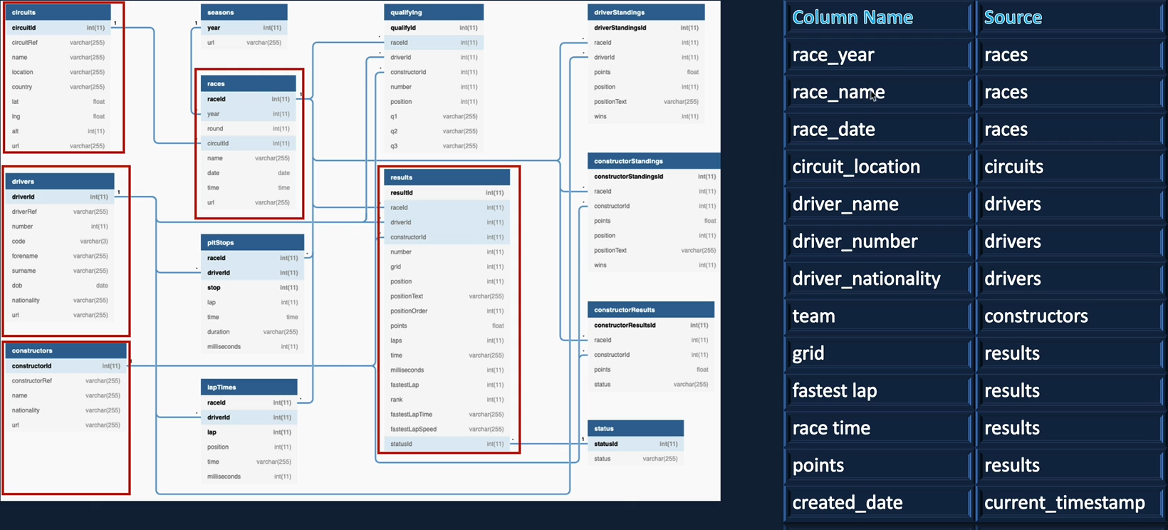

In order to satisfy our requirement for the dashboard or the API, we need to read data from drivers file to get the driver details, constructors file to get the team name and then the results file to get the race results. We also need to read data from the races file to get the rest details as well as we need to read from the circuits file to get the location of the race in our example that was just mentioned that we saw on the website. So the table I've given here will give you the list of columns we want in our data set and also the sources from where they're coming. So in our case, we've got the racing name and the data that come from a race as file circle location would come from the circuit file. And then you've got the driver details like driver name number and the nationality would come from the drivers file. And then you've got the team name that comes from the constructors file and the rest of the details here, such as grid, fastest lap, race time and the points would come from the results file. And also I've added a new column here and call it created_date, which is similar to the ingestion date on the other file to be processed previously, and that would be set with the current timestamp. So I would like you to create a data frame that contains all of these data items and then write that to a parquet file under a new container called presentation. So there are two separate things we need to do here. One is to create a container called presentation in our formula1dl storage account and mount that to our workspace so that we can write to that point. And also we need to create a notebook which will produce a dataframe with the data items we are seeing here, and then write that as a parquet file into the newly created mount called the presentation.

As you have previous experience, creating mount points and creating the container. And also recently you worked on the joint transformation. So I'm hoping you can do this as an assignment. So that's what I would like it to do.

### Setup Environment – Presentation Layer

In the earlier lessons we set up the environment for the Raw and the Ingestion layers. But now we want to process the data for our presentation layer. So in this lesson, lets create the environment for the presentation layer. You might be wondering why we are creating another container. Data projects usually have different layers to keep the data for a different number of reasons. Most importantly, it helps the consumers to understand the nature of the data they're dealing with. Also, it helps to provide the right access to the right consumers. For example, you do not want an API to have access to the Raw data. Instead, it should have access only to the presentation layer. So by splitting them into different layers, you can manage your security and access controls as well.

Different architectures name the layers differently, and there can be any number of layers depending on the project need, most projects will have at least three layers. As we've seen, database architecture recommends calling them bronze, silver and gold. Bronze would have the raw data and silver would have the data with the structure applied and data cleaned, etc. Gold would have the data as required for reporting and presentation. We've called them as Raw, Processed and Presentation and they're synonymous with bronze, silver and gold. You can follow these conventions are if you want to change this, please feel free to do so. Let's be clear in the presentation layer. This requires us to create the presentation container in our data lake as well as create a mount in our database workspace so it has access to the container. Let's start by creating the container first. Here we are in Microsoft Azure Storage Explorer and this is my subscription, which is the 'Pay as you Go' subscription, and this is the storage account that we created for our project, which is Formula One bill. And under that we got the two containers that we created raw and processed. And we want to create the third one. And this is going to be called presentation. OK, that's now created, so let's switch to our database workspace and create the mount point for that, we have already created our set up scripts, so let's let's navigate to that.

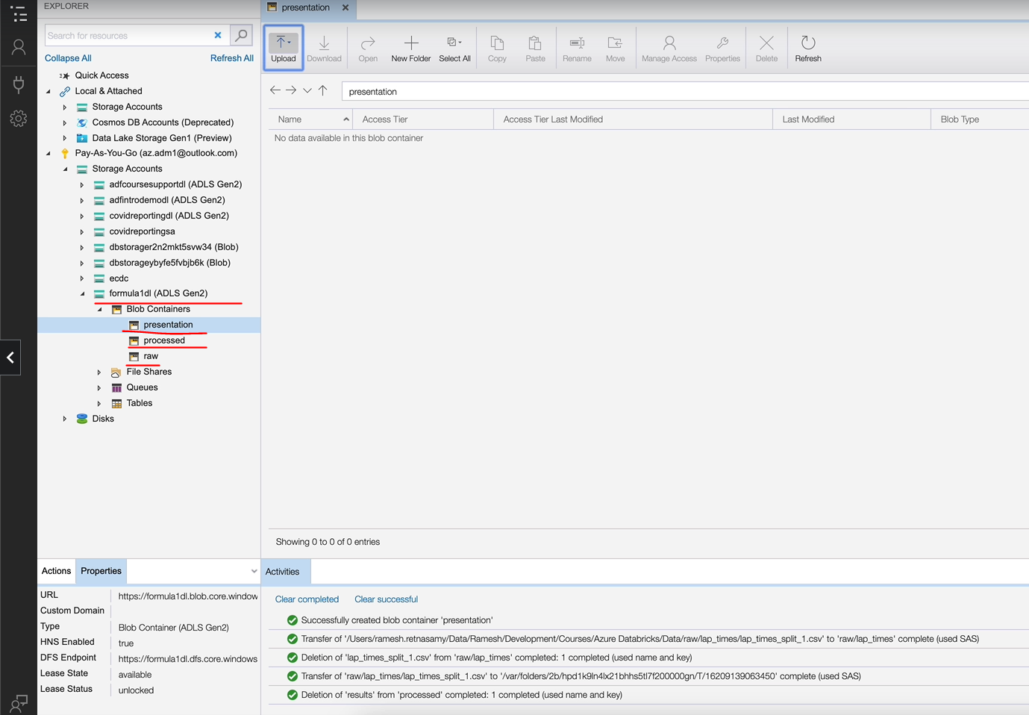

So that is under the Formula One folder. Under setup, we got the Mount ADLS storage and here we created the Mount for raw as well as processed. So now we need the third one, which is going to be the presentation. So let's execute the book, we don't want to execute the entire notebook because we've already created the and the processed containers and the point. So let's do what's necessary.

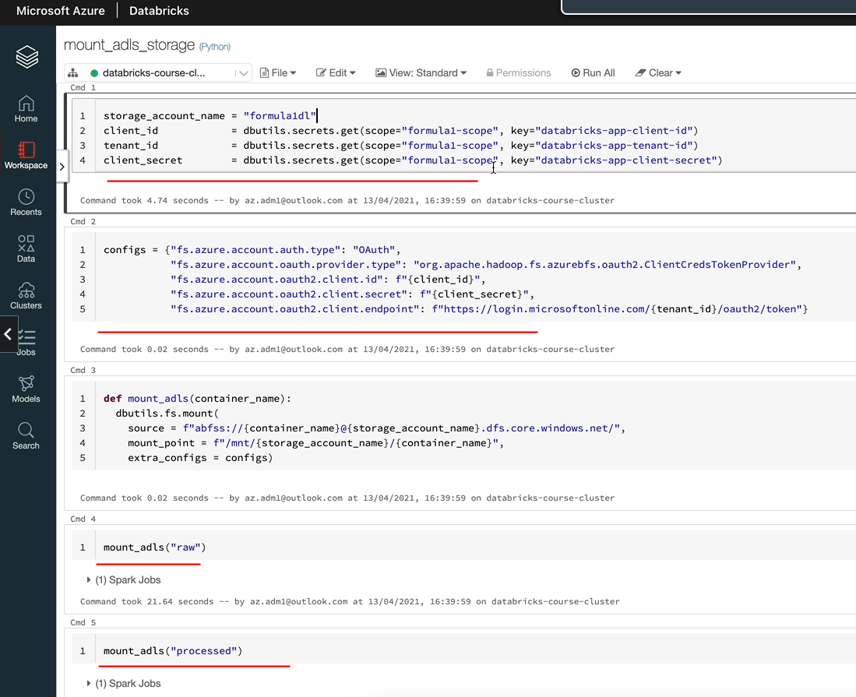

So we need the statement just to set up the secret details and fix gear. And then we also want the function materials. So we just we want to miss these two ( i.e. mount_adls("raw") and mount_adls("processed"), and we want to run the presentation mount_adls("presentation") that mounts the new container for us. That's now mounted, let's list the mount points just to make sure that we can see the mount. Yeah, we got an empty string out, but our empty list out, but that's because we have got no files in this folder, no files of folders in this container. So this has worked.

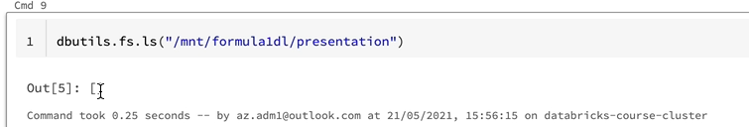

So the one more thing we need to do here is under configuration if you remember, we are keeping the folder paths, so let's keep the folder path for presentation as well so that we can use it in our notebook.

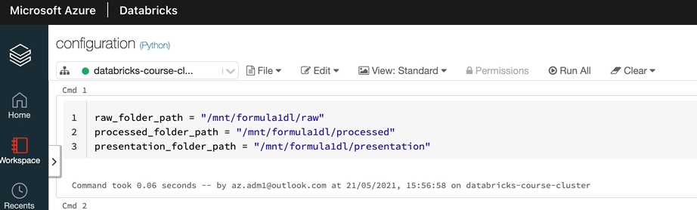

OK, so that's done, so that's everything. Now, the next thing we want to do is to create the notebook, to transform our data.

### Join Race Results – Solution

Let's create a new folder to keep our new notebook so that our work is organized, so we got the injured and already I'm going to create another folder and I'm going to call this one as trans. This is a transformation, basically. So click create folder. And within that one, we're going to create a new notebook.

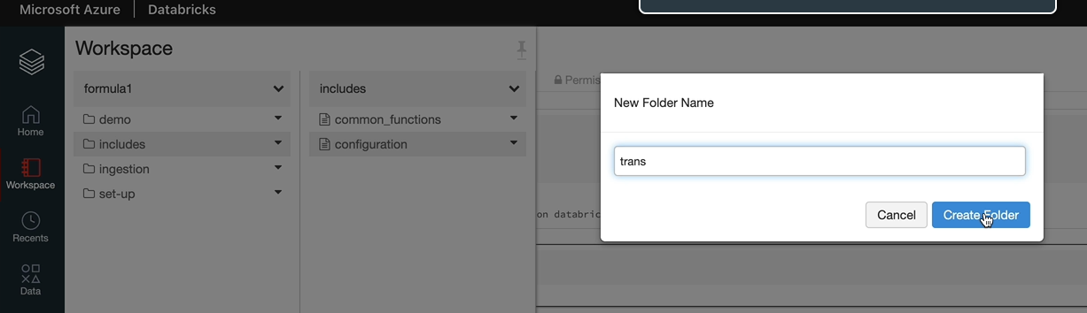

And I'm going to call this new notebook as race results, because that's what we're getting and that is the notebook and attached to the same cluster here.

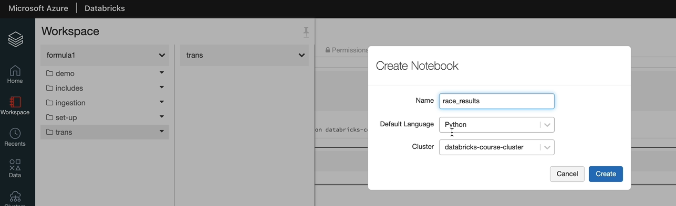

And click create. So the first thing we want to do is read all of our data as we need. If you remember, we wanted to read data from five of the tables, which is a drivers, circuitous constructors races as well as results. So let's read all of that data into data frames first.

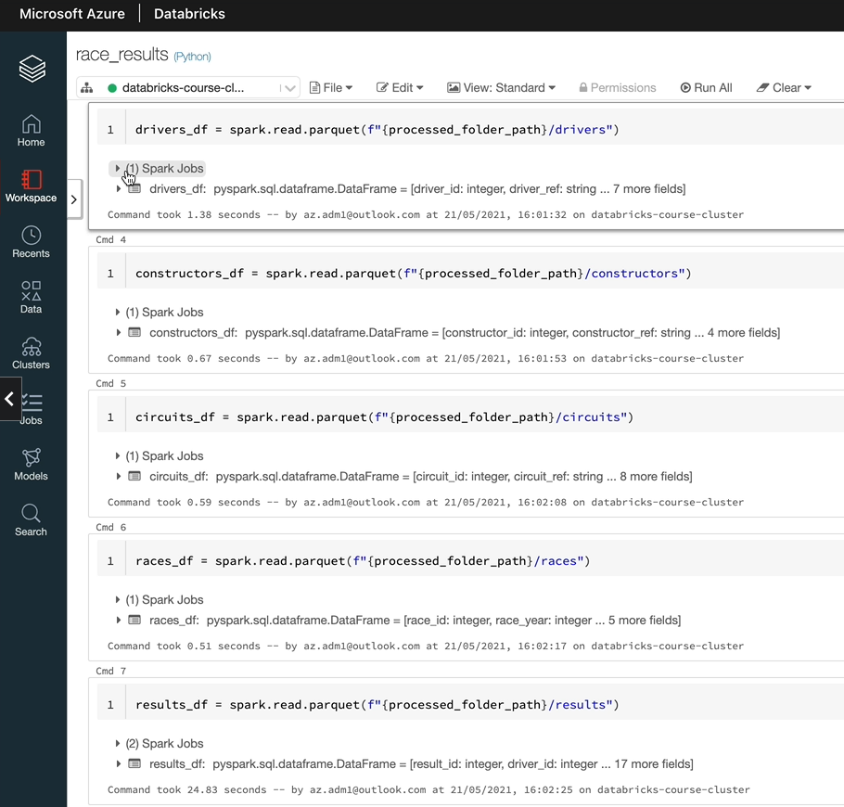

So we have now read all the five files into data frames here, but one thing we want to look at is actually if I extend this one so as you can see, the driver data frame has got a number for the driver number. That's something we are interested in and the name and the nationality. But we are going to have a conflict with other files here. So, for example, we're going to have the name duplicated here as well in constructor.

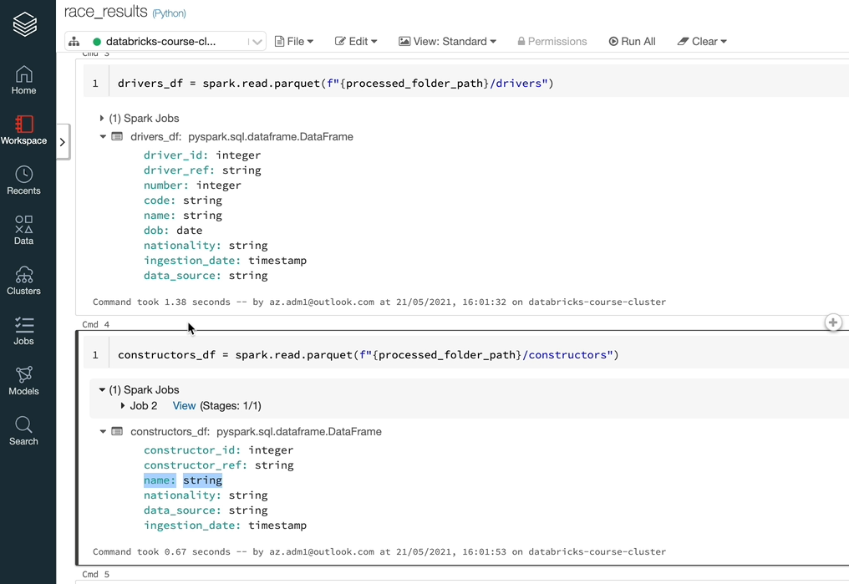

So when you join up the data frames, you're going to have ambiguous column names. So we want to rename them here so that actually they could be used without any conflicts. So we discussed this earlier when we talked about Joynes I hope you can remember otherwise you can go back and watch the video as to why we're doing it. So let's do that next.

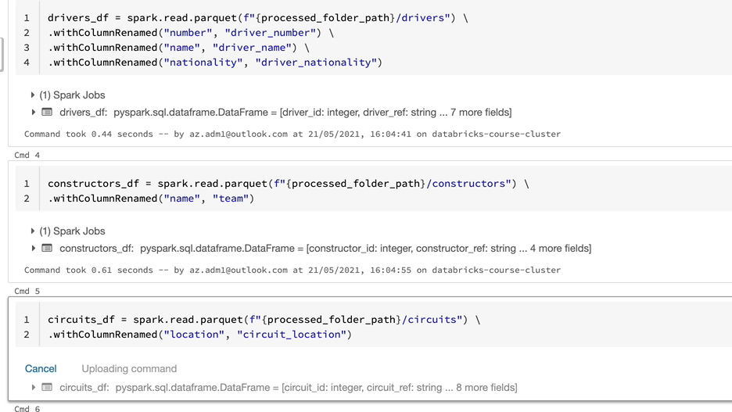

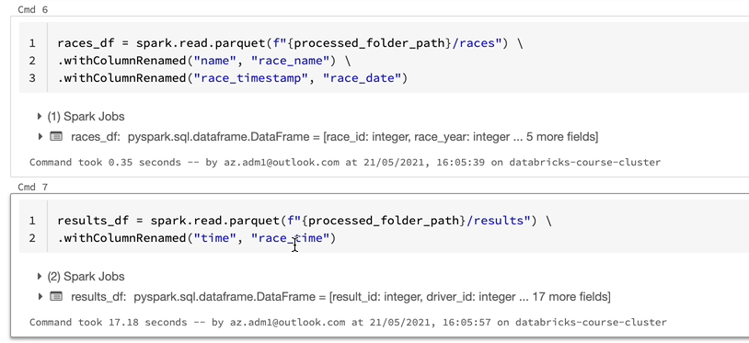

OK, that's done now, so you might be wondering, actually, why I changed things like time to rest time and rest time to real estate and things like that, because that is our requirement. If I switch back to the presentation, as you can see, we said actually these are the column names we want our output to have.

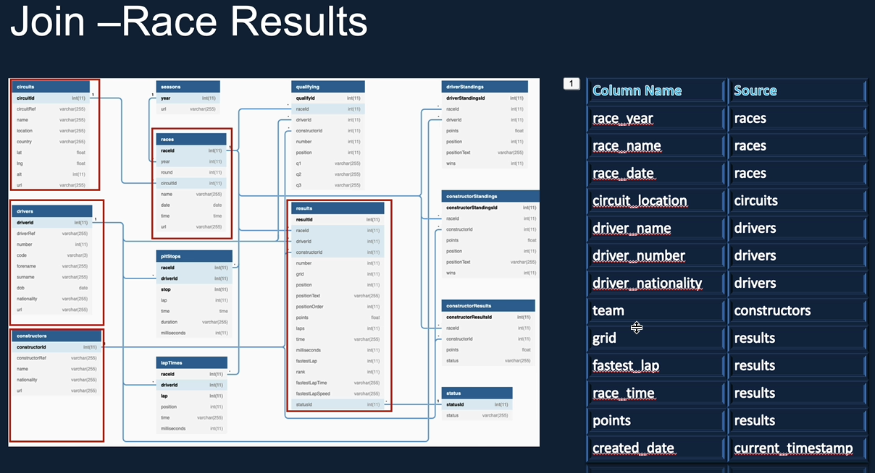

That's why I changed those as well, apart from the ones which already conflict because of ambiguous names. The next thing we want to do is to join the data frames so we have five data frames we need to join. So let's have a think about what the best way to join those. So let me switch to the entity relationship diagram here.

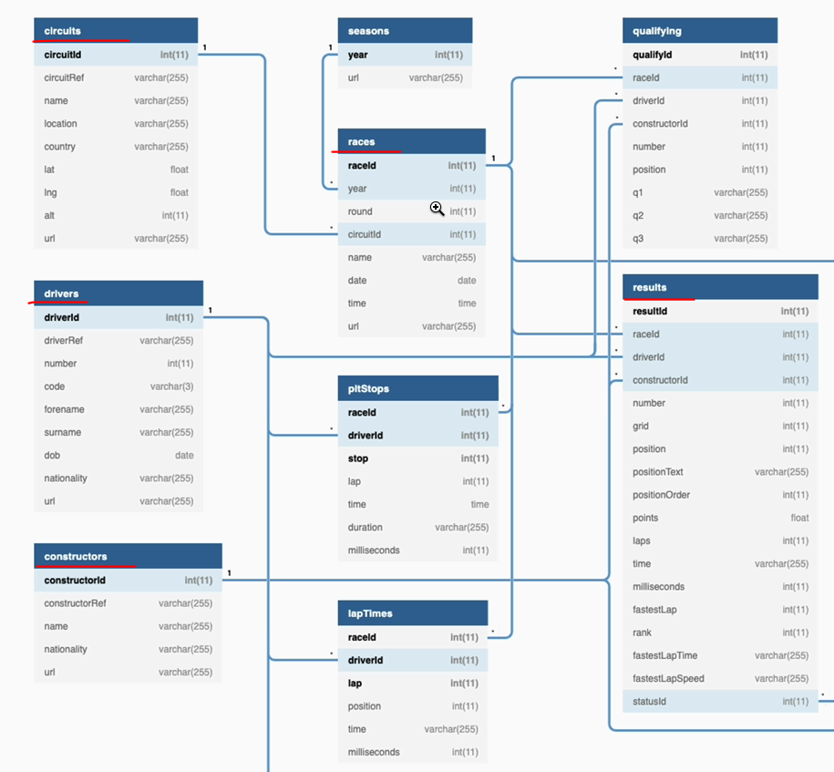

And as we said, the ones we're interested in these three, which is circuit, drivers and constructors and then races and results. One thing you may notice is results has got a link to most of the table. So it's got the race_id. So you can use the race_id to link to the races table and you can use the driver_id to link to the drivers table and construct_id to link to the constructors table. But it doesn't have a circuit_id to link to the circuits table, but races_id can link to circuits using the circui_id. So what we would do is we would write a join to join these two data frames to create a new data frame, and then we'll join the new data frame and these two together to the results date different. So we'll end up having two statements rather than five different statements. That's the most efficient way of doing this.

So let's start with the first one, which is to join the circuits data frame to the races data frame. So as you can see, we've joined the race data frame to the second data frame using the security and I left the third parameter blank, but the default, as you know, is in. So we're doing it in a join, but it's brought back 15 different columns. And that includes things like security, potentially duplicated twice because it appears on both data frames. So the next thing we want to do is just to select the columns we're interested in. So let's do that. OK, we got the columns we want to get out of that, so the next thing we want to do is to join this data frame, which will have the and records, as well as the drivers and constructors which we pulled out here into the results table.

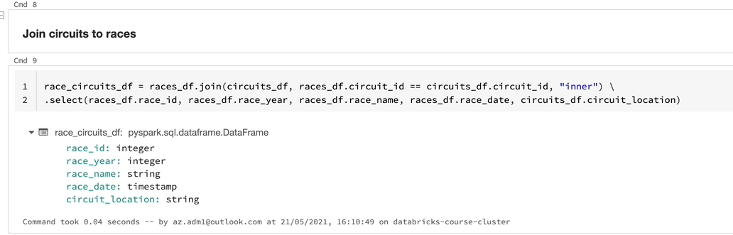

So results data frame. So that's what we're going to do the next. So we've now joined the results data frame to the other three data frames here, but one thing which is new for you potentially is we are joining multiple data frames to this data frame. In the past, we only had one data frame as an example.

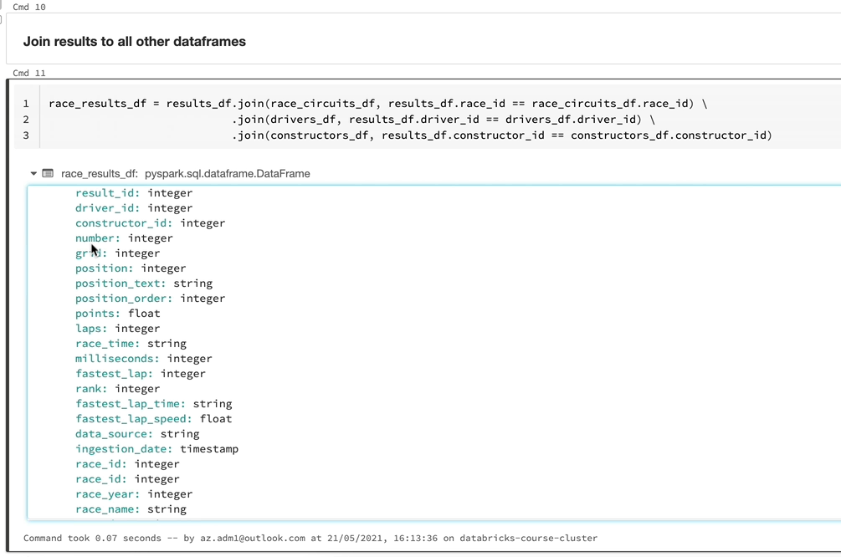

So you can do what we are doing here. So results data frame here is being joined to that. Three other data frames using various different ideas. And if I expand the columns listed here, as you can see, we got things like, say, idea repeated twice and we got other fields as well, potentially. So we want to select what we need in order to report. So let's do that.

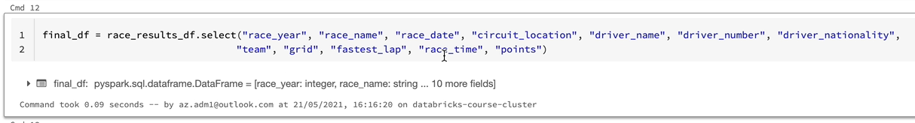

So we've selected the fields to be needed, so that is the 10 fields here. But if you remember, we also had a requirement to add the created date at the end, which is year, which includes the current timestamp. So it's probably appropriate to do it here. So let's add that column. So as you know, as we've seen previously, we can use with column to add a new column. So let's do that. And we need to import current timestamped, so let's do that as well. All our work here is done now except for writing to our container, but before we write to the containers, the parquet file, let's have a look at the data to ensure that we have got the right data.

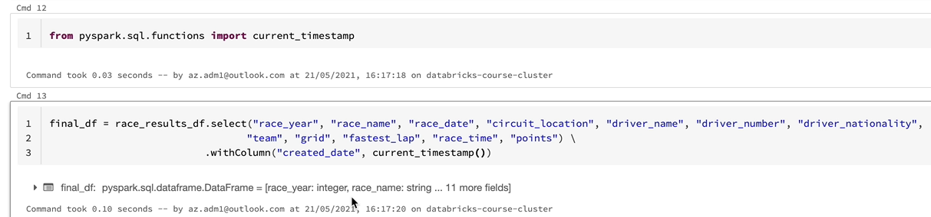

So I'm just doing a display on the final data frame we've created here. OK, as you can see here, we got the data as be expected, pretty much, I think, and so we got some nulls here first time that is OK, because not everyone finishes the race and fastest lap is now less well.

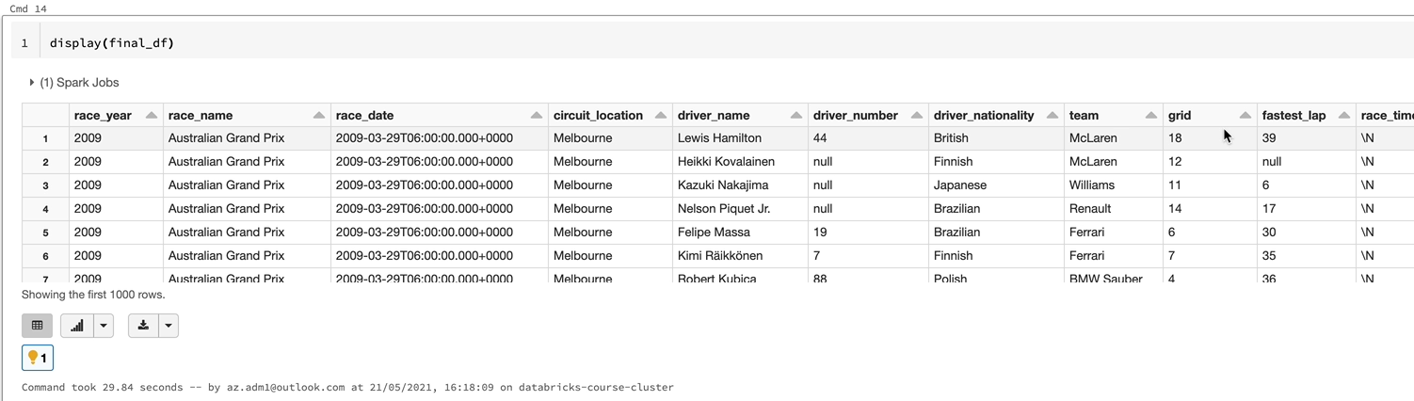

But this /n is null notation in my sequel because that data we got is my second complaint. But if you are doing any machine learning, you will replace that with proper null or replace with any other value. So created data is also populated as we would expect. But in order to see the validity of the data, let's look at the 2020 Abu Dhabi Grand Prix results so that we can be sure we got the right data in the right order as well. So let's have a quick look. So in order to do that, I'm going to use the filter transformation here. So we got the 20 records, but this is not been really ordered by anything, so it's it's difficult to tell actually whether we match the results here because Verstappen finished first and then Bartosz finished second and Lewis Hamilton the third.

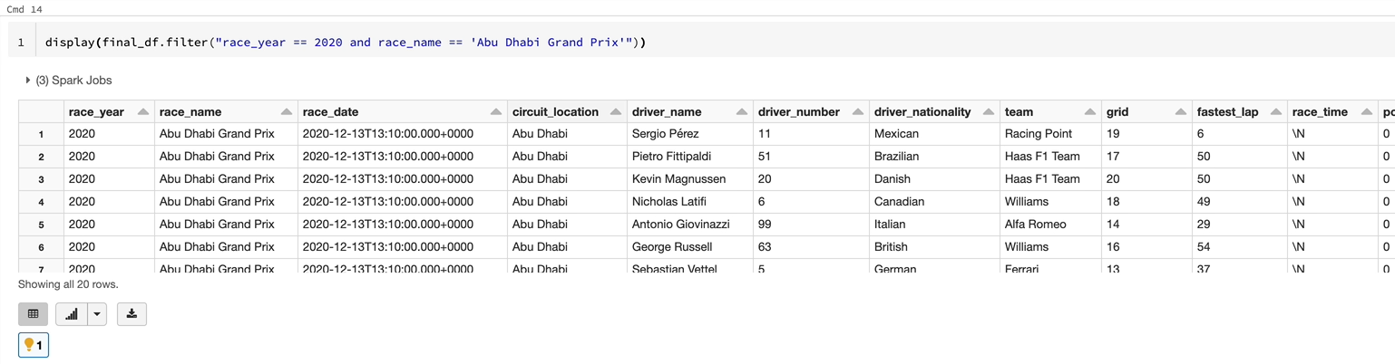

So we should see the results in the same way in order to be able to compare this data against the data in the BBC Sport website. They'll also order by the data, by the points. So as you can see, the winner gets twenty five points and the second person gets eighteen and then it keeps going down.

So if we do an order by on points by descending, then we will be able to see the data in the same order in our output as well. So park gives you a function called orderby, so which you can apply on dataframe less. So let's go to the AP reference and then go to data from APIs and we should see orderby. As you can see, that supplied on a date frame and then you can send in your columns so the way you can invoke there are a few options here. So you can either dataframe dot column name dot descending or ascending, or you can go for things like the date frame column name, and then you can specify ascending false and things like that.

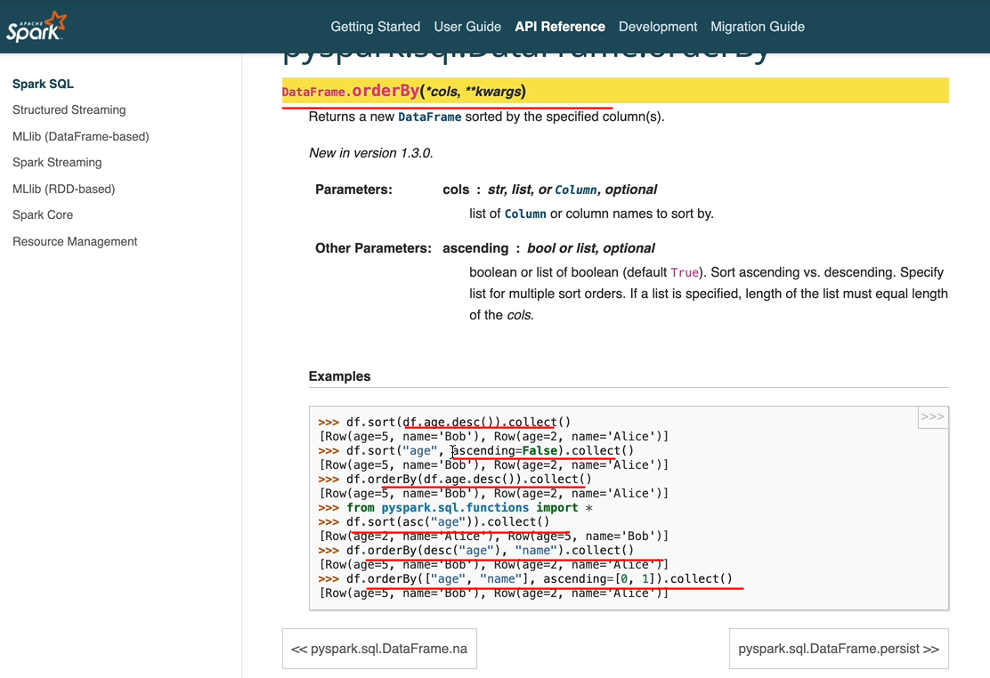

So we're going to go with a simple method here, but I would encourage you to try this as well. I'm going to apply order by here on the date frame. And that's going to be on the final data frame and we want to do an order by point and it's going to be descending. So let's apply that. And if I hit enter, we should see the data in the same order. It's up there. So as you can see, we got Max best happens, got twenty five points about 18 and Lewis Hamilton 15. And it's the same order. And we got all the 20 drivers listed here.

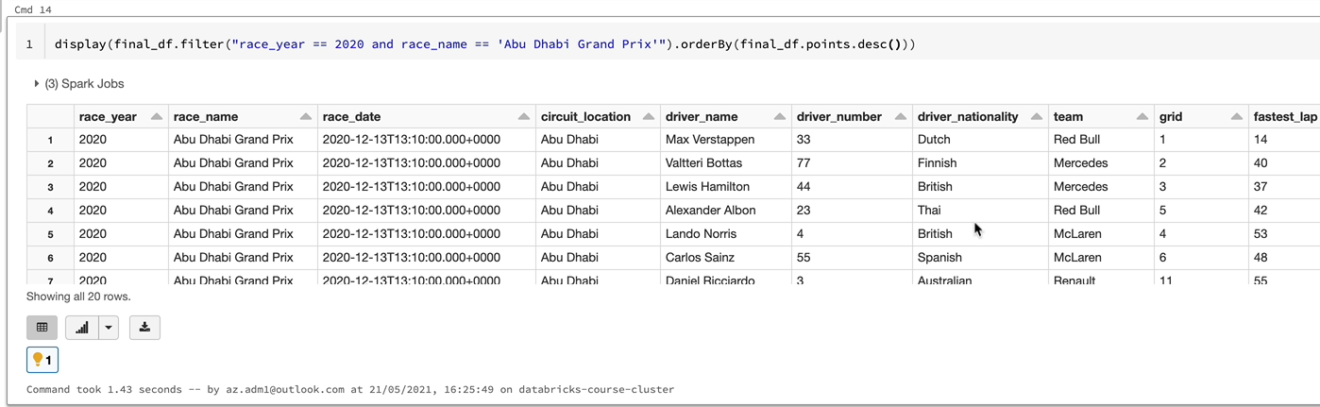

So this data here is exactly the same as what we're seeing here. And if someone's built a website or a dashboard, they could just point that to this data here and they can use it. So the final thing we want to do is to write this data to our presentation layer.

So I'm going to do that. It'll be quite familiar for you because we are going to use the data from. Right, which we've been using all along. So, again, this case, I'm going to go over the data if it's already there, and then I'm going to write the data in the park format. The one thing we each will be different is we are going to use a different layer here. So that will be the presentation layer. And that is going to raise results for the. So let's execute that.

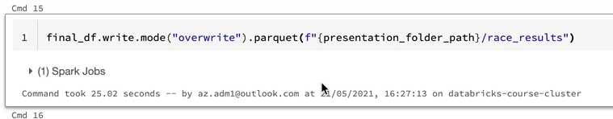

All of that data is now written and we will use that data later on when we come to learn things like aggregations and stuff like that.

## Aggregations

|  |  |
| --- | --- |
| In this section, we are going to focus on aggregate functions and Spark Spark provides a great set of aggregate functions. First, we look at simple aggregate functions such as some average Min, Max, etc. will then look at doing aggregations by grouping data, will then learn about performing functions such as rank, lead, lag, etc. on a window of data which are called window functions. Finally will apply all of these functions to our Formula One project to identify driver standings and constructors standings in a season by the end of this section. I hope you will have a good understanding about various aggregate functions in the park and also have the confidence to apply them in your project. |  |

### Simple Aggregate Functions

We are going to look at a few examples of simple aggregate functions built into the Spark library, examples of these are things like sum, count, min, max etc. These functions can be applied on the dataframe object via the select method, which we've seen previously. We generally apply them on an entire data frame and the output will be a single record with the aggregations applied. To get a better understanding of those let's switch over to the databricks workspace and look at some examples. Here we are in our databricks workspace, just to save a bit of time, what I've done is I've created a notebook already and the notebook resides in the demo folder that we used for that filter and the join before. And the notebook is called the Aggregation Demo. And that's attached to our cluster as well, which is in my case, databricks course cluster. And the first thing we do here is to run the includes configuration, which is going to give us access to the folder path and things like that. And the next thing we're doing is reading the results file that we created as part of the Join lesson. And that's going to have all the races and results and the drivers and the teams associated with that as well in one data frame. So let's have a quick look at that and we can then work on that data and apply our aggregations to that.

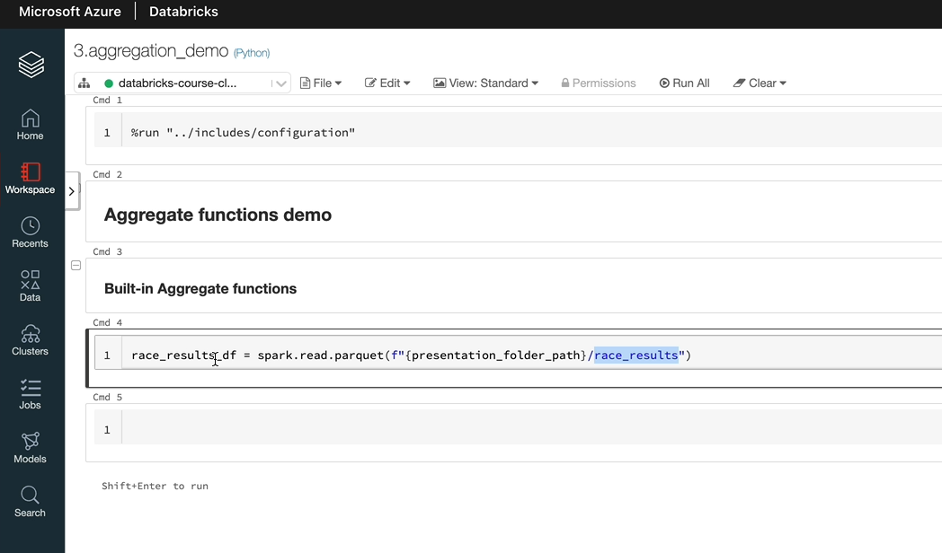

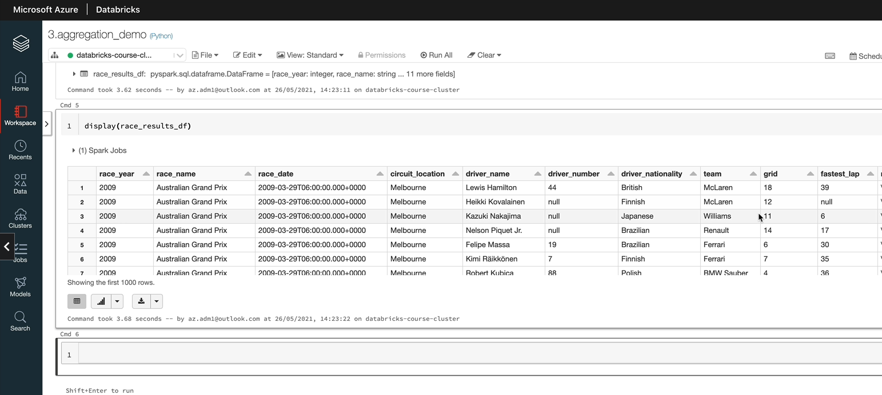

OK, as we said here, we got the race here and the race name and circuit details and the slider and the driver details and the team details and also the points and things like that. So that's all we need. But one thing we want to do is we want to cut down this data because it's quite a lot of data to work with. So let's just filter on 2010 Teresia so we have small data frame to work with. So that data frame is going to have one data related to 2020, and that's what we're going to work in this lesson and that is 340 records. Before we start writing the code to do the aggregate functions. Let's look at the API reference and I'll show you where to look for. So under functions in the API reference, if you go, you'll see a lot of functions. So for example, this one is an aggregate function. So if you search for aggregate, you're going to find the ones. So you've got an average and you've got a collect list, collect set, you've got count, first, grouping. All of those things are aggregate functions. So we're going to look at a few of those. We're going to look at count, count distinct and sum to be precise. So I'm going to import those first. So let's write the count on this data frame.

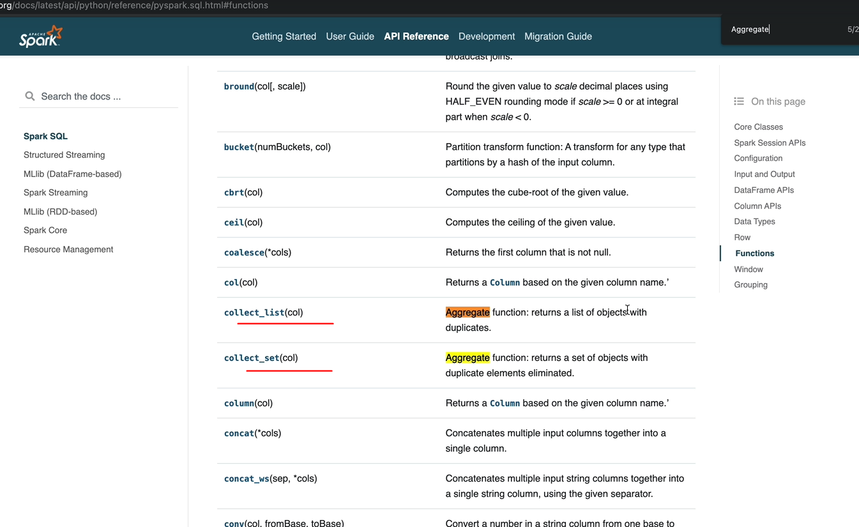

So in order to do that, you would do demo_df and then select and you can use count any of the aggregate functions here, any of the built in functions like you would normally use. So in this case, it's going to be just to count. You could do count(*), for example, and that's going to give you the number of records in this data frame. So in this case, it's going to give us 340 because that's what we saw there. But let's say that we don't want that. We want to look at the raised names. So let's pick a column and you're going to get the exact same number because it's counting every single record where the race name is not null. That's what you're going to get.

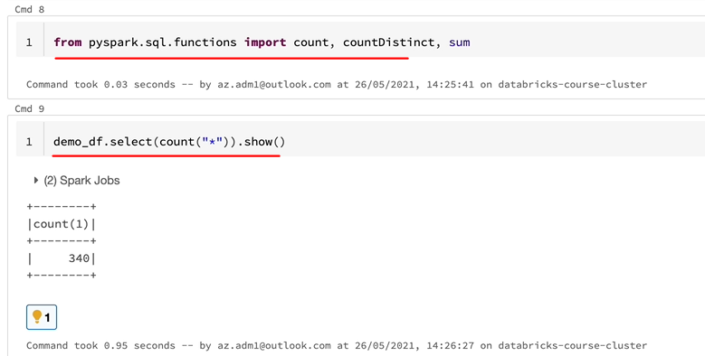

But if let's say our objective is to look at the unique number of races that happen during 2020, we can use count distinct for that. So let's do that. So all you would do is instead of count, you will do count distinct, and that should give us the distinct race names. So as you can see, it's 17 races that happened in 2020.

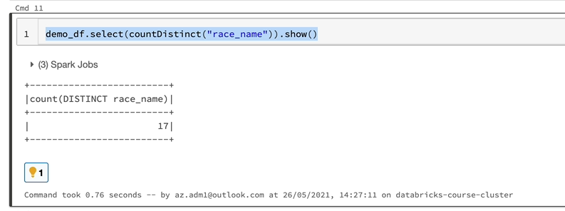

Normally, it's between about 20 and 22. But because of covid, actually, there were less races in 2020. So let's say now we want to use the some function and some will just add the values between different records. And in this case, let's say we want to see the total number of points being awarded in last year's race. So that's going to be some of the points here and that will come up with a massive number. So which is 1734. And if you wanted to look at how many points, for example, Lewis Hamilton scored, then you could just do a demo of demo_df which is our data frame dot, and then you can apply the full transformation for that. So as you can see, he's had 347 points out the 1734 and we had 20 drivers, so that's why he's the champion.

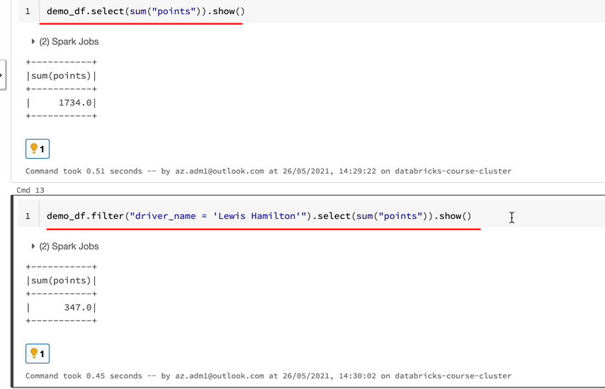

He scored most of the points. So one more thing I want to show you before we move on is you can put as many functions as you want. So in this case, we were used to just to some of point one function all the way through. But at the same time, if you wanted to get the distinct number of races he's raised as well, we can just put that function in here. And that's going to give you two columns here, the sum of points is three forty seven and the count of the distinct races is number 16.

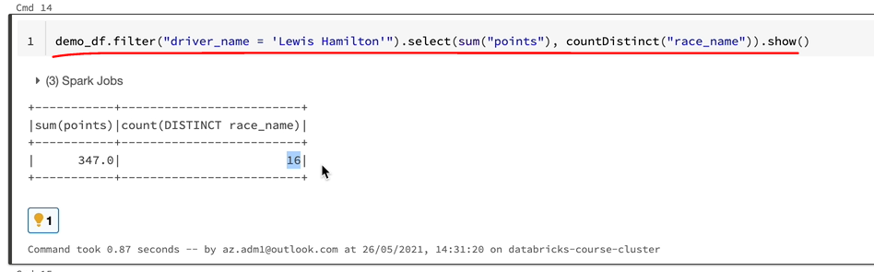

He hasn't raised in one of the races. That's why it's not 17, because he had covid for that race. So one thing you may have noticed is the column names look a bit weird. As you can see, it's got sum of points rather than just points or total points. So as we have already been through, we can use the withColumnRename to rename the columns as well. So that's what you should do. Otherwise, when you come to reference this column, you're going to have problems.

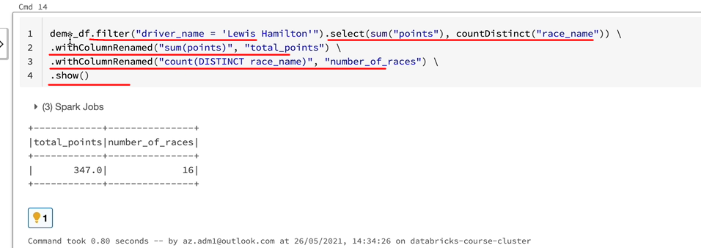

As you can see, we got a new column name, so if you just stir that in under the date frame and then reference it later on, you can reference using these column names. So that's one important thing you need to remember when you are using the aggregate functions within select like this. But as you've noticed, actually, we're only getting back one record, which is not normally what you would be looking for. And we've done a filter on a driver named Lewis Hamilton, that's why all of this makes sense. But in a production scenario, you would normally want to have every driver being listed with their appropriate total points and the number of races they have raced on, for example. So in order to do that, you need to use group buy.

### Group By

We're going to look at goup allegations. In this example, the filtered the data frame on the driver name Lewis Hamilton. And we've got a record which gives us the total points and the number of races for Lewis Hamilton. But in a prediction scenario, you would want to have a data frame returned, not just with one record. You would want to have total points and a number of races for every single driver.

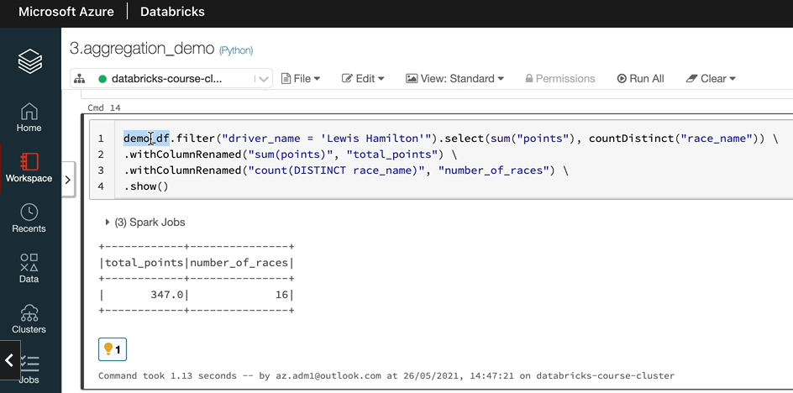

So let me switch to Excel and show you what I mean by that. What I did is actually I took the demo, the demo and discovered the output and put that into the spreadsheet. And we're going to go over that. So as you can see here, each driver has had sixteen or seventeen races or whatever, really in twenty twenty. So what we want is we want to group the data based on the driver name. So in this case, Alexa Albon is the driver and we've got 17 records. So we want to group all of this and we want to add the total number of points here, as you can see, which is one hundred and five for him and seventeen races.

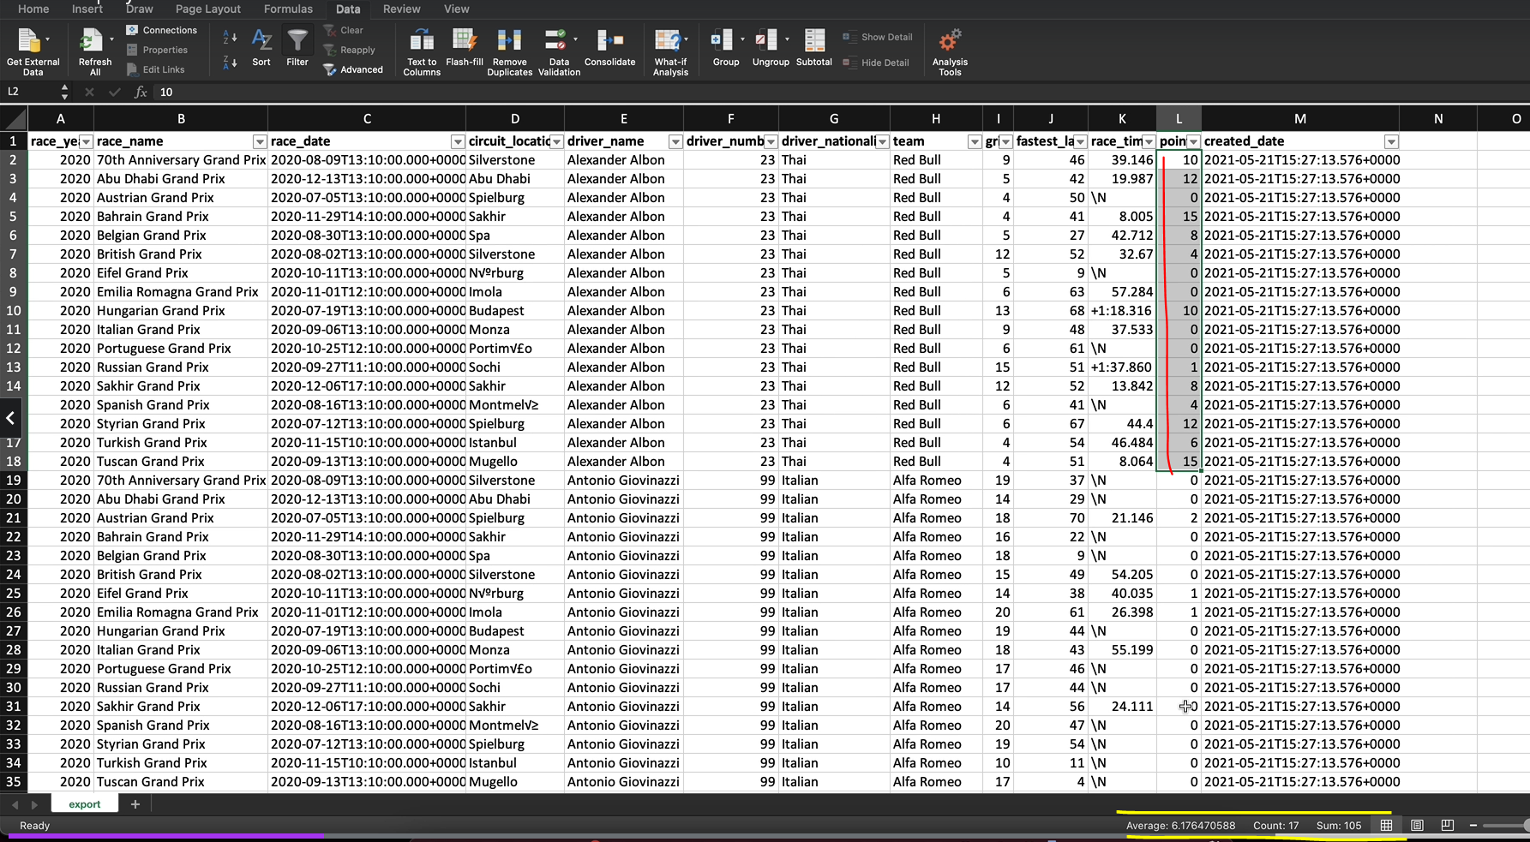

And we want to get one record out of this with Aleksandra Albon as the driver name and the count as number 17, which is number of races and the total number of points as one hundred and five. Similarly, if we take Lewis Hamilton because we were looking at his data, so we have got Lewis Hamilton here. So what we want to do is we want to group all the data related to Lewis Hamilton here, and we want to get the total number of points for him in the last year, which is, Tony, 20, which is three hundred and forty seven points in total. And he raised on sixteen races. So that's what we want. We want one record for Lewis Hamilton, one for Max with Verstappen, one for London. And as we said, every driver would have one record. So that's what we aim to do in this lesson. So let me switch back to the notebook. And as we said, so in order to do that, what we do is we apply a group by method on a data frame with the columns we want to group by on. In our case, it's the driver name and that returns back something called the group data object. And on a group data object, Spark lets us apply a number of aggregations and that's what we would apply. Let me show you what I mean. So if I just take this data frame, which is our demo_df data frame and if I apply group by on driver name. What you get back is a group data object and spark gives you a number of aggregations, you can apply on that. So let me go back to the reference. And if you look at the grouping, you have got a number of methods you can apply on group data object. So you've got the average, count, min, max, mean and all of those things. So that's what we would do. So let's switch back to the notebook.

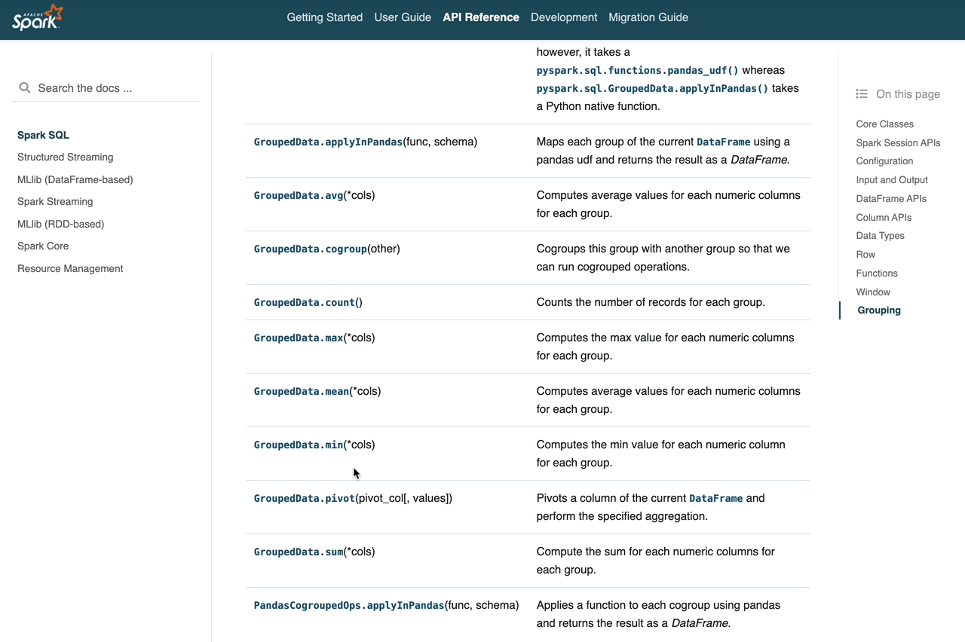

And what we can do here is, for example, in our case, we wanted to get the total number of points. So in this case, let's do some of points. If I did that, the output should be a data frame, as you can see here, and that contains the driver name some of points

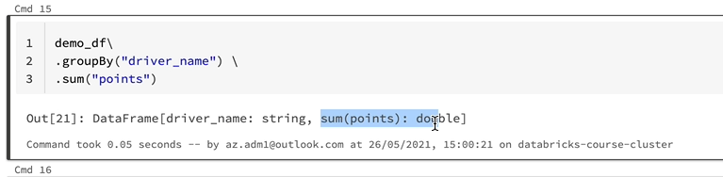

and let me do a show on the data frame and see the data. That should have the driver name, which gave us the group, which is the driver name here and the sum of points. So we got a record for each of the drivers. And as we discussed previously, Lewis Hamilton got thean 47 points. And if I find Alexa Albon that he should have hundred and five.

As you can see here, we have got one more aggregation to apply as we did previously, which is the count distinct number of races. So that will tell us how many races he raised. You would think you can just do this as current thing and then the race name and that would give you the output, which is not going to be the case.

|  |  |
| --- | --- |
| That's because, as it says here, data frame object has no attribute count distinct. In order to apply current distinct, you need to have the group data object. But as soon as you apply some here, your output is going to be a data frame.    So let me go back. If I just take this out and run it. As you can see, the type of the sum here is a data frame rather than a grouped data object. So let me do that. |  |

So when you try and apply current distinct honor data frame, that's not really available. So basically what we seeing here is you can't apply more than one aggregation when you do it this way. But interestingly, Spot gives you another method that's called the GroupedData.agg and for this method you can give an expression with a number of built-In functions.

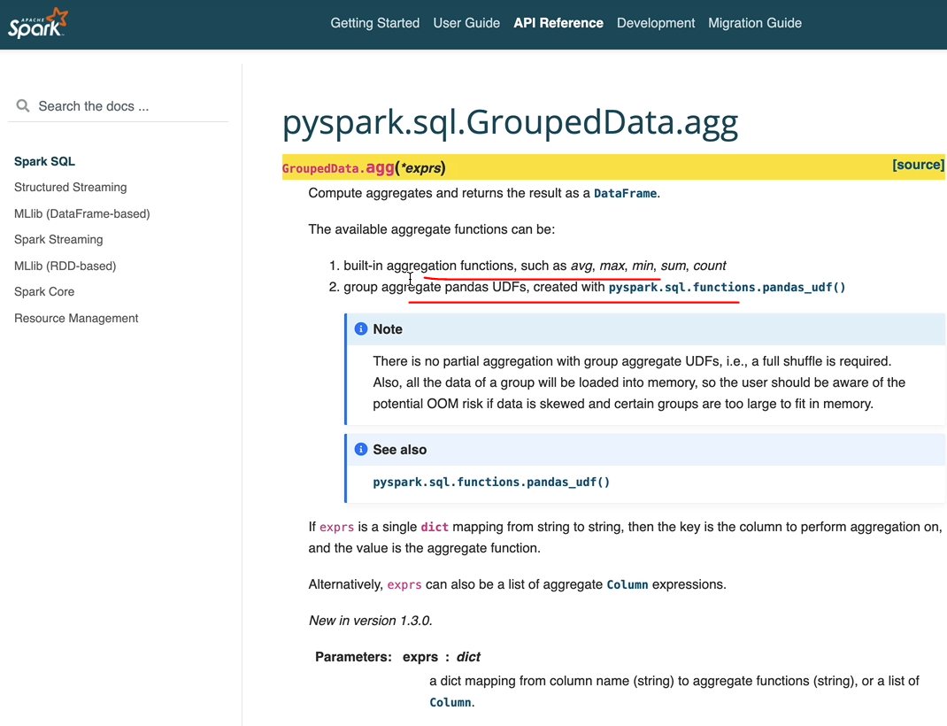

You can give more than one. That's what we want to do. Or you can give a pantless UTF as well. But we're not going to focus on policy here. We're going to focus on this one. So let's do that. Let me switch back to the notebook. And instead of some, we're going to use AG and within the AG, we using the builtin function rather than the function on the group data. Object and we're going to do both them and that we need an extra bracket here. And if I run this one, we should see the output we expect to see. So, as you can see, we've got the driver name some points and the count of race name.

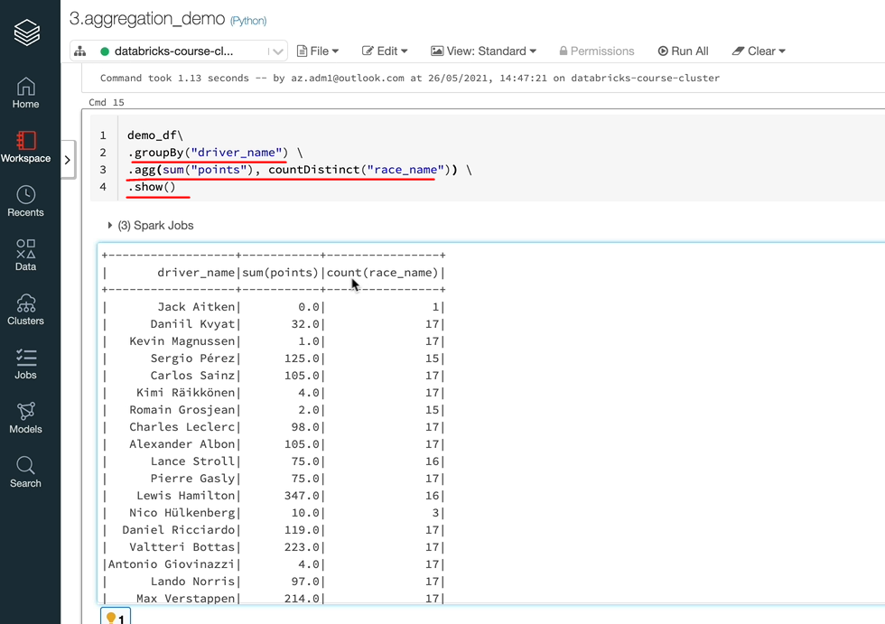

And if I can go to Hamilton, you've got the three and forty seven and sixteen races here. And similarly, Alexa Albans got one hundred and five points and is raised on seventeen races, as we did before. You may notice that actually we don't have a proper column name for this one, so we got the sum of points and the count of names rather than total points and the number of races. You can use the fifth column renamed like we did here, or there is a shortcut, you can do an alias here. So as you can see, the column names have now changed to total points and number of races, and we've got the data as we would expect. So that's how gloopy works. Just to summarize again by let's you group your data based on the columns you've specified here, you can have more than one column will use more than one column in the forthcoming lesson. And also you can apply any number of aggregate functions you want to apply on the data, but it applies on other specific groups and produces one record out of each of the group. And that's what you get out in Europe and hope that makes sense.

### Window Functions

We are going to look at binda functions, but before we start, let's create a data frame with some data which will make sense to use a window function so that I can explain it better. So let's get started. The first thing I want to do is I want to create the data frame with more than one year's worth of data. So I'm going to get the data for 2019 and 2020 because we've been working with only one year's worth of data so far. So that demo_df is now going to have 2019 and 2020 data. Let's do that. And as you can see, you've got a race here for 2019, and you will see 2020 as well, which is great. And while working on this, I'm going to also show you how to use multiple column names on the group by. So let's copy this again and use it here. And instead of the driver name, let's use the race here as well, because we have got two years of data here. That's brilliant, as you can see, we got every driver having now to record some drivers didn't race in twenty nineteen, so you won't see them in 2020 and vice versa as well.

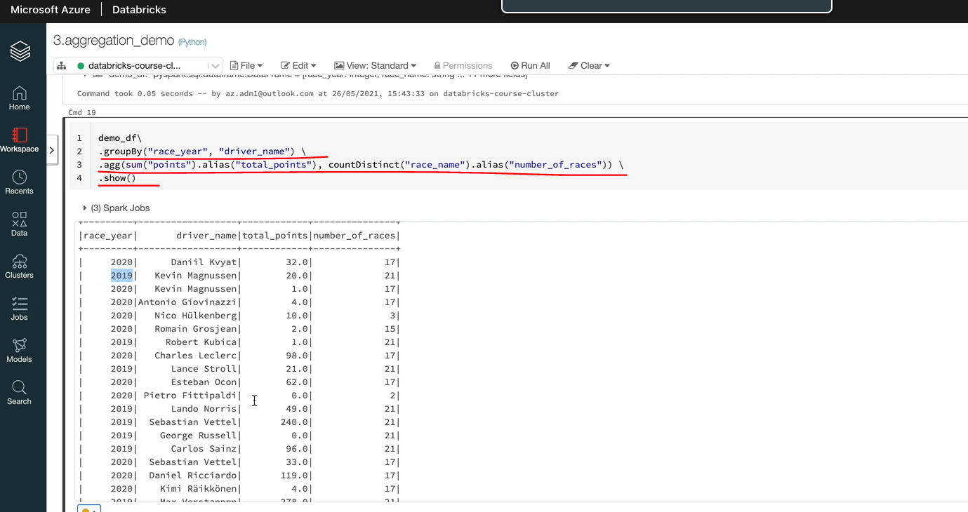

But if you had a driver who raised on both, then you're going to see him on board. So, for example, Sebastian Vettel based on 2019 and 2020 and his points are here as well. So let's put this into a data frame. I've got this data exported into a spreadsheet, so let's have a look at that and I'll explain what we want to get out of this. So as you can see, this is exactly the same data. All I've done is I've ordered it by the total points and the tax. So we got the twenty nineteen data here, the attorney races, and then you've got the 2020 data. And as you can see, Hamilton would be number one and number two and WAPT number three like that. So what we want to do is in our output data frame, we want to create a new column, call it rank, and we want to give them the rank based on their total points descending. So in order to do that, Spark gives you something called a window function. So you create initially a window specification. In that specification, you tell Spark how to partition the data and what to order by, and then you tell it what function you want to apply. So there are three things I just said. One is

1. how do you want to partition the data. In this case, we want to partition the data by this year because we don't want to mix the data from 2019 with the data from 2020. We want to create 2019 separated 2020. So because of that, our partition by column is our race year and we want to order by something. So in our case, the order by is the total points and

2. We want to order by descending the highest to the smallest. And then

3. We want to apply a function to produce the output here in this case, Spark gives you a function called a rank.

So that's what we would use. So let's switch back to our notebook. And the first thing we want to do is we want to create a window specification, so in order to do that, you need to import window. So let's do that. So we have created our window specification, as we said, very important window, and I called my specification as Drybar rank specification because that's what you need to do and that will be window dot partition by that is a partition by column and then order by. We want to order based on the total points and descending because this ending is a function, we need to import that as well.

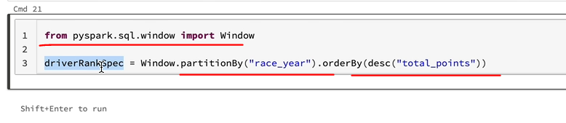

So the next thing we want to do is to apply our window function, which is the lank to our data frame using the window we've specified here as well. Let's do that. So our data frame here is the demo group dataframe and we want to say window. In this case, we have to add a new column because that is what we are doing that and that is going to be called a rank. So let's do the. And that column is going to have the rank function applied using the window specification we've specified. So all we have to do is in order to do that, you have to say over and then you give the window specification that we've created already. So if I go back again, so we apply that on a date frame and add a new column called Rank, and we're going to use the built in function rank() to go over our data set using the specification that we've created. So it'll go over this data frame using the specification here, which is the race year partitioned by and then the order by total points descending. So one more function we need to import a rank because we using that function here as well. So let's do that.

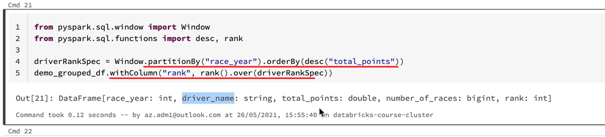

And that's worked, so the output we've got is a data frame with the Eurasia driver named Total Points and the number of races and rank. So let's see whether that's got the output we want at. And as you can see, it's done the job, so for twenty 19, Lewis Hamilton has scored 413 points and his number one ranked and it goes in that order and it's got the top 20 record.

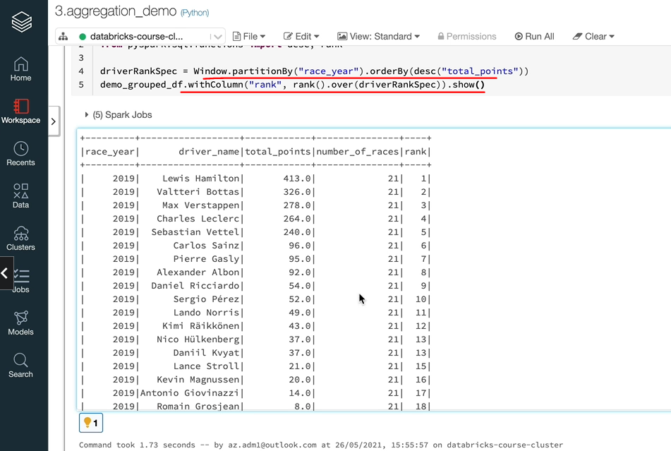

So if I did top 100, it's going to bring all the data back. Because we would have about 40 odd records, so Tony, 19 goes all the way, and then you've got 20/20 again, Hamilton's won the championship and then you've got about Verstappen and Paris. And so it goes all the way like that and you've got some ties as well. As you can see, we've had people with 4 points, is that total points? Yep, so we've had, uh, uh, juvenile Sea and Richen and having 4 points and both of them are ranked number 16. And similarly, these guys haven't scored any points and they are all number 21 here. So that's how it works. You have got a number of other functions you can use against him in the specification and they're called window function. So the way you find them is you come over to the reference and the functions. If I now search for rank, that's going to say it's a window function. So similarly, if you look for window function, you are going to find all the window functions. So let me do that. And these are all window the.

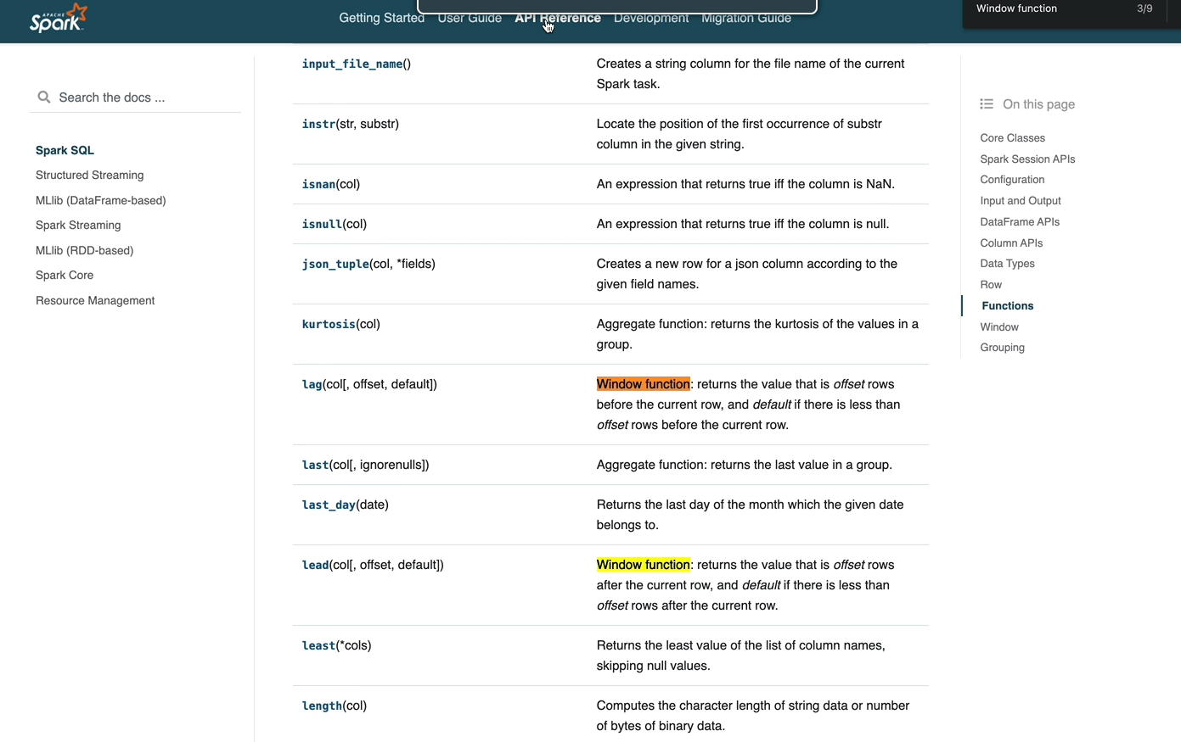

So you got like lead and all of those things, and if you want to look at the window specifications and all of those kind of things, you can look them here and be used the order by the partition, by. But you have other things like rows between.

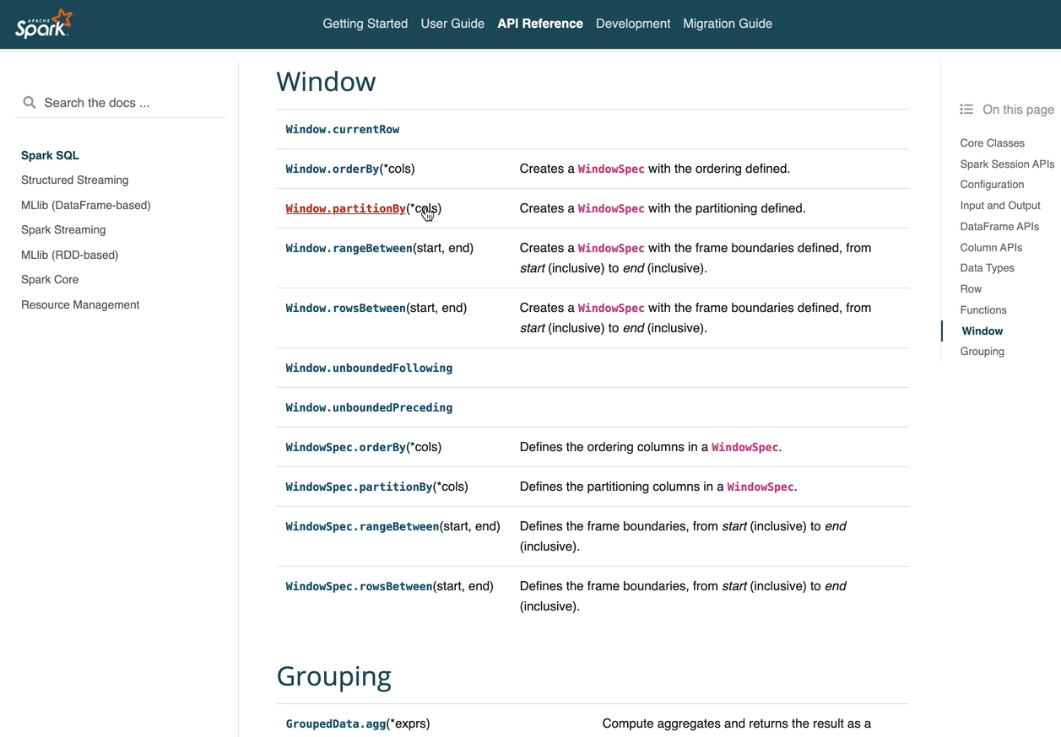

So within a window you can specify which roles you want to pick. You can go one above, one below or all of those kind of stuff. So I would encourage you to read this documentation for that. So that's the end of this lesson.

### Driver Standings

Now that we understand how the aggregate transformations work and we've seen some demos, let's put that into practice. So for this one, again, we're going to take some inspiration from the BBC website. So let's assume that we got to expose the data to an API that will pull the data into a website or something similar. So I'm on the BBC website, and if I go under Formula One understanding's, we would see both drivers and the constructors standings. So we're going to try and replicate the drivers standings first. So in order to do this, we need data related to the driver. So as you can see, you've got the driver's nationality in the form of a flag and then you've got the driver name and the team for which the driver is racing, for which we call constructors in our data and the number of wins he's had and the number of total points he scored in that season.

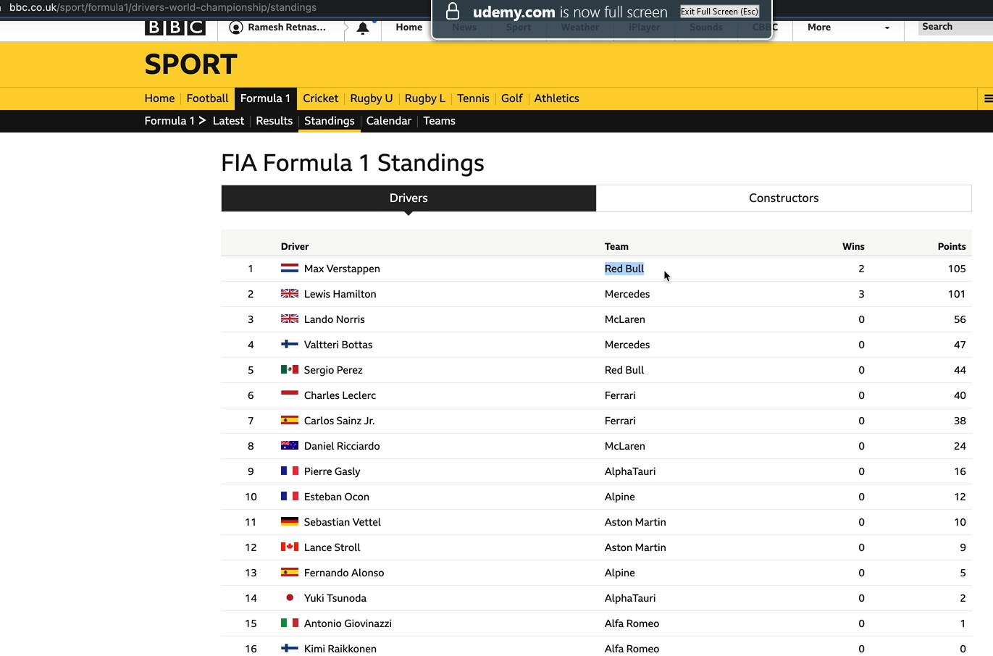

So what you're seeing here is for the current system, which is 2021, but we would make sure that we have data for all of the seasons. So in our demo, we did most of the things we did. The driver details, the team details, and we also did the total points and we ranked the drivers as well so we can put that together. But one thing we didn't do is the number of wins. So in order to do that, we have got another attribute in our results table. So let's switch to the data model.

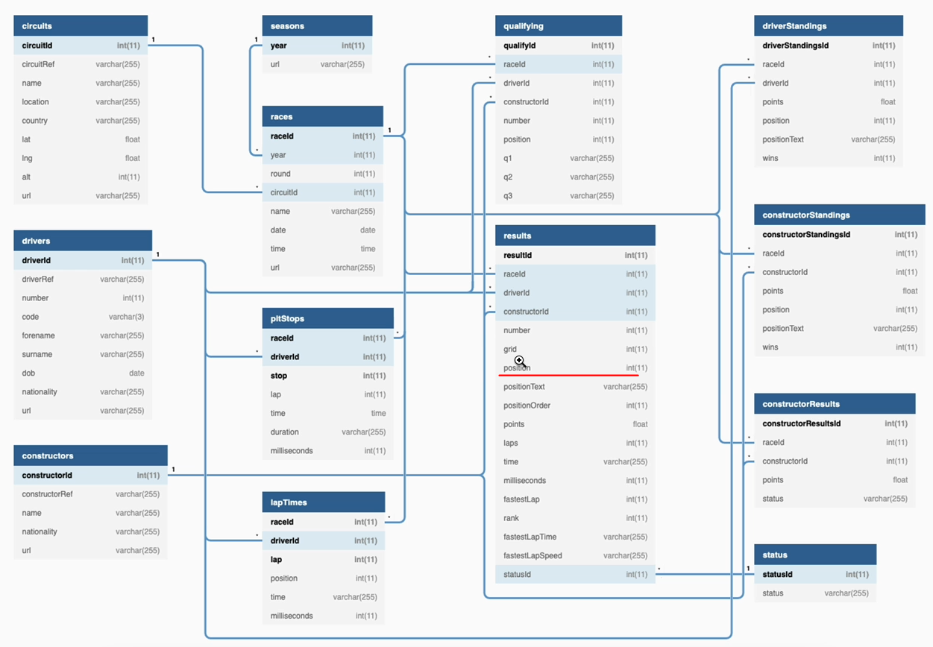

As you can see here on the results table, we have a column called Position and that has the position in which the driver finished the race. So if it is one, that means he won the race. So that's the one we can use in order to find whether the driver won the race. And then we'll summarise it for the season and then output how many races he won. So let's switch to the data workspace before we start. You may have noticed that the user interface has slightly changed. Yesterday was the data and a conference for 2021 and data breaks announced a lot of new things and they rolled out a lot of new things. And one of them seemed to be the user interface. It's not vastly different, is different. They've grouped things together. So we have got a dropdown here for data science and engineering and machine learning.

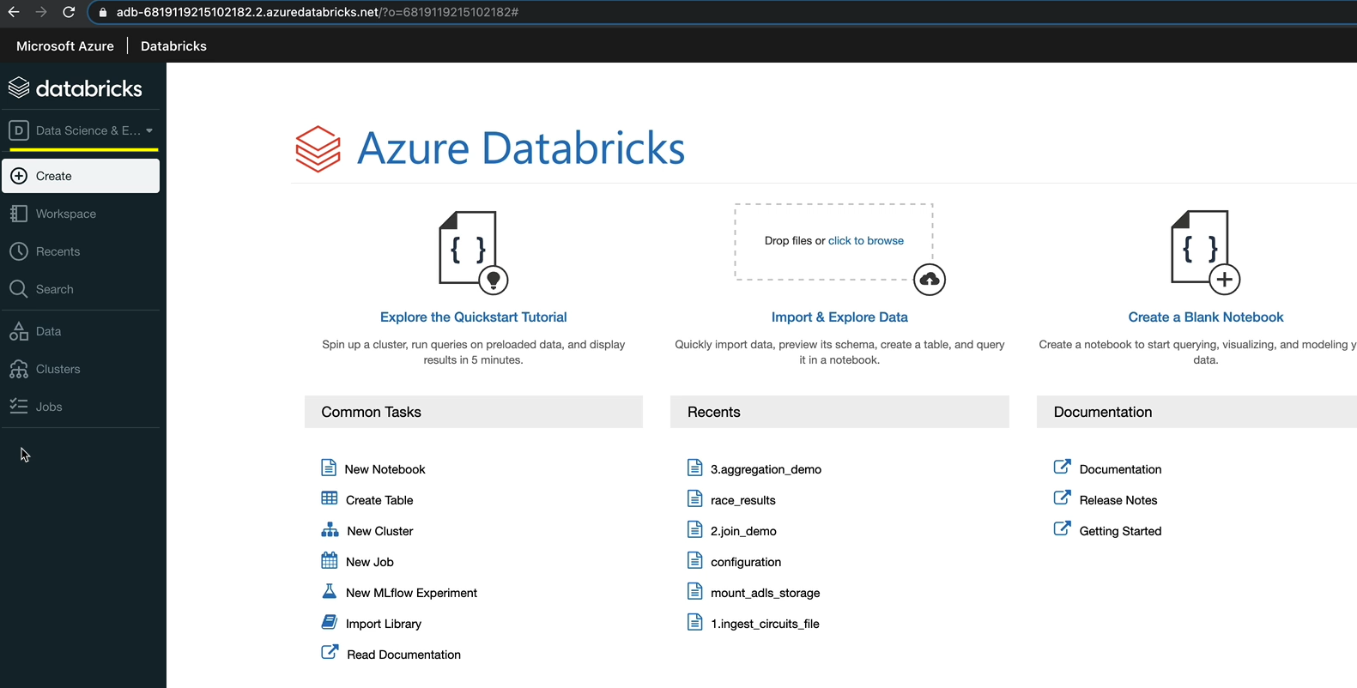

So things like experiments and features, tools and models are grouped and the machine learning, but are working on the data science and engineering here. Mostly everything looks the same, except that actually you got some shortcuts here to create notebooks, tables, clusters and jobs. But everything we went through previously still holds true because you can go into the workspace and then create whatever we were creating previously. So you have the option to do those as well. And these are just shortcuts in the outer user interface. So let's go to the workspace, and before we start doing this aggregation work, we want to do, we want to make changes to what we did previously, because position is a new column we want to bring in, which we haven't got at the moment. So let's go to France and under race results, we want to pull in the position as well. So we got the points here. So let's add position column as well, and we can do it on all. But before we do that, I have missed my naming standard here. So I was having numbers at the beginning. So this is one race results. So I've just done the change as well. And let's do it all. OK, that's now completed, and as you can see, we've got the position here and on the tight end to Abu Dhabi Grand Prix. Max Verstappen scored five points and he finished the race first as well. And then you've got botas second with 18 points, things like that. So this is what we want.

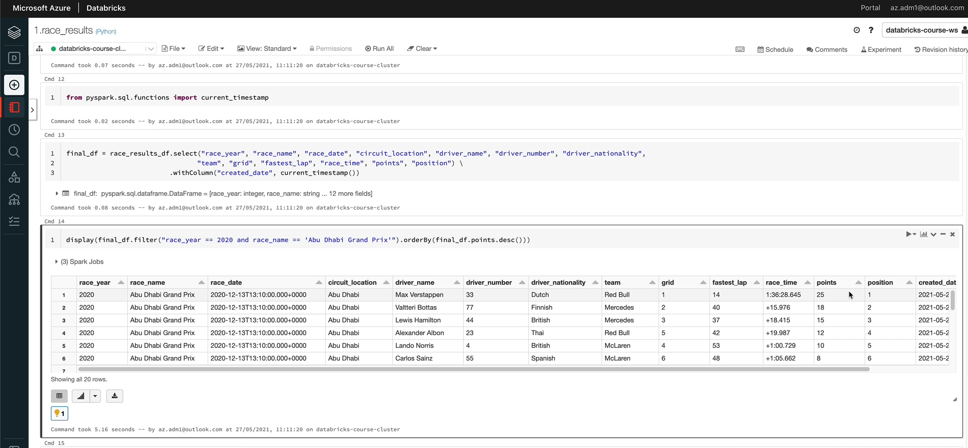

So we are going to use the position as number one to indicate that he won the race. So let's create the new notebook for us to have the driver standing. So I'm going to create a new notebook and call that as two drivers standings. So the first thing we want to do is to run the configuration so that we get access to our main points in the fall to parts.

%md

##### Produce driver standings

**Produce driver standings**

%run "../includes/configuration"

So the next thing we want to do is to read the data, which is the race results into a data frame. So let's do that. So we now have the data in our races and the results data frame, and I'm going to just display that so we can work on that data. So let's read that into a data frame, so I'm going to put that into a data frame called the drivers_standings_df and we want to read the race_results_df. And the first thing we want to do is, as we said, is to group by the data. So let's do the group by. So we want a group by race here, obviously, because we want that. And this is driver standing. So we want to have the driver name. And as we said, we need the driver nationality. And also, if you remember, we got the team as well, so these are the columns we want to group by. So which is the driver nationality name and the team name? And these are the aggregations we want to perform. So let's go back here and add the team name as well.

And the next thing we're going to do is to do the aggregation. So in terms of aggregation, we know that we need the sum of points. So let's do that first. And let's also import some function, because we are using this built in some function here. So let's run that through just to see the data and I'm going to do a display on the data here. And as you can see, we got the total points and we got the racecar driver name, nationality and team.

from pyspark.sql.functions import sum, when, count, col

driver_standings_df = race_results_df \

.groupBy("race_year", "driver_name", "driver_nationality", "team") \

.agg(sum("points").alias("total_points"),

count(when(col("position") == 1, True)).alias("wins"))

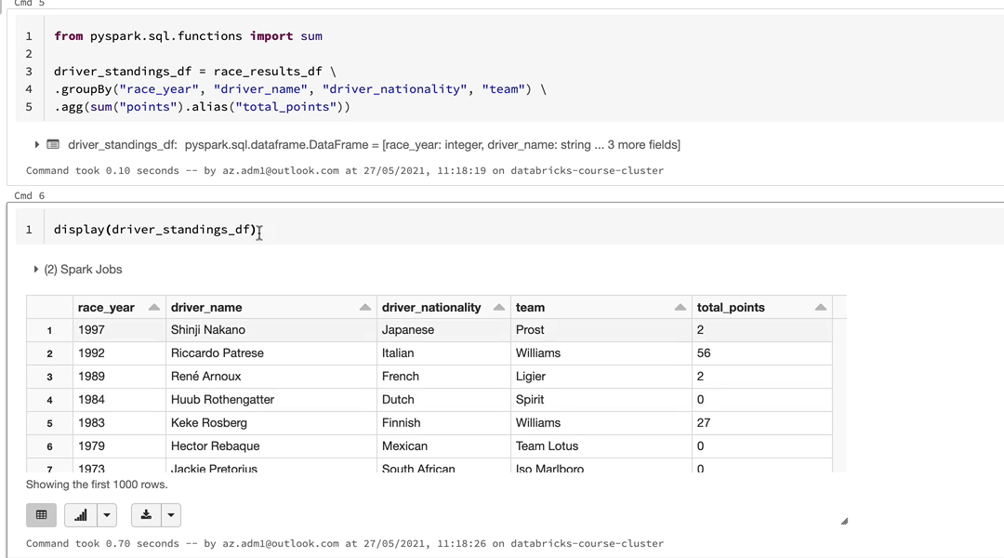

So I'm going to just do a filter on one of the years so that it will be easier to look at the data. OK, so that looks good

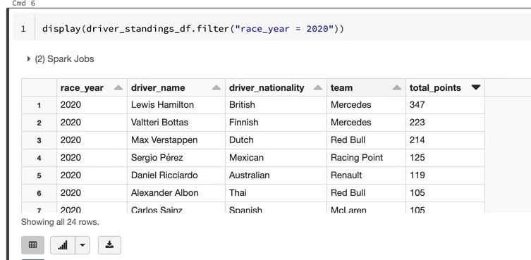

So the next thing we want to do is the tricky one, which is to count the number of beans. So I'm going to add that, as we said before, within the AG function, you can have as many aggregations as you want. So we know for a fact that we need the count. But it's not a simple count we're looking for. We're looking for a condition. So then the position is 1. So we got positions here. And if the position is 1, we want to consider that as have been. So in order to do that Spark gives you another function called the when. So I'm going to use that. And you need to import when as well. Within, when we want to say if the position is 1, then count it otherwise don't count it. So I'm going to read the position column here and then say when that is equal to 1, because the Python notation, you got to use == double equals there and that is equal to one. You're going to be begin to say that's true. Otherwise it's false. So the count is only going to count the trues here. So with that, we have got the count done, but let's do an alias for that into a column called Wins. And now we should have the Wins in our data frame as well. So I have an import function count, so let's import that as well. And again, I have an imported the call function, so I've done that as well. So now this data frame should have the Wins as the column there, so let's run this to see whether we have got the.

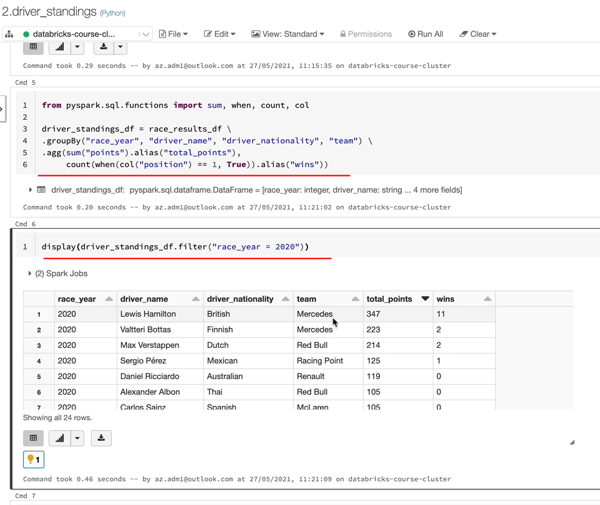

So we have got the new Columbine's, so let's honor the by the total points descending and then he can say 20-20 was won by Lewis Hamilton and he's had ten forty seven points and 11 points. So he said a very dominant year there. And Portus had two wins and things like that. So we have got all the wins here as well. So this is kind of what we wanted. So if we go back there. So we've now achieved the wins and the points. So there is one more thing to do, which is to have the rank for the drivers.

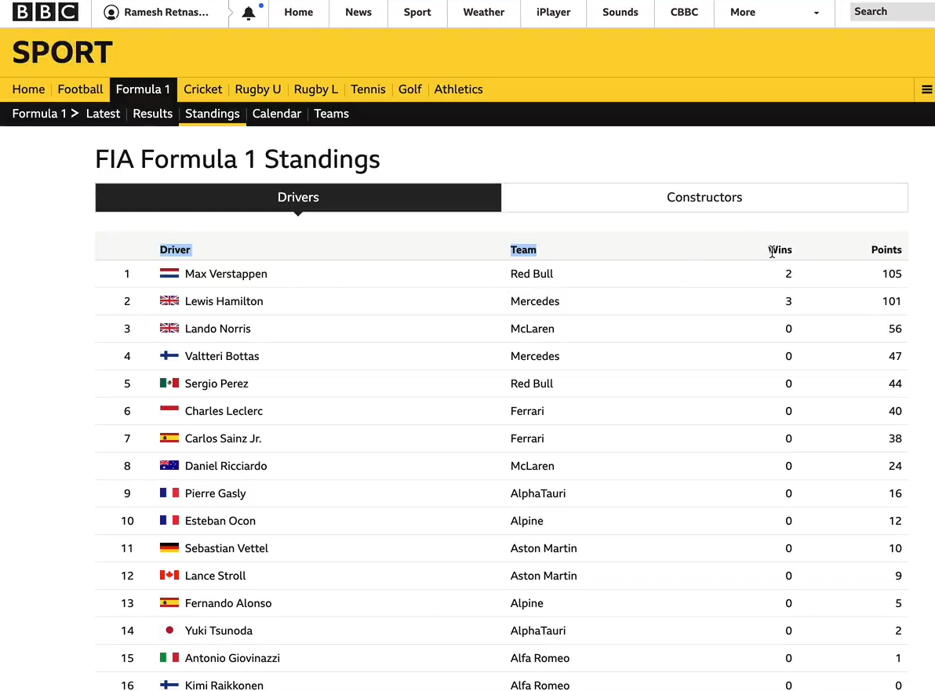

In order to do that, we now know that we need to use the window function. So let's get started with that. So I've just imported the window and the descending and the rank function. So we would need and the next thing to do is to create the window spec. So let's do the. So our partitioned by column would be races, because we are ranking the driver within the race here, which we did in our demo lessons as well, and we need to do an order by. And they are the body has to be based on the descending total points. And we could use another order, because if the total points a driver has tied, then the ranking could be based on the number of wins, for example. So I would do a ascending, sorry, descending, and that would be number of wins as well. So once we've done the total points, if it if there is a tie, then based on the win, actually the driver with the most wins would be given the highest ranking. So that's done. And we need to create the data frame now with the window spec being applied. So let's do that. So that will be this data from the data frame we've created already with a new column being added. And we're using the rank function, as we said, and that's going to be war with the spec we just created here, which is the driver of rank specification.

So that should give us a date frame, which would contain the rank as well. So I'm going to do a display on the final date frame. So let me copy that. And as you can see now, we've got the rank, if you look at the 2020 data, so Lewis Hamilton came first and all of this, but we got a tie here and they've both been given the rank of six. But if one of them had been win and the other one didn't, then they would have a higher ranking compared to the other one, which you can see here.

from pyspark.sql.window import Window

from pyspark.sql.functions import desc, rank, asc

driver_rank_spec = Window.partitionBy("race_year").orderBy(desc("total_points"), desc("wins"))

final_df = driver_standings_df.withColumn("rank", rank().over(driver_rank_spec))

display(final_df.filter("race_year = 2020"))

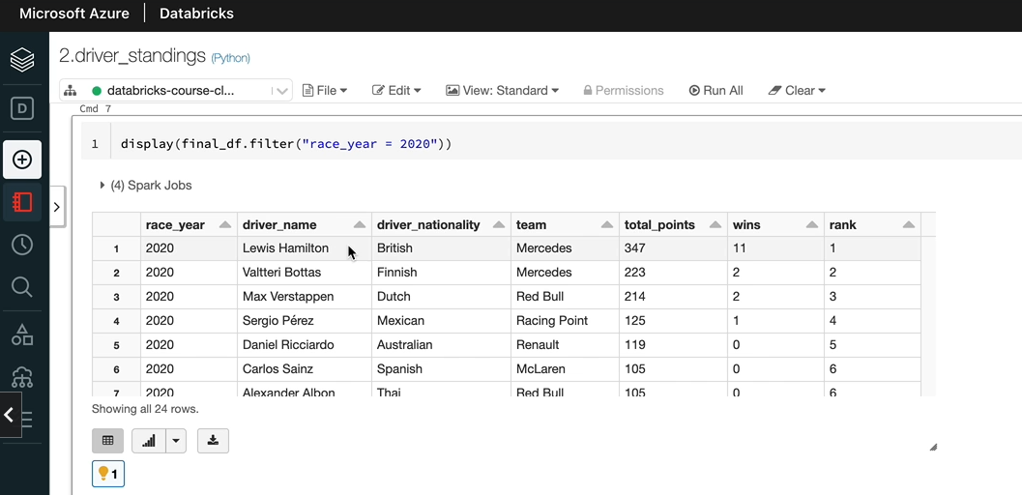

Uh, Gastly and Stal has got seventy five points, but Gastly had been. So that's why he's being ranked higher than Struhl. So so that's how you do the render functions, but the last thing we want to do is to write to the parquet file. That data is now written.

final_df.write.mode("overwrite").parquet(f"{presentation_folder_path}/driver_standings")

Full Code

**Produce driver standings**

%run "../includes/configuration"

race_results_df = spark.read.parquet(f"{presentation_folder_path}/race_results")

from pyspark.sql.functions import sum, when, count, col

driver_standings_df = race_results_df \

.groupBy("race_year", "driver_name", "driver_nationality", "team") \

.agg(sum("points").alias("total_points"),

count(when(col("position") == 1, True)).alias("wins"))

display(driver_standings_df.filter("race_year = 2020"))

from pyspark.sql.window import Window

from pyspark.sql.functions import desc, rank, asc

driver_rank_spec = Window.partitionBy("race_year").orderBy(desc("total_points"), desc("wins"))

final_df = driver_standings_df.withColumn("rank", rank().over(driver_rank_spec))

display(final_df.filter("race_year = 2020"))

final_df.write.mode("overwrite").parquet(f"{presentation_folder_path}/driver_standings")

### Constructor Standings

Now that we produce the data required for the drivers standings, let's look at the constructors standings and as you can see, it's quite simple. So we got the team name, which is the constructor name in our case, and it's the number of wins the team had, including both drivers. So the team, as you know, has two drivers and two cars racing. So it's a combination of both drivers Wins accounted here and the points from both drivers are counted as well. But for you, it shouldn't matter if you bring all the data together, you do the aggregation against the team. And once we've done that, we want to rank the team as well in the order of their points first and then the events similar to how we did the driver standing. We can drive the constructors standing of the race results data set as well.

The first thing I want to do is to take the driver standing, not the conclusion it so that we can just use the logic in the drivers standings. And I'm going to call this not because constructors standings. And as we said before, we can use the same file, which is the race results, which is got the team details as well, so that'll be good for us. But we want to rename the data frames to constructors standings because that would make sense. And in the group, why we don't want the driver details anymore. We only want to do the summary on the team detail so that both drivers details are summarized. Uh, the the aggregations are exactly the same, it's just that we've taken the driver details of the group by so the somebody is going to be on the team as opposed to the two drivers in the team. Uh, let's change the date frame name here to. And in terms of the ranking, again, it's the same logic within the race here, we want to see which team ranked first, second and things like that based on the total points and events. The one thing I would do is to rename the specification name here, as well as the date frame details. And I want to when we write the data, we want to write it to a new file called Constructors Standings. So I think I've done all the changes we needed to make.

**Produce driver standings**

%run "../includes/configuration"

race_results_df = spark.read.parquet(f"{presentation_folder_path}/race_results")

from pyspark.sql.functions import sum, when, count, col

constructor_standings_df = race_results_df \

.groupBy("race_year", "team") \

.agg( sum("points").alias("total_points"),

count(when(col("position") == 1, True)).alias("wins") )

display(constructor_standings_df.filter("race_year = 2020"))

from pyspark.sql.window import Window

from pyspark.sql.functions import desc, rank, asc

constructor_rank_spec = Window.partitionBy("race_year").orderBy(desc("total_points"), desc("wins"))

final_df = constructor_standings_df.withColumn("rank", rank().over(constructor_rank_spec))

display(final_df.filter("race_year = 2020"))

final_df.write.mode("overwrite").parquet(f"{presentation_folder_path}/constructor_standings")

So let's run it through and look at the data. So one thing you may notice is when we closed the notebook, the notebook is not attached to the cluster we want. So you've got two choices. Either click, attach and run or go and attach it here so you can cancel out and then go back and do it.

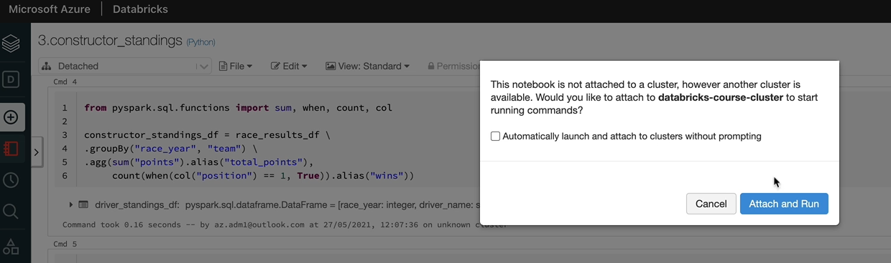

And that should attach to the cluster, which it's done. And it's running the notebook now. And that successfully completed and let's have a look at the outputs, so as you can see, this is our final output for 2020 Mercedes where the champions and between the two drivers, the total number of points is 573 with 13 wins. So the ranking has been applied as we expected, and all the data looks good to me.

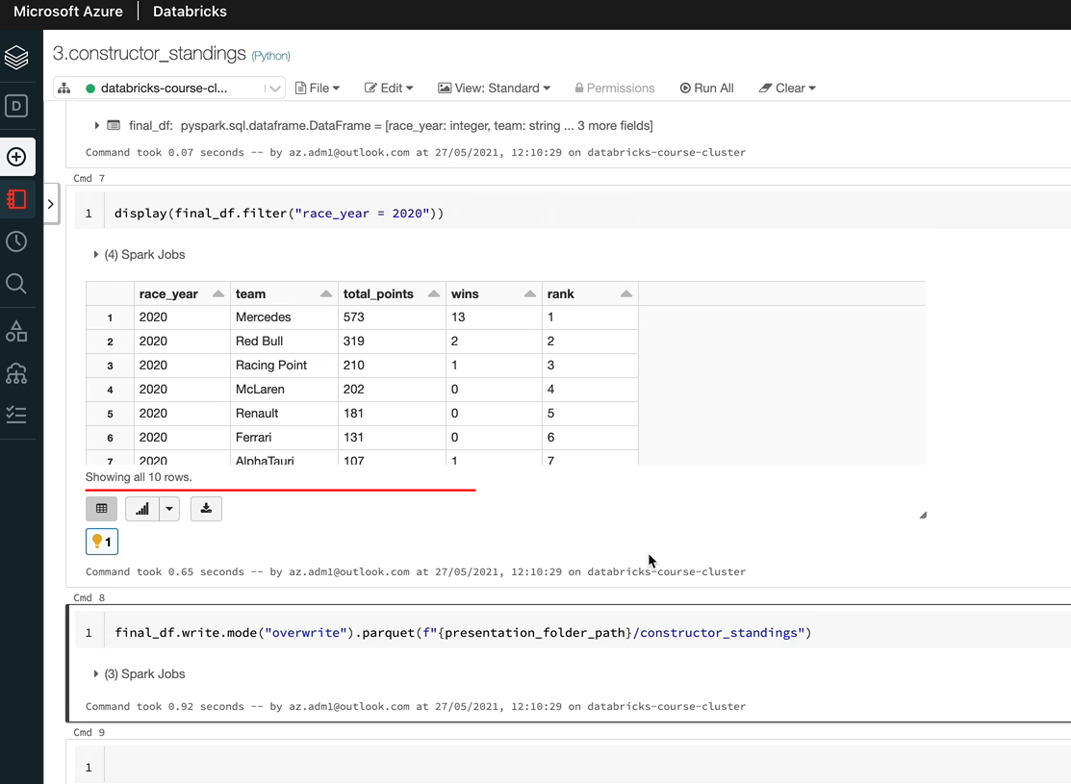

## Using SQL in Spark Applications

### Local Temp View

In this lesson, we're going to look at how to access a data frame from school in order to access data frame from sequel Spark gives you two options. One is to create a template view and the other one is the global view. So in this lesson, we are going to look at creating temporary views. Our objectives here are to create a temporary view on a date frame, and then we'll access that view from a SQL cell as well as Python cell. So what I've done here is I've already created a Python notebook, as you can see, and I put that into our demo folder and called it 4.sql_temp_view_demo.

%md

#### Access dataframes using SQL

##### Objectives

1. Create temporary views on dataframes

2. Access the view from SQL cell

3. Access the view from Python cell

%run "../includes/configuration"

So the first thing we want to do is to run our configs notebook so that we get access to the variables with the folder paths. And the next thing we want to do is to create a data frame so that we can create a single view.

On top of that, I'm going to use the arrays, underscore results file that we created previously with the races and results data. And as we know, that's a parquet file. I'm going to read the parquet file and put it in this data frame race_results_df dataframe. Let me execute that one. And the next thing we want to do is to create a view on top of this data frame. That's what we want to do so that we can run a sequel on that view. So in order to do that, this path gives you a method called the create temp. We know is the key thing here is as the camel case. So it's lowercase c and then uppercase T and B, so you have to make sure you use in that. Otherwise you'll get an error and you pass in a parameter to that. That will be the name of the view. So I'm going to call mine v_race_results. Let me execute that. And now we have that view already created for us. So we need to access the view. So we have got the temporary view on our data frame

race_results_df = spark.read.parquet(f"{presentation_folder_path}/race_results")

race_results_df.createOrReplaceTempView("v_race_results")

So the second step is to run it from a SQL cell. As we know, this is a python notebook. So I'm going to do percentages, equal magic command, and then you can just access the view like you would on any relational database. So let me do a select from the will select * from v_race_results and that will give you the output.

%sql

SELECT COUNT(1)

FROM v_race_results

WHERE race_year = 2020

And if you want to add a better class to fill to some data, you can do that. So let me do that. This year equals 2020 and you've only got the data from 2020 so you can do any kind of aggregation.

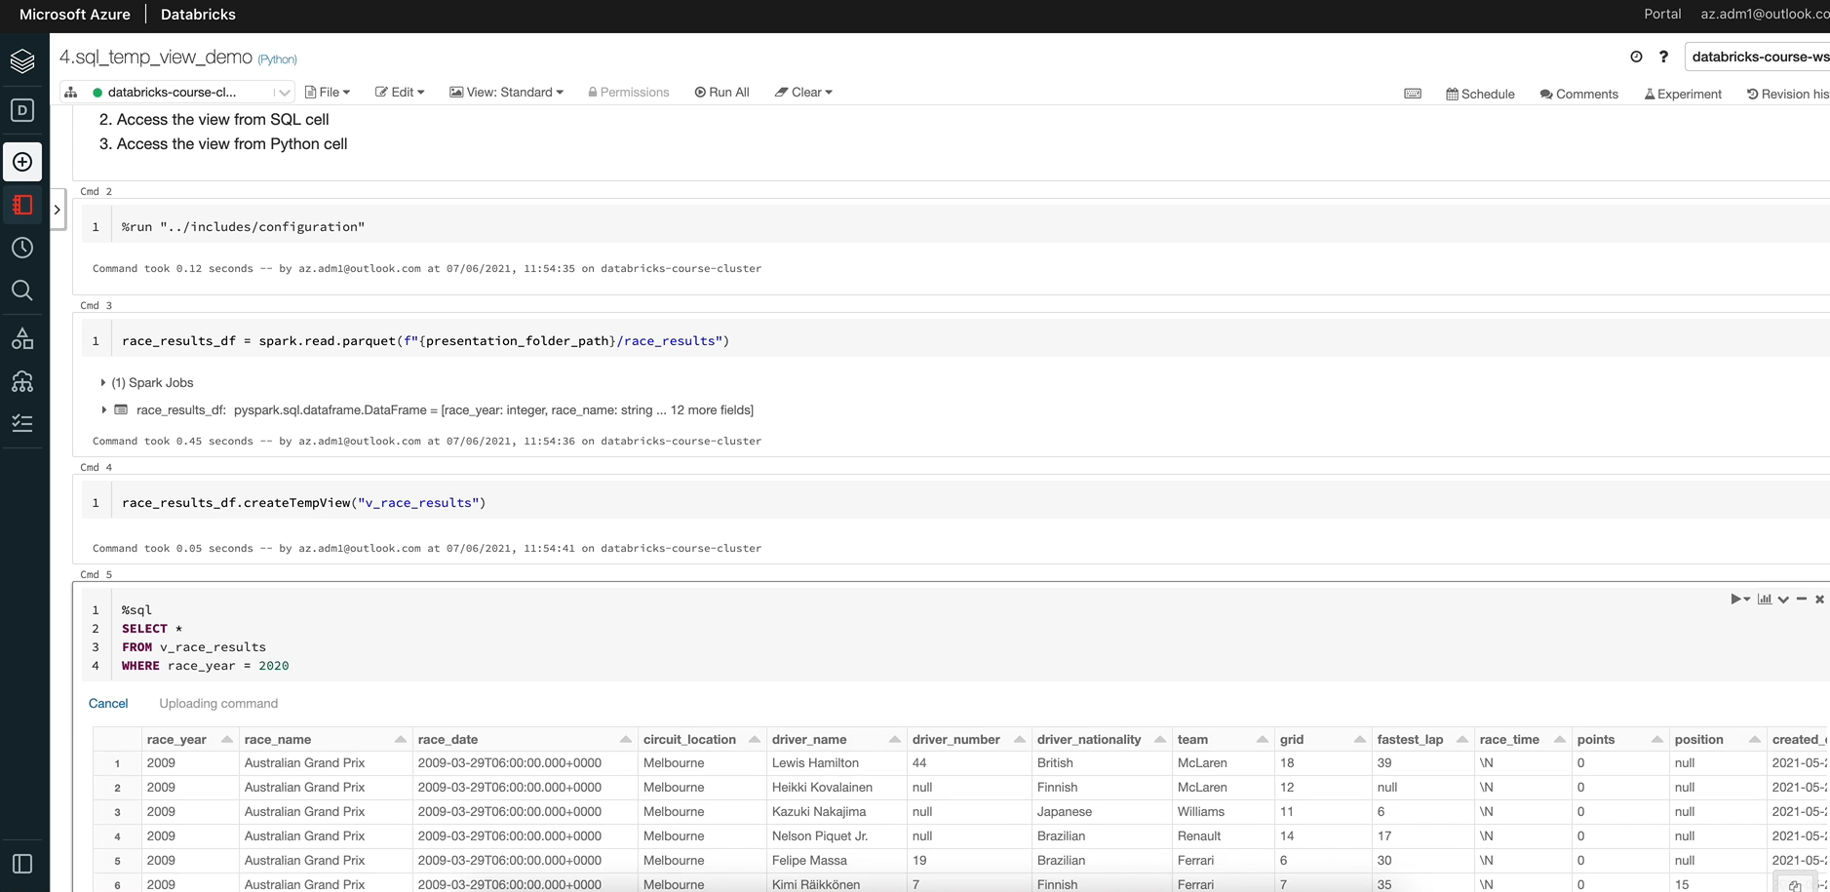

So let me do a count and that will tell me the number of records there. So that's three hundred and forty.

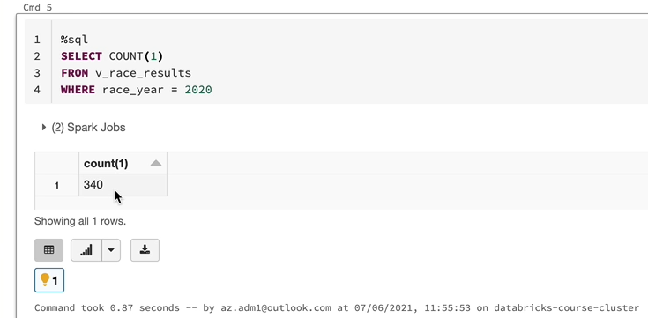

So you can do everything you normally do in SQL against this view, which is really powerful. So let's now look at how to run SQL statements from a python cell. We are in a python notebook, so we don't need any magic commands. In order to execute a SQL from Python, Spark gives you a function called SQL, so you access it by spark.sql and then you just send in the SQL we want to execute. So in our case, if we say select * from v_race_results, which is our view, and it could give a filter where race here is 2019, for example, executing this statement would give you a data frame. So let's put that into a variable. So I'm going to call this one nice race_results_2019 date frame equals. And I see you have, as you can see, that return the data frame and that's in here. And if I just do a display on the data frame, I would see the results.

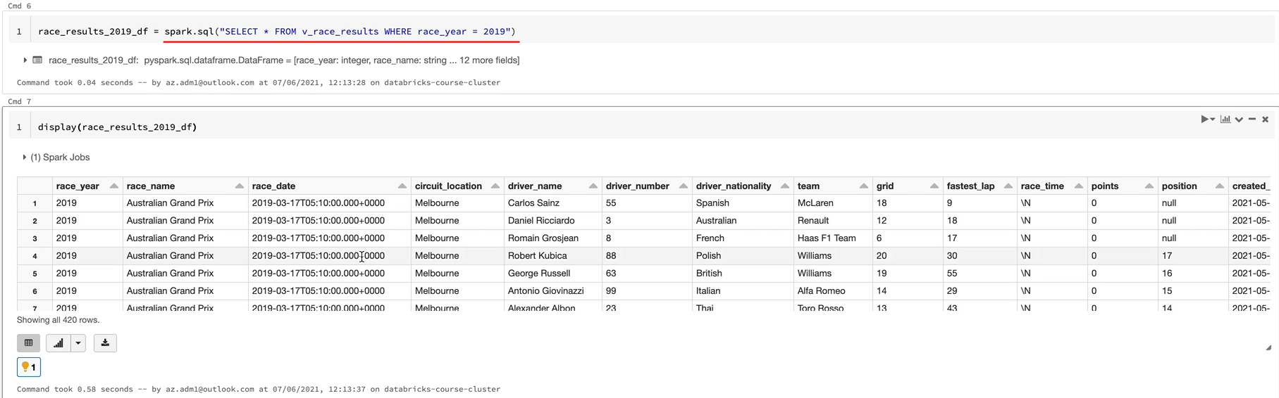

So that's quite powerful, as you can see. You can run a sequel from the SQL cell as well as from the SQL function, which you can use within Python as well as Scala. So you can combine both SQLs and the Python statements in your notebooks and get the best out of both. Really, you might be wondering when to use the SQL Cell as it is, and then to use the spark.sql. Spark gives you the ability to put that data into a data frame and then you can use your data frame API to do whatever you want it to do. And also there is one other benefit is actually, for example, if race year is in a variable and you want to pass that into the second statement, this is the way to do it. You can't really use a python variable within a SQL cell. But if in your case, for example, you are getting a parameter into the notebook by the widgets, and that's called the race year. And the value is being passed in. And you want to use that in your SQL statements, you can do something like this. Let me show you.

p_race_year = 2020

race_results_2019_df = spark.sql(f"SELECT * FROM v_race_results WHERE race_year = {p_race_year}")

So I have a parameter and I call it race year, and that's 2019. And we want to use that in your 2nd statement. Let me execute this first. And you could just do the string and then you can use the variable here. So now, as you can see, I've managed to send the race here as a parameter so I can quite easily change the year in the variable value and make my SQL query, quite dynamically so you can even pass in a different table name, you can put in a variable name. You can do whatever you want and manipulate this. So, for example, if I wanted to write the data from this table into separate files based on the years, I can put it in a for loop and then pass in the ratio for each of the years and output the data frame into a file, a separate file every time.

I hope you now understand how to use a SQL to access a data frame. One more thing I want to show you before we finish this lesson is that this is basically a temporary view. A temporary view is only valid within a Spark session, so it's not available in another notebook. And also if you detach the notebook from the cluster and reattach it, this view is not going to be available. So let's create another notebook and then we'll try and access this view from there and it won't be available. So let's do the.

So if I just did select * from the in the race results and let me do a %sql as well, and that's going to tell me the table of you does not exist.

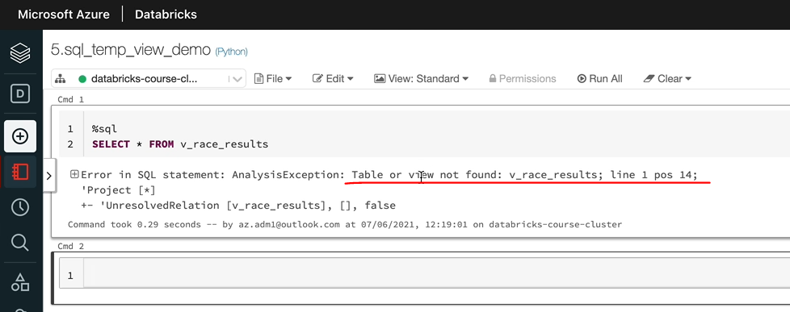

And also, if we go back to our other notebook and if I detach and reattach the cluster, that's going to give the same error in this notebook. So basically, this view is only available within that box. And so if I run this one, I'm going to get the error table does not exist or it's not found. So temp reviews are only available within this box session in the databricks context. That is the current notebook that you have created. The view is the only notebook, which is got access to that view. So in order to access the view again, we like to recreate it. So let let me run the entire notebook. And as you can see, that's now given us back the results as 340. One more thing we always do is to be able to realign our notebooks. But in this case, if I on the notebook again, it's going to fail because this view already exist and created temp view is going to tell me that it already exist. So it's going to give me an exception. So in order to replace a view which already exist, there is a method called createOrReplaceTempView(). So that's what we use here.

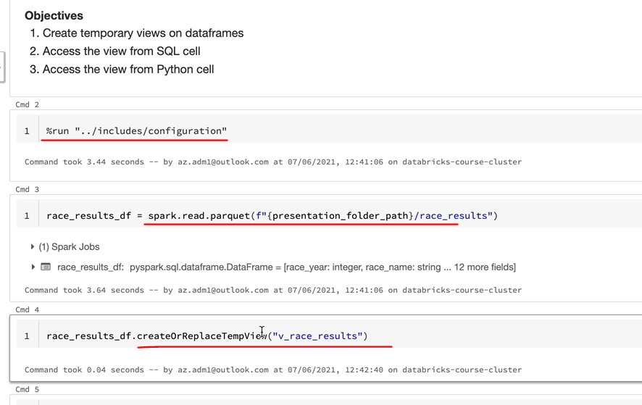

So that is, again, make sure you notice the case in their. So when I run it now, it's going to click The View if it doesn't already exist, otherwise, it'll replace the existing view. In our case, we already have it. So it's going to replace the view and it just succeeds. So my personal preference normally is to always use clay or replace temporal rather than using you. So that's everything I wanted to cover in this lesson. And in the next lesson, they look at the global temporary reviews, which will be available across notebooks.

### Global Temporary Views

In this lesson, we are going to look at global temporary views similar to the temporary views we created in the last lesson, global temporary views can be created on dataframes. So that's what we're going to do. We're going to create a global temporary view on a data frame, and then we'll access the global temporary view from a SQL cell as well as a python cell. And also we will try and access the global temporary view from another notebook. The main difference between the local and the global temporary view is that the local temporary view is only available within this Spark Session. In the context of databricks that is just the notebook from where it's being created, whereas the Global temporary view is available within the entire application. In the context of databricks, an application is basically all the notebooks that are attached to the databricks cluster. So any notebook we attach to this cluster here will have access to the global temporary view. But if we have another cluster and we try and access the global temporary view, that will be available. So let's create the global temporary view first, I'm going to use the same data frame that we used for the temporary view previously and use the global temporary view. The only difference is when you create the view instead of just saying createOrReplace temp view, you're going to say createOrReplaceGlobalTempView.

%md

##### Global Temporary Views

1. Create global temporary views on dataframes

2. Access the view from SQL cell

3. Access the view from Python cell

4. Acesss the view from another notebook

race_results_df.createOrReplaceGlobalTempView("gv_race_results")

And I'm going to call this one as gv_race_results, and let's execute that one, and that's done. So let's try and access it from SQL first, if I just did SQL style from gv_race_results.

%sql

SELECT *

FROM global_temp.gv_race_results;

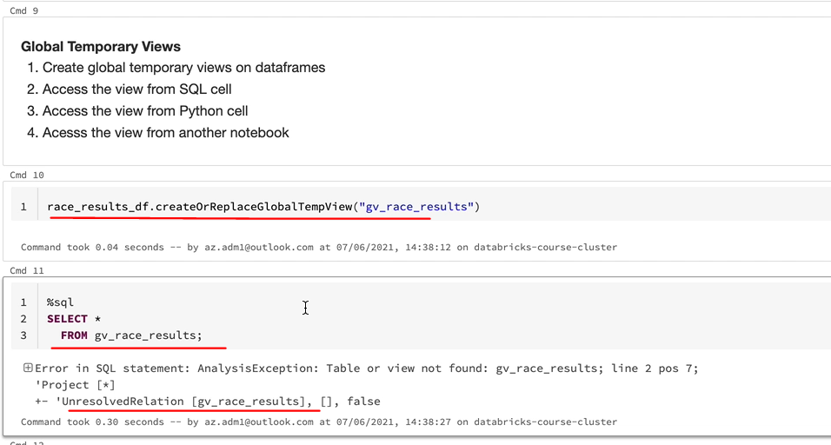

It's not going to work because what happens is when we create a global temporary view, databricks will register that view, our spark will register that view against a database called Global Undiscovered Temp. I'll show you how to see that I'm going to run a command called Show Tables.

And that list all the tables in the current database, but in this case, our current database is just default. So that's why we're only seeing the v_race_results, which is our temporary view that we created and as it says here, isTemporary as true.

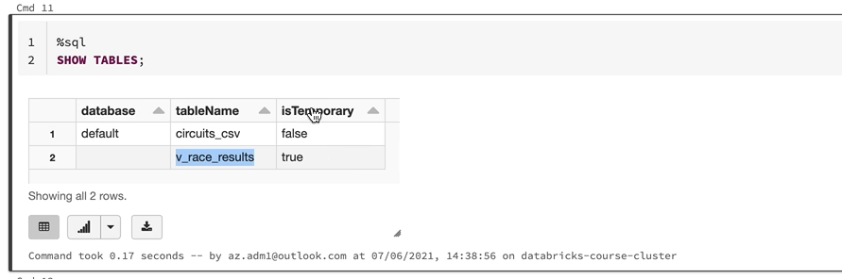

But in order to see the one under the global temp, you just do so tables in global temp and you will be able to see the view there.

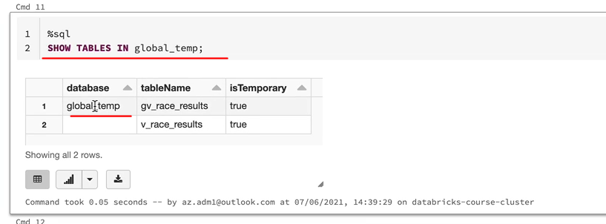

So as you can see on the global temp database, we got the gv_race_results and this is the database name you'll have to qualify your table with in order to see the view. So if I just do that, I'm going to see all the data within the view. So the only difference is when you access the global temporary, would you like to use global and temp as the database and then dot the table name or the view name? You're going to get the results.

%sql

SELECT *

FROM global_temp.gv_race_results;

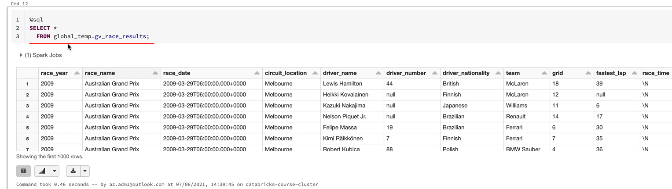

Accessing it from Spark equal is exactly the same. So that will be spark.sql and then you just put the select statement and I'll just copy the statement there. And let me do a show just to see the data from that. So, as you can see, it's got the data we expect to see. So that's cool. We've created the temp review and we've access to temp preview.

spark.sql("SELECT * \

FROM global_temp.gv_race_results").show()

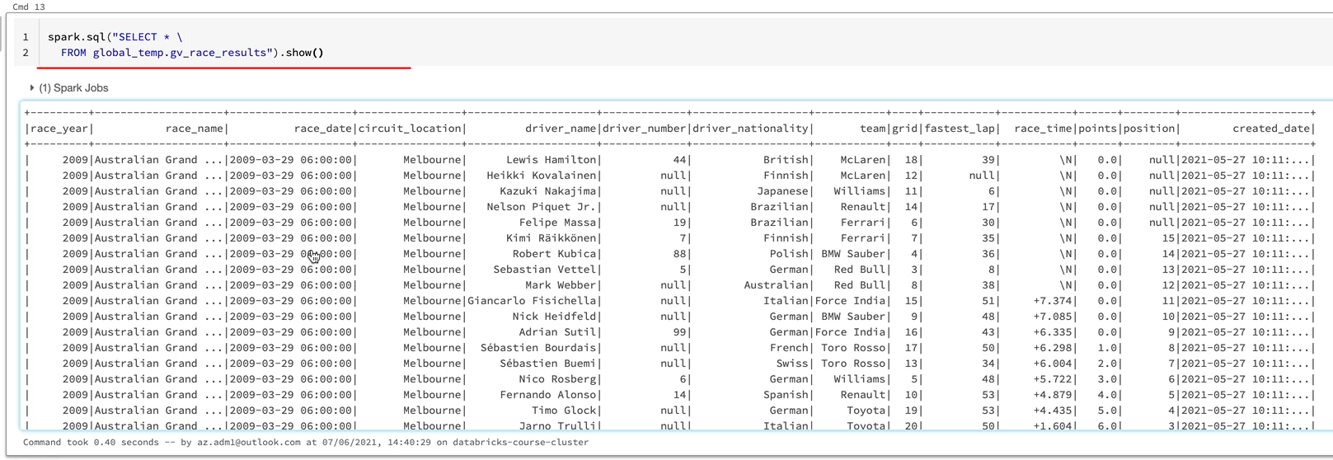

So let's now try and use it from another notebook. So I'm going to use the other notebook that we created, I'm going to do a command click if you are in windows, if you do a controlled click, it's going to open up another tab with that notebook. And that's what I did here. And let us access the global temporary. We should be able to get the same results here as well. So as you can see, we're able to access the global temporary review from more than one notebook.

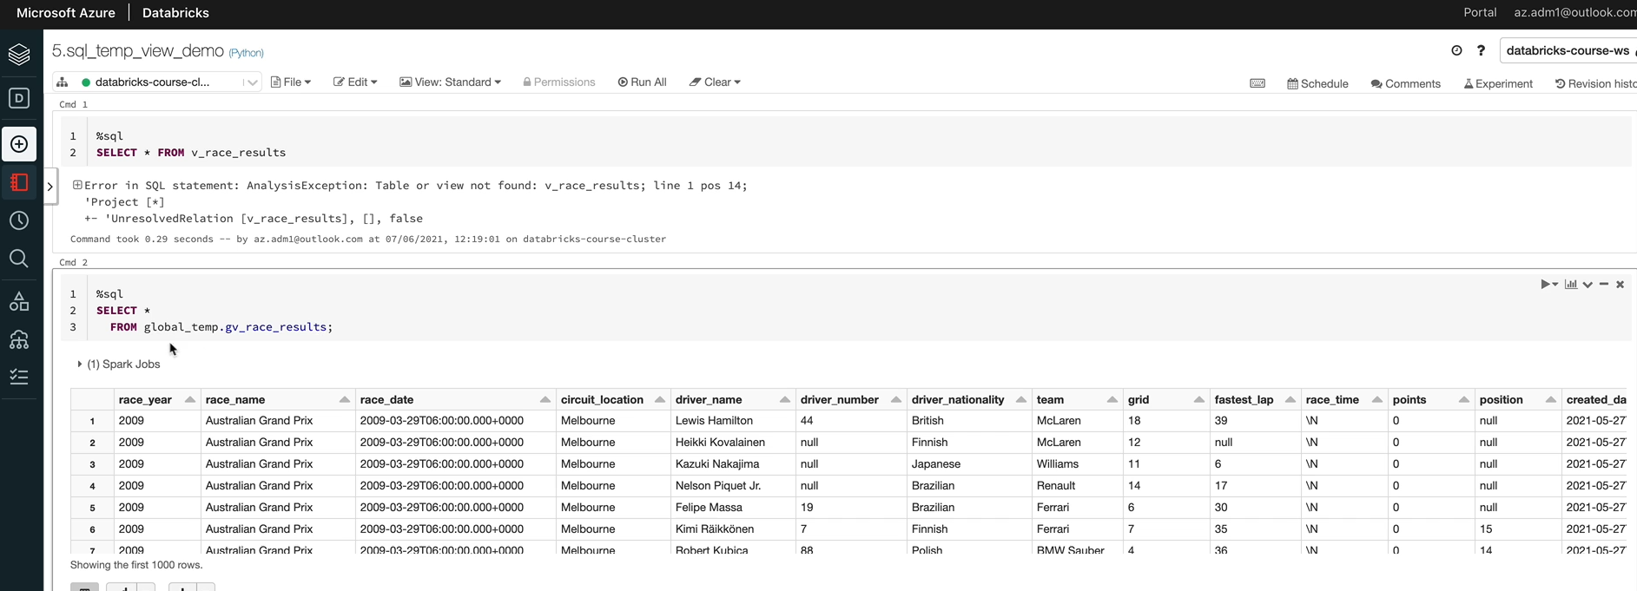

You can detach and attach to the same cluster again, and you'll still be able to see the global temporary view.

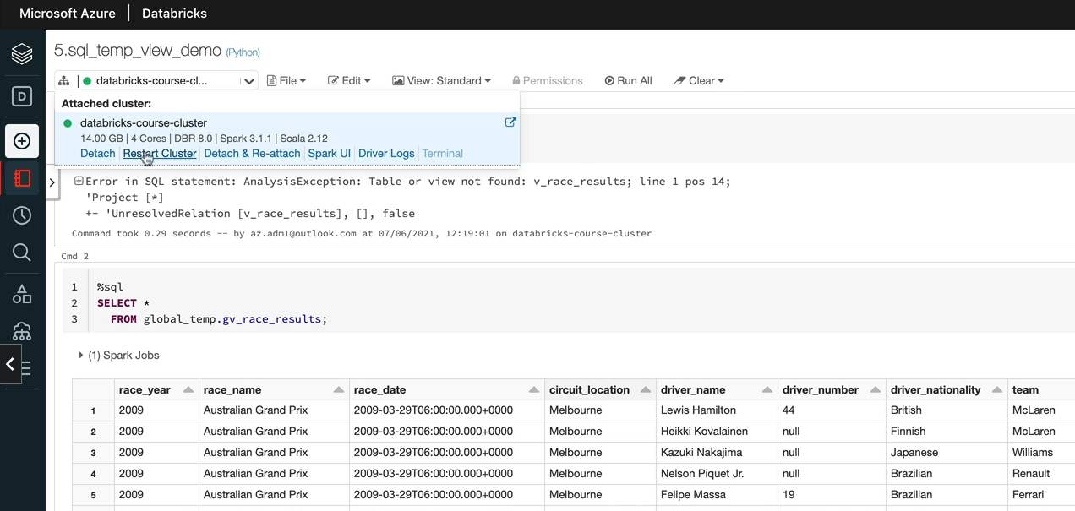

Until the cluster goes down or you restart the cluster, you are still going to be able to access your global temporary bill. So you might be wondering actually when to use the normal temp feel and then to use the global temporary. So the scenario where you would use the local temp for you is actually your scope is just a notebook. So you create the view and then you access it. And then after that, you don't need that view. So you go for a local temporary view. But whereas actually, if you want to take all your temporary view within a notebook and then you have other notebooks working on those views, then you would create a global temporary view so that you can create the view upfront and then your other notebooks could be using those views. I hope this has given you an understanding about global temporary views and when to use them. So that's the end of this lesson.